Oberservations :

1. There should be tooltip at side menu, side menu should be easy access.

Should be like below screen if there is sub menu.

1. Demand entry should have a mandatory field like title or Position Name. (Shiva suggested to keep only 2 fields as mandatory for now)

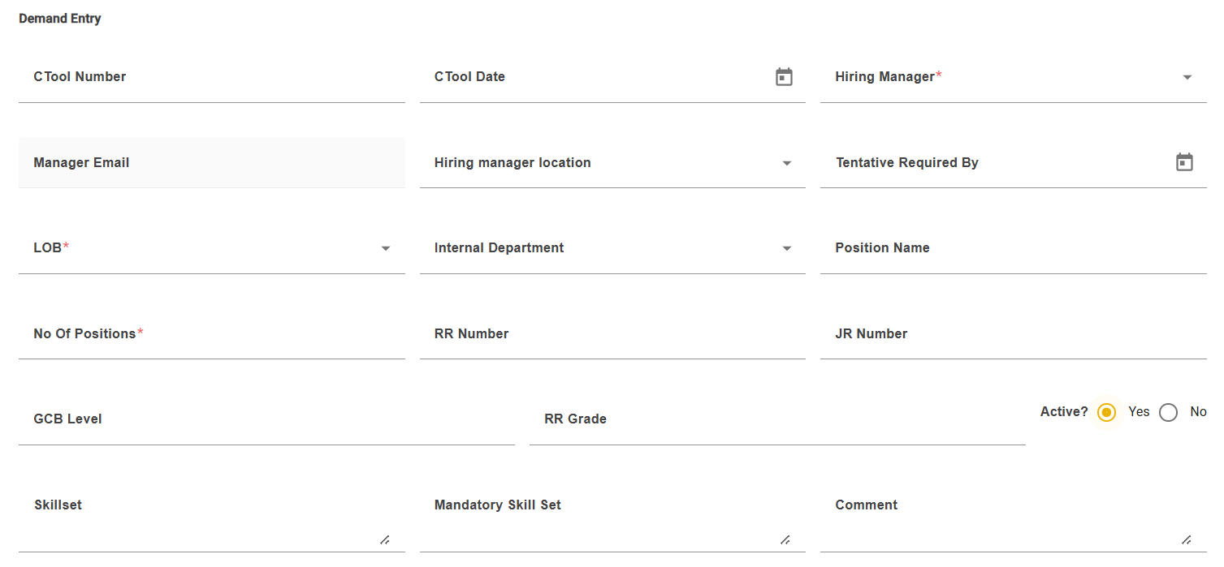

1. Demand lists need to look again:

1. Pie chart on dashboard: ????

1. Age of application issue :

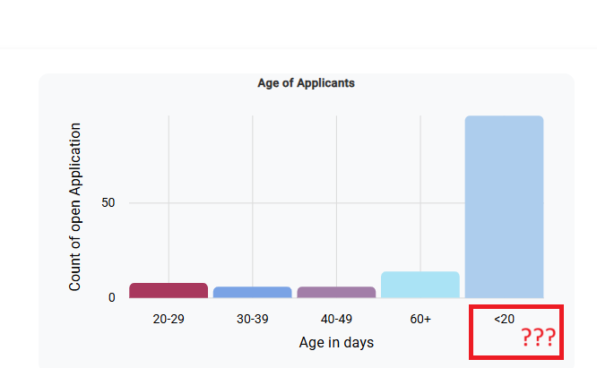After 60+ why <20+

1. UI should be consistent with logo size and text



1. Demand list should be moved to side bar.

Please check above screen shot. (its moves coz of easy access as suggested by shiva)

1. Status should not load each status , it should load only valid status .

1. View should be simplified:

Candidate search is not easy and not working properly. Need to work on view .

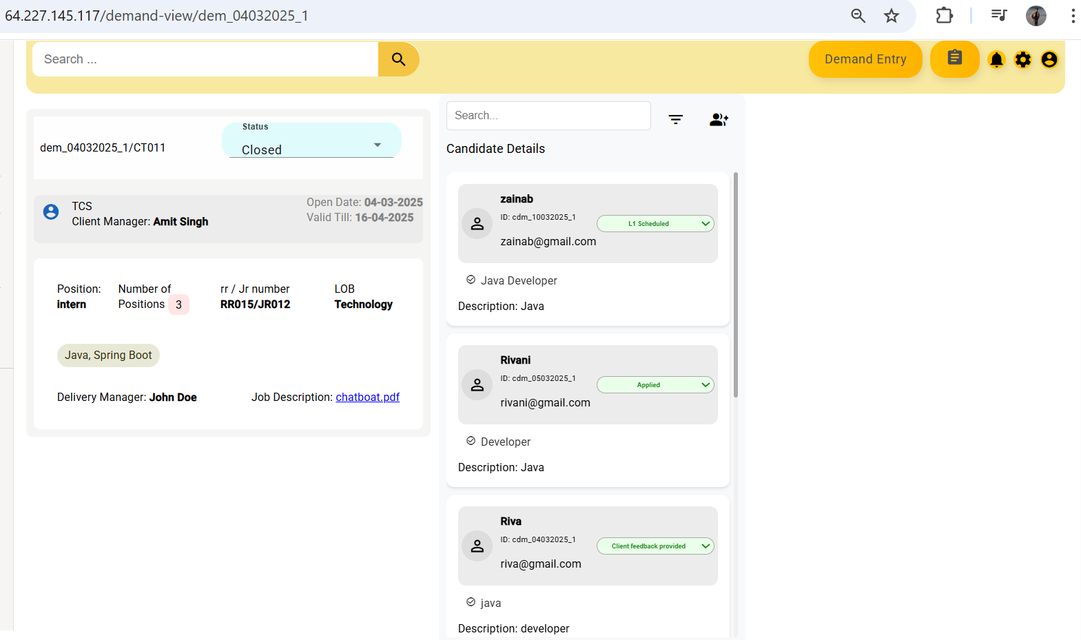

1. Something wrong with the view /services

