**Practical No:11**

Roll No.:2217021 Batch: B DOP:

Name: Epshita Ninawe DOC:

**Aim** Execute commands to –

* Copy a file from/To Local file system to HDFS.
* Move file from source to destination.
* Remove a file or directory in HDFS.
* Copy a file from/To Local file System to HDFS.

**Theory:**

**Hadoop Distributed File System (HDFS)** is designed to store large files across multiple machines in a distributed environment. It is highly fault-tolerant and is optimized for high-throughput data access.

Key features of HDFS:

* **Scalability**: HDFS can scale horizontally by adding more nodes.
* **Fault Tolerance**: Data is replicated across different nodes to ensure availability.
* **High Throughput**: Designed for large datasets rather than low-latency access to small files.

**HDFS Commands**

**1. Copy a File from Local File System to HDFS**

The put command is used within HDFS to copy files from the local file system to HDFS. It's functionally the same as the copyFromLocal command.

**Syntax:** hdfs dfs -put /path/to/local/file /path/in/hdfs/

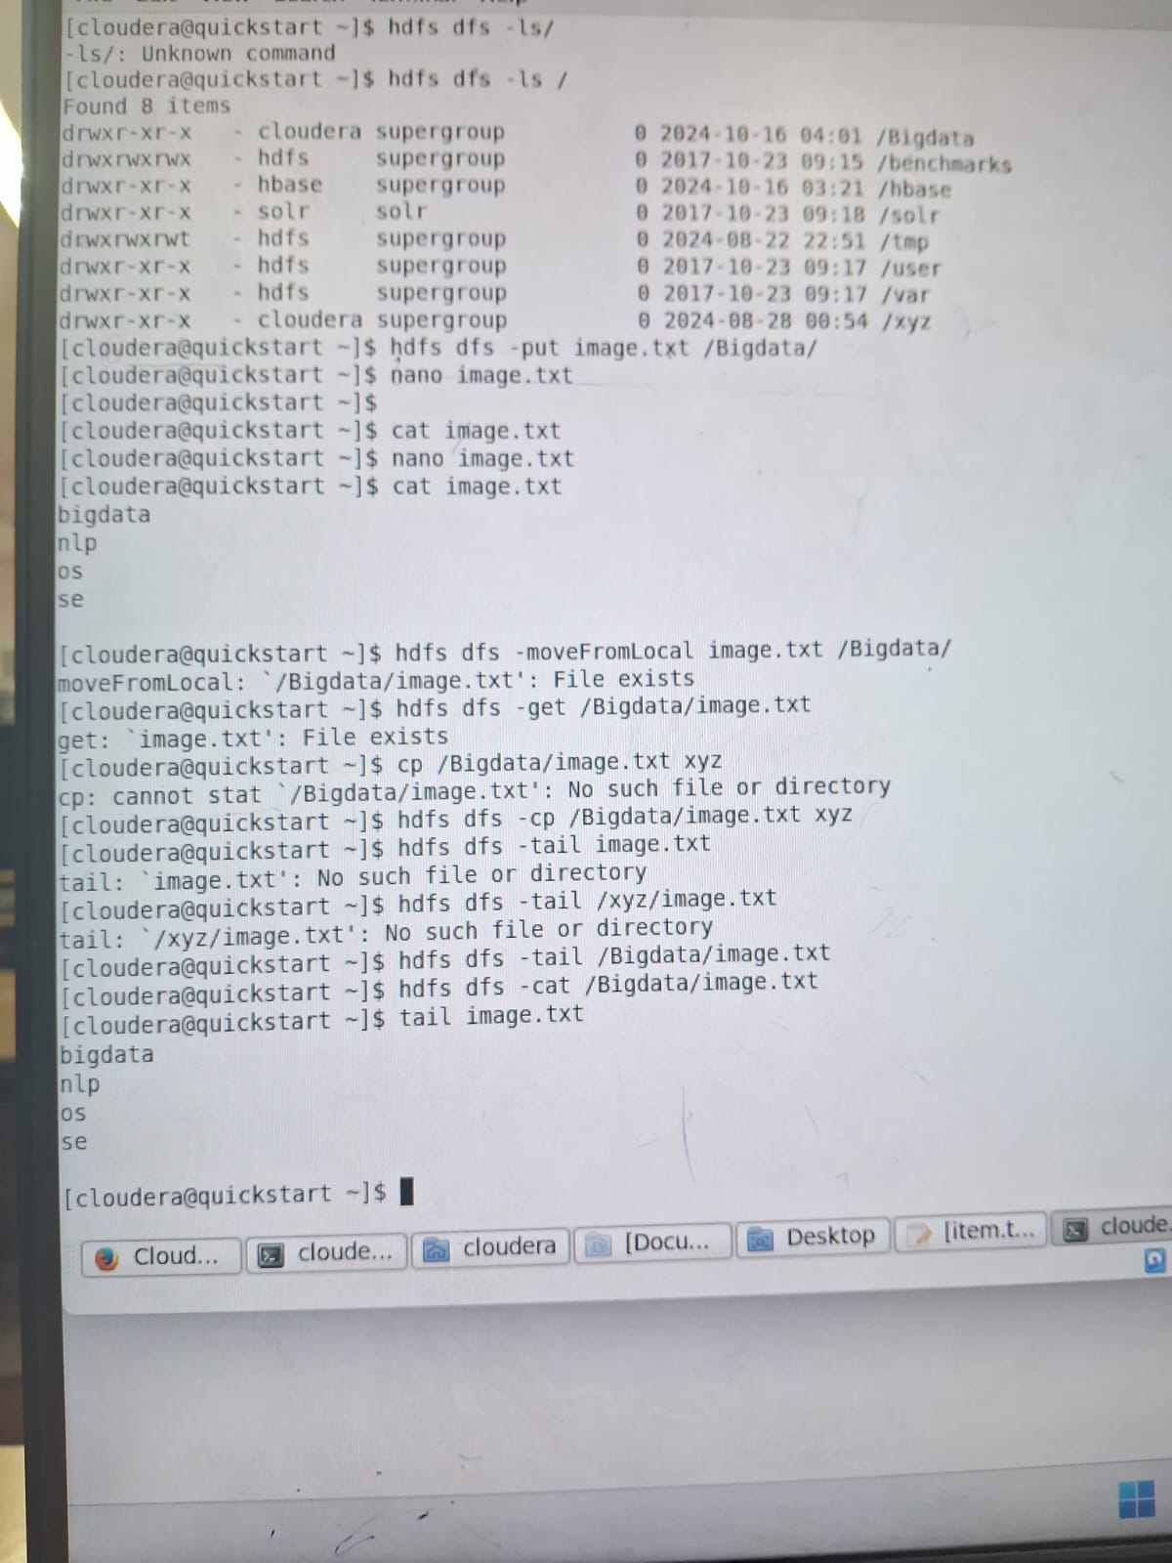

**2. Move a File from Source to Destination in HDFS**

To move a file within HDFS, use the hadoop fs -mv command:

**Syntax:** hadoop fs -mv /source/path/in/hdfs/file.txt /destination/path/in/hdfs/



**3. Remove a File or Directory in HDFS**

To remove a file or a directory in HDFS, use the hadoop fs -rm command:

**Syntax:** hadoop fs -rm -r /path/in/hdfs/directory/

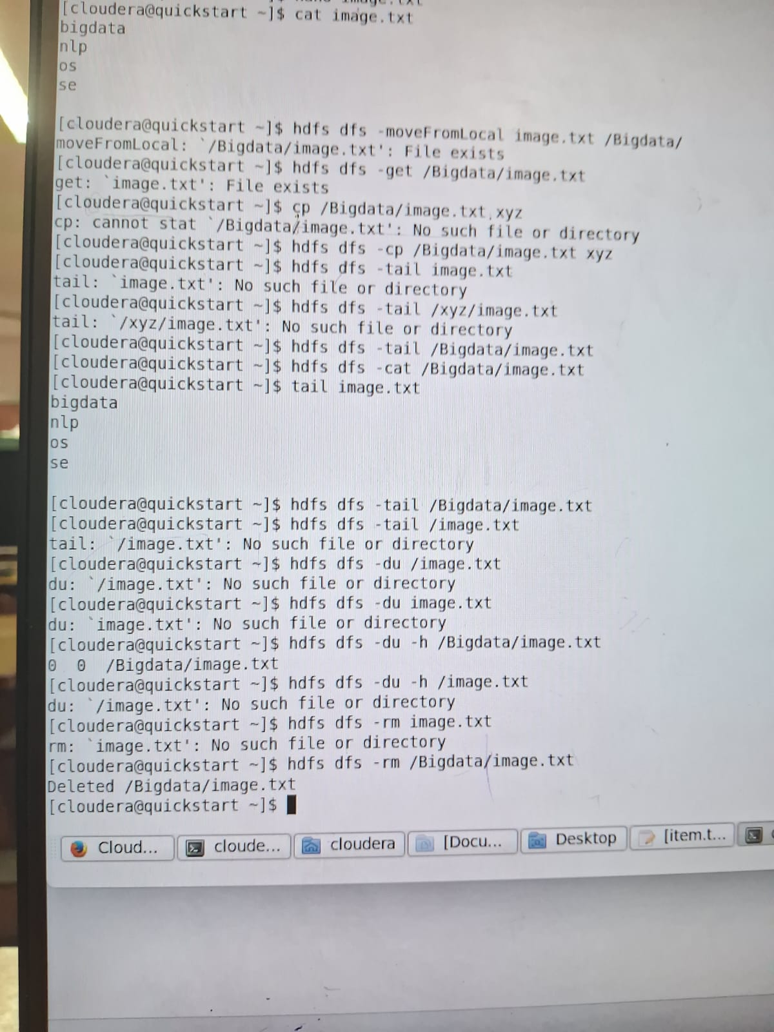

**4. Copy a File from HDFS to Local File System**

To copy a file from HDFS back to your local file system, use the hadoop fs -get command:

**Syntax:** hadoop fs -get /path/in/hdfs/file.txt /path/to/local/



**Conclusion:** Hence , I have successfully Executed commands to – Copy a file from/To Local file system to HDFS. Move file from source to destination,Remove a file or directory in HDFS, Copy a file from/To Local file System to HDFS.

Sign of Teacher