**REVDOC**

**Employee/Doctor Management Portal**

**Application Design**

**V1.0**

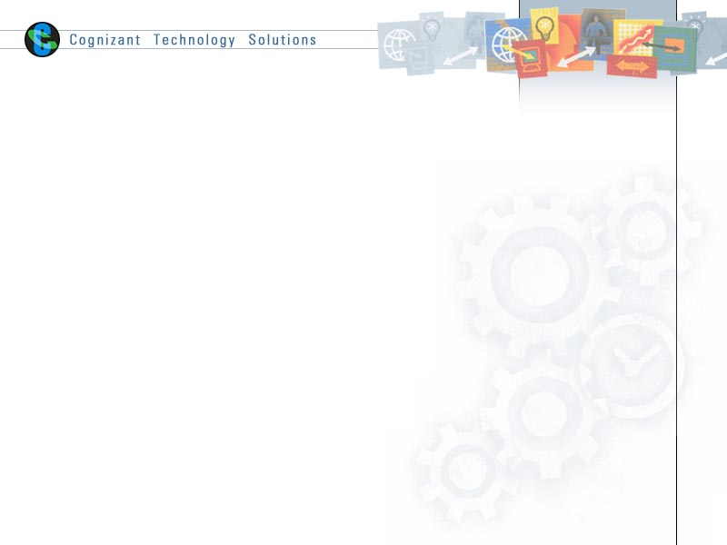

|  |  |  |  |
| --- | --- | --- | --- |
|  | **Prepared By** | **Reviewed by** | **Approved By** |
| **Name** | 1905 Aug-05 |  |  |
| **Role** | Trainees |  |  |
| **Signature** |  |  |  |
| **Date** |  |  |  |

Table of Contents

1.0 Introduction 3

1.1 Purpose of this document 3

1.2 Scope 3

1.2.1 In Scope 3

1.2.2 Out Scope 3

1.3 Intended Audience 3

2.0 Conventions and Standards Followed 4

3.0 Assumptions, Dependencies and Risks 4

4.0 Object Model 5

4.1 System Object Model 5

4.2 UI Controls 6

4.3 UI Design 7

4.3.1 Search UI 7

4.3.2 Advance search UI 7

4.3.3 Pagination 8

4.3.4 Calendar 8

4.3.4 Appointment card 9

4.3.4 Create appointment 9

4.3.4 Delete/View/print appointment 10

4.4 E-R Diagram (Relationship between tables) 10

# Introduction

## Purpose of this document

The purpose of this documentation is to guide future Revature trainees to understand the bare bones of the application. This document will guide them step by step on how each module works. Allowing trainees to understand the workflow of the application.

Furthermore, every module can be enhanced for forthcoming improvements.

## Scope

### In Scope

* Employee can search doctor based on Experience in year, Specialization, Condition, Location
* Employee can Add/Edit/Delete/View appointment
* Employee can rate Doctor
* Employee can follow Doctor
* Doctor can Add/Update/Edit his/her profile
* Doctor Edit Availability

### Out Scope

* Migrating monolithic application to microservices
* Doctor can Confirm/Deny appointments

## Intended Audience

The intended audience for this document is

* Developers, testers, other associates in the project

# Conventions and Standards Followed

*Employee Management system will follow Oracle’s java coding standard.*

**

# Assumptions, Dependencies and Risks

**Assumptions**:

* Application is assuming the user (Revature Associate/Doctor) has successfully entered correct log in credentials.
* Doctor has registered successfully in application’s registration page

**Dependencies**

NA

**Risk**

* With the current system design application can perform optimally with less than 1000 employee.

# Object Model

## System Object Model

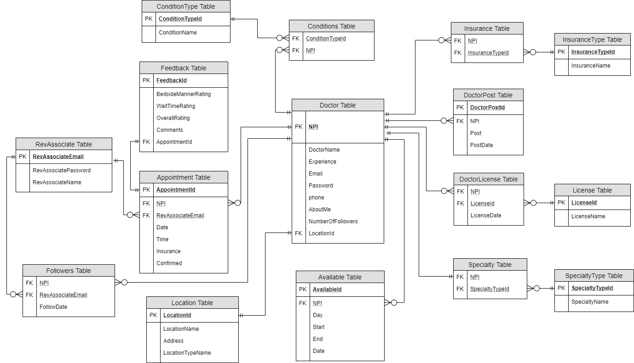

## UI Controls

**Login Revature Associate**

|  |  |  |  |  |  |
| --- | --- | --- | --- | --- | --- |
| **Data Element** | **Control type** | **Default Values** | **Editable Field** | **Restrictions** | **Mandatory/**  **Non Mandatory** |
| User Email | Textbox | Yes | Yes | No | Mandatory |
| Password | Textbox | Yes | Yes | No | Mandatory |

**Login Doctor**

|  |  |  |  |  |  |
| --- | --- | --- | --- | --- | --- |
| **Data Element** | **Control type** | **Default Values** | **Editable Field** | **Restrictions** | **Mandatory/**  **Non Mandatory** |
| User Email | Textbox | Yes | Yes | No | Mandatory |
| Password | Textbox | Yes | Yes | No | Mandatory |

**Add/Edit Appointment**

|  |  |  |  |  |  |
| --- | --- | --- | --- | --- | --- |
| **Data Element** | **Control type** | **Default Values** | **Editable Field** | **Restrictions** | **Mandatory/**  **Non Mandatory** |
| Doctor Name | Textbox | Yes | No | Only Alphabets | Mandatory |
| Appointment Id | Textbox | Yes | No | Only Numbers | Mandatory |
| Date and Time | Textbox | Yes | Yes | Valid Date | Mandatory |
| Address | Textbox | Yes | No | Only Alphanumeric | Mandatory |
| Insurance | Dropdown | No | Yes | - | Mandatory |

**Search Field**

|  |  |  |  |  |  |
| --- | --- | --- | --- | --- | --- |
| **Data Element** | **Control type** | **Default Values** | **Editable Field** | **Restrictions** | **Mandatory/**  **Non Mandatory** |
| Search doctor by name | Textbox | Y**es** | No | Only Alphabets | Mandatory |
| Search doctor by NPI | Textbox | Yes | No | Only Numbers | Mandatory |
| Search doctor by condition | Textbox | Yes | No | Only Alphanumeric | Mandatory |
| Search doctor by Years of experience | Textbox | Yes | No | Only Numbers | Mandatory |
| Search doctor by insurance | Textbox | Yes | No | Only Alphabets | Mandatory |

## UI Design

### Search UI

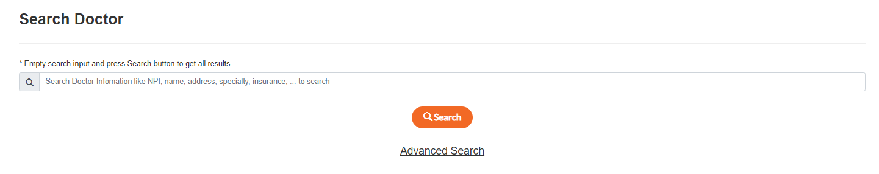

### Advance search UI

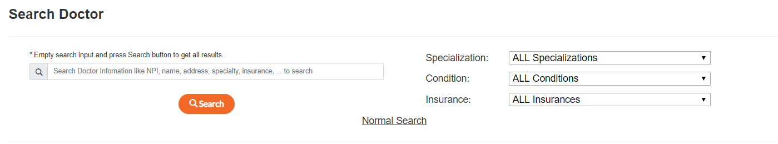

### Pagination

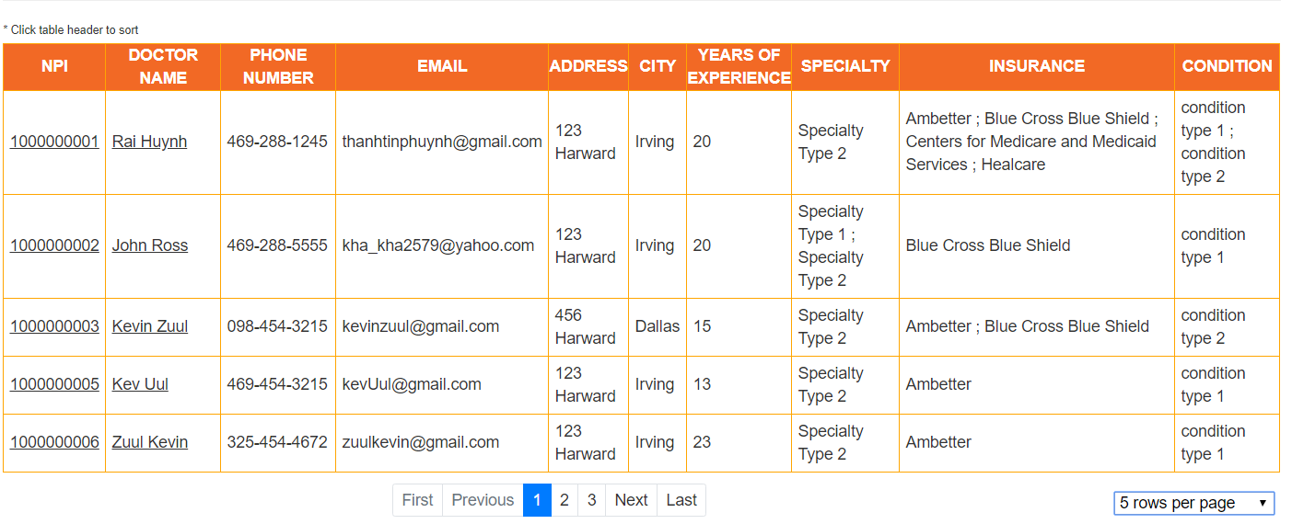

### Calendar

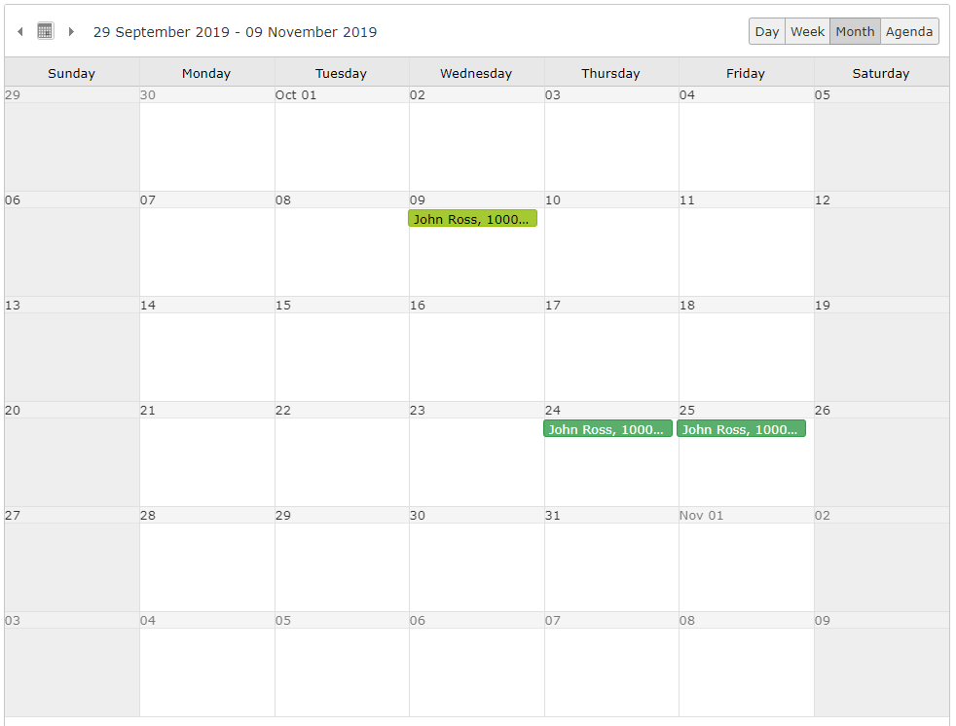

### Appointment Card

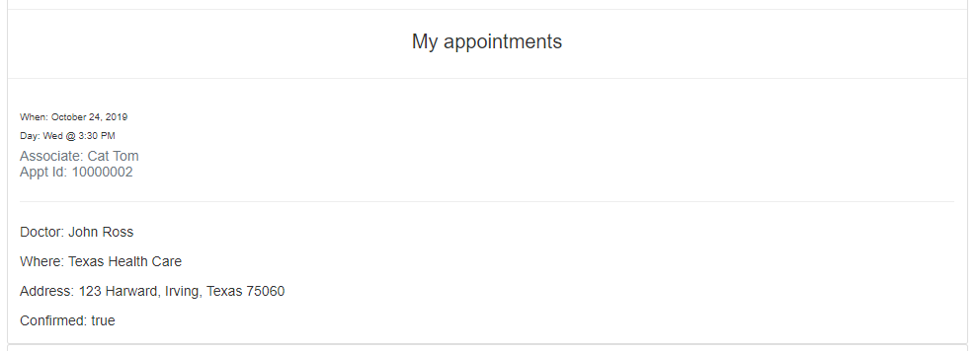

### Create appointment

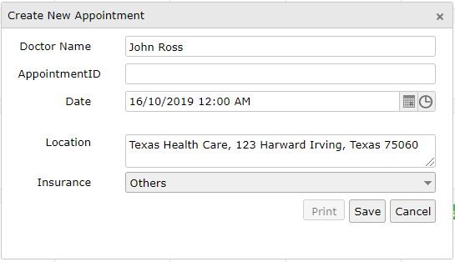

### Delete/View appointment

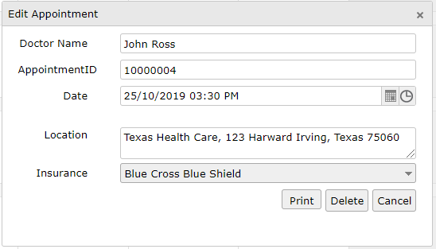

## E- R Diagram (Relationship between Tables)

# 