1. What is the Bayes equation? (in words & equation)

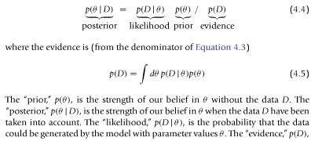

1. What is the prior distribution, and what is a conjugate prior?

The prior distribution is a probability distribution describing amount of belief across a range of parameter values. A conjugate prior is a prior distribution of a form that when multiplied by a likelihood distribution yields a posterior distribution that is in the same form of the prior distribution. Being of the same form is nice because it means you can keep adding more data to the model and subsequently, and easily, calculate your new belief (posterior) of the parameter values.

1. What are the ways we’ve learned to assess the posterior if we can’t calculate is exactly?

We have learned to approximate it. First, we studied grid sampling (ch6), then the Metropolis algorithm (ch7), and now Gibbs sampling (ch8).

1. When is Grid approximation effective, when is it not effective?

Grid sampling is a way to approximate the posterior distribution. The idea is to calculate the value of the posterior distribution at many possible levels of theta. This is tractable for only a small number of parameters because values of theta because the size of the grid increases quickly. A nice property of grid sampling is that your prior need not be conjugate and can be very flexible. 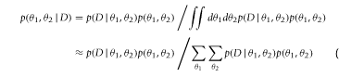

1. What is MCMC and how have we learned about its use in Bayes analysis?

Markov chain Markov chain Monte Carlo is a way to set up how to sample, in this case, we want to repeatedly sample the posterior distribution, and do it in a way that covers the parameter space efficiently. Markov chains have a useful property of forgetfulness, in that your next step in the chain is only based on your current position (‘first-order’). We have used Markov chains in bayes analysis to sample parameter values and calculate the posterior distribution at these posterior values.

1. What is the Metropolis algorithm, when is it not effective?

The Metropolis algorithm is an MCMC approach to sample from the posterior distribution when the parameter space is too large to approximate by grid sampling.

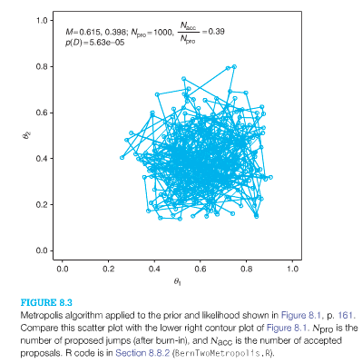

1. What is Gibbs sampling? When is it possible?

Gibbs sampling is another approach to sample from the posterior distribution and also uses MCMC like Metropolis. It is useful when you can’t calculate the posterior distribution directly but can calculate the conditional joint distributions, from which you can calculate the values of the posterior distribution. Limitations arise when you can’t derive the conditional probabilities of the parameters, or if the parameters are strongly correlated.

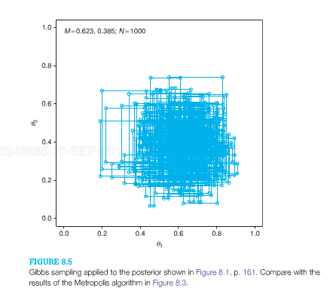

1. Is it possible to analytically solve for the posterior distribution with more than one parameter?

Yes. It is still possible to devise conjugate priors for multiparameter spaces.

For example, a joint beta prior for a bivariate Bernoulli example.

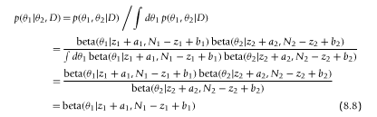

1. What is a proposal distribution? What are the differences between Gibbs & Metropolis with respect to the proposal distribution?

A proposal distribution is a probability distribution that determines how to select the next step in the MCMC walk. In the Metropolis algorithm, the proposal distribution is set by the user, and needs to be tuned so as to allow for efficient sampling (~ 75% rejection rate). In Gibbs sampling, the proposal distribution comes from the conditional probability of the parameters, it depends on the current location of the parameter space.