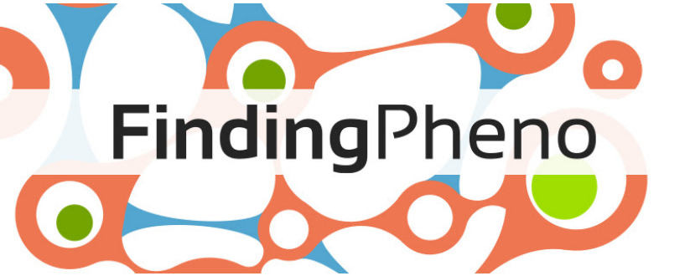

July 18, 2022

**Diagnosing cancer with AI**

Updated: Jan 12, 2024

Did you know that cancer cells have distinct features that set them apart from normal cells? They have different shapes, sizes, organization, and even express different proteins. It is amazing how these differences can aid in the diagnosis of cancer – determining the types and stages of the disease. Typically, doctors (pathologists) take a small sample of tissue from the affected area (a biopsy), slice and stain the tissue to see what is going on inside, and examine it under a microscope. A fascinating process in the fight against cancer!

Traditionally, when conducting biopsy diagnosis, a pathologist would analyzes tissue images to understand and interpret patterns and features. These images are [visually complicated and highly variable](https://revistas.unimilitar.edu.co/index.php/rmed/article/view/1184/908), making the process laborious for trained pathologists, [creating shortages in diagnostic capacity](https://www.global-engage.com/life-science/challenges-facing-the-pathology-department/) (*see image of biopsy sample of colon sections*) and subjective. Pathologists rely on their experience to make diagnostic decisions, which may lead to delayed patient diagnosis and required treatment.

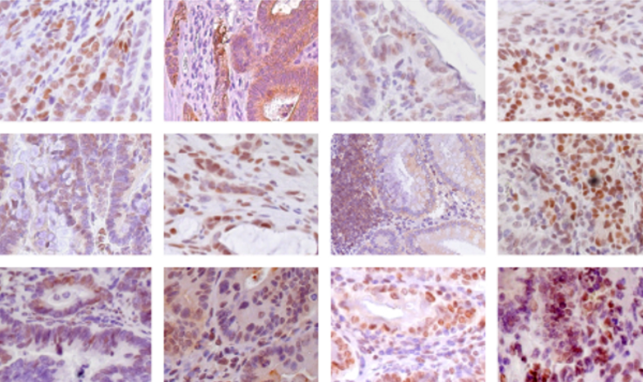Doctors are now using exciting new technology to help diagnose cancer, called machine learning (ML)-based image analysis. This involves taking pictures of tissue samples and analyzing them with computers to identify and classify cancerous cells. They use a specialized type of ML called deep learning (DL). DL neural networks are more complicated than standard ML algorithms. They have multiple layers and nodes inspired by the neural connections in our brains. This approach is great for medical image analysis because it breaks down the problem into smaller, logical steps. Overall, it is an amazing way to help doctors catch cancer early and save lives!

When we analyze an image, we start by looking for the hard edges in the pixelated data and make lines or simple shapes from them. As we go through the layers, we add more details, patterns, or other features until we can tell what the image is showing. Then we categorize the images into either cancer or non-cancer and figure out the stage of cancer. Once we have all the information, we can make a final diagnosis.

The greatest strength of deep learning algorithms is their unbiased nature, which makes them highly efficient at identifying important factors for decision-making. Sometimes, however, this lack of context can make the system focus on unimportant things, leading to incorrect classifications. For example, if all the non-cancer samples in the training data have blue staining, the system might start to identify blue samples as cancerous, even if they are not.

DL digital pathology systems can be faster and more accurate than analysis by a pathologist, reducing their workload and allowing for more effective allocation of their time and attention. When coupled with robotic workstations, automated microscopy, image acquisition, and microscopy, these powerful AI-based methods have the potential to give a fast, efficient high-throughput workflow with improved detection rates and quicker diagnosis time.

Training and validating DL image analysis systems with high-quality clinical data is crucial because these algorithms are complex and can produce irrelevant classifications. But, once these systems are trained, they can perform better and faster than pathologists. For example, they can take [15 seconds instead of 30 minutes](https://www.techtarget.com/searchhealthit/tip/Medical-imaging-AI-improves-speed-accuracy-of-diagnoses) and be [93% computer accurate vs 73% human](https://arxiv.org/abs/1703.02442) accuracy. Although pathologists should still review and contextualize the digital diagnosis, this can reduce their overall workload and enable them to use their time more effectively. When combined with robotic workstations, automated microscopy, image acquisition, and microscopy, these powerful AI-based methods can provide a rapid, efficient high-throughput workflow with improved detection rates and quicker diagnosis times.

Intrigued? [Take a look at our video](https://www.findingpheno.eu/video2) for more information and some fascinating case studies on using different types of machine learning in biology.

**Written**: Shelley Edmunds

**Updated**: Marie Sorivelle