Vidzeme University of Applied Sciences

**Faculty of Engineering**

Mobile Technology Solutions

group 03

practical work #02

Valmiera, 2020

Table des matières

1 Goal 3

2 Difficulties 3

2.1 Try with react native 3

2.2 Return on android studio 3

2.3 Run on physical device 3

3 Result 4

List of used resources 4

|  |  |  |  |
| --- | --- | --- | --- |
| Document versions | | | |
| Version | Status / Changes | Date | Author |
| 1.0 | Final version | 11.11.2020 | BOYE Loan |

|  |  |  |  |
| --- | --- | --- | --- |
| Contacts and responsible (-s) | | | |
| Name Surname | Department | Position | Contact information (e-mail) |
| Elloy Pierre | Group #03 | Coordinator | pierre.elloy@va.lv |
| Boyé Loan | Group #03 | Member | Loan.boye@va.lv |

# Goal

Our goal with this application was to create a simple AR application if possible in react native.

This application must be able use simple AR functionalities like detect flat surface and put 3D object on it.

We also wanted, if possible, implement a control over the 3D object once placed.

# Difficulties

## Try with react native

Firstly, we tried to install required resources through the expo AR add-ons, but it never worked.

After that we tried to create it through android studio, but same things happened.

## Return on android studio

Seeing that nothing good will come from react native we decided to follow the course material by using the provided official AR example.

## Run on physical device

After that we had some trouble to compile and run the project on our physical device.

We finally manage to run the example, permitting us to start to explore AR on Phone device.

# Result

Finally we manage to modify the example to load the 3D model of our choose and understand how work the flat surface detection and the 3D object loading.

In the end, we didn’t had time to implement the loaded 3D object movement.

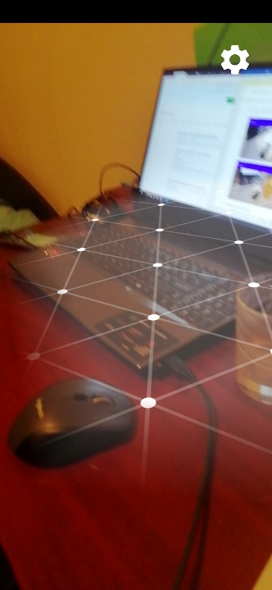 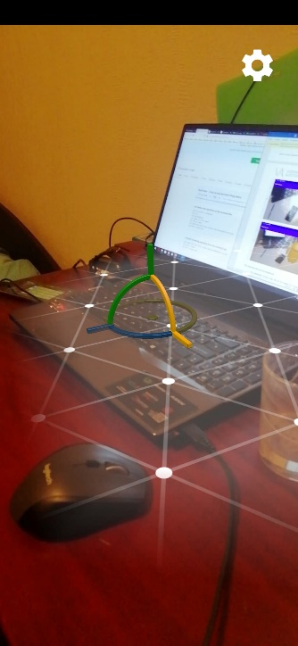 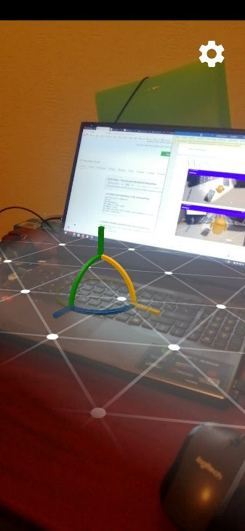

# List of used resources

Project git : <https://github.com/finelame8815/ar_test.git>

Android studio : <https://developer.android.com/studio/install>

Example AR git : <https://developers.google.com/ar/develop/java/quickstart>