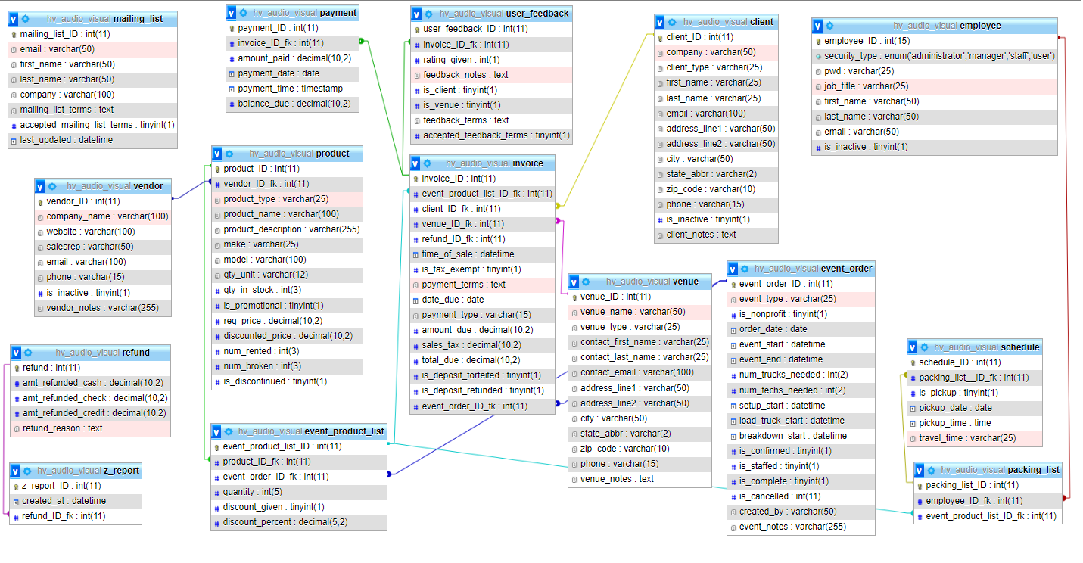

Jennie Q. Colabella

HVAV Database design, v8

Group 1

2022-4-9