1. **Add New Book**

Each book in the system has information about its ISBN, Title, Author/s, Publisher, Place of Publication, Edition, Copyright Year, and cost of the book

The ISBN is unique for each edition of a particular book.

Multiple copies of the same book edition would have the same ISBN.

The copy number would be written on each physical book. This copy# would mainly be for the staff use. Ex: say the library stores 3 copies of each edition 4 of the book ‘Fundamentals of Database Systems’. The information would look like this– Fundamentals of Database Systems, Edition 4 and ISBN 0-321-12226-7, and there are three copies for this book numbered copy1, copy2, copy3. Each copy will have the same ISBN 0-321-12226-7.

ISBN

Title

Category

Author

Publisher

Published Date

Edition

No. of Copies

Cost of @Books

Copyright Year

1. **Search**

Search a book with its ISBN, Title, Author and Category

The user would be shown the availability of the book. If the book is not available, then the system maintains the earliest date when it becomes available. That date is based on the last check-out of that copy or the hold-status. Non-availability of the book implies that none of the copies of the book are available

The ‘**book on reserve’** field would be pre-populated from the database along with the number of the book copies available for a given ISBN. Reserved books are kept in a separate area in the library and are available for a day checkout inside the library only. The user cannot request a hold on any book on reserve. For those books he should go to the library and request them in person. All copies of the same book (that means same ISBN) are either reserved or available for checkout.

1. **Request hold on a book**

Once the availability of the book is shown, the user, if the book is available for checkout, can request a hold on the book. When a user puts a book on hold, it is valid for three days during which the user must go and check the book out.

Books on hold are brought to the desk area by the check-out staff for a speedy check-out. **After three days** the book is put back on the shelf and becomes available to other users if not picked up.

In any case, when the book is requested for hold, the today’s system date would be taken as the hold request date and the system would automatically generate an estimated return date of 17 days later (which includes 3 days on hold and 14 more days for check-out). This is to give the user a buffer of maximum three days to pick his book from the library and a 14 day period to keep the book. When the user physically checks out the book from the library, this estimated return date is updated to exactly 14 days from the checkout date. For a particular book there can be only one hold request by one user. Hold requests on a book with multiple copies are applied to the copies in ascending order of copy number. Every time a book is placed on hold, the count of the number of copies available decreases by 1 in the database. Any attempts to make additional hold request will be rejected when all copies are on hold.

The system would also generate an **‘issue_id’** associated with a request which would be recorded and displayed to the user for editing his request at a later date if needed.

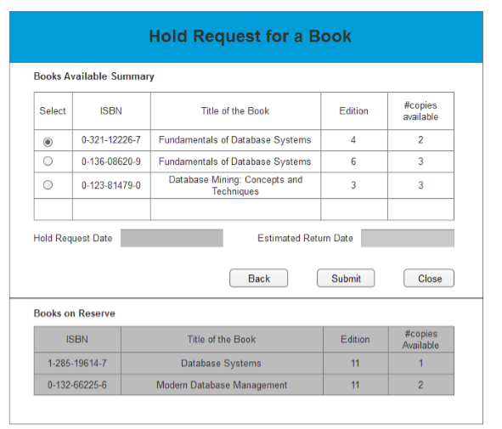

1. **Request extension for an issued Book**

If a user wants to keep the book for a longer time period than assigned, he can request an extension (reissue) from the system as well. He can only use this functionality on a book that he has physically checked out from the library. For a student maximum 2 extensions are allowed per issue of a book. For faculty this number is 5. The estimated return date of the book updates to 14 days from the date of the extension request if that request is accepted. Note that a student can only keep a book for a maximum of 28 days from the original check-out date whereas a faculty can keep it for up to 56 days. . When the book is first checked out the checkout date and extension-request date are same and the expected- return-date is 14 days from check-out. Thereafter, with every extension, the extension-request-date is updated, and the expected-return-date is updated. The original checkout date is always recorded to check that a user can keep a book for a maximum of 28 days. Also, the extension of a book is only allowed if that book has not already been requested for future hold by another user.

For e.g. If I have a book ‘Fundamentals of Database Systems, Edition 4’ issued to me from 2015-01-02 to 2015-01-16 and if I want to extend this duration, I need to go to the Extension Request form and reissue the book. If I do so on 2015-01-10 and if the book hasn’t been requested by some other user then my return date would become 2015-01-24. And this would be counted as one extension, leaving me with 1 more extensions possible for this particular issue of the book.

Each user is allowed 2 extensions for each issue of a book. (For a new checkout of the same book by a user, 2 extensions will be granted again for each new issue.) This information about how many times a user rechecks out a book is recorded. And if the user is a faculty then he is allowed 5 such requests.

Below we show an example of how the dates would be updated with every extension requests made. (Just an example, this does not show all attributes involved in the transaction, such as ISBN, copy# etc.)-

Book Checked-out on January 1st.

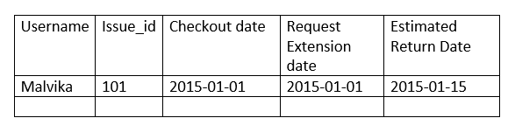

First extension request made on Jan 6th.

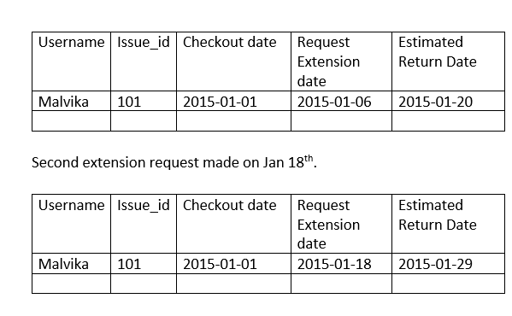

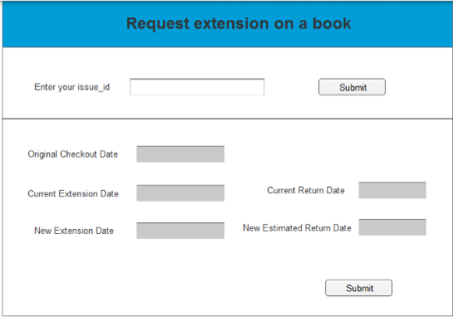

The user enters the issue_id assigned to him and then submits. The system looks for his record and auto-populates the current checkout date, current extension request date (which will be same as the checkout date if this is the first extension being requested) and current return date. (These would be non-editable fields). The new extension request would be the current system date (uneditable) when he is making this request and the new return date (uneditable) would be system generated date of 14 days later than new extension request date. Once the user submits, the system would check if the book has been requested on hold by someone or not; if not, the extension is accepted. If any book has a future hold then extension is denied for that book.

1. **Track location**

This functionality helps one locate a book in the library. Each book is associated with a subject category and each book can belong to only one subject. Each subject has a name, number of journals, and keywords associated with it. The library has three floors. Each floor has a floor number, number of copiers, and a number of student assistants. Each floor can hold books on multiple subjects. All books of the same subject are on the same floor. And there can be multiple shelves on each floor. Each shelf has a shelf number, an aisle number and can hold multiple books.

We are assuming that all copies of the same book are placed together on the same shelf.

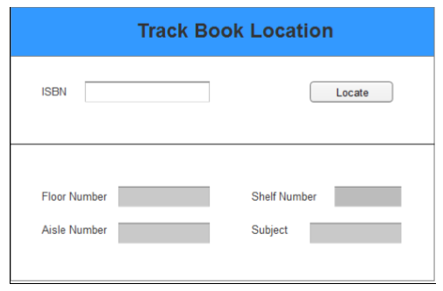

1. **Checkout**

After requesting a hold on the book, the user has to check out the book from the library. He can come to the library, go pick up the book and then go to the terminal where he’ll checkout from this screen. The process will be facilitated by the staff. The user can enter the issue_id and the book will have the information about the ISBN and copy number which will be scanned and shown on the screen along with the user name. (Imagine that the user scans his card which automatically populates his username and name.) The date fields are also auto-populated from the database. If there was a hold request placed by that user on that copy, then it will be dropped from the system when the book is checked out against it.

Remember that when this check out is done, the estimated return date for the issue is to be updated to 14 days from this checkout date or the last allowed date(based on the maximum number of days allowed to him and the maximum number of extensions allowed to him), and the isCheckedout flag has to be updated as well. Also, in case the user is coming to pick up his book after the admissible grace period of 3 days, the system should throw him an error saying that his hold has been dropped. If a copy of that book is still physically in the library, he can locate it, and still check it out. If no copy is physically available, he may place a “hold request for future” on a copy that has the lowest estimated availability date.

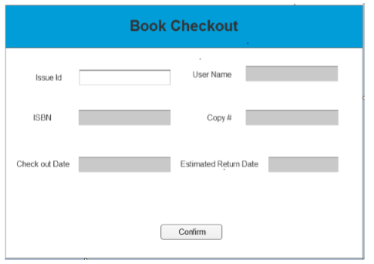

1. **Return Book**

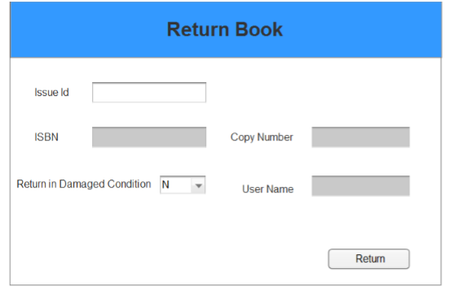

Similar to the checkout function, the terminal would have a return book function for the user. When the user comes in to return a book, the staff would check if the book is damaged or not. If it is damaged, the staff will go to the Penalty charges screen shown next to charge the user account.

If the book is being returned after the due date, then the user account would be automatically charged with the late penalty. Penalty is assessed at **Rs.0000** per day for each late day (regardless of days of the week).

1. **Penalty charges for lost/damaged book**

The staff would charge penalty to the user student account if the book is lost or damaged by the borrower. E.g., for a damaged book, the user would be charged a penalty equal to 50% of the price of the book. And if the book is reported as lost, then the user would be charged the cost of the book.

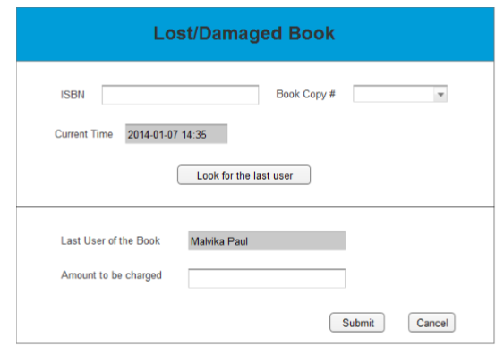

The system time would be taken as current time. Once the library staff clicks on ‘Look for the last user’, the application should take the book ISBN, copy# and the current time, based on which the result should return the last user of the book as shown in the bottom half of the screen. The staff would then manually enter the penalty charges on the user account. Once a book is marked damaged, it cannot be used for any future issues (is not available for borrowing anymore).

1. **Damaged Books Reports**

This report shows the number of damaged books for three selected subjects for a given month.

Once a book is marked damaged, it cannot be used for any future issues

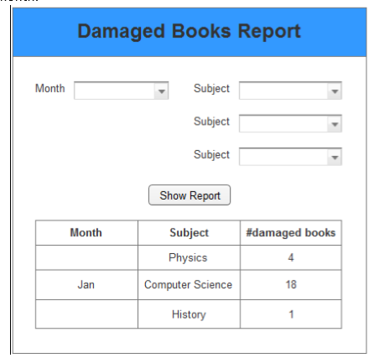

**# Option to generate requisition for Books**