**Technical report**

Test of DBS artefact removal with Independent Component Analysis (ICA).

1. ***Algorithms :***

***Algorithm 1 – ICA on raw data.***

* 1. *High-pass filtering.*
  2. *ICA decomposition.*
  3. *Spectral analysis of the obtained Independent components.*
  4. *Detection of aliased frequencies with the Hampel identifier.*

***Algorithm 2 – ICA on band-pass filtered data.***

1. *High-pass filtering and Low-pass filtering below the stimulation frequency*
2. *ICA decomposition.*
3. *Spectral analysis of the obtained Independent components.*
4. *Detection of aliased frequencies with the Hampel identifier.*
5. ***Results***

***Fig 1 :*** *Spectral analysis of the signal, before ICA.*

**B**

**A**

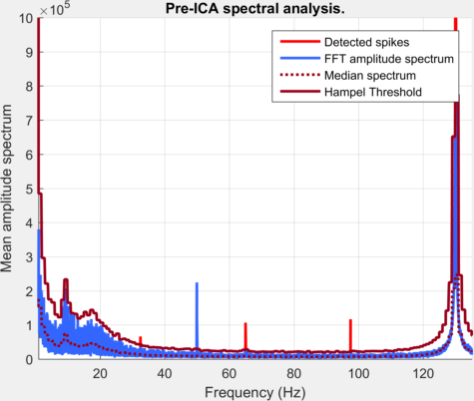 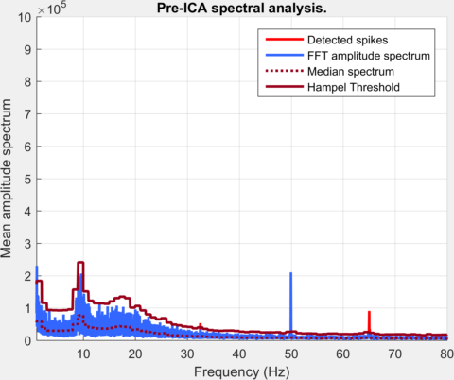

**A** : High resolution power spectrum before low frequency filtering – The stimulation at 130Hz can be observed in the spectrum with aliased frequencies (in light red) detected at 97.5 Hz, 65 Hz and 32.5 Hz. **B** : High resolution power spectrum after low-pass filtering (cutting frequency = 90Hz). The aliased frequencies at 65Hz and at 32.5 Hz are still present.

***Fig 2 :*** *Spectral analysis of the independent components (Algorithm 1).*

**IC 2**

**IC 4**

**IC 6**

**IC 8**

**IC 10**

**IC 1**

**IC 3**

**IC 5**

**IC 7**

**IC 9**

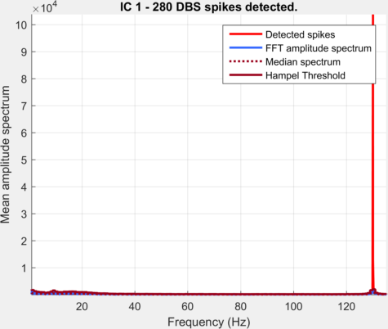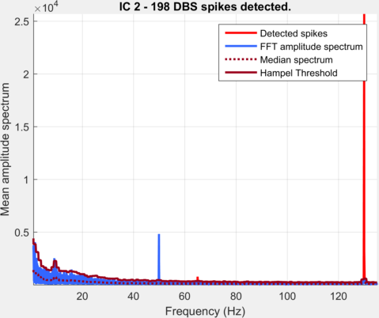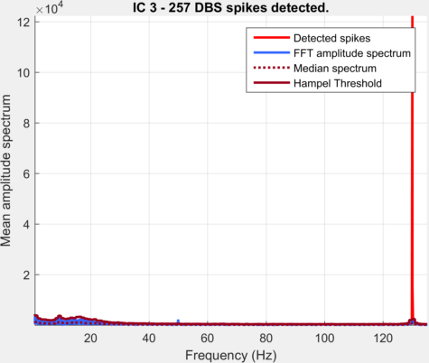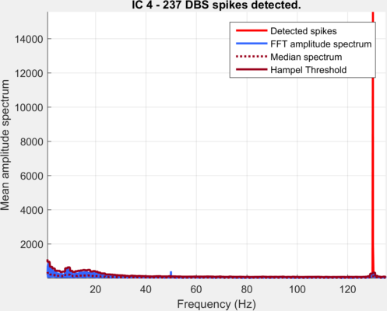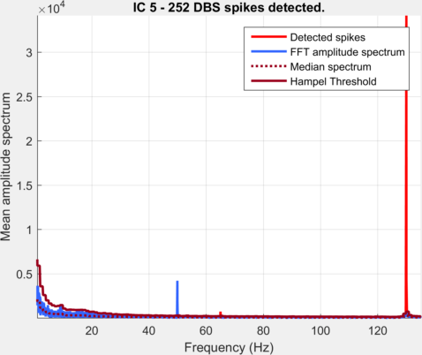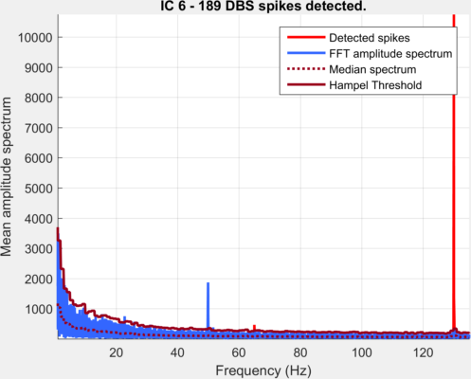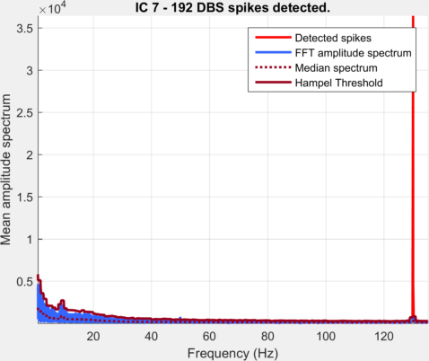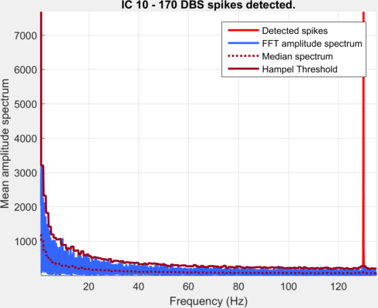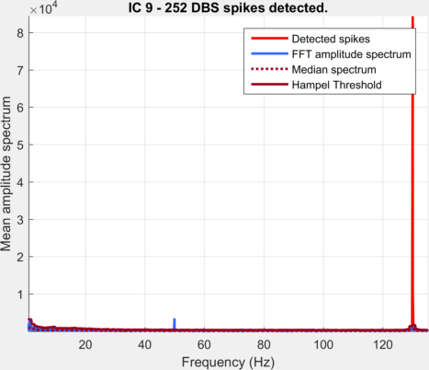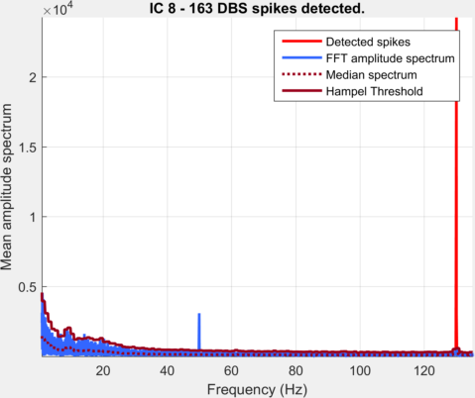

High resolution power spectrum of the 10 estimated Independent Components (ICs) : The stimulation artefact at 130Hz can be observed in the spectrum of all ICs : The ICA algorithm fail to perfectly dissociate the artefact and the neural signal.

***Fig 3 :*** *Spectral analysis of the independent components (Algorithm 2).*

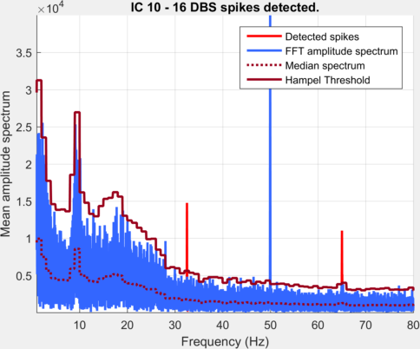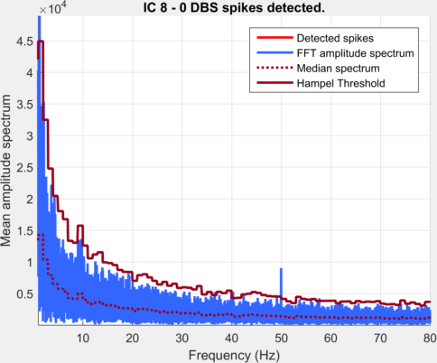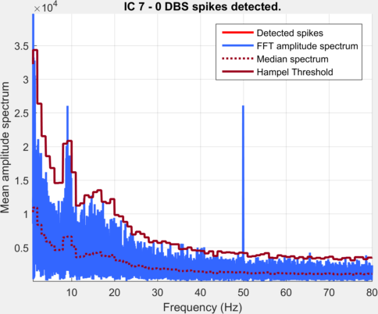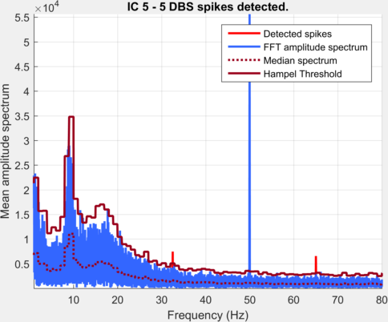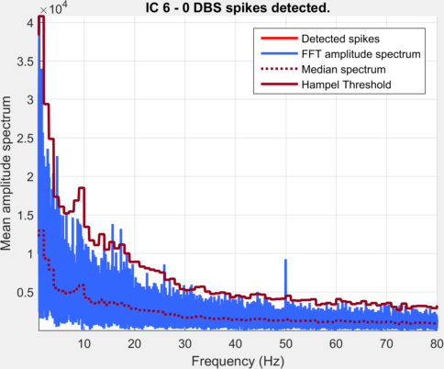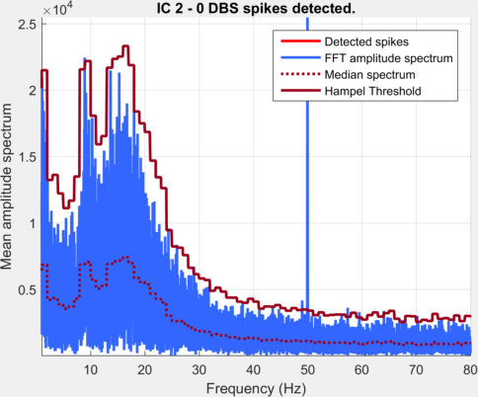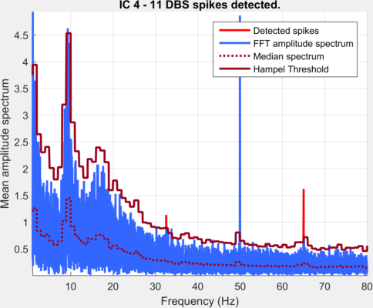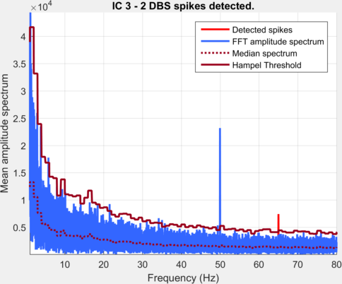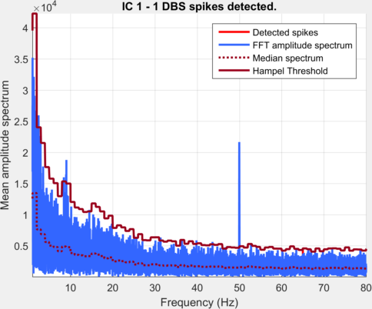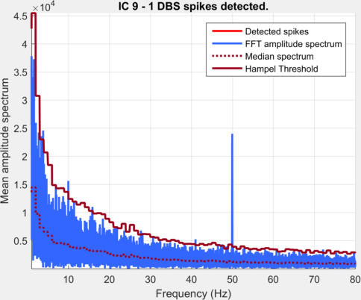

High resolution power spectrum of the 10 estimated Independent Components (ICs). ICA can be used to remove the aliased frequencies of the stimulation artefact if the algorithm if one ‘stimulation artefact component’ can be extracted from the background neural signal. Aliased frequencies of the stimulation artefact appear in 4 ICs (IC 3 – 4 – 5 and 10), while neural signals remain in the high resolution power spectra (e.g. Alpha peak at ≈10Hz).

To conclude, if the spatial filter obtained after an ICA can greatly reduce the aliased frequencies of the stimulation artefact in some sources, the ICA algorithm is sub-optimal to dissociate these components from the neural signal.

1. ***Code :***

%% DBSFILT DBS and ICA

% Author : G. Lio

% Centre de Neurosciences Cognitives, CNRS UMR 5229, Lyon, France

% v1.0 2016

%

% Simple test for DBS artefacts removal with an Independent Component

% Analysis (ICA) algorithm.

%

% ICA is applied on the data, then a high resolution power spectrum is

% calculated for each estimated independent component (IC).

% If the characteristic DBS induced spikes are detected in only one IC, the

% DBS artefact can be considered as well isolated from the neural activity

% by the algorithm.

%

%

%% 1- Script initialization

clear all

close all

clc

fprintf('Welcome to the DBSFILT ICA demo\n-----------------------------------\n\n')

%% 2- User parameters

%) A- file

%) Pre-attenuation of the DBS artefact by low-pass filtering - only the aliased component of the artefact have to be removed with the ICA decomposition.

filename='DBSFILT_P1_dbs_ON_EC_filtered.set'; % Bandpass filtered data

flagHighpassFiltering=0;

%) High pass filtering, but no attenuation of the DBS by low pass filtering.

%filename='DBSFILT_P1_dbs_ON_EC.set'; % Raw data

%flagHighpassFiltering=0;

%) B- Display results

Fmin=1; % Lower frequency to display

%Fmax=135; % Higher frequency to display

Fmax=80; % Higher frequency to display

%% 3- Data processing

%) A- load data

EEG=pop_loadset(filename);

if(flagHighpassFiltering==1)

% High pass filter

Fcut2=1; % cutting frequency (Hz)

Fbandwidth2=1; % transition and width (Hz)

Aattenuation2=80; % amplitude attenuation (dB)

Aripple2=0.01; % ripple in the stop band (dB)

% Edge effet suppression

Tcut=4; % Time window (s) to suppress to avoid edge effects.

EEG.data=DBSFILT_highpassfilter(EEG.data,EEG.srate,Fcut2,Fbandwidth2,Aattenuation2,Aripple2);

EEG=pop_select(EEG, 'time', [Tcut EEG.xmax-Tcut]);

end

%% 3b - Spectral analysis before ICA

[spikes, FFTlength, DATAlength]=DBSFILT_PrepareSpikesDetection(EEG.data,EEG.srate);

type=2; % Hampel identifier and refined spike identification (type=1 - Hampel identifier only)

HampelL=1; % windows size for automatic spike detection (Hz)

HampelT=2.2; % Hampel threshold for automatic spike detection.

FdbsL=130; % DBS frequency (Hz) (left hemisphere)

FdbsR=130; % DBS frequency (Hz) (right hemisphere)

nmax=5; % max number of sub-multiples of the stimulation frequency considered

eps=0.002; % estimated precision of the frequency measurements

[spikes, nb_spikes]=DBSFILT_SpikesDetection(spikes, type, HampelL, HampelT, FdbsL, FdbsR, nmax, eps);

str='Pre-ICA spectral analysis.';

FlagSpikes=1;

DBSFILT_display_rawfftspectraFAST(spikes,FlagSpikes,Fmin,Fmax,str);

ylim([0 1*10^6])

%% 4- Process ICA (insert your own ICA algorithm here)

EEG=pop_reref(EEG,[]);

[Wefica, ISRef, Wsymm, ISRsymm, status, icasig]=efica2(EEG.data);

IC=Wefica*EEG.data; % EFICA algorithm

%IC=Wsymm*EEG.data; % Sym-FASTICA algorithm

%% 5- DBS spikes identification component by component (a good DBS artefact identification with ICA should identify only one IC with the characteristic DBS aliased frequencies)

nb_ic=size(IC,1);

cpt_dbsic=0;

for ic=1:nb_ic

[spikes, FFTlength, DATAlength]=DBSFILT_PrepareSpikesDetection(IC(ic,:),EEG.srate);

type=2; % Hampel identifier and refined spike identification (type=1 - Hampel identifier only)

HampelL=1; % windows size for automatic spike detection (Hz)

HampelT=2.2; % Hampel threshold for automatic spike detection.

FdbsL=130; % DBS frequency (Hz) (left hemisphere)

FdbsR=130; % DBS frequency (Hz) (right hemisphere)

nmax=5; % max number of sub-multiples of the stimulation frequency considered

eps=0.002; % estimated precision of the frequency measurements

[spikes, nb_spikes]=DBSFILT_SpikesDetection(spikes, type, HampelL, HampelT, FdbsL, FdbsR, nmax, eps);

str=sprintf('IC %d - %d DBS spikes detected.',ic,nb_spikes);

fprintf('%s\n',str);

%if(nb_spikes~=0)

% display detection

FlagSpikes=1;

DBSFILT_display_rawfftspectraFAST(spikes,FlagSpikes,Fmin,Fmax,str)

if(nb_spikes~=0)

cpt_dbsic=cpt_dbsic+1;

end

end

fprintf('\n %d/%d IC with detected DBS artefacts.\n',cpt_dbsic,nb_ic);