**Technical report**

Test of DBS artefact removal with peaks detection in the temporal space.

Principal reference:

*J Neurosci Methods. 2016 Mar 31;266:126-136. doi: 10.1016/j.jneumeth.2016.03.020.*

*Moving average template subtraction to remove stimulation artefacts in EEGs and LFPs recorded during deep brain stimulation.   
Sun L1, Hinrichs H2.*

1. ***Algorithm :***
   1. *High-pass filtering.*
   2. *Upsampling.*
   3. *Peaks detection by thresholding in the temporal domain.*
   4. *Detections based epoching.*
   5. *Spectral analysis of the obtained signal.*
   6. *Suppression of the aliased frequencies (equivalent to the resampling strategy to cope with clocks desynchronization of the stimulation and the recording devices).*
   7. *Filtered signal reconstruction.*
2. ***Results***

***Fig1 -*** *Visualization of the peaks detection (c) - 130Hz synchronized left right stimulation in the subthalamic nucleus – Upsampling = 20 kHz:*

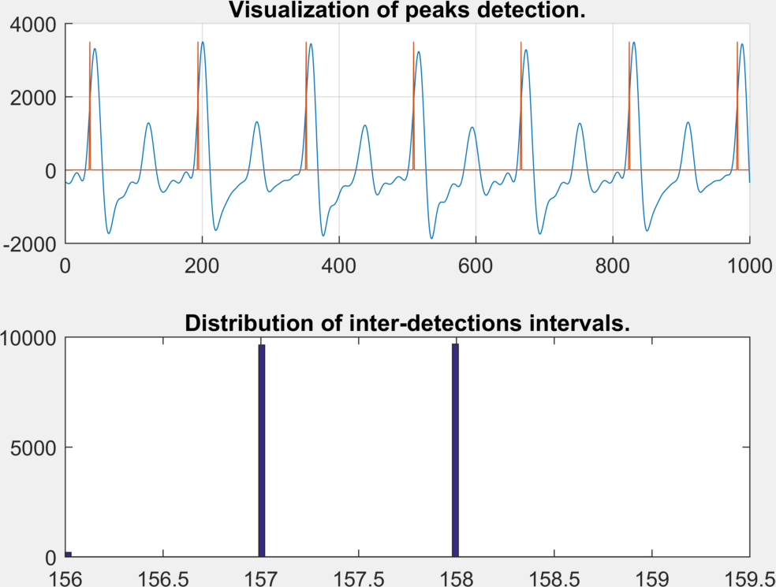

Sampled at 2048 Hz with a Delta-Sigma Analogical to Digital Converter, upsampled to 20480 Hz, all stimulation peaks are detected in the signal. Note the two peaks (blue waveform) between two detections (red signal) of the synchronized left and right stimulations at 130 Hz. If two stimulations are not synchronized, a technique based on a simple threshold cannot be used anymore.

***Fig 2 -*** *Visualization of the detected stimulation peaks.*

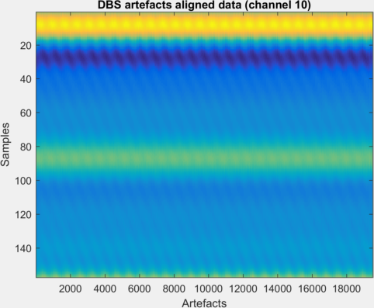

Graphical representation of the detected stimulation artefacts. Note the periodic variations of the detected artefacts waveforms mostly due to the desynchronization between the clocks of the stimulation and the recording devices. These variations can be detected in the frequency domain as outlier frequencies in a high resolution spectrum.

***Fig 3a -*** *Spectral analysis after the steps a, b, c,d and e.*

**A**

**B**

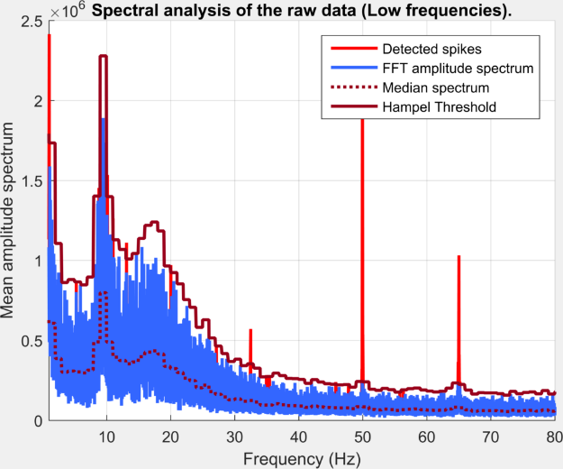 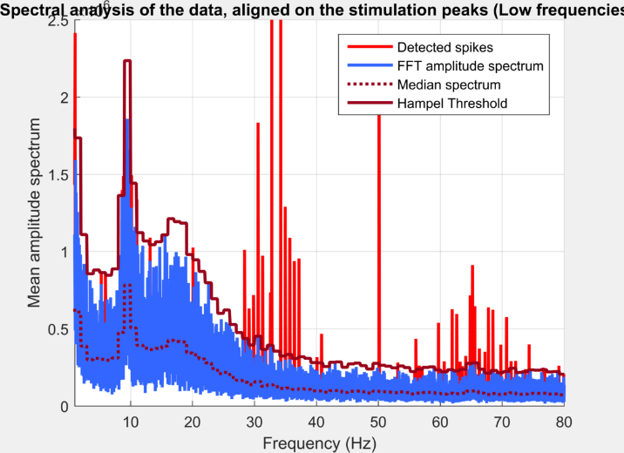

**C**

**D**

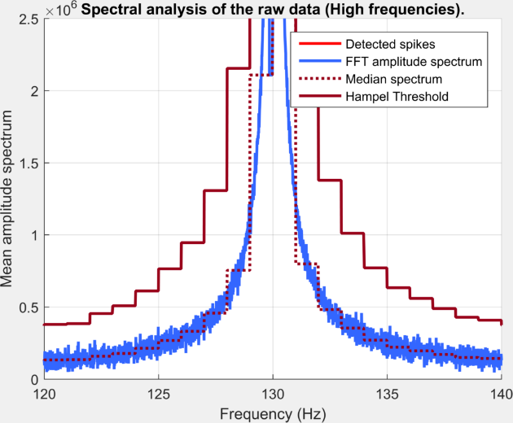 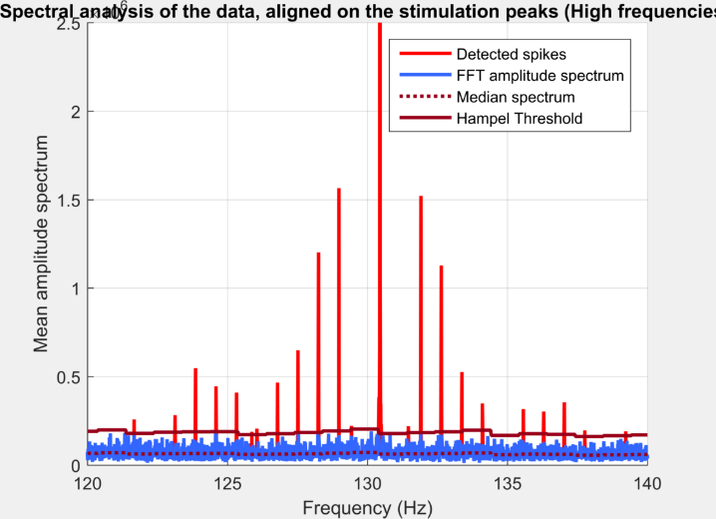

**A** and **B** : High resolution power spectra in the low frequency band for respectively the raw and the aligned signal (based on stimulation peaks detection and re-epoching). Outlier frequencies are represented in light red. **C** and **D** : High resolution power spectra around the stimulation frequency for respectively the raw and the aligned signal.

A direct beneficial effect of the method appear to be a better definition of the artefact in the high resolution power spectrum around the stimulation frequency. This property could be highly beneficial when the stimulation frequency is low and located in the frequency band of interest. Besides, the main drawback is an augmentation of the amplitude and the number of aliased frequencies, particularly in lower frequency bands. Therefore, the method can be counter-productive if these new aliased frequencies are not filtered aposteriori.

***Fig 3b -*** *Spectral analysis after the steps a, b, c,d and e.*

**A**

**B**

**C**

**D**

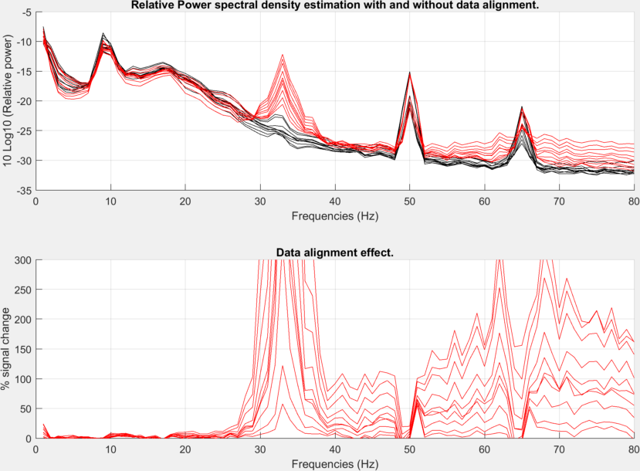

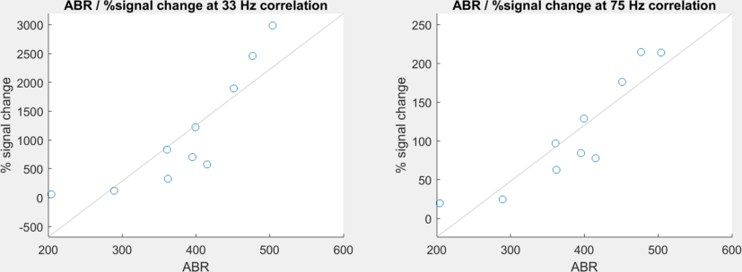

**A** : Relative power spectral density of the RAW data (black), and the same data after peaks detection and data alignment (red). **B** : Effect of the data alignment relative to the original data. A huge augmentation of the power can be detected in all frequency bands above 25 Hz. **C** and **D** : Correlation between the ABR (Artefact to background amplitude ratio) and the % of signal change after the data alignment for respectively 33 and 75 Hz.

***Fig 4 -*** *Spectral analysis after the filtering (steps f and g).*

**A**

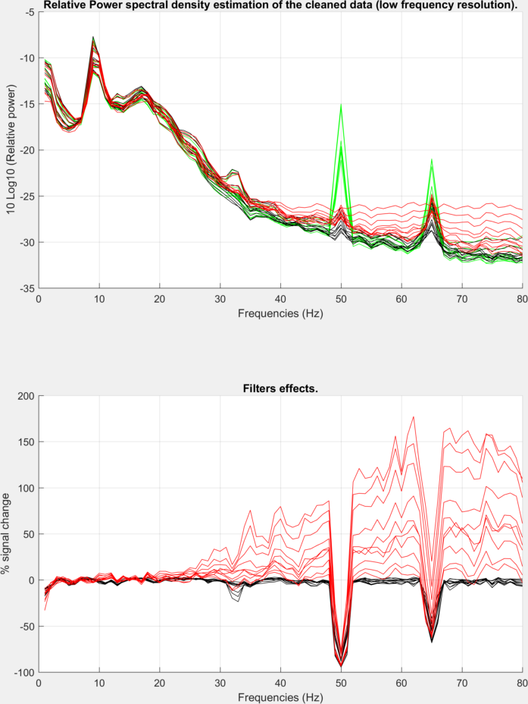

**B**

**A** : Relative power spectral density after three methods of DBS filtering. Green : Simple low pass filtering. Black : Low pass filtering and frequency domain filtering with the hampel identifier. Red : Peaks detection in the temporal space, data alignment and DBS substraction. **B** : Effect of the filtering, relative to the simple low-pass filtering method. Black: Low pass filtering and frequency domain filtering with the hampel identifier. Red : Peaks detection in the temporal space, data alignment and DBS substraction.

**Conclusion :** Methods based on peaks detection needs a data-alignment based on these detections. Spectral analysis reveals than this procedure can significantly alter the spectral integrity of the signal in the whole spectrum. These results are in contrast with the power spectral analyses reported by Sun and Hinrichs 2016 where the spectral integrity of the signal seems to be preserved. An explanation can be that according to these authors, the maximum observed ABR (Artefact to Background amplitude ratio) was among 10, mostly due to bipolar stimulations. In this study, with STN pseudo-monopolar stimulation, the ABR is ten time higher and the spectral deformation of the signal is correlated to this value. To conclude, these results suggest that frequency domain filtering with Hampel identification should be the method of choice to remove DBS artefact of pseudo-monopolar stimulation.

1. ***Code :***

%% DBSFILT SCRIPT DEMO 3

%

% Author : G. Lio

% Centre de Neurosciences Cognitives, CNRS UMR 5229, Lyon, France

% v1.0 2016

%%

%

% Methods comparison

% 1- Simple LowPass Filtering

% 2- Simple LowPass Filtering + Frequency domain Hampel detection

% 3- Upsampling + Temporal domain peaks detection + Frequency domain Hampel detection

%

%% 1- Script initialization

clear all

close all

clc

fprintf('Welcome to the DBSFILT script demo\n-----------------------------------\n\n')

%% 2- User parameters

%) A- file

filename='DBSFILT_P1_dbs_ON_EC.set';

%% 3- Pre-filtering High pass filter parameters

% High pass filter

Fcut2=0.75; % cutting frequency (Hz)

Fbandwidth2=0.5; % transition and width (Hz)

Aattenuation2=120; % amplitude attenuation (dB)

Aripple2=0.01; % ripple in the stop band (dB)

% Edge effet suppression

Tcut=1; % Time window (s) to suppress to avoid edge effects.

%% 4- Data preparation.

%) A- load data

EEG=pop_loadset(filename);

%) B- pre-filtering

% remove low frequency drifts and others low frequency artefacts

EEG.data=DBSFILT_highpassfilter(EEG.data,EEG.srate,Fcut2,Fbandwidth2,Aattenuation2,Aripple2);

EEG=pop_select(EEG, 'time', [Tcut EEG.xmax-Tcut]);

%) Upsampling

% upsampling for a better artefact identification and simplification for

% the treatment of the clock drift between the stimulation and the

% recording device.

upsamprate=10;

EEG=pop_resample(EEG,EEG.srate*upsamprate);

%% 5- Peaks detection

Fc=100; % Cutting frequency for peaks detection (below the stimulation frequency (130Hz))

PPVseglen=6; % Segment length for threshold estimation (6s, same as Sun and Hinrichs, 2016 paper).

threshold=0.6; % Threshold adjustment

plotfig=1; % Plot results

[peaks, FirstLastIndex, ABR]=DBSFILT_StimPeaksDetection(EEG.data,EEG.srate,Fc,PPVseglen,threshold,plotfig);

%) display clocks jitter

x=squeeze(peaks(10,:,:));

figure

imagesc(x);

title('DBS artefacts aligned data (channel 10)')

xlabel('Artefacts')

ylabel('Samples')

%% 6- Spectral analysis of the signal, aligned on peak detections.

peaks=reshape(peaks,EEG.nbchan,[]);

%) Hampel detection for highlighting the outlier frequencies

% parameters

type=1; % Hampel identifier and refined spike identification (type=1 - Hampel identifier only)

HampelL=1; % windows size for automatic spike detection (Hz)

HampelT=2; % Hampel threshold for automatic spike detection.

FdbsL=130; % DBS frequency (Hz) (left hemisphere)

FdbsR=130; % DBS frequency (Hz) (right hemisphere)

nmax=5; % max number of sub-multiples of the stimulation frequency considered

eps=0.002; % estimated precision of the frequency measurements

% detection on aligned data -------------------------------------------

[spikes, FFTlength, DATAlength]=DBSFILT_PrepareSpikesDetection(peaks,EEG.srate);

[spikes, nb_spikes]=DBSFILT_SpikesDetection(spikes, type, HampelL, HampelT, FdbsL, FdbsR, nmax, eps);

% detection on raw data -------------------------------------------

[spikes2, FFTlength2, DATAlength2]=DBSFILT_PrepareSpikesDetection(EEG.data,EEG.srate);

[spikes2, nb_spikes2]=DBSFILT_SpikesDetection(spikes2, type, HampelL, HampelT, FdbsL, FdbsR, nmax, eps);

Fmin1=1; % Lower frequency to display

Fmax1=80; % Higher frequency to display

Fmin2=120; % Lower frequency to display

Fmax2=140; % Higher frequency to display

% display detection

FlagSpikes=1;

str_title='Spectral analysis of the data, aligned on the stimulation peaks (Low frequencies).';

DBSFILT_display_rawfftspectraFAST(spikes,FlagSpikes,Fmin1,Fmax1,str_title)

ylim([0 2.5*10^6])

str_title='Spectral analysis of the data, aligned on the stimulation peaks (High frequencies).';

DBSFILT_display_rawfftspectraFAST(spikes,FlagSpikes,Fmin2,Fmax2,str_title)

ylim([0 2.5*10^6])

str_title='Spectral analysis of the raw data (Low frequencies).';

DBSFILT_display_rawfftspectraFAST(spikes2,FlagSpikes,Fmin1,Fmax1,str_title)

ylim([0 2.5*10^6])

str_title='Spectral analysis of the raw data (High frequencies).';

DBSFILT_display_rawfftspectraFAST(spikes2,FlagSpikes,Fmin2,Fmax2,str_title)

ylim([0 2.5*10^6])

%% ) Power spectral density and %signal change after data alignment.

segmentLength = EEG.srate;

noverlap = round(segmentLength/2);

[pxx, f] = pwelch(EEG.data',segmentLength,noverlap,segmentLength,EEG.srate);

[pxx2, f] = pwelch(peaks',segmentLength,noverlap,segmentLength,EEG.srate);

Fmin=1; % Lower frequency to display

Fmax=80; % Higher frequency to display

index1=find(f>=Fmin,1,'first');

index2=find(f>=Fmax,1,'first');

f=f(index1:index2);

pxx=pxx(index1:index2,:);

pxx2=pxx2(index1:index2,:);

for i=1:EEG.nbchan

pxx2r(:,i)=pxx2(:,i)./sum(pxx2(:,i));

pxxr(:,i)=pxx(:,i)./sum(pxx(:,i));

end

figure

subplot(211)

hold on

plot(f, 10*log10(pxxr),'k')

plot(f, 10*log10(pxx2r),'r')

hold off

grid on

title('Relative Power spectral density estimation with and without data alignment.')

xlabel('Frequencies (Hz)')

ylabel('10 Log10 (Relative power)')

subplot(212)

hold on

plot(f, (((pxx2)-(pxx))./(pxx))*100,'r')

hold off

grid on

title('Data alignment effect.')

xlabel('Frequencies (Hz)')

ylabel('% signal change')

ylim([0 300])

%

Foi=33;

index=find(f>=Foi,1,'first');

Poi=(((pxx2(index,:))-(pxx(index,:)))./(pxx(index,:)))*100;

Foi2=75;

index=find(f>=Foi2,1,'first');

Poi2=(((pxx2(index,:))-(pxx(index,:)))./(pxx(index,:)))*100;

figure

subplot(121)

scatter(ABR, Poi);

lsline

title('ABR / %signal change at 33 Hz correlation')

xlabel('ABR')

ylabel('% signal change')

subplot(122)

scatter(ABR, Poi2);

lsline

title('ABR / %signal change at 75 Hz correlation')

xlabel('ABR')

ylabel('% signal change')

%%

%% 7- Remove the DBS signal

% crop the EEG structure, based on peaks detection. (remove incomplete 'peaks')

EEG=pop_select(EEG, 'point', [FirstLastIndex(1) FirstLastIndex(2)-1]);

% DBS signal removal on the aligned data

peaks=DBSFILT_SpikesRemoval(spikes, peaks, EEG.srate);

EEG3=EEG;

EEG3.data=peaks;

% DBS signal removal with low pass filter

Fcut=94.5; % cutting frequency (Hz)

Fbandwidth=2.5; % transition and width (Hz)

Aattenuation=120; % amplitude attenuation (dB)

Aripple=0.01; % ripple in the stop band (dB)

EEG.data=DBSFILT_highpassfilter(EEG.data,EEG.srate,Fcut2,Fbandwidth2,Aattenuation2,Aripple2);

% DBS signal removal with hampel identifier on the low pass filtered data

[spikes2, FFTlength2, DATAlength2]=DBSFILT_PrepareSpikesDetection(EEG.data,EEG.srate);

[spikes2, nb_spikes2]=DBSFILT_SpikesDetection(spikes2, type, HampelL, HampelT, FdbsL, FdbsR, nmax, eps);

EEG2=EEG;

EEG2.data=DBSFILT_SpikesRemoval(spikes2, EEG.data, EEG.srate);

%) remove edge effects

Tcut=4; % Time window (s) to supress to avoid edge effects.

EEG=pop_select(EEG, 'time', [Tcut EEG.xmax-Tcut]);

EEG2=pop_select(EEG2, 'time', [Tcut EEG.xmax-Tcut]);

EEG3=pop_select(EEG3, 'time', [Tcut EEG.xmax-Tcut]);

%% %) 8- Display results

Fmin=1; % Lower frequency to display

Fmax=80; % Higher frequency to display

str_title='Cleaned data. (LowPass)';

DBSFILT_display_rawfftspectra(EEG.data,EEG.srate,Fmin,Fmax,str_title)

str_title='Cleaned data. (Hampel)';

DBSFILT_display_rawfftspectra(EEG2.data,EEG.srate,Fmin,Fmax,str_title)

str_title='Cleaned data. (Temporal thresholding + Hampel)';

DBSFILT_display_rawfftspectra(EEG2.data,EEG.srate,Fmin,Fmax,str_title)

% Plot relative power.

segmentLength = EEG.srate;

noverlap = round(segmentLength/2);

[pxx, f] = pwelch(EEG.data',segmentLength,noverlap,segmentLength,EEG.srate);

[pxx2, f] = pwelch(EEG2.data',segmentLength,noverlap,segmentLength,EEG.srate);

[pxx3, f] = pwelch(EEG3.data',segmentLength,noverlap,segmentLength,EEG.srate);

index1=find(f>=Fmin,1,'first');

index2=find(f>=Fmax,1,'first');

f=f(index1:index2);

pxx=pxx(index1:index2,:);

pxx2=pxx2(index1:index2,:);

pxx3=pxx3(index1:index2,:);

for i=1:EEG.nbchan

pxx3r(:,i)=pxx3(:,i)./sum(pxx3(:,i));

pxx2r(:,i)=pxx2(:,i)./sum(pxx2(:,i));

pxxr(:,i)=pxx(:,i)./sum(pxx(:,i));

end

%%

figure

subplot(211)

hold on

plot(f, 10*log10(pxxr),'g')

plot(f, 10*log10(pxx2r),'k')

plot(f, 10*log10(pxx3r),'r')

hold off

grid on

title('Relative Power spectral density estimation of the cleaned data (low frequency resolution).')

xlabel('Frequencies (Hz)')

ylabel('10 Log10 (Relative power)')

subplot(212)

hold on

plot(f, (((pxx2)-(pxx))./(pxx))*100,'k')

plot(f, (((pxx3)-(pxx))./(pxx))*100,'r')

hold off

grid on

title('Filters effects.')

xlabel('Frequencies (Hz)')

ylabel('% signal change')