Practical Work 6. Writing a Research Report
Retrieval for Retrieval-Augmented Generation (RAG) in Kazakh: A Small-Scale Comparison of Simple Search Methods on KazQAD
Student: Name_Surname · Group: GroupNumber · Instructor: ____________________
International Information Technology University (IITU), Almaty, 2026
Abstract
Retrieval-augmented generation (RAG) lets a large language model answer from an organisation’s own documents: a retriever finds relevant passages and the model writes the answer from them. The quality of the answer therefore depends on the retriever. This small-scale project compares five simple retrieval methods for Kazakh — BM25 over words, BM25 over words truncated to five characters (prefix-5), TF-IDF over character n-grams, latent semantic analysis (LSA) and hybrid reciprocal rank fusion (RRF) — on the open KazQAD dataset (1 929 exam questions, 100 000 passages of Kazakh Wikipedia). Prefix-5 BM25 achieved the best nDCG@10 (0.473 vs 0.371 for word-level BM25), hybrid RRF the best Recall@100 (0.859), and LSA performed poorly (0.032). Passing 20 instead of 5 passages to the model raised recall from 0.53 to 0.71 for the best method. BM25 needed less than 2 ms per question. The results suggest prefix-5 BM25 with 5–20 passages as a simple, fast default retriever for a Kazakh-language AI platform. Keywords: retrieval-augmented generation, RAG, Kazakh language, BM25, information retrieval, KazQAD.
Table of Contents

1. Introduction

1.1 Topic overview
Large language models (LLMs) write fluent text, but they know only what they saw during training: they do not know a university’s current regulations, schedules or internal documents, and they sometimes invent facts. Retrieval-augmented generation (RAG) solves this in a simple way [1]. Documents are split into short passages and indexed in advance; when a user asks a question, a retriever finds the most relevant passages, they are added to the prompt, and the model writes the answer from them, ideally citing the sources (Figure 2). RAG is the most common way to connect an AI platform to an organisation’s knowledge, because it needs no retraining of the model and the knowledge can be updated by re-indexing documents [2], [3].
Because the model can only use what the retriever gives it, the retriever is the weakest link of RAG: if the right passage is not retrieved, the answer will be wrong or invented. For Kazakh this is especially important. Kazakh is an agglutinative language — one word stem appears with many suffixes (for example кітап, кітаптар, кітаптарымыздан) — so a question and a passage often use different word forms of the same stem. This report studies which simple retrieval method works best for Kazakh in a RAG pipeline. It is a small, practical part of the AI platform designed in this course, and it supports the national goal of developing AI solutions that work in the Kazakh language [4].

1.2 Focused literature review
RAG. Lewis et al. [1] combined a neural retriever with a generator and showed more factual answers than the generator alone. Surveys describe how RAG systems have developed from “retrieve then read” pipelines to modular systems with hybrid search and reranking [2], [3]. Even models that accept long inputs use information in the middle of long contexts poorly, so a good retriever that puts the right passages first remains important [5].
Lexical retrieval. BM25 ranks passages by how many query words they contain, how rare those words are and how long the passage is; it remains a strong baseline in information retrieval [6], [7]. Dense retrieval represents questions and passages as vectors. Neural dense retrievers trained on question–passage pairs can outperform BM25 [8], and sentence-embedding models make this practical [9]; an older, unsupervised dense method is latent semantic analysis (LSA), which compresses a term–document matrix with singular value decomposition [10]. Hybrid retrieval combines several rankings; reciprocal rank fusion (RRF) is a simple and popular way to do this [11].
Morphology. For Turkish, another agglutinative Turkic language, truncating every word to its first five characters was as effective as complex stemmers [12]. For Kazakh, KazQAD provides a corpus of more than 800 000 Wikipedia passages, exam questions and relevance judgements; its best published retriever reached nDCG@10 = 0.389 on the full corpus [13], [14]. Benchmarks also show that LLMs have gaps in Kazakh-language knowledge [15], which makes retrieval even more useful.
Table 1. Positioning of the study in the literature – Name_Surname
Topic | What is known | What this study adds
RAG | Retrieval makes answers more factual [1], [2] | Measures the retrieval step for Kazakh questions
Ranking methods | BM25, dense vectors and fusion are standard options [6], [10], [11] | Compares them under identical conditions
Morphology | Prefix truncation helps Turkish [12] | Tests prefix-5 truncation for Kazakh
Kazakh resources | KazQAD dataset and baselines exist [13] | A simple, reproducible pipeline with statistics and speed
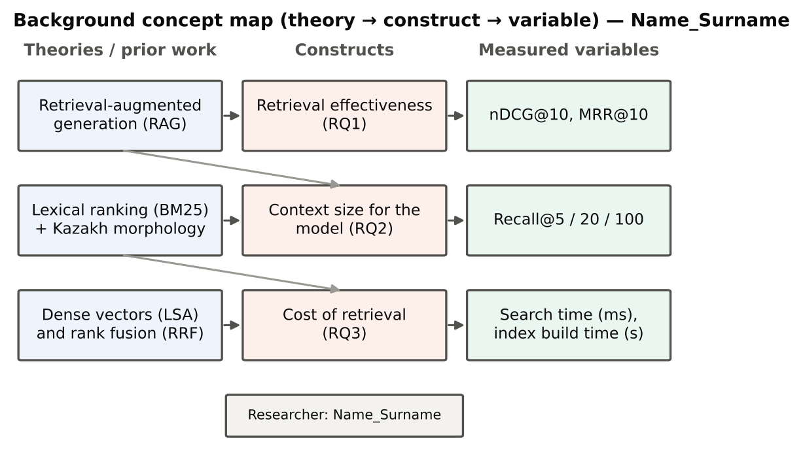
Figure 1. Background Concept Map – Name_Surname

1.3 Research problem, questions and hypotheses
Problem. The AI platform needs a retrieval tool for Kazakh documents that is accurate, gives the model enough relevant context and is fast. It is not known which simple method best meets these needs.
- RQ1. Which retrieval method finds relevant Kazakh passages best?
  - H1a: hybrid RRF gives the highest nDCG@10.
  - H1b: prefix-5 truncation improves BM25 compared with full words.
- RQ2. How many passages should be passed to the model?
  - H2: for the best method, at least 70 % of relevant passages are found within the top 20.
- RQ3. How fast are the methods?
  - H3: BM25-based search takes less than 10 ms per question on an ordinary CPU.
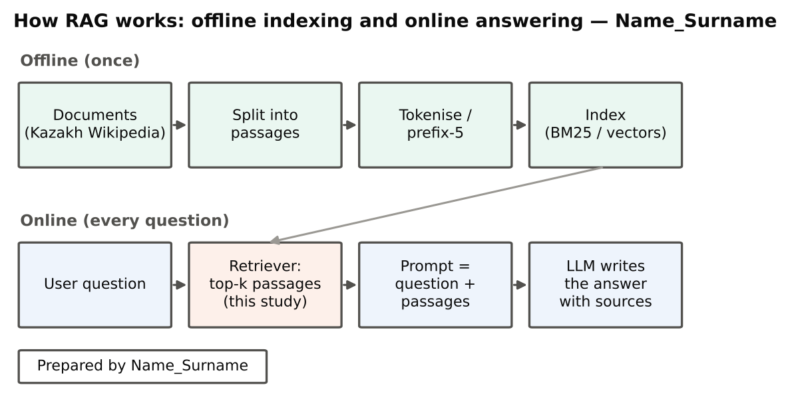
Figure 2. Background diagram: how RAG works – Name_Surname

1.4 Significance
Theoretical: the study adds evidence on how simple lexical, sub-word, dense and hybrid retrieval compare for an agglutinative, lower-resource language. Practical: it gives the AI platform a tested default retriever, a recommended number of passages per prompt and expected speed. Contribution: an open, reproducible pipeline that anyone can rerun with one command.
Summary. RAG lets an LLM answer from an organisation’s own documents by retrieving relevant passages and adding them to the prompt. The retriever is the weakest link, because the model cannot use what is not retrieved. Kazakh morphology makes exact word matching difficult, and the literature suggests prefix truncation and hybrid ranking as simple remedies. The KazQAD dataset makes it possible to test these methods on real exam questions. Three research questions ask which method is most accurate, how many passages the model needs and how fast the methods are. The answers give the platform an evidence-based default retriever.

2. Methodology

2.1 Research design
A quantitative, computational experiment was chosen. All retrieval methods answered the same set of questions (a within-subjects design where questions play the role of subjects), so the methods can be compared with paired statistical tests. The design fits the research questions because accuracy, recall and speed are numbers that can be measured directly and objectively. No people were involved, because the study evaluates a software component, not a user experience. In the terms of the course lecture on research methodology, the study is applied, empirical and quantitative and uses the experimental approach: one factor — the retrieval method — is changed while everything else stays the same.
Table 2. Design of the study – Name_Surname
RQ | Independent variable | Dependent variables | Instrument | Analysis
RQ1 | Retrieval method (5 levels) | nDCG@10, MRR@10 | KazQAD questions and judgements | Mean, 95 % bootstrap CI, Friedman test, Wilcoxon + Holm, effect size r
RQ2 | Number of passages k (5, 20, 100) | Recall@k | Same | Mean recall by k
RQ3 | Retrieval method | Search time per question, index build time | Timer in the script | Mean time

2.2 Sample
Questions. All 1 929 questions of the KazQAD test set were used [13]. They are real questions of the Unified National Testing (UNT) exam in five subjects: Kazakh history (659), biology (379), literature (368), geography (346) and world history (177). Every question has at least one passage marked relevant by annotators (2 718 relevant judgements, 1.41 per question). Using the whole test set avoids sampling error and gives high statistical power.
Passages. The full corpus has 825 309 passages. To keep the project small and runnable on a normal computer, a sub-corpus of 100 000 passages was built: all 2 660 passages judged for the test questions plus 97 340 randomly selected other passages (random seed 42; passages shorter than 40 characters were skipped). The average passage has 39 words and the average question 7 words.
Ethics. No people and no personal data were involved. KazQAD is open data (licence CC BY-SA 4.0) and is cited in this report.

2.3 Materials and instruments
- Retrieval methods (Python, scikit-learn, SciPy [16]):
  - BM25 (word) — classic BM25 over lower-cased words (k1 = 0.9, b = 0.4) [6];
  - BM25 (prefix-5) — the same, but every word is cut to its first five letters, so different forms of one word match [12];
  - TF-IDF (char 3–5) — similarity over 3–5-letter pieces of words;
  - LSA (dense, 256 dimensions) — passages compressed into 256-number vectors [10];
  - Hybrid RRF — the rankings of methods 2 and 3 merged with reciprocal rank fusion (k = 60) [11]. Settings were taken from the cited sources and were not tuned on the test questions.
- Quality measures. nDCG@10 — how good the first 10 results are, giving more credit to relevant passages at the top (0 = nothing useful, 1 = perfect); MRR@10 — how high the first relevant passage is; Recall@k — the share of relevant passages found in the top k.
- Computer. 4 CPU cores, 15 GB RAM, Linux, Python 3.13.
Reliability and validity. The code is deterministic and uses fixed random seeds, so rerunning it gives the same quality numbers; times may vary slightly with computer load. Validity rests on KazQAD’s manual relevance judgements. The metric code was checked against hand-calculated examples (test_metrics.py).

2.4 Procedures
The procedure (Figure 3) has six steps, all run by one command bash run_all.sh in about three minutes:
- Download KazQAD from GitHub (prepare_data.py).
- Build the 100 000-passage sub-corpus and compute dataset statistics.
- Build the five retrievers.
- For every question, retrieve the top-100 passages with each method and record the time (run_retrieval.py).
- Compute the quality measures and the statistical tests.
- Save results as CSV/JSON files and draw the figures (make_figures.py).
No separate pilot was needed because no questionnaire or interview was used and no parameter was tuned.
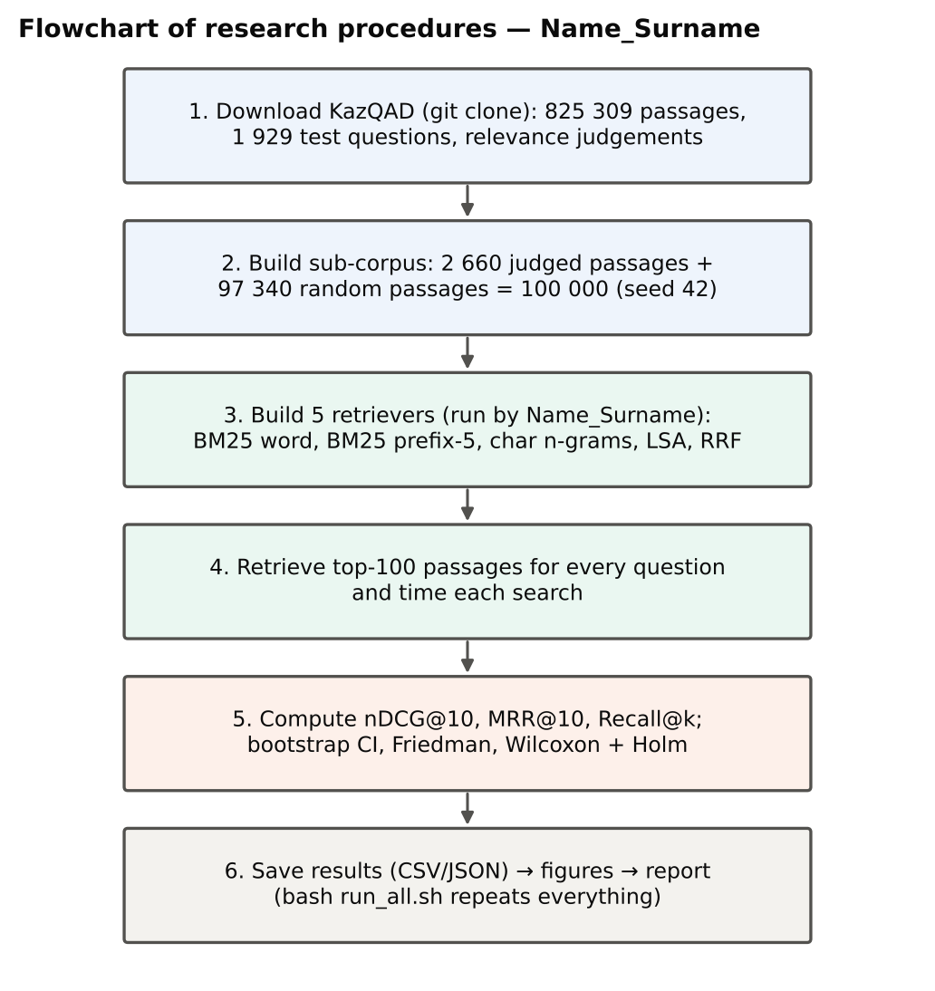
Figure 3. Flowchart of research procedures – Name_Surname

2.5 Data analysis
For each method, averages over the 1 929 questions were calculated with 95 % bootstrap confidence intervals (2 000 resamples). The Friedman test checked whether the five methods differ overall in nDCG@10. Seven pairwise comparisons used the Wilcoxon signed-rank test, which suits paired data that are not normally distributed, with Holm correction for multiple comparisons; the rank-biserial correlation r shows the size of each difference (about 0.1 small, 0.3 medium, 0.5 large). Recall was compared across k = 5, 20 and 100, and speed as the average time per question.
Summary. The study is a quantitative computational experiment in which five retrieval methods answer the same 1 929 Kazakh exam questions. A 100 000-passage sub-corpus keeps the project small while including every judged passage. The methods use standard settings from the literature, and quality is measured with nDCG@10, MRR@10 and Recall@k. Six scripted steps produce all results with one command, and fixed seeds make them repeatable. Bootstrap intervals, the Friedman test and Holm-corrected Wilcoxon tests with effect sizes are used for analysis. Data and code are open, so the study can be replicated exactly.

3. Results

3.1 Description of the data
Table 3. Descriptive statistics of the evaluation data – Name_Surname
Characteristic | Value
Passages in the full KazQAD corpus | 825 309
Passages in the sub-corpus (judged + random) | 100 000 (2 660 + 97 340)
Test questions (all with ≥ 1 relevant passage) | 1 929
Questions by subject: Kazakh history / biology / literature / geography / world history | 659 / 379 / 368 / 346 / 177
Relevant / non-relevant judgements | 2 718 / 653
Mean relevant passages per question | 1.41
Mean question / passage length, words | 6.9 / 39.4

3.2 RQ1: which method finds relevant passages best
Table 4 and Figure 4 show the quality of the five methods over all 1 929 questions. BM25 with prefix-5 truncation had the highest nDCG@10 (0.473; 95 % CI 0.456–0.490) and MRR@10 (0.456). It was followed by hybrid RRF (0.459 and 0.434), word-level BM25 (0.371 and 0.361), character n-gram TF-IDF (0.327 and 0.292) and LSA (0.032 and 0.030).
Table 4. Retrieval quality on 1 929 KazQAD test questions (mean, 95 % bootstrap CI) – Name_Surname
Method | nDCG@10 | MRR@10 | Recall@5 | Recall@20 | Recall@100
BM25 (word) | 0.371 (0.354–0.388) | 0.361 (0.343–0.379) | 0.409 | 0.568 | 0.711
BM25 (prefix-5) | 0.473 (0.456–0.490) | 0.456 (0.436–0.475) | 0.533 | 0.712 | 0.850
TF-IDF (char 3–5) | 0.327 (0.312–0.342) | 0.292 (0.276–0.307) | 0.381 | 0.612 | 0.825
LSA (dense 256-d) | 0.032 (0.026–0.038) | 0.030 (0.024–0.036) | 0.034 | 0.093 | 0.265
Hybrid RRF | 0.459 (0.443–0.476) | 0.434 (0.416–0.453) | 0.520 | 0.720 | 0.859
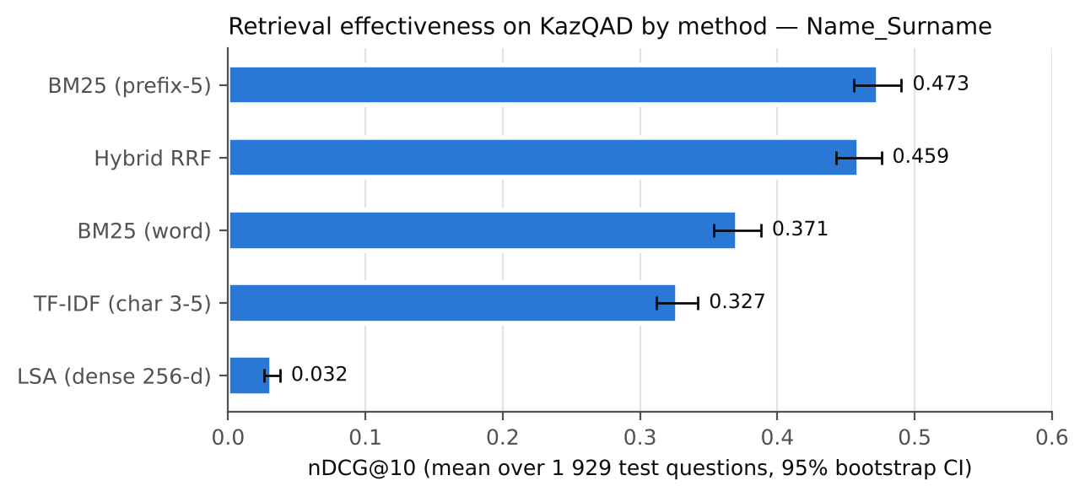
Figure 4. Retrieval quality (nDCG@10) by method – Name_Surname
The Friedman test showed that the methods differ, χ²(4) = 2 754.6, p < 0.001. All seven pairwise comparisons were significant after Holm correction (Table 5). Prefix-5 truncation improved word-level BM25 by 0.102 (r = 0.49, a large effect). Hybrid RRF was 0.014 lower than prefix-5 BM25 (r = −0.12, a small effect). Character n-grams were 0.044 lower than word-level BM25 (r = −0.21).
Table 5. Pairwise Wilcoxon signed-rank tests on nDCG@10 (Holm-adjusted) – Name_Surname
Comparison (A vs B) | Difference A − B | p (Holm) | Effect size r
BM25 (prefix-5) vs BM25 (word) | +0.102 | 1.2 × 10⁻⁴² | 0.49
Hybrid RRF vs BM25 (prefix-5) | −0.014 | 0.0016 | −0.12
Hybrid RRF vs BM25 (word) | +0.088 | 2.8 × 10⁻³¹ | 0.41
Hybrid RRF vs TF-IDF (char 3–5) | +0.132 | 7.1 × 10⁻¹¹⁷ | 0.80
Hybrid RRF vs LSA | +0.428 | 3.2 × 10⁻²¹⁸ | 0.99
TF-IDF (char 3–5) vs BM25 (word) | −0.044 | 1.7 × 10⁻⁹ | −0.21
TF-IDF (char 3–5) vs BM25 (prefix-5) | −0.146 | 1.7 × 10⁻⁸¹ | −0.65
In practical terms, prefix-5 BM25 placed a relevant passage at the very first position for 34.6 % of the questions and somewhere in the top 10 for 70.1 % of them. The corresponding values were 31.5 % and 70.6 % for hybrid RRF, 26.7 % and 56.9 % for word-level BM25, 17.6 % and 56.8 % for character n-grams, and 1.6 % and 7.0 % for LSA (Table 5a). Compared question by question with word-level BM25, prefix-5 truncation gave a better nDCG@10 for 705 questions, a worse one for 331 and the same value for 893.
Table 5a. Share of questions with a relevant passage at rank 1 and in the top 10 – Name_Surname
Method | Relevant at rank 1 | Relevant in top 10
BM25 (word) | 26.7 % | 56.9 %
BM25 (prefix-5) | 34.6 % | 70.1 %
TF-IDF (char 3–5) | 17.6 % | 56.8 %
LSA (dense 256-d) | 1.6 % | 7.0 %
Hybrid RRF | 31.5 % | 70.6 %
Prefix-5 BM25 had the highest nDCG@10 in every school subject, from 0.42 in geography to 0.50 in Kazakh history and world history; its advantage over word-level BM25 ranged from 0.09 to 0.12 (Figure 7, Appendix B).
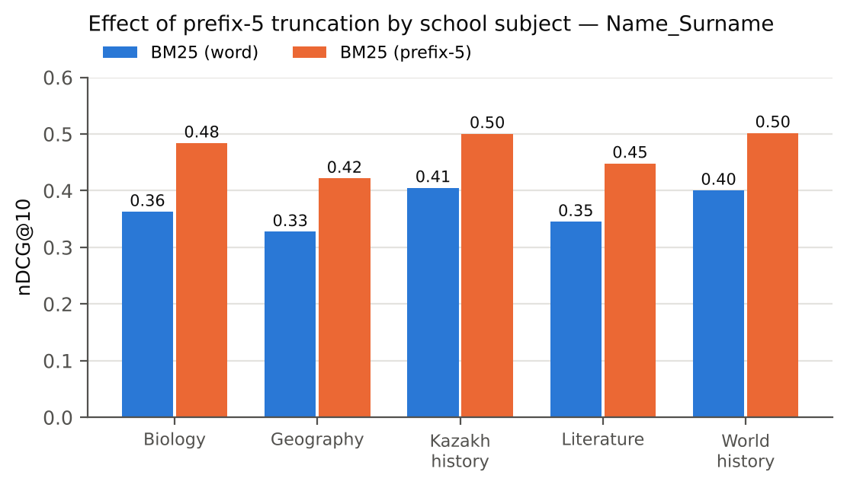
Figure 7. Effect of prefix-5 truncation by school subject – Name_Surname

3.3 RQ2: how many passages to pass to the model
Recall grew with the number of passages k for every method (Figure 5). For prefix-5 BM25 it was 0.533 at k = 5, 0.712 at k = 20 and 0.850 at k = 100; for hybrid RRF 0.520, 0.720 and 0.859. The number of questions with no relevant passage in the top 100 was 215 for hybrid RRF, 227 for prefix-5 BM25, 270 for character n-grams, 454 for word-level BM25 and 1 338 for LSA.
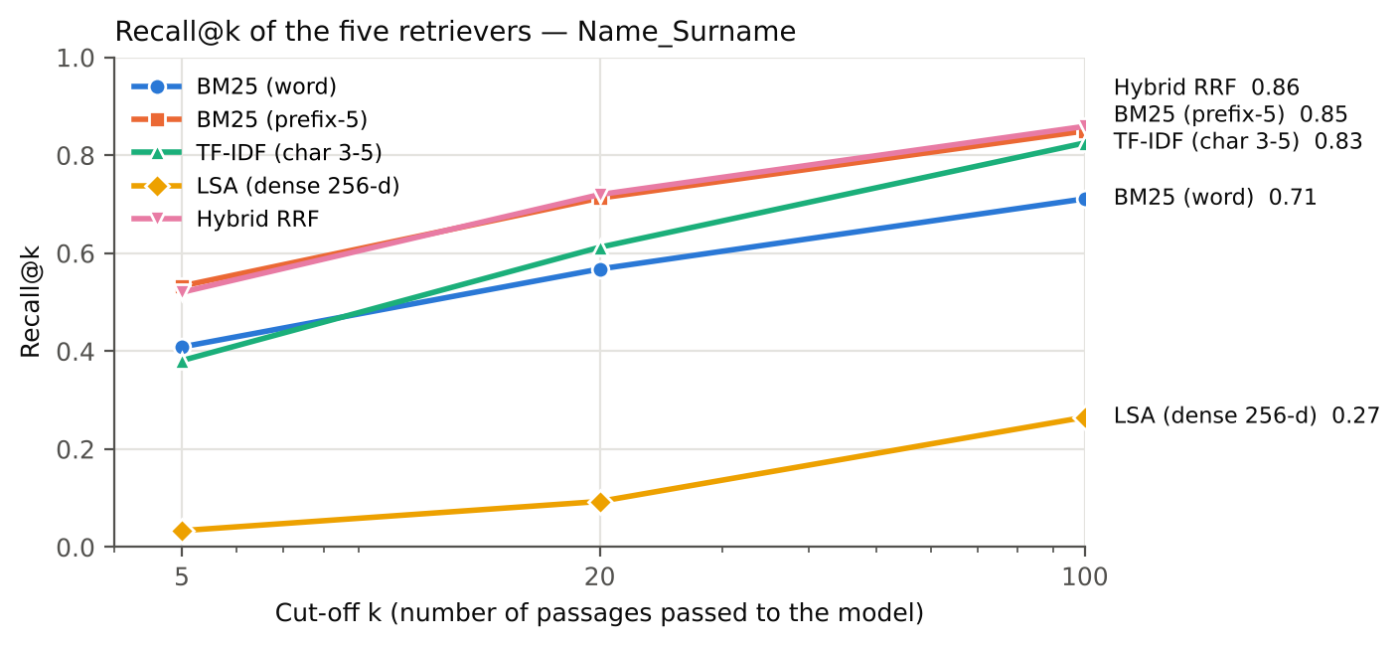
Figure 5. Recall at k = 5, 20 and 100 by method – Name_Surname

3.4 RQ3: speed
Average search time per question was 1.4 ms for LSA, 1.6 ms for prefix-5 BM25, 1.8 ms for word-level BM25, 7.0 ms for character n-grams and 8.6 ms for hybrid RRF, which runs two searches (Table 6, Figure 6). Building the index for 100 000 passages took 5.4 s for prefix-5 BM25, 6.9 s for word-level BM25, 19.8 s for LSA and 66.7 s for character n-grams.
Table 6. Speed of the methods (100 000 passages, 4 CPU cores) – Name_Surname
Method | Search time, ms per question | Index build time, s
BM25 (word) | 1.8 | 6.9
BM25 (prefix-5) | 1.6 | 5.4
TF-IDF (char 3–5) | 7.0 | 66.7
LSA (dense 256-d) | 1.4 | 19.8
Hybrid RRF | 8.6 | 72.1 (both indexes)
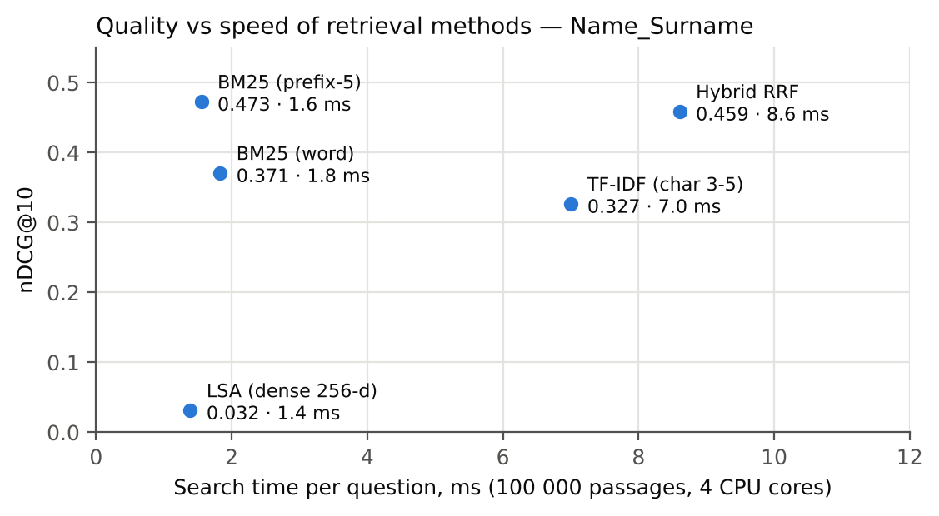
Figure 6. Quality versus speed of the methods – Name_Surname
Summary. The evaluation used 1 929 Kazakh exam questions and 100 000 passages. Prefix-5 BM25 reached the highest nDCG@10 (0.473) and MRR@10 (0.456), hybrid RRF the highest Recall@20 and Recall@100, and LSA the lowest values on all measures. All pairwise differences were statistically significant, with a large effect for prefix-5 over word-level BM25 and a small effect between prefix-5 BM25 and hybrid RRF. Prefix-5 BM25 led in every school subject. Recall of the best methods rose from about 0.53 at five passages to about 0.71–0.72 at twenty. BM25 searches took under 2 ms per question, while the hybrid run took 8.6 ms. These observations are interpreted in the Discussion.

4. Discussion

4.1 Hypotheses
Table 7. Hypotheses versus results – Name_Surname
Hypothesis | Expected | Observed | Verdict
H1a | Hybrid RRF is best (nDCG@10) | Prefix-5 BM25 is best (0.473); RRF 0.459 | Not supported
H1b | Prefix-5 improves BM25 | +0.102 nDCG@10, large effect | Supported
H2 | ≥ 70 % recall within top 20 | 71.2 % (prefix-5), 72.0 % (RRF) | Supported
H3 | BM25 < 10 ms per question | 1.6–1.8 ms | Supported

4.2 What the results mean
Prefix-5 works because of Kazakh morphology. Cutting every word to five letters turns many forms of one word — with case, plural and possessive suffixes — into the same index term, so the question and the passage match even when they use different endings. The improvement of about 27 % over word-level BM25 shows that word-form mismatch is the main problem of simple search in Kazakh. This agrees with the result for Turkish, where five-letter truncation was as good as complex stemmers [12]. It is good news for practice: a one-line change in tokenisation gives a large gain without any language-specific tools.
Why the hybrid did not win. Reciprocal rank fusion helps most when the merged rankings are of similar quality and make different mistakes [11]. Here the character n-gram ranking was clearly weaker at the top, so mixing it in slightly lowered precision; however, it added some relevant passages deeper in the list, which is why the hybrid had the highest Recall@100. For a simple RAG pipeline that passes the top results directly to the model, prefix-5 BM25 is better; for a pipeline with a second step that re-sorts candidates (a reranker), the hybrid list is a better starting pool [2].
Why LSA failed. LSA compresses all passages into 256 numbers without any training on questions, so it cannot separate the precise facts asked in exam questions [10]. This result should not be applied to modern neural embedding models, which are trained on question–passage pairs and can beat BM25 [8], [9]; such models were outside the scope of this small study.
How many passages to give the model. Going from 5 to 20 passages raised recall from 53 % to 71 %, while going to 100 passages added only about 14 percentage points more and would make the prompt very long — and models use the middle of long prompts poorly [5]. A practical setting is therefore 10–20 passages, or 50–100 candidates if a reranker selects the best ones.
Speed is not a problem. BM25 needs under 2 ms per question, which is negligible compared with the time an LLM needs to write an answer, so a simple retriever does not slow down the platform.
Comparison with the literature. The scores are higher than KazQAD’s published baseline (nDCG@10 = 0.389) [13], but our sub-corpus is about eight times smaller, which makes search easier. Therefore the ranking of the methods, not the absolute numbers, is the main finding.

4.3 Unexpected results
Two results were unexpected: the hybrid did not beat its best component, and character n-grams were worse than plain words. Plausible explanations are methodological (fusion of unequal rankings; TF-IDF lacks BM25’s handling of repeated words and passage length) and contextual (exam questions contain distinctive names and terms that favour stem matching). Because the sample is very large, even small differences become statistically significant, so the effect sizes matter more: the gap between prefix-5 BM25 and the hybrid is small in practice.

4.4 Limitations
- Sub-corpus. 100 000 instead of 825 309 passages makes the task easier and raises absolute scores.
- One dataset and domain. School-exam questions over Wikipedia; university regulations or business documents, and Russian or mixed-language texts, may behave differently.
- No neural models. Pretrained embedding models and rerankers were not tested.
- Retrieval only. The quality of the final LLM answers was not measured.
- Fixed settings. Parameters were not tuned; tuning might change the order of close methods.

4.5 Future work
Next steps are: add multilingual neural embeddings and a reranker on top of the hybrid candidate list; run the test on the full corpus and on Russian and English university documents; measure the quality of the final answers generated by an LLM with metrics such as faithfulness [17]; and connect the best retriever to the AI platform as a search tool.
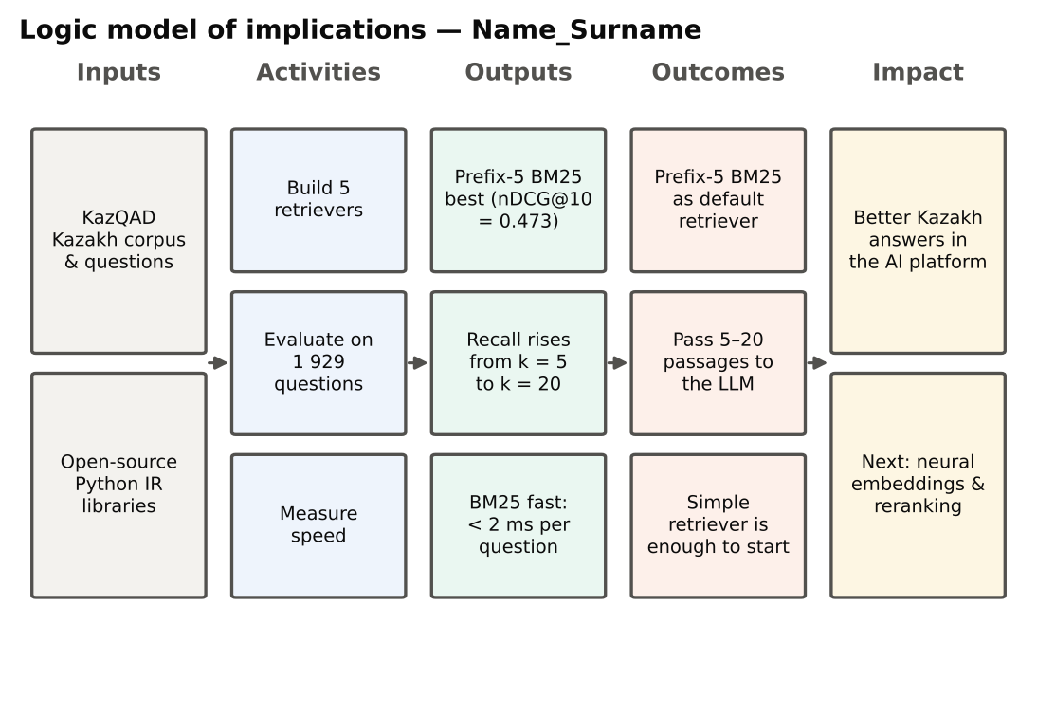
Figure 8. Logic model of implications – Name_Surname
Summary. Three of the four hypotheses were supported: prefix-5 truncation strongly improves BM25, the best methods find over 70 % of relevant passages within twenty results, and BM25 is very fast. The hybrid did not outperform prefix-5 BM25, because fusion with a weaker ranking lowered precision at the top, although it gave the best deep recall. The main explanation of the results is Kazakh morphology, in line with findings for Turkish. LSA should not be confused with modern neural embeddings, which remain to be tested. The main limitations are the reduced corpus, a single domain and the absence of neural models and answer-level evaluation.

5. Conclusion

5.1 Recap
This study asked which simple retrieval method should be used in the RAG component of a Kazakh-language AI platform, how many passages should be given to the model and how fast retrieval is. On 1 929 real exam questions, BM25 with words truncated to five letters was the most accurate method (nDCG@10 = 0.473, 27 % better than plain BM25). Passing 10–20 passages captures most relevant information (71 % recall at 20). All BM25 searches took under 2 ms.
Answers to the research questions. RQ1: the most accurate method is BM25 with prefix-5 truncation; the hybrid is close at the top and better deeper in the list, while character n-grams and LSA are weaker. RQ2: the model should receive 10–20 passages; five passages miss almost half of the relevant information, while one hundred passages make the prompt long for a small gain. RQ3: lexical search is fast enough for interactive use; only the character n-gram index is noticeably slower to build.
What this means for the AI platform. In the platform designed in this course, the retriever is offered to the language model as a search tool. The results show that this tool can start with a very simple, transparent and cheap configuration — an inverted index with five-letter tokens — that runs on an ordinary server without a GPU and can be rebuilt in seconds when documents change. More complex components, such as neural embedding models and rerankers, can be added later and compared against this baseline using the same pipeline. This order of work — first a strong simple baseline, then measured improvements — reduces cost and risk for organisations that are only starting to use AI.

5.2 Contributions
Academic: evidence that simple prefix truncation handles Kazakh morphology very effectively and that rank fusion helps only when its components are equally strong. Practical: a tested default configuration for the platform’s RAG retriever and an open, one-command pipeline that can be rerun on new documents.
The study also shows a way of working that is useful beyond this topic: open data, fixed settings taken from the literature, paired statistical tests and one command that reproduces every number. Other students and developers can reuse the pipeline to test retrieval on their own Kazakh or Russian documents.
Limitations to keep in mind. The conclusions are based on a reduced corpus of Wikipedia passages and school-exam questions, on simple methods only, and on retrieval quality rather than final answer quality. They should be confirmed on the platform’s real documents before deployment.

5.3 Recommendations
Table 8. Recommendations from the results – Name_Surname
Priority | Recommendation | Based on
1 | Use BM25 with prefix-5 truncation as the default retriever for Kazakh documents | RQ1, Tables 4–5
2 | Pass 10–20 passages to the LLM; use 50–100 only together with a reranker | RQ2, Figure 5
3 | Keep the hybrid list as the candidate pool when a reranker is added | RQ1–RQ2
4 | Do not use unsupervised LSA; test modern neural embeddings next | RQ1, Section 4.2
5 | Re-evaluate on the platform’s real documents (regulations, syllabi) and measure answer quality | Section 4.5

5.4 Executive summary panel
Executive summary — Retrieval for RAG in Kazakh (KazQAD, small-scale study)
Question. Which simple search method should the AI platform use to find Kazakh passages for RAG, how many passages should the model get, and how fast is it?
Data and method.
- 1 929 real UNT exam questions; 100 000 Kazakh Wikipedia passages (KazQAD, open data)
- 5 methods: BM25 word, BM25 prefix-5, char n-grams, LSA, hybrid RRF
- Measures: nDCG@10, MRR@10, Recall@5/20/100, time; Friedman and Wilcoxon tests
Key findings.
- Best: BM25 prefix-5, nDCG@10 = 0.473 (+27 % over word BM25, 0.371)
- Hybrid RRF: 0.459 at the top, but best Recall@100 (0.859)
- LSA does not work for this task (0.032)
- Recall of the best method: 53 % at 5 passages, 71 % at 20, 85 % at 100
- BM25 search: under 2 ms per question
Recommendations.
- Default retriever: BM25 with prefix-5 truncation
- Give the model 10–20 passages; more only with a reranker
- Next: neural embeddings, reranking, real university documents
Limitations. Reduced corpus, one domain, no neural models, answers not evaluated.
Name_Surname

Summary. The report followed one line of argument: RAG answers are only as good as the retrieved passages, so the retriever for Kazakh must be chosen by evidence. A real experiment on 1 929 exam questions showed that BM25 with five-letter truncation is the most accurate and very fast option, and that 10–20 passages give the model most of the relevant information. Fusion with a weaker method and unsupervised LSA did not help at the top of the ranking. These results give the AI platform a simple, tested default configuration. The next steps — neural embeddings, reranking and evaluation on real university documents — follow directly from the limitations of this study.

References
[1] P. Lewis et al., “Retrieval-augmented generation for knowledge-intensive NLP tasks,” in Advances in Neural Information Processing Systems 33 (NeurIPS 2020), Curran Associates, 2020, pp. 9459–9474. Available: https://proceedings.neurips.cc/paper/2020/hash/6b493230205f780e1bc26945df7481e5-Abstract.html
[2] Y. Gao et al., “Retrieval-augmented generation for large language models: A survey,” 2023, arXiv: arXiv:2312.10997. Available: https://arxiv.org/abs/2312.10997
[3] W. Fan et al., “A survey on RAG meeting LLMs: Towards retrieval-augmented large language models,” in Proceedings of the 30th ACM SIGKDD Conference on Knowledge Discovery and Data Mining (KDD ’24), New York, NY: ACM, 2024, pp. 6491–6501. doi: 10.1145/3637528.3671470.
[4] Resolution of the Government of the Republic of Kazakhstan No. 592 “On approval of the Concept for the development of artificial intelligence for 2024–2029”. 2024. Accessed: Oct. 12, 2026. [Online]. Available: https://adilet.zan.kz/rus/docs/P2400000592
[5] N. F. Liu et al., “Lost in the middle: How language models use long contexts,” Transactions of the Association for Computational Linguistics, vol. 12, pp. 157–173, 2024, doi: 10.1162/tacl_a_00638.
[6] S. Robertson and H. Zaragoza, “The probabilistic relevance framework: BM25 and beyond,” Foundations and Trends in Information Retrieval, vol. 3, no. 4, pp. 333–389, 2009, doi: 10.1561/1500000019.
[7] C. D. Manning, P. Raghavan, and H. Schütze, Introduction to information retrieval. Cambridge: Cambridge University Press, 2008.
[8] V. Karpukhin et al., “Dense passage retrieval for open-domain question answering,” in Proceedings of the 2020 Conference on Empirical Methods in Natural Language Processing (EMNLP), Association for Computational Linguistics, 2020, pp. 6769–6781. doi: 10.18653/v1/2020.emnlp-main.550.
[9] N. Reimers and I. Gurevych, “Sentence-BERT: Sentence embeddings using Siamese BERT-networks,” in Proceedings of the 2019 Conference on Empirical Methods in Natural Language Processing and the 9th International Joint Conference on Natural Language Processing (EMNLP-IJCNLP), Association for Computational Linguistics, 2019, pp. 3982–3992. doi: 10.18653/v1/D19-1410.
[10] S. Deerwester, S. T. Dumais, G. W. Furnas, T. K. Landauer, and R. Harshman, “Indexing by latent semantic analysis,” Journal of the American Society for Information Science, vol. 41, no. 6, pp. 391–407, 1990, doi: 10.1002/(SICI)1097-4571(199009)41:6<391::AID-ASI1>3.0.CO;2-9.
[11] G. V. Cormack, C. L. A. Clarke, and S. Büttcher, “Reciprocal rank fusion outperforms Condorcet and individual rank learning methods,” in Proceedings of the 32nd International ACM SIGIR Conference on Research and Development in Information Retrieval (SIGIR ’09), New York, NY: ACM, 2009, pp. 758–759. doi: 10.1145/1571941.1572114.
[12] F. Can, S. Kocberber, E. Balcik, C. Kaynak, H. C. Ocalan, and O. M. Vursavas, “Information retrieval on Turkish texts,” Journal of the American Society for Information Science and Technology, vol. 59, no. 3, pp. 407–421, 2008, doi: 10.1002/asi.20750.
[13] R. Yeshpanov, P. Efimov, L. Boytsov, A. Shalkarbayuli, and P. Braslavski, “KazQAD: Kazakh open-domain question answering dataset,” in Proceedings of the 2024 Joint International Conference on Computational Linguistics, Language Resources and Evaluation (LREC-COLING 2024), ELRA and ICCL, 2024, pp. 9645–9656. Available: https://aclanthology.org/2024.lrec-main.843/
[14] ISSAI, “KazQAD: Kazakh open-domain question answering dataset (version 1.0),” GitHub. Accessed: Oct. 13, 2026. [Online]. Available: https://github.com/IS2AI/KazQAD
[15] M. Togmanov et al., “KazMMLU: Evaluating language models on Kazakh, Russian, and regional knowledge of Kazakhstan,” in Proceedings of the 63rd Annual Meeting of the Association for Computational Linguistics (Volume 1: Long Papers), Association for Computational Linguistics, 2025, pp. 14403–14416. Available: https://aclanthology.org/2025.acl-long.701/
[16] F. Pedregosa et al., “Scikit-learn: Machine learning in Python,” Journal of Machine Learning Research, vol. 12, pp. 2825–2830, 2011, Available: https://jmlr.org/papers/v12/pedregosa11a.html
[17] S. Es, J. James, L. Espinosa Anke, and S. Schockaert, “RAGAs: Automated evaluation of retrieval augmented generation,” in Proceedings of the 18th Conference of the European Chapter of the Association for Computational Linguistics: System Demonstrations, Association for Computational Linguistics, 2024, pp. 150–158. doi: 10.18653/v1/2024.eacl-demo.16.

Appendices

Appendix A. How to reproduce the study
All code is in pw-06-research-report/experiment/. Requirements: Python ≥ 3.10, pip install scipy scikit-learn matplotlib, Git, about 1 GB of disk space.
cd pw-06-research-report/experiment
bash run_all.sh # download data → retrieval experiment → figures → checks (≈ 3 min)
File | Purpose
prepare_data.py | Downloads KazQAD and builds the 100 000-passage sub-corpus
retrievers.py | The five retrieval methods (BM25, prefix-5, char n-grams, LSA, RRF)
metrics.py | nDCG, MRR, Recall, bootstrap CI, Wilcoxon, Holm correction
run_retrieval.py | Runs the experiment and saves results/*.json, results/*.csv
make_figures.py | Draws all figures
test_metrics.py | Checks the metric code against hand-calculated examples

Appendix B. nDCG@10 by subject
Table B1. nDCG@10 by subject and method – Name_Surname
Method | Biology (379) | Geography (346) | Kazakh history (659) | Literature (368) | World history (177)
BM25 (word) | 0.363 | 0.328 | 0.405 | 0.345 | 0.401
BM25 (prefix-5) | 0.484 | 0.422 | 0.501 | 0.448 | 0.502
TF-IDF (char 3-5) | 0.370 | 0.269 | 0.336 | 0.315 | 0.343
LSA (dense 256-d) | 0.021 | 0.031 | 0.047 | 0.019 | 0.029
Hybrid RRF | 0.481 | 0.403 | 0.481 | 0.442 | 0.477

Appendix C. Example of prefix-5 truncation
Word in text | Meaning | After prefix-5
кітап | book | кітап
кітаптар | books | кітап
кітаптарымыздан | from our books | кітап
Қазақстан | Kazakhstan | қазақ
Қазақстанның | of Kazakhstan | қазақ
All forms of one stem become the same index term, so a question and a passage with different endings still match. The side effect is that some different words share a prefix (e.g. қазақ “Kazakh” and Қазақстан), which is acceptable for search.

Appendix D. Ethics statement
The study involved no human participants and no personal data. KazQAD is used under the CC BY-SA 4.0 licence with attribution. Therefore no consent forms, survey instruments or interview protocols were needed for this computational study.

