<https://ncgcommunication.cloudmlm.online/admin/rankbonus>

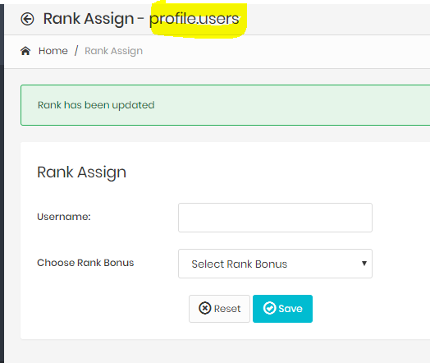

https://ncgcommunication.cloudmlm.online/admin/users

