AT&T Developer Program
Microsoft ® Visual Studio ® Extensions for the AT&T API Platform
Installation, Setup, and Instruction Guide

Revision 6.0
Revision Date September 11, 2012

Legal Disclaimer

This document and the information contained herein (collectively, the "Information") is provided to you (both the individual receiving this document and any legal entity on behalf of which such individual is acting) ("You" and "Your") by AT&T, on behalf of itself and its affiliates ("AT&T") for informational purposes only. AT&T is providing the Information to You because AT&T believes the Information may be useful to You. The Information is provided to You solely on the basis that You will be responsible for making Your own assessments of the Information and are advised to verify all representations, statements and information before using or relying upon any of the Information. Although AT&T has exercised reasonable care in providing the Information to You, AT&T does not warrant the accuracy of the Information and is not responsible for any damages arising from Your use of or reliance upon the Information. You further understand and agree that AT&T in no way represents, and You in no way rely on a belief, that AT&T is providing the Information in accordance with any standard or service (routine, customary or otherwise) related to the consulting, services, hardware or software industries.

AT&T DOES NOT WARRANT THAT THE INFORMATION IS ERROR-FREE. AT&T IS PROVIDING THE INFORMATION TO YOU "AS IS" AND "WITH ALL FAULTS." AT&T DOES NOT WARRANT, BY VIRTUE OF THIS DOCUMENT, OR BY ANY COURSE OF PERFORMANCE, COURSE OF DEALING, USAGE OF TRADE OR ANY COLLATERAL DOCUMENT HEREUNDER OR OTHERWISE, AND HEREBY EXPRESSLY DISCLAIMS, ANY REPRESENTATION OR WARRANTY OF ANY KIND WITH RESPECT TO THE INFORMATION, INCLUDING, WITHOUT LIMITATION, ANY REPRESENTATION OR WARRANTY OF DESIGN, PERFORMANCE, MERCHANTABILITY, FITNESS FOR A PARTICULAR PURPOSE OR NON-INFRINGEMENT, OR ANY REPRESENTATION OR WARRANTY THAT THE INFORMATION IS APPLICABLE TO OR INTEROPERABLE WITH ANY SYSTEM, DATA, HARDWARE OR SOFTWARE OF ANY KIND. AT&T DISCLAIMS AND IN NO EVENT SHALL BE LIABLE FOR ANY LOSSES OR DAMAGES OF ANY KIND, WHETHER DIRECT, INDIRECT, INCIDENTAL, CONSEQUENTIAL, PUNITIVE, SPECIAL OR EXEMPLARY, INCLUDING, WITHOUT LIMITATION, DAMAGES FOR LOSS OF BUSINESS PROFITS, BUSINESS INTERRUPTION, LOSS OF BUSINESS INFORMATION, LOSS OF GOODWILL, COVER, TORTIOUS CONDUCT OR OTHER PECUNIARY LOSS, ARISING OUT OF OR IN ANY WAY RELATED TO THE PROVISION, NON-PROVISION, USE OR NON-USE OF THE INFORMATION, EVEN IF AT&T HAS BEEN ADVISED OF THE POSSIBILITY OF SUCH LOSSES OR DAMAGES.

- Contents
1. Introduction 4
2. Architectural Overview 5
3. Installation Guidelines and Notes 6
4. Installing the Components 7
5. Using the Components 8
6. About the Components 11
6.1. SMS Sender Control 12
6.2. SMS Voting Control 13
6.3. Speech Control 15
6.4. MMS Sender Control 16
6.5. MMS Coupon Sender Control 17
7. About the Sample Application 18

Introduction
The AT&T API Platform combines the power of the Microsoft .NET platform with AT&T services so that developers can quickly bring C# and Visual Basic applications to the market.
The Visual Studio ® Extensions go even further, delivering pre-packaged controls with a Windows 8 look and feel that significantly reduces the complexity of building applications targeted to the AT&T platform services. These controls can run in any windows environment that supports Microsoft Windows Store ® style applications.
The Microsoft ® Visual Studio ® Extensions for the AT&T API Platform include the following pre-packaged controls:
- SMS Sender Control
- SMS Voting Control
- Speech Control
- MMS Sender Control
- MMS Coupon Sender Control

Architectural Overview
The Visual Studio ® Extensions provide simplified access for .NET developers to the AT&T API Platform services. This access is provided through the following components:
- Windows Application - The final developer code. A Windows application written in VB or C# that makes use of the controls in this package.
- Extensions - This package. The controls in the package can be embedded in Visual Studio applications. These controls handle all messaging back to the SDK Wrapper Library.
- .NET Wrapper Library - The Visual Studio ® Extensions provide a special set of wrapper functions called the .NET Wrapper Library that are written in C# but are available to any .NET runtime language. This layer of objects that inherit from the AT&T API Platform provides APIs with a simplifying syntax that gives application developers a set of uniform and easy to use interfaces with which to address the AT&T REST APIs.
- AT&T API Platform - This layer consists of APIs that communicate with AT&T services via REST.
You can find more information about the SDK Wrapper library and the AT&T API Platform in the Getting Started Guide on the AT&T website.

Installation Guidelines and Notes
To run the Microsoft ® Visual Studio ® Extensions Package for the AT&T API Platform you will need the following:
- A computer with Microsoft Windows 8 installed.
- Microsoft Visual Studio ® 2012 Professional (Or a version with comparable or greater capabilities).
- An internet connection (required to download the necessary tools).
Please note the following about the controls in this package:
- They are designed to be used in Microsoft Windows Store ® style applications and will not work with prior versions of the operating system or compilers.
- They are only capable of sending messages to phones on the AT&T network. Sending SMS, MMS, and other messages to phones outside of the network, on other carriers, is not supported.
In order to use the AT&T network, you and your organization must abide by the AT&T API agreement. To send messages on the AT&T network, a secret key and an API key are required. You can obtain these keys by joining the AT&T developer program.
There are two types of keys Sandbox keys and Production keys:
- Sandbox keys are available for free, and allow programmers to demonstrate proof-of-concept and perform testing on applications using the AT&T APIs.
- Production keys provide the same capabilities, but are designed to handle a much larger amount of traffic.
You can learn more about how to obtain these keys by creating an account and signing in to http://developer.att.com.

Installing the Components
To install the components of the Microsoft ® Visual Studio ® Extensions for the AT&T API Platform, do the following:
- In Microsoft Visual Studio ®, open the Tools menu and select ”Extensions and Updates”. The “Extensions and Updates” dialog will appear.
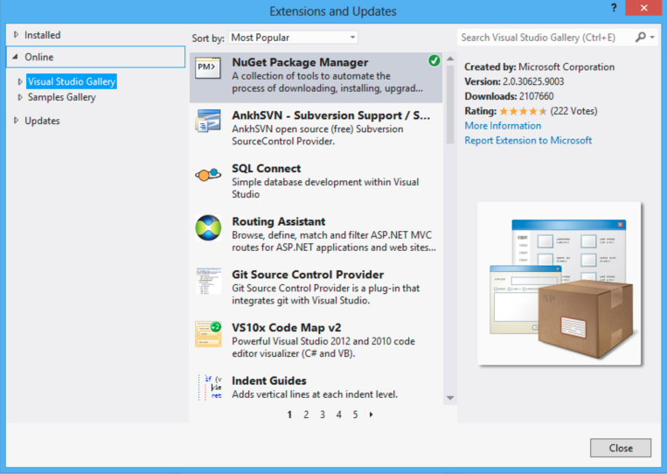
Figure 1: The Microsoft Visual Studio ® Extensions and Updates dialog.
- In the “Extensions and Updates” dialog, open Online and click “Visual Studio Gallery” (as shown in figure 1). Wait a few seconds for the tool to retrieve the most popular extensions.
- When the gallery has finished loading, type “AT&T Extensions” into the search box and hit <ENTER> or Return. The Visual Studio ® Extensions for the AT&T API Platform will appear in your list of search results.
- Click ”AT&T Extensions” in the search list to highlight the selection, and then click “Download” to download and install the components.
When this process has completed, the AT&T Extensions components are installed and ready for use. Congratulations!

Using the Components
To use the AT&T Extensions components in an application, do the following:
- Create a “Windows Store” project by opening the File menu, selecting “New project”, and under “Templates”, selecting “Windows Store”.
Note: These controls are “styled” for Windows Store, and are not intended for traditional Windows, WCF, Web, etc., styled programs.
- Select an application name and path, and click OK.
- Click on “MainPage.xaml”. You will see an empty “Windows Store” form, and on the left, before the File menu, a new, vertical toolbar will appear with the label:
“Toolbox | Device | Document Outline | Data Store”.
- Click to expand the “Toolbox” and options will appear that include “AT&T Control Category”. Click the triangle to expand the category, and the full list of controls will appear as in the following figure.

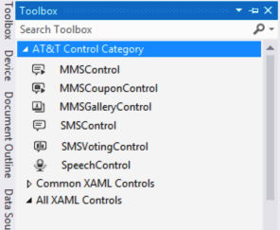

Figure 2: Toolbox with the AT&T Control Category expanded showing the AT&T Extension Controls.

- Once you see the list of controls, simply drag your preferred control onto the main page and let go; your control will appear!

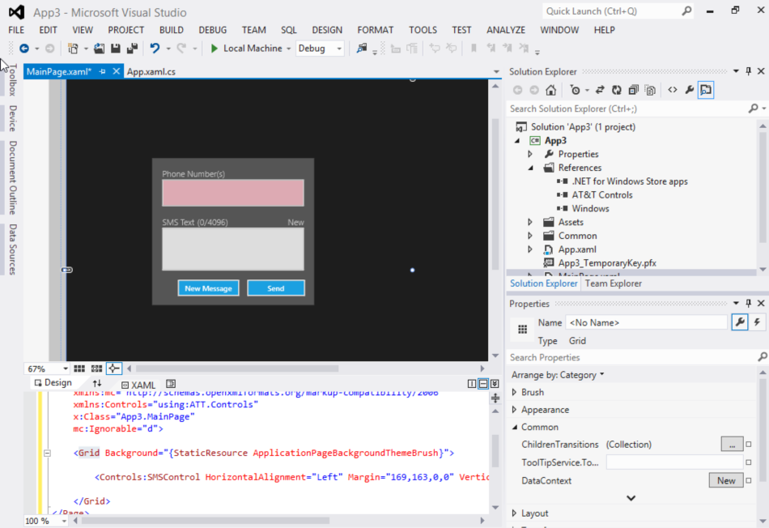

Figure 3: The SMS Control in Microsoft Visual Studio ® 2012 Professional.
At this point, the application can be compiled and it can send messages on the AT&T network using a rotating, encrypted set of API keys to send messages. These keys are sufficient for proof of concept work, but they are not intended to be used for production deployments. Instead, developers should obtain their own organization Secret Key and API Key at developer.att.com and configure the application to use those keys.
To change to your production keys, do the following:
- Click on the control itself, and look at the Properties pane on the right to find the properties of the control. (The Properties pane is shown in figure 3.)
- Scroll down the Properties pane to “Miscellaneous” and expand the category. The fields listed under “Miscellaneous” include both the Secret Key and the API Key.
- Obtain your keys and paste them in to these fields.
Your application can now send messages on the AT&T Network, as long as it is running on a computer with an internet connection.

If your application uses many controls, you can set the Secret Key and the API Key values in the global application variables ATTSetting.SecretKey and ATTSetting.APIKey.
The following code demonstrates this:

AttSettings.SecretKey = "real value of secret key";
AttSettings.ApiKey = "real value of API key";

To test your application, do the following:
- Open the Build menu and select “Build Solution”.
- Open the Debug menu and select “Start Debugging”.
It really is that easy!

About the Components
The September Release of the Microsoft ® Visual Studio ® Extensions for the AT&T API Platform contains these five controls:
- SMS Sender
- SMS Voting
- Speech
- MMS Sender
- MMS Coupon Sender
Note: For all of these controls, you must enter the Secret Key and the API Key in the miscellaneous properties of the control, or in the global application ATTSetting variables. For a description of how to do this, see the previous section of this document “Using the Components”.
The following sections describe these controls in more detail.

SMS Sender Control
The simplest of the controls, SMS Sender allows a user to send a text message, up to 4096 bytes in length, to a phone or short code.
Phone numbers should be of the form abbbccccdddd, where ‘a’ is the optional country code (1 for the United States), ‘bbb’ is the three-digit area code, ‘ccc’ is the three-digit switch, and ‘dddd’ is the four-digit number.

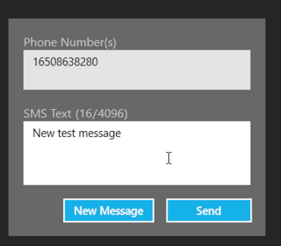

Figure 4: The SMS Sender Control
At runtime, the “Phone Number(s)” text box will appear red until a valid number is entered. The SMS control will accept multiple phone numbers that are either comma or semi-colon delimited.
When users click the ”Send” button, the input text boxes will be disabled during transmission. After transmission, a ”message sent” message or an error message will appear.
The maximum length of a message on the AT&T network (as of September 10, 2012) is 4096 bytes.

SMS Voting Control
Similar to the SMS Text Control which uses SMS messaging to send text, the SMS Voting Control uses SMS to display voting statistics as they appear on a server.
In essence, this control brings the web interface in the AT&T Platform API, as described in the AT&T Platform API Getting Started Guide, to the desktop.
The SMS Voting Control allows the following actions:
- Clearing the current voting statistics.
- Updating the chart with new voting statistics from the server.
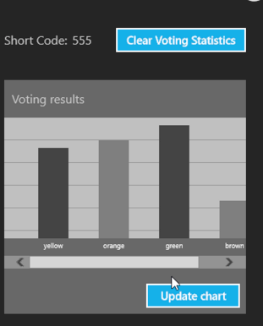

Figure 5: The SMS Voting Control

To use the SMS Voting Control in an application, you must configure the short code property of the control with a valid short code value provided by the user.
The following code demonstrates this:

// The real value of the short code must be provided by the user

string shortCode = "real value of short code";
controlVoting.SmsShortCode = shortCode;
controlVoting.SmsVotingStorage = new ATT.Controls.SmsVotingFileStorage("file.txt", shortCode);

Speech Control
The Speech Control interacts with AT&T servers via REST API. It takes an audio file (currently, the WAV and AMR file types are supported), uploads that file to an AT&T server, and returns the text of the audio.

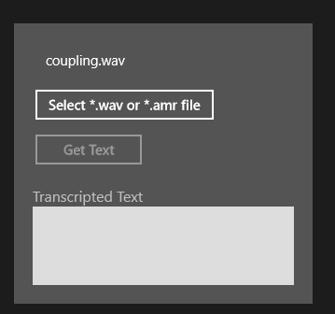

Figure 6: Speech Control

MMS Sender Control
The MMS Sender Control sends a file and text message via REST API over Multi-media Message Standard (MMS). These messages can be up to 600KB in length.

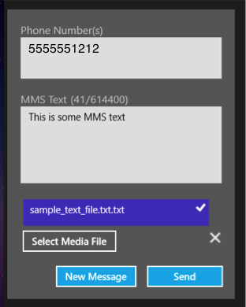

Figure 7: MMS Sender Control

MMS Coupon Sender Control
The MMS Coupon Sender Control is similar to the MMS Sender, but allows the user to preview the image before it is sent. Supported file types for the image include JPEG, GIF, BMP, and PNG.
More information about MMS messages is available on the AT&T Website.
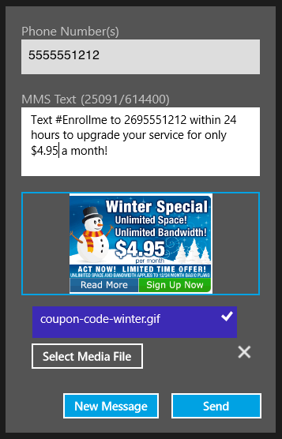

Figure 8: MMS Coupon Sender Control

About the Sample Application
In addition to the controls, the Microsoft ® Visual Studio ® Extensions for the AT&T API Platform package provides the AT&T API Platform Demo sample application which demonstrates the functionality of each control.
The download process should go something like this:
- Go to the AT&T Extensions github site:
https://github.com/attdevsupport/ATT_APIPlatform_MSVS.
- Click the “ZIP” button to download the repository as a .zip file to your computer.
- Extract the files from the .zip file to the desired directory.
To load the sample application in Microsoft ® Visual Studio:
- Use Windows Explorer to browse to the location where you extracted the files.
- Double-click on the Visual Studio Project File to open it.
When the sample application opens, you will see a home screen like the one in the following figure that allows you to select each of the individual controls and explore their capabilities.
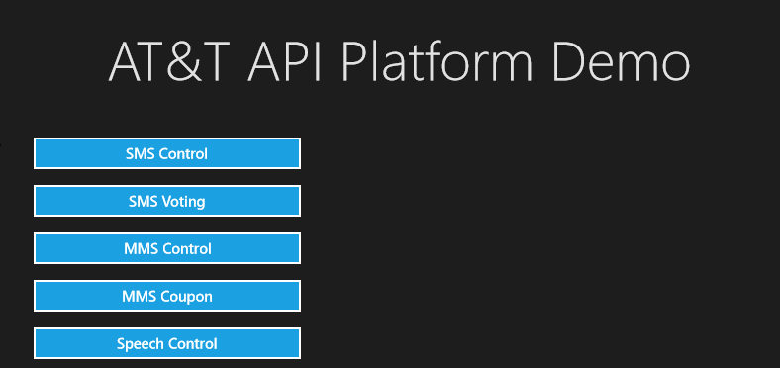

Figure 9: The home screen of the AT&T API Platform Demo sample application.

