Investigation and Critical Evaluation

**Human-Computer Interaction Overview**

Human-Computer interaction (HCI) is a field of User Interface design that focuses on the psychology behind a user’s behaviours when interacting with applications. Over time, this field has grown with the aims of improving user experience within an app and making applications as effective as possible at guiding the user through the process. (Carroll, 1997)

When considering HCI, there are multiple approaches to sorting and labelling the different aspects of good design. For this project, I utilized Nielsen’s Ten Heuristic Principles in order to ensure a good user experience, but other approaches are also viable. These include Shneiderman’s Eight Golden Rules and Norman’s Seven Principles. (Wickramasinghe, 2020)

While the guidelines vary slightly depending on the wording and intention of the designer, the following design concepts are consistent across all of them;

* Ensure visibility is taken into consideration.
* Visual design should be simple yet effective.
* Errors should be prevented and handled without distressing the user.
* Ensure tasks are simple to carry out and do not require much memory load.

When designing an app, typically users can only focus well on one task at a time. If too much information is presented to the user at once, the user may become overwhelmed and leave the task uncompleted. One approach to this is by “chunking” data into individual sections that the are handled one at a time to reduce stress on the user. (Usability First) An example of this can be seen in my project in the Main Menu screen. By only showing one group at a time, it allows the user to focus on the task rather than being overwhelmed.

**Critical Review of the Application with Regards to HCI**

*Visual design:*

* Overall, the application utilizes a very minimalistic approach, using simple block colours to highlight important areas of the screen and draw the user’s attention.
* User progression is displayed via progress bars and numerical values to ensure that the user understands how much progression they have made, and how close they are to levelling up.
* Icons are utilized to improve recognition and guide users around the app. More icons could have been used however, such as replacing the “Back” text with a left arrow and the “Profile” text with a profile symbol.

*Interaction design:*

* To accommodate for user reach, all important app controls are located at the bottom of the screen to enable ease of use and reduce the amount of distance the user needs to travel. The areas of the screen that I considered are as follows: 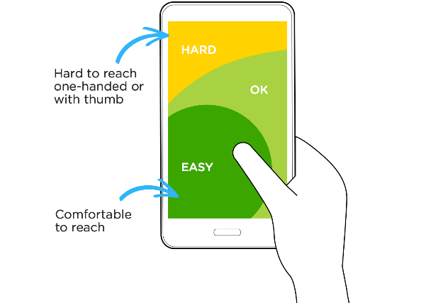 (Wroblewski, 2014)
* Controls are laid out so that the buttons that take the user deeper into the app are found on the right hand side, whereas the buttons that return the user to previous pages are found on the left side. This aims to match the real world, where users are used to reading from left to right.
* When creating a new group, selected movies appear at the bottom of the screen in an easy to read list. This allows for ease of control, letting the user easily manage and remove movies they have selected.
* Main menu group controls could be organised better. Currently, there is a chance that the user may accidentally tap the “remove group” button while trying to reach the “back” button.

# References

Carroll, J. M. (1997). HUMAN-COMPUTER INTERACTION: Psychology as a Science of Design. *Annual Review of Psychology*, Vol. 48: 61-83.

Usability First. (n.d.). *HCI Design Approaches.* Retrieved from Usability First: https://www.usabilityfirst.com/usability-methods/hci-design-approaches/index.html

Wickramasinghe, B. (2020, December 26). *Human-Computer Interaction — Principles, Evaluation and Universal Design Principle.* Retrieved from Medium: https://bimalics.medium.com/human-computer-interaction-principles-evaluation-and-universal-design-principle-3687123b5b2a