05 November 2012
Version 5
Dimensions and the cuts of Iron Pipes (Furniture Type)
Iron Pipe Shelter Frame
For the Workshop Use

- Introduction

The objective of this paper is to serve as “an instruction manual” for the workshop or an industrial unit that will be tasked to cut and weld pieces of pipes for the Iron Pipe Shelter Frame (IPSF). It should be underlined that the approach and design of Iron Pipe Shelter Frame is based on simplicity, structural integrity, in line with way of sheltering in the region, ease of transport (all component are almost straight pipes that can be batched together), ease of assembly and ease of monitoring work of the workshop or the industrial unit fabricating the parts. It should be mentioned that other pipes/components could be added to this structure but there is no need for such additions as they just add to the weight and difficulty of process and have nil effect on the structural value of the frame. However in terms of semi-permanent and permanent shelter other components such as galvanized iron sheet maybe added in accordance with the scope of UNHCR assistance programme.

- Bill of Quantity (BoQ)

For the proposed Iron Pipe Shelter Frame (IPSF) we need the following pipes:

No | Size | Quantity | Type | Thickness
a | 1.0 inch or 25.0 mm | 06 Lengths | Furniture type Iron Pipe of 6 m long | 1.2 – 1.5 mm
b | 1 ¼ inch or 32.0 mm | 03 Lengths | Furniture type Iron Pipe of 6 m long | 1.2 – 1.5 mm
c | 1 ½ inch or 38.0 mm | 02 Lengths | Furniture type Iron Pipe of 6 m long | 1.2 – 1.5 mm
d | 1.5mm binding wire | 250 grams | Binding wire | 1.5 mm
Total |  | 11 Lengths | With the above dimensions are required

Important: It should be noted that for furniture type iron pipe, unlike water pipes either black or galvanized, size/diameter is the measurement of the outside diameter of pipe

The above pipes need to be cut and welded/fabricated to form the components of IPSF therefore in the following paragraphs the lengths and number of cuts related to the each three types of pipes is explained. Kindly note the sign of “+” signifies the length could not be accurate as not all the lengths of pipes are exactly 6.00 m long.

- Cuts and welding for the 1.0 inch pipe (for Purlins/Battens)

From each 1.0 inch pipe a 540cm length is cut off leaving us with 60+ cm long piece pipe. In total we will then have 6 pieces of 540cm long and 6 pieces of 60+ cm long pipes. The 540cm pipes are kept as they are but each one of the 6 pieces of 60+cm pipes are cut into the followings lengths or sections:

- 3 pieces of 30 cm long (for the upper part of the A frame or Rafters) and
- 18 pieces of 15+cm long “a” (for welding to Purlins/Battens for connecting to the Rafters). The + the size need not be exact as each pipe may not be exactly 6.00 meters long.

By these cuts our need for connecting 1.0 inch pipes is met. Please see attachment ONE.
This needs to be done for all 6 m length pipes.

The 540cm length 1.0 inch pipe will be used as Purlins/Battens

30cm 240cm 240cm 30cm

a=15 cm a=15 cm a=15 cm

The 15+cm pieces are welded to the 540cm pipe (Purlins/Battens) as shown above.
However the 3 pieces of 30 cm long would be welded to the 1 ¼ inch pipe of A frame or Rafters shown in the next topic.
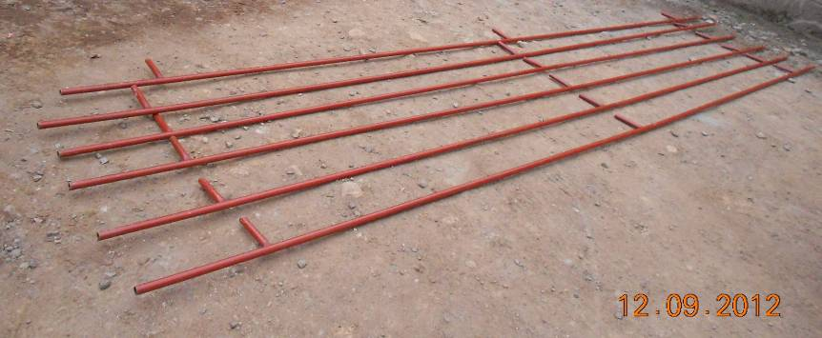

Since the length of this component is 5.40 meters, we cut the component 20cm from the middle connector. After welding the 25 cm 1 ¼ pipe (included in the below section) to one side of the cut section with at least 15 cm overlap the two pieces can be put together when assembling the shelter. This is only to facilitate transportation as the original length of 5.40m is rather long for transportation in a container and by doing this the longest component becomes 290cm for 4 lengthwise in loading a 40 ft container.

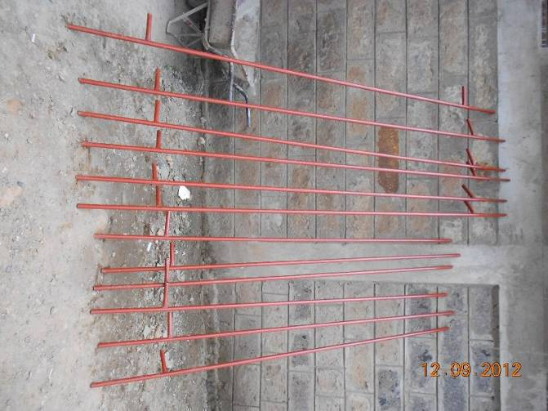

- Cuts and welding of the 1 1/4 inch pipe (for Rafters)

From each 1 ¼ inch pipe, 4.0 m length pipe is cut out. This is for the both sides of the A frame roofing or Rafters. This 4.0 m length is then cut into two 2.0 m pieces at 45 degrees angle.

After this first cut what is left from each 6.0m pipe is 2.0 m long pipe (6.0 m – 4.0 m) that will be used for the following cuts:

a. One cut of 40cm as female connector for the A frame or Rafters, total 40 cm
b. Six cuts of 10cm each as female connectors for the both sides of the A frame or Rafters total 60cm
c. Two cuts of 25 cm each as male connectors for insertion of the A frame or Rafters into the 1 ½ inch columns total 50cm
d. Two cuts of 25+cm (from the remaining length) for connecting the cut Purlins/Battens to each other for facilitation of transportation total 50+cm

The grand total of the above cuts will be 200+ cm (40+60+50+50+cm). Please refer to the Attachment TWO. This has to be repeated 3 times to cover all 3 lengths of 1 ¼ in pipes.

a = 40 cm
c = 25 cm
b = 10 cm
b = 10 cm
b = 10 cm
Size of all the pipes in this diagram is 1 1/4 inch

60*
30*
30 cm from
the lower end

90 cm from the lower end

165 cm from the lower end for both components

1.0 inch and 30 cm long
c = 25 cm
b = 10 cm
b = 10 cm
b = 10 cm
Size of all pipes in this diagram is 1 1/4 inch with the exception of the 30 cm one as the male connector on top of the A frame which is 1.0 inch diameter in size.

30*
60**
30 cm from the lower end

90 cm from the lower end

165 cm from the lower end for both components

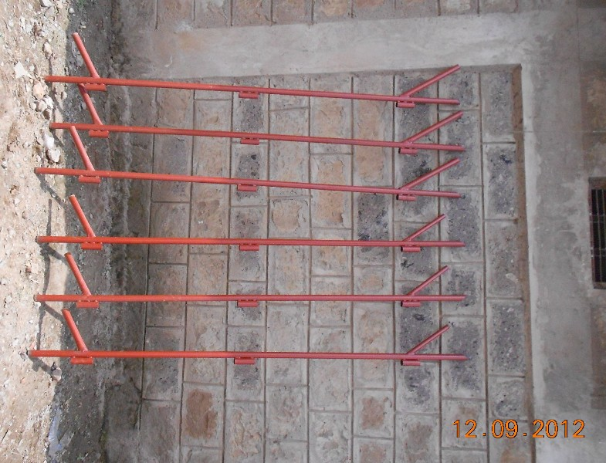

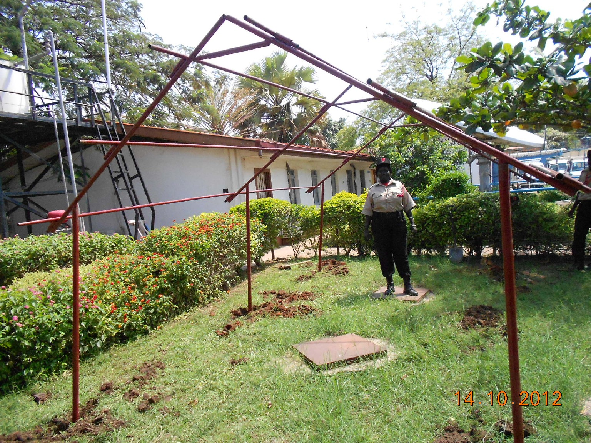
The fame is based on the version five and implementation of the
above mentioned measurements.

- Cuts and welding for the 1 1/4 inch pipe

Each length of 1 1/2 inch pipe are cut into three pieces of 170cm length giving us 3 pieces of each 170cm long pipe and leaving us with one piece of 90+cm long pipe.

The 90+cm then is cut into 3 pieces of 30+cm each which will be welded to the 170cm length pole as a “T” section. Depending on the nature of the ground/soil, 30cm to 40cm or more should be buried in the ground. This will give us 130cm to 140cm height (or less if we need to bury the column deeper)for the lowest sides of the shelter frame. (Attachment THREE)

The poles are made of 1 1/2 inch pipes.

170 cm
30 Cm

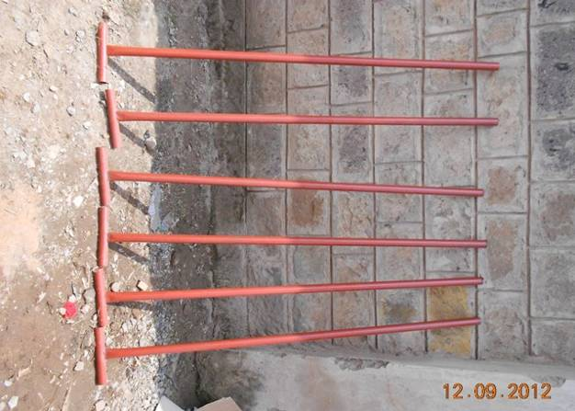

- Assembled Frame:

The pictures in the following page show one sample welding and assembled frame.

We first assemble the A frame or the roof and then we put the poles under the roof and have our frame which should be buried in the ground 30-40cm or more depending on the nature of the soil or .

Ghassem Fardanesh
Physical Planning and Shelter Unit
UNHCR Regional Support Hub
Nairobi, Kenya

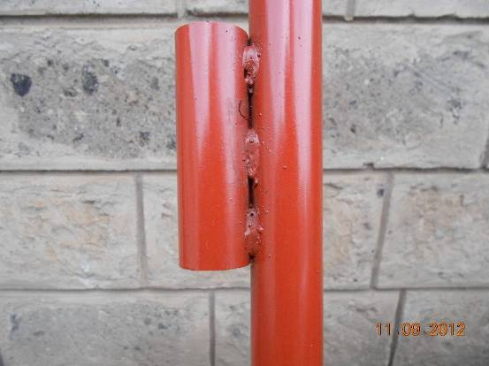  Sample welding | 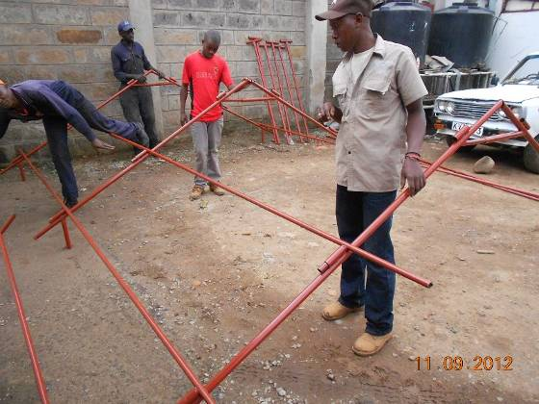  Assembly process in the workshop
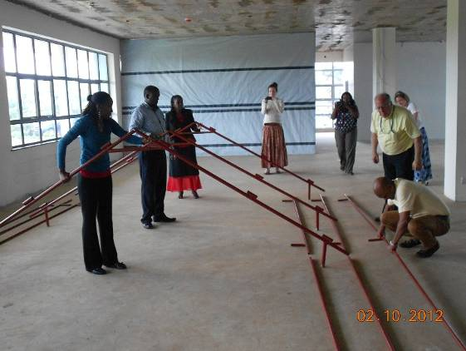  Assembly process in RSH by Colleagues | 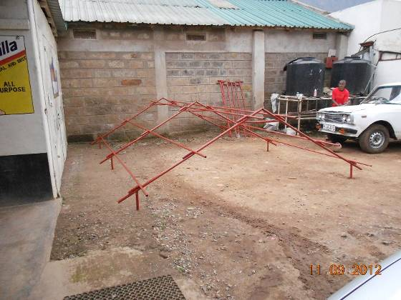  Assembled roof
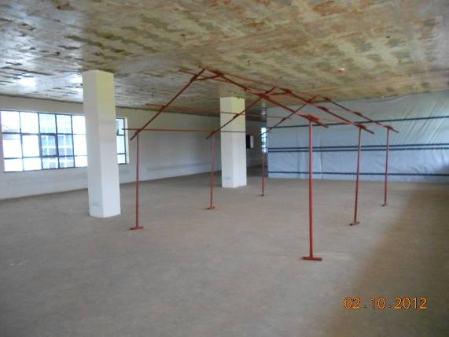  Assembled frame, 30-40 cm or more should  be buried depending on the nature of the soil. | 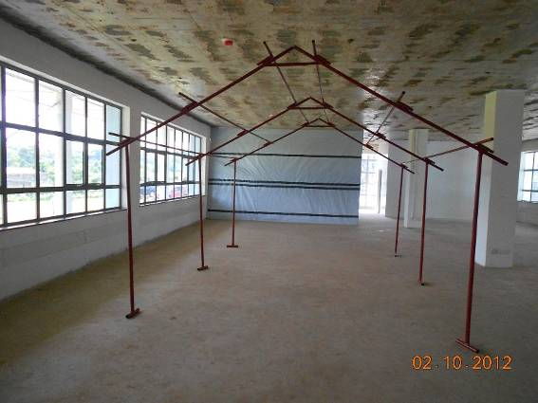  Assembled frame, 30-40 cm or more should be buried depending on the nature of the soil.

Attachment ONE

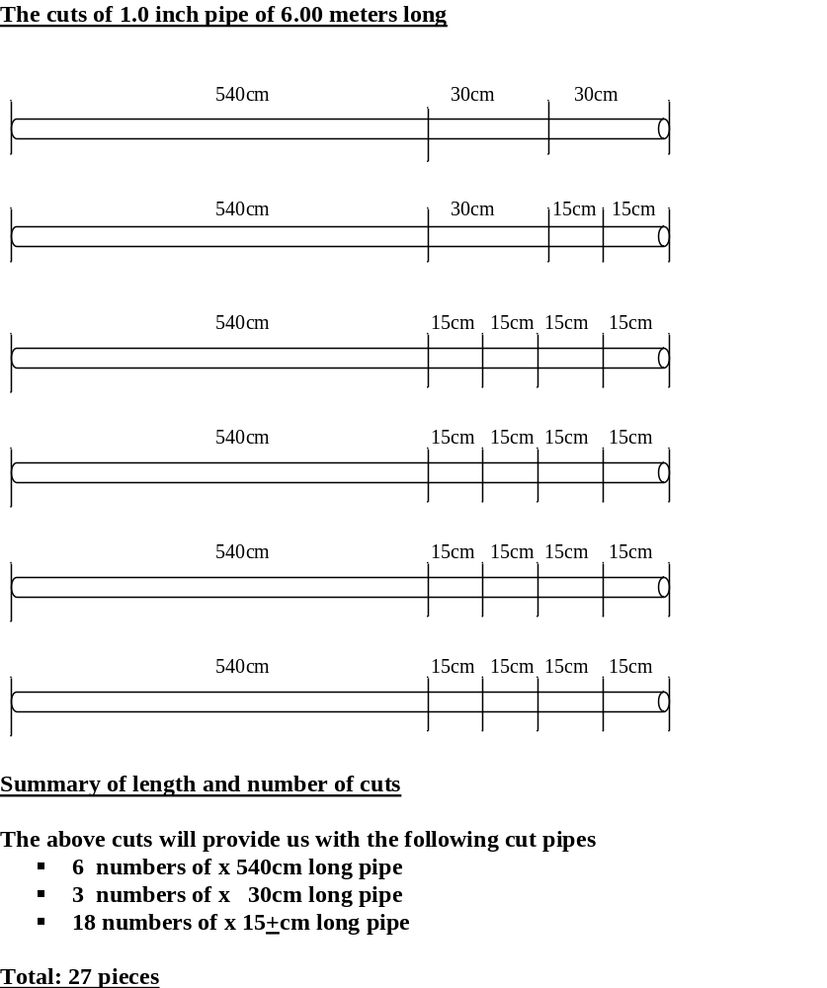

Attachment TWO

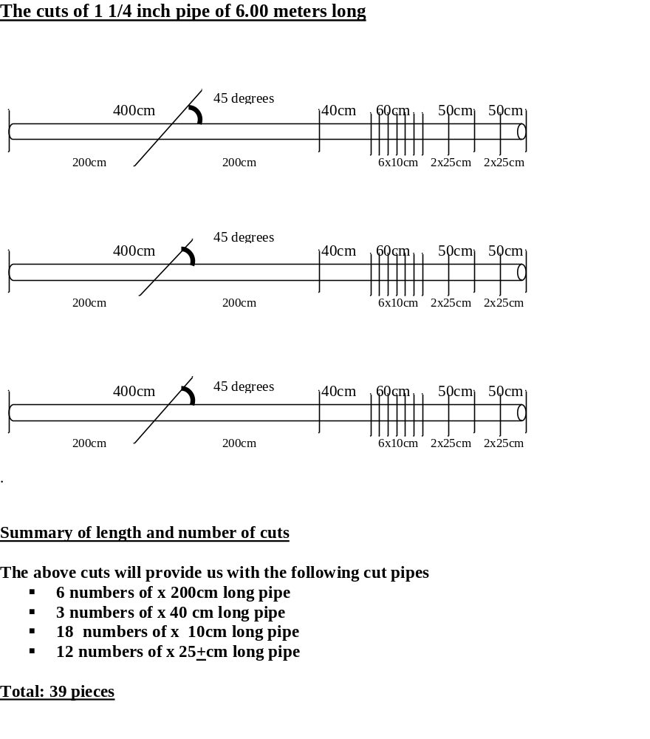
Attachment THREE

