NextFlow: Step-by-Step Guide
A beginner-friendly guide to registering and running experiments
Before starting to register your experiment on NextFlow, make a folder into your server folder and label it NextFlow then add these 3 files in it:
- ixm_template.xlsx Update it for your experiment name according to your experiment on IXMfrom4Galaxy
- IXM-platemap.csv only the wells that you need the data
- Your HTS file which is related to your specific experiment you could find it here: Finkbeiner-Robodata/IXM4Galaxy

Overview
This guide walks you through the complete process of working with NextFlow, from connecting to the server to running your experiment. The workflow has two main phases:

Phase 1: Register your experiment
Phase 2: Run your experiment

Step 1: Connect to the Server
First-time setup only: If this is your first time using NextFlow, follow these steps:
1. Go to: https://app.scaleft.com/t/gladstone/user/servers
2. Select fb-galaxy-dev01.gladstone.internal
3. Click the Connect button:


Step 2: Open Your Workspace in Visual Studio Code
1. Open Visual Studio Code 
2. In the left sidebar, click Remote Explorer 
3. Click on your workspace folder under SSH:fb-galaxy-dev01 (NOT the shared nextflow-cluster repo — that is read-only)
4. In your workspace, open finkbeiner.config to edit your run settings.
First time only: copy a fresh config template into your workspace. From the terminal: cp /gladstone/finkbeiner/steve/work/projects/nextflow-cluster/finkbeiner.config.template /path/to/your-workspace/finkbeiner.config
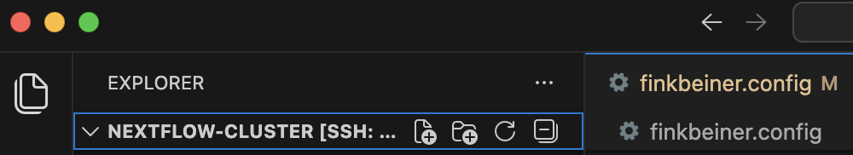

Step 3: Register Your Experiment
Before running an experiment, you must first register it in the system.

3.1 Configure the Settings
Set the workflow flags to enable registration mode:
params.DO_STD_WORKFLOW_IXM = false
params.DO_REGISTER_EXPERIMENT = true

Important: In Section 2 (INDIVIDUAL MODULE TOGGLES), only DO_REGISTER_EXPERIMENT should be true. Set every other DO_* flag in Section 2 to false.

3.2 Update Your Experiment Details
Update the following sections with your experiment information:
• Section 3 (EXPERIMENT), Section 4 (REGISTER EXPERIMENT), and Section 5 (SEGMENTATION)

Important: The input_path is case-sensitive. Always use: /gladstone/finkbeiner/robodata (exactly as shown)

Note: There is no well exclusion feature in this version. Your platemap should only contain wells you want to process, then select "all" when prompted.

Example input path:
params.input_path = '/gladstone/finkbeiner/robodata/IXM4Galaxy/Zohreh/JAKZF-AlphaDOP12-SiRICC1-10172025'

3.3 Save and Run Registration
1. Save your changes: Command + S (Mac) or Ctrl + S (Windows)
2. Open the Terminal in Visual Studio Code:
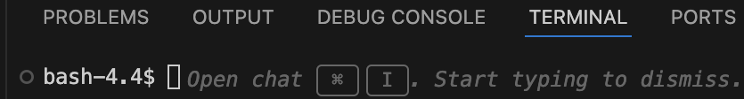
3. Copy and paste the registration command into the terminal and press Enter

sbatch /gladstone/finkbeiner/steve/work/projects/nextflow-cluster/run.sh -c finkbeiner-user.config
Ex: if Kanchan is running then rename the file to finkbeiner-kanchan.config and run
sbatch /gladstone/finkbeiner/steve/work/projects/nextflow-cluster/run.sh -c finkbeiner-kanchan.config

squeue
4. A Job ID will be generated - note this down!

3.4 Check Registration Status
To check if registration completed successfully:
1. Open the log file in your workspace folder — it is named <username>_<YYYYMMDD>_<HHMMSS>_<jobid>_<experiment>.out (replaces the old slurm-JobID.out naming)
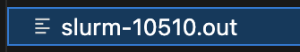
2. In the left sidebar of Visual Studio Code, find your experiment ID under Slurm:
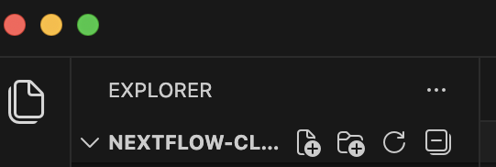
Tip: Click Refresh each time you check the status to see the latest updates.

Tip: You can also verify registration by checking your output folder for newly created folders.

This is how a slurm file will look like

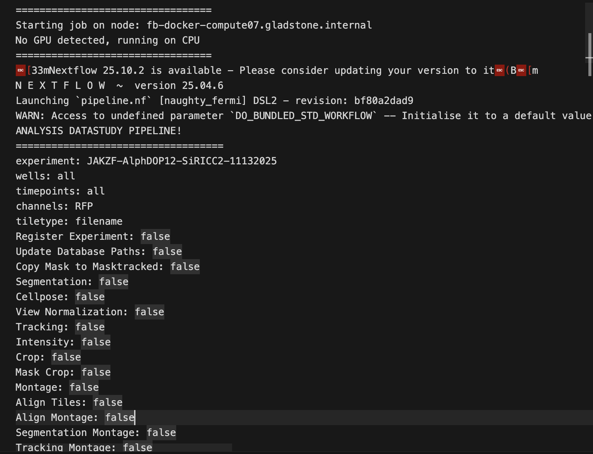

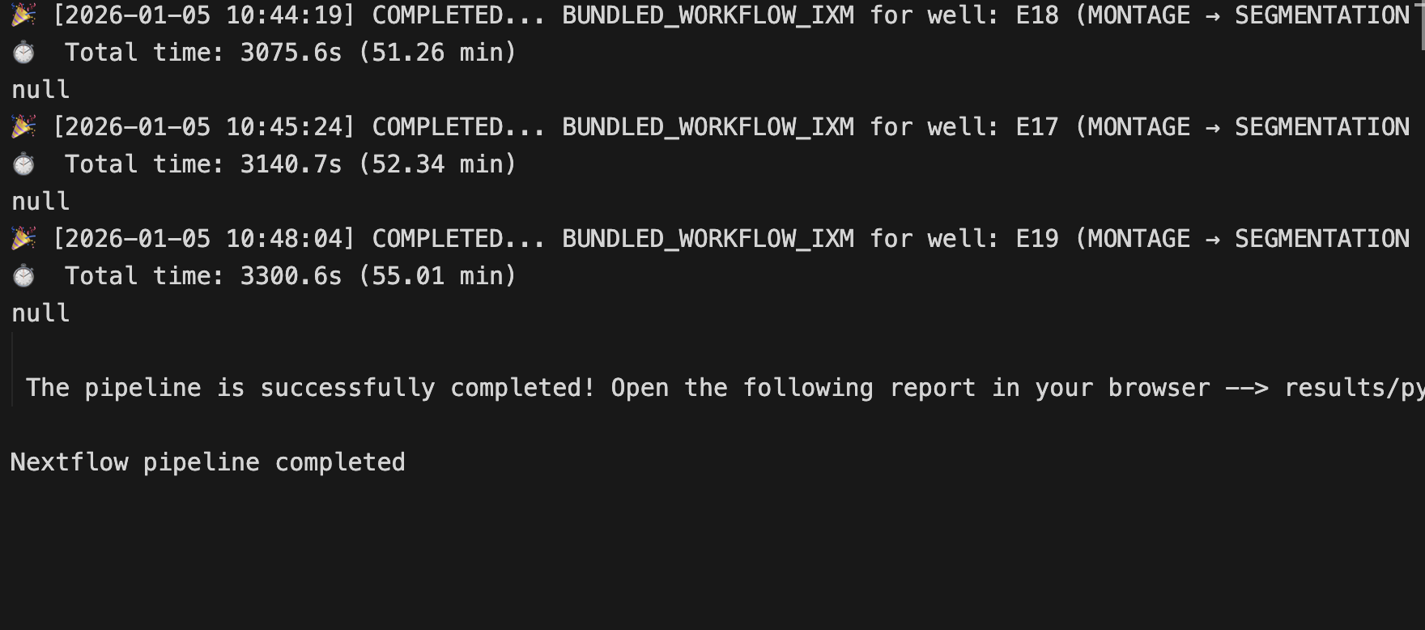

In the last line of the slurm output file, you will see if the pipeline has ran successfully or not.

Step 4: Run Your Experiment
After registration is complete, you can run your experiment.

4.1 Switch to Run Mode
Change the workflow flags in your config file:
params.DO_REGISTER_EXPERIMENT = false
params.DO_STD_WORKFLOW_IXM = true

4.2 Save and Run
1. Save your changes: Command + S
2. Run the experiment command in the terminal (same as registration)
Copy and paste these commands into the terminal of Visual Studio and press Enter

sbatch /gladstone/finkbeiner/steve/work/projects/nextflow-cluster/run.sh -c finkbeiner.config
squeue

3. Note the new Job ID that is generated
4. Check status using the same method as registration (Step 3.4)

Tip: You can monitor progress in the terminal window where you ran the experiment.

Quick Reference: File Paths
Here are example file paths for common files:
File Type | Example Path
HTS Files | /gladstone/finkbeiner/robodata/IXM4Galaxy/1 HTS/Zohreh/[experiment].HTS
IXM Template | /gladstone/finkbeiner/kaye/Zohreh/NEXTFLOW/ixm_template.xlsx
IXM Platemap | /gladstone/finkbeiner/kaye/Zohreh/NEXTFLOW/[experiment]/IXM-platemap.csv

What's New (May 2026)
The pipeline now uses a shared-install model. Every user runs the same code from /gladstone/finkbeiner/steve/work/projects/nextflow-cluster — you do not need your own clone, and you no longer have to git pull when the code is updated.
Your workspace is a personal folder you create on the share. It only needs to contain your finkbeiner.config (plus the IXM template, platemap, and HTS file when registering an experiment). Logs and per-run reports are written to this folder.
Run commands now require an explicit -c flag pointing at your config file. For example: sbatch /gladstone/finkbeiner/steve/work/projects/nextflow-cluster/run.sh -c finkbeiner.config. Running without -c gives a clear error.
Log files are named <username>_<YYYYMMDD>_<HHMMSS>_<jobid>_<experiment>.out (instead of slurm-<jobid>.out). They land in your workspace folder, not in the shared install.
Each run gets its own work directory: work_<jobid>/ in your workspace. Old runs no longer collide.
Config validation is now strict. The validator catches typos, smart quotes (e.g. ' vs '), hidden characters (BOM, NBSP, zero-width spaces), duplicate parameters, and '#' comments (use '//' instead). Errors are reported with line and column.
Segmentation can now drop clumped cells. Set params.proximity_filter_radius (in Section 5) to a pixel radius — any pair of cells whose centroids are closer than that is removed. Set to 0 to disable.
Overlay images are now grayscale (white text and leader lines) instead of RGB green.
Stable-cell filter (optional). After tracking, you can run /gladstone/finkbeiner/steve/work/projects/nextflow-cluster/bin/stable_cell_filter.R to identify cells that are stably tracked across all timepoints. The script writes the stable IDs to a CSV that you can plug into params.overlay_montage_cell_ids for an overlay of just those cells.
Channel names cannot contain underscores. Spaces and special characters (parentheses, slashes) should also be avoided. Use sanitized names such as TexasRed624 or mApple593 in your template.
Important: Remember: All paths starting with /gladstone/finkbeiner/robodata are case-sensitive!

