Instructions for purchasing dry ice and liquid nitrogen

- Login to the computer using your EID and EID password.
- Go to the DNA LIMS website: http://coreweb.icmb.utexas.edu/index.html
- Login using your LIMS account or create a new LIMS account and login. At the “Select LIMS” pull-down menu pick “Dry Ice- LN2”, then hit “Submit”
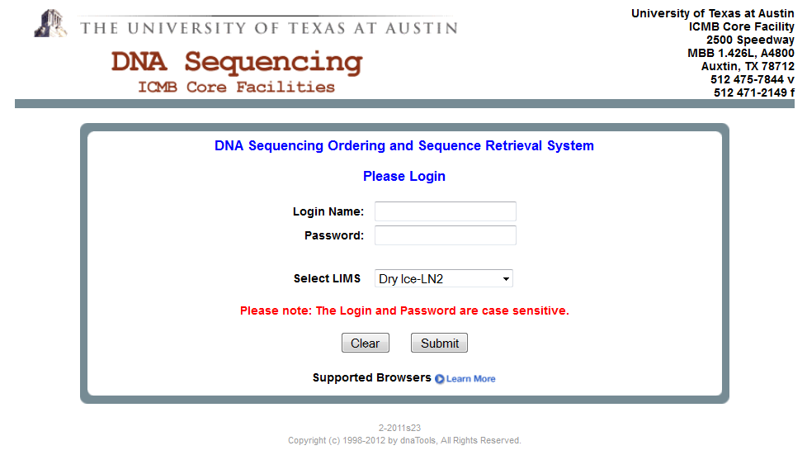
- Select “Place a New Order”

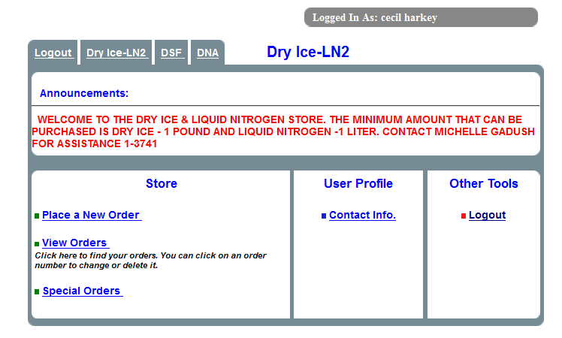

- Enter the amount of dry ice or liquid nitrogen. There is now a scale so you can weigh the dry ice if you take less than a block. The minimum amount that you can order is 1lb of dry ice and 1liter of liquid nitrogen.
- Select “Step2: Preview Order”
- Enter the grant account number. You must enter a valid grant number each time.
- Select “Place Order”.
- Close browser and log out.

