Part Numbers:
Item: Company- Part Number
Automatic Dicing Saw: Disco- DAD321 (Discontinued, New model 322)
6 inch Tape Frames: Disco- MDTFR150-02
Diamond Dicing Blade: Disco- DGAR1153
Blue medium tack dicing tape: Semiconductor Equipment Corp.- 18074-8.00
1mM thick fused quartz wafer: University Wafer- 153234

Instructions:
- 100mM diameter (4 inch), 1mM thick fused quartz wafers are used in this process. It is possible to make 6 flowcells out of this process, 4 wafers from the core (in green) and two from the lip (in blue). The first three cuts will separate the core and the two lips, while the remaining cuts separate each slide individually.
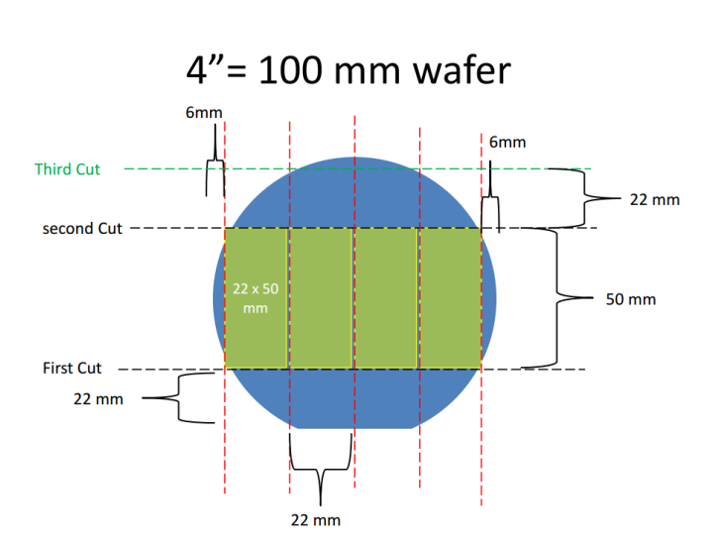
- Use a guide to draw lines for your initial cuts. The guide pattern is the outline of the slides to be cut.
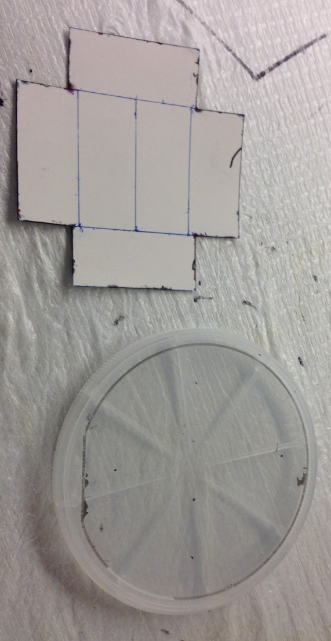

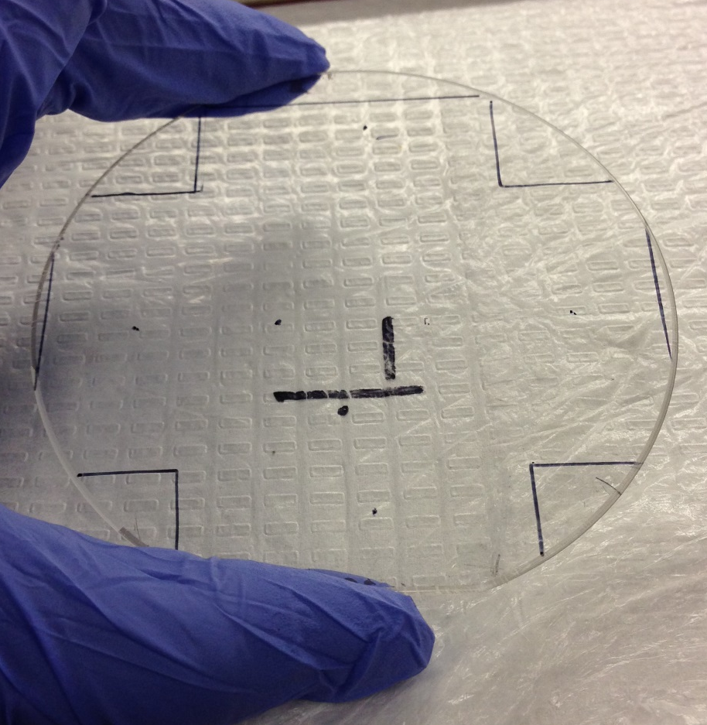

- Go to the clean room, and sign in to use the dicing saw. Turn on the Nitrogen, Water, and power source (to the right of the water and nitrogen). Make sure you see water flowing in the drain and hear the nitrogen before proceeding. This step is CRITICAL as not turning on these things could ruin the dicing blade or the entire instrument.
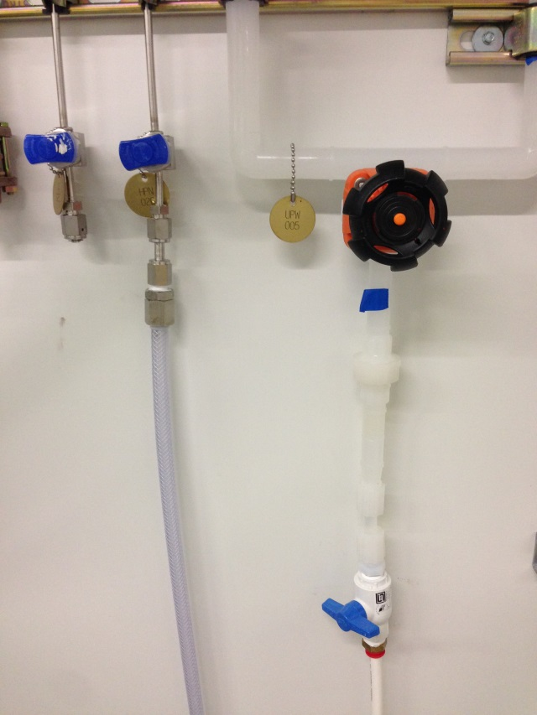
- Note: In case of MAJOR emergency when cutting, press the large yellow “EMO” button on the front of the machine.
- Start the instrument with the start key. After booting up the main menu will look like this.
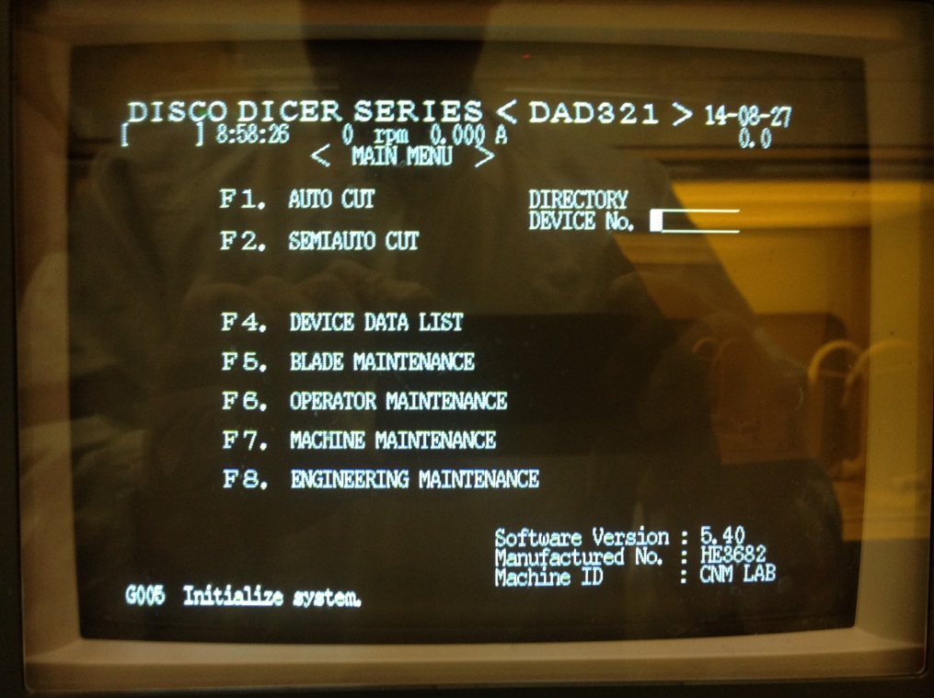

- To initialize the system, press the SYS INIT key on the menue keypad. Follow the prompts to initialize the system.
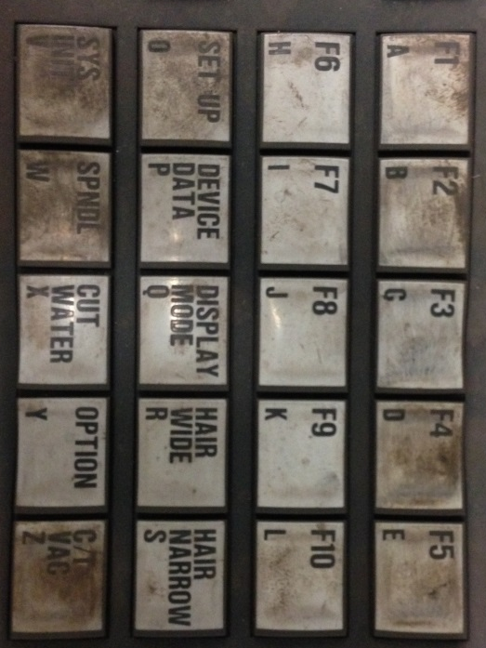
- Note: The alarm on the dicing saw goes off all the time, even after successfully finishing a cut. To turn the alarm off at any time press the “ALRMCLR|HELP” button to the right of the menu keypad.
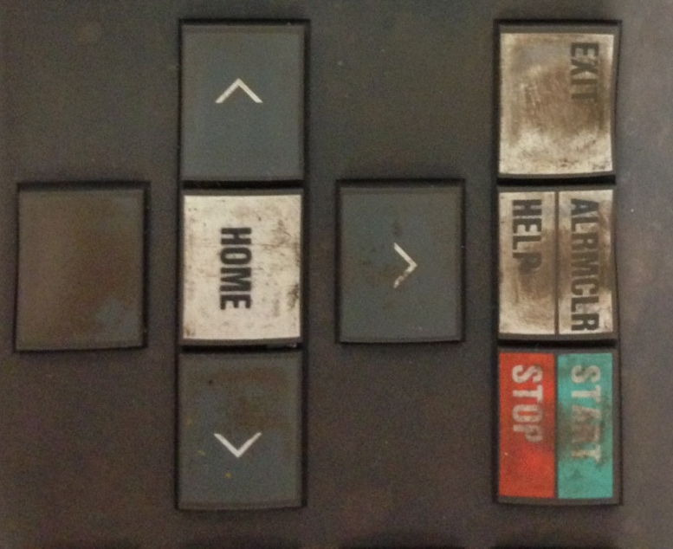
- Measure the blade thickness by pressing the “SET UP” key right above the “SYS INIT” key. Follow the prompts and record the blade thickness, and if using your own blade track the wear.

- At the main menu, press the F4 key to enter the device data list. Scroll down to a pre-made process or a process to be modified and press enter to begin editing the process.
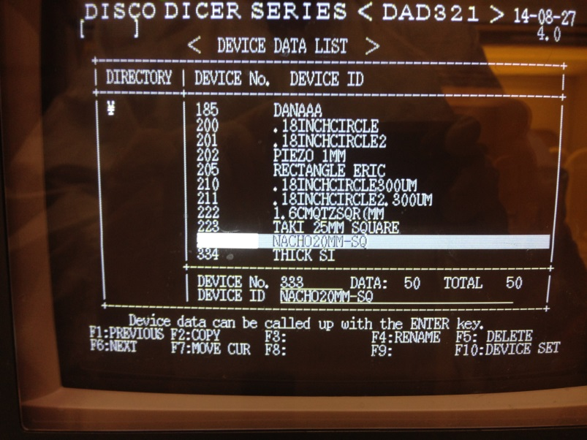
- Set the parameters for the cut. Use the number pad to the right of the menu pad to enter the values of your cutting variables. Critical variables include the following.
  - Sample defining variables: Unit, Cut Mode, Cut shape, RND and SQR work size
    - Correct values guide the dicing blade to start before the sample and end after the sample. Incorrect values can break the blade!
  - Cut depth and speed defining variables work thickness, tape thickness, blade height, and feed speed
    - Correct values guide the blade to cut through the entire sample depth. Incorrect values can ruin the blade and damage the chuck!
  - Cut axis defining variables Y Index CH1 and CH2
    - Correct values ensure your cuts are evenly and correctly spaced. Incorrect values can ruin your sample!
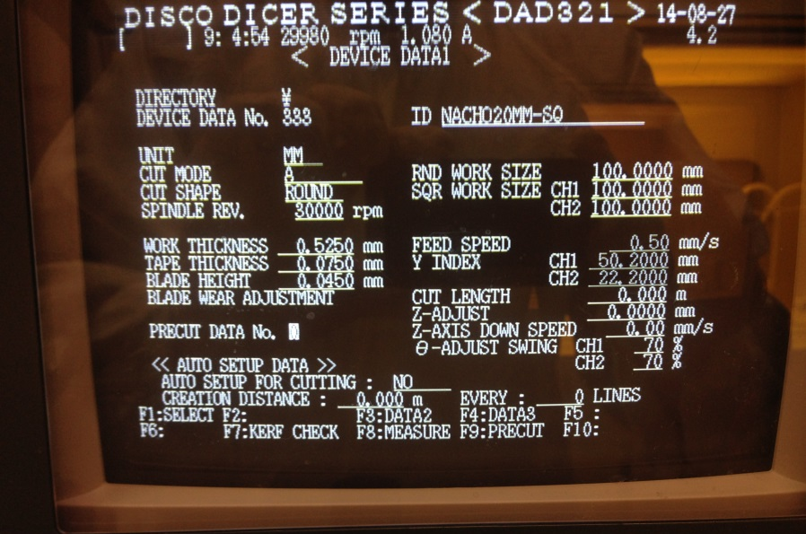
- Press enter to save the changes you made and exit to the main menu.
- Begin prepping your sample by cutting off a piece of blue mounting tape and stretching it across the tape frame like a drum.
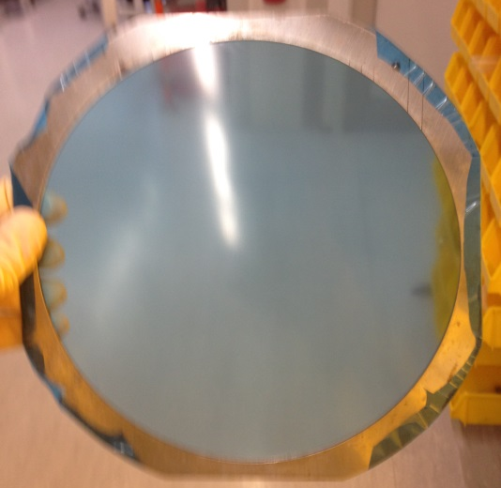
- Place the wafer on the sticky side of the mounting tape pattern side up. Then place another piece of mounting tape sticky side down on the pattern side of the wafer. Smooth out bubbles so as few as possible are on the wafer
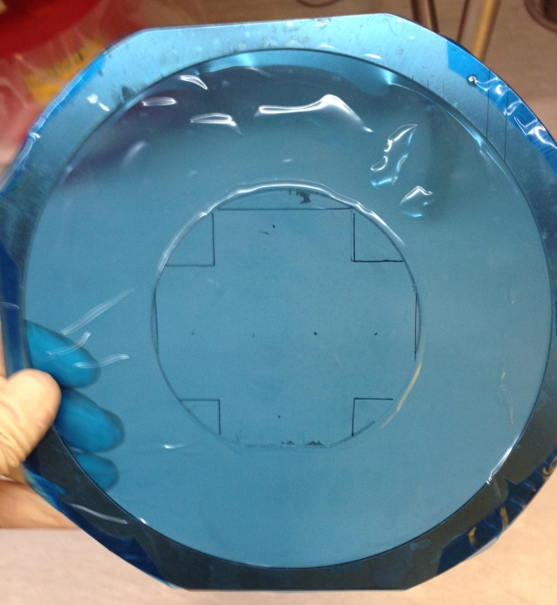

- Place the wafer on the chuck with the flat towards you. Press “C/T VAC” on the keypad to vacuum the sample to the chuck. Press it again to move the sample to zero position. Forgot to take a picture of this step, so I included a picture of a later mounting step.
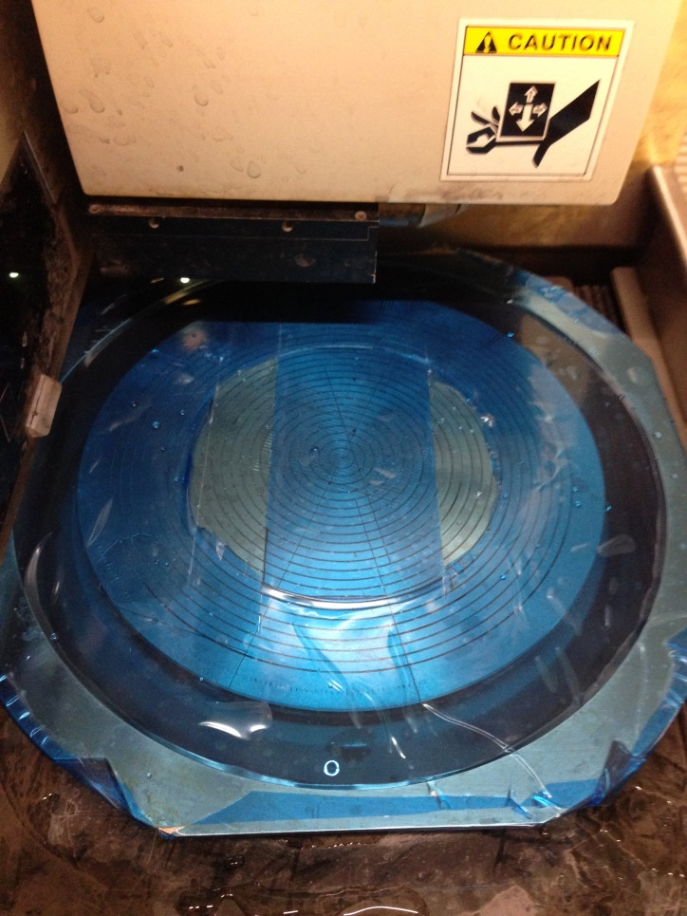
- On the keypad, press “F2” to enter SEMIAUTO CUT. The screen will look like this. Press “F4 to begin alignment.
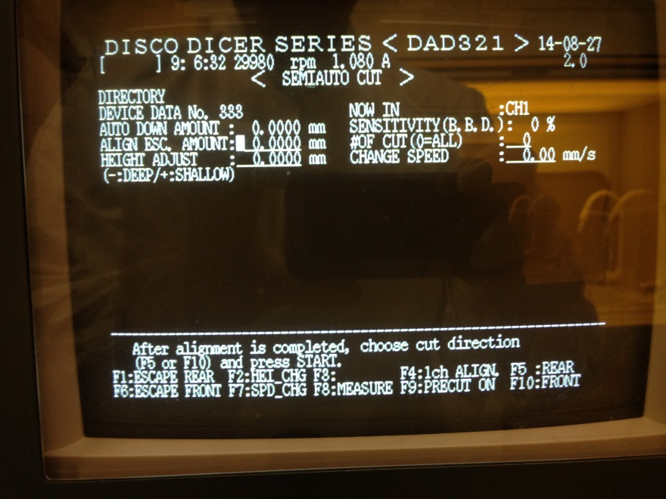

- To align the sample, you will need to use the directional pad shown below. The various buttons are explained as follows.
  - “Z EM”. Emergency button. Immediately suspends cut and sounds the alarm. Use in case of minor cutting emergency.
  - All movement directions. Moves the sample in the indicated axis. X, Y, and ѳ are the only directions used.
  - “INDEX”. Highlights when pressed. When highlighted, moves the amount set in CH1 and CH2 in process editing. Good for quickly moving and previewing cuts.
  - “SLOW”. Highlights when pressed. When highlighted, moves very slowly. Good for alignment.
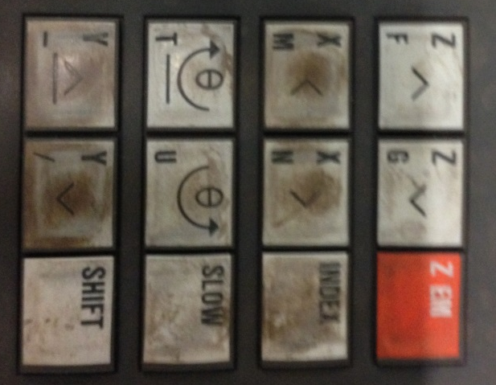
- Press “F4” in SEMIAUTO CUT to enter the alignment window. Move the sample to the edge of the flat. Use the screen and the small beam of light used to image the sample to determine when the edge of the flat is in the middle of the alignment plane. Press “F5” to move to the other side of the flat. Align to this edge and press “ENTER”. Check the alignment and move on to cutting.
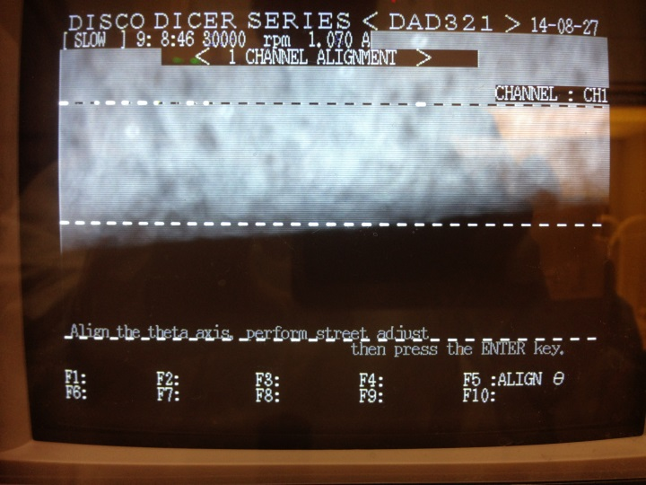
- After alignment, move to the guideline for the “First Cut”, and align using the screen and the light beam.
- Use the “Index” and movement keys to check that you will be cutting were you think you will be cutting.
- After lining up on the guide line, press “F5” to activate REAR cut.
- After the first two cuts are done, line up on the guideline for the “Third Cut” and Rear cut again.
- Your core and lips are now separated. Remove the lips with a razor blade and re-mount the core on the dicing saw.
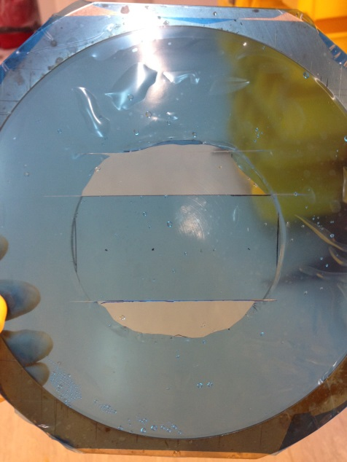
- Use the large flat to align the sample, and then use “INDEX” and move “ѳ” to rotate the sample 90 degrees.
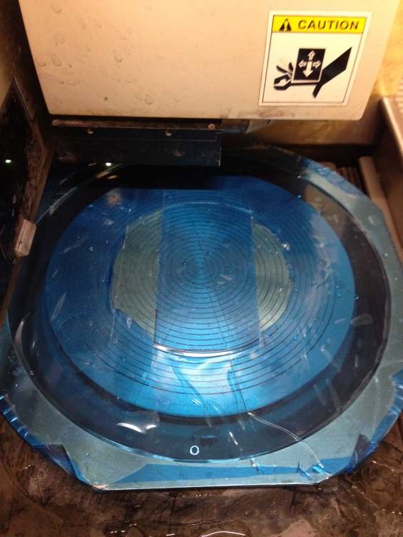
- Line up on your front cut guideline and use “INDEX” to check your cuts. After checking use REAR cut again.
- To cut the lips you will need to go back to the program editor, and change the CH2 cut spacing to 50mM. After that, line up your lips on new mounting tape by aligning the cut guidelines. Then align the sample using the flat, and rotate as you did with the core. Use the front guidelines to align your first cut and REAR cut.
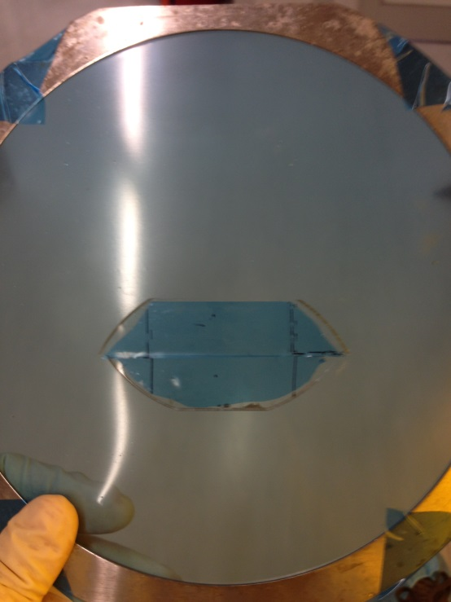
- Congratulations, you have 6 perfectly cut samples.
