The stocks to be checked:

Stock info:

name: ????

code: sh600007

main inflow:257.31

main outflow:116.73

retail inflow:249.6

retail outflow:227.34

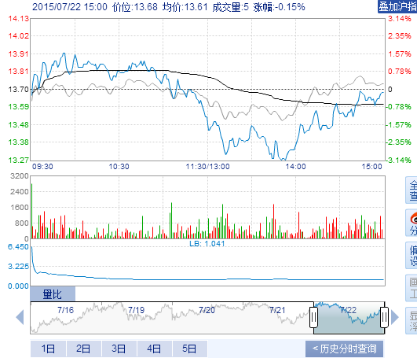

Stock info:

name: ????

code: sh600026

main inflow:3957.08

main outflow:1737.94

retail inflow:216.98

retail outflow:250.16

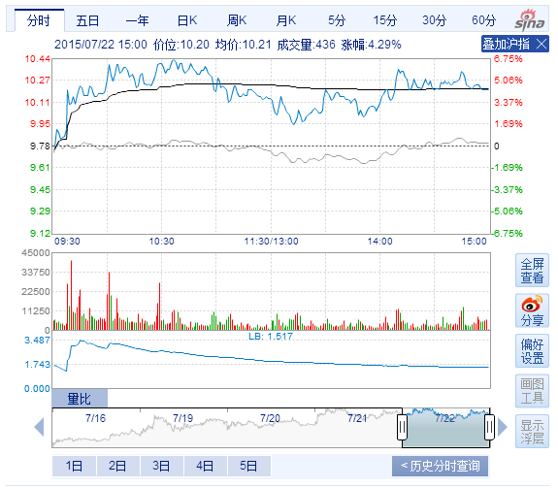

Stock info:

name: ????

code: sh600035

main inflow:29085.8

main outflow:2013.55

retail inflow:436.08

retail outflow:0.0

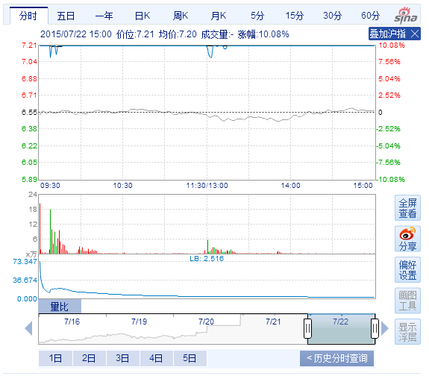

Stock info:

name: ????

code: sh600038

main inflow:5596.07

main outflow:2791.31

retail inflow:106.92

retail outflow:62.59

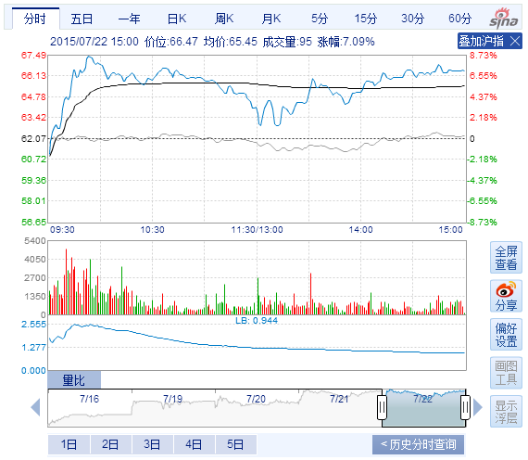

Stock info:

name: ????

code: sh600072

main inflow:3519.74

main outflow:1657.91

retail inflow:186.41

retail outflow:206.19

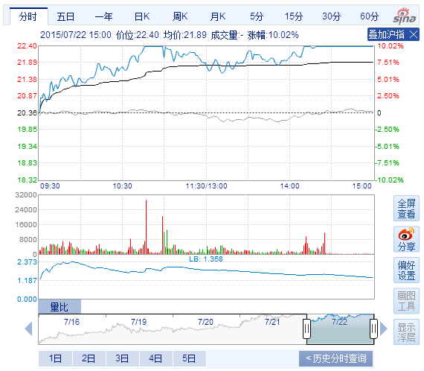

Stock info:

name: ????

code: sh600091

main inflow:483.43

main outflow:180.94

retail inflow:145.49

retail outflow:199.81

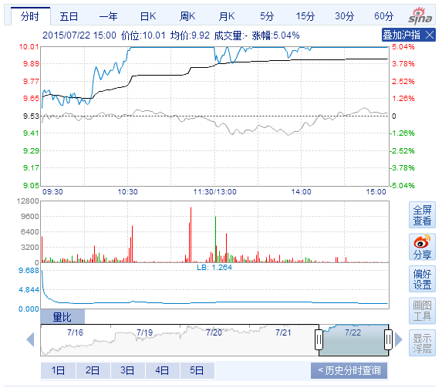

Stock info:

name: ????

code: sh600133

main inflow:1602.0

main outflow:658.54

retail inflow:189.68

retail outflow:188.59

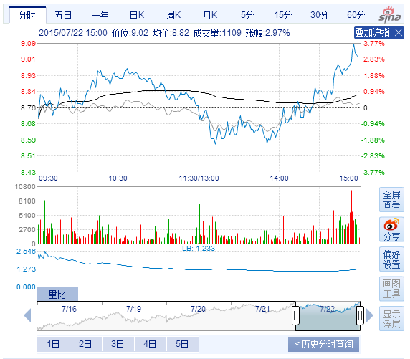

Stock info:

name: ????

code: sh600165

main inflow:70.18

main outflow:0.0

retail inflow:34.02

retail outflow:0.0

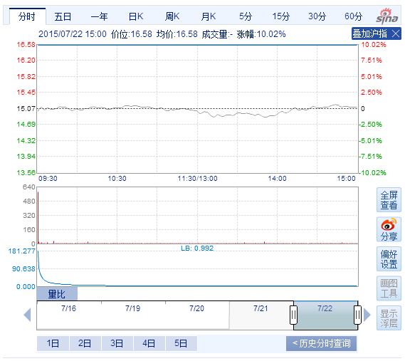

Stock info:

name: ???

code: sh600184

main inflow:5194.4

main outflow:2561.63

retail inflow:58.96

retail outflow:43.86

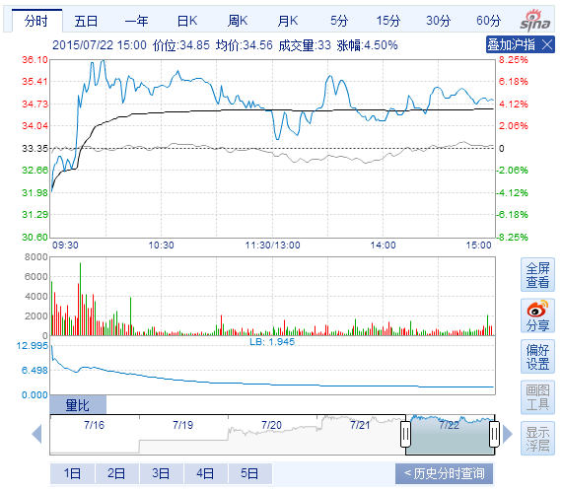

Stock info:

name: ????

code: sh600192

main inflow:650.49

main outflow:279.55

retail inflow:298.84

retail outflow:235.76

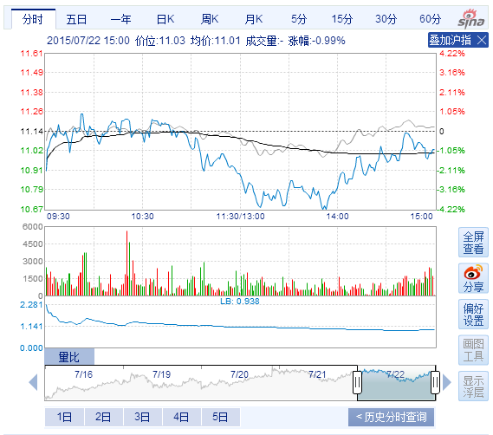

Stock info:

name: ????

code: sh600195

main inflow:3563.71

main outflow:1400.68

retail inflow:148.49

retail outflow:166.33

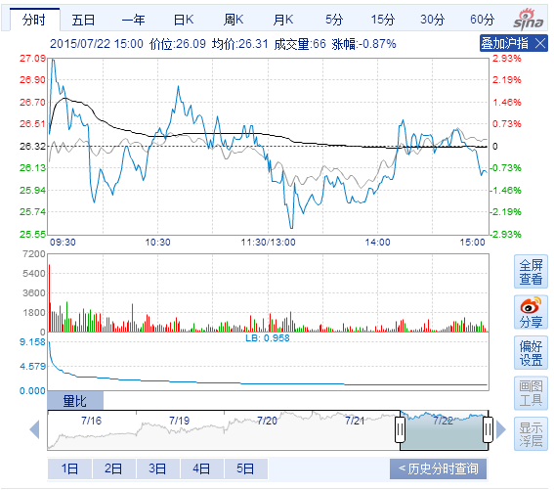

Stock info:

name: ????

code: sh600216

main inflow:821.74

main outflow:379.06

retail inflow:369.65

retail outflow:221.44

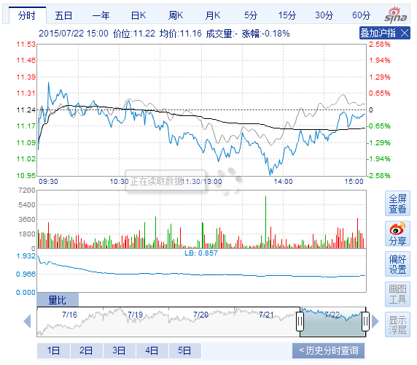

Stock info:

name: ????

code: sh600241

main inflow:1404.06

main outflow:152.52

retail inflow:128.3

retail outflow:195.84

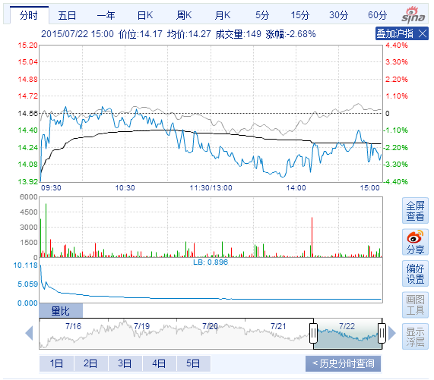

Stock info:

name: ????

code: sh600247

main inflow:91.74

main outflow:0.0

retail inflow:55.7

retail outflow:0.0

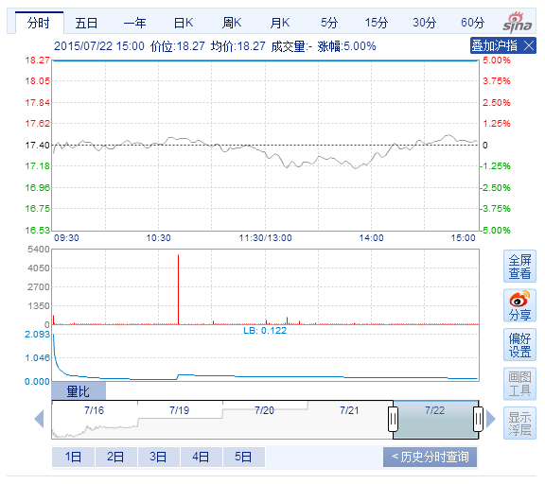

Stock info:

name: ???

code: sh600249

main inflow:642.74

main outflow:312.26

retail inflow:231.92

retail outflow:192.47

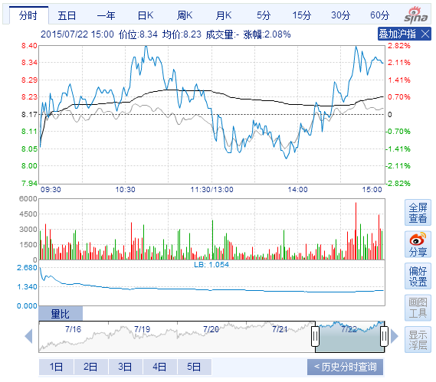

Stock info:

name: ???

code: sh600275

main inflow:1094.58

main outflow:517.58

retail inflow:288.62

retail outflow:202.89

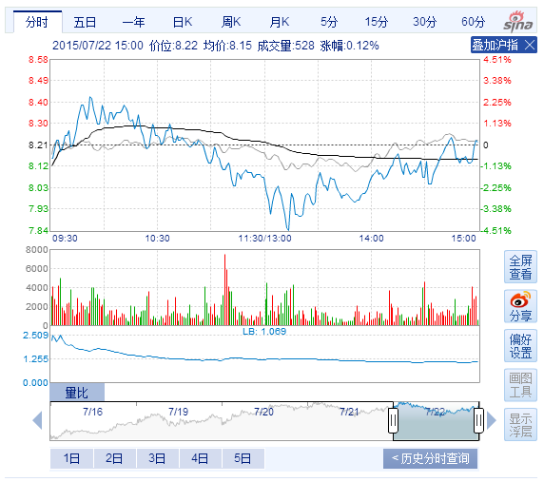

Stock info:

name: ????

code: sh600280

main inflow:285.17

main outflow:0.0

retail inflow:32.48

retail outflow:0.0

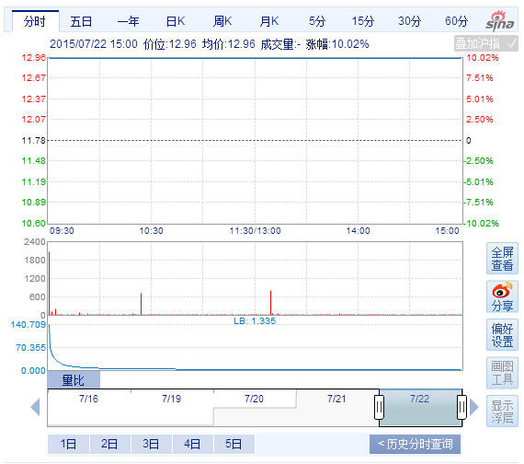

Stock info:

name: ????

code: sh600290

main inflow:47991.3

main outflow:9164.28

retail inflow:42.02

retail outflow:0.0

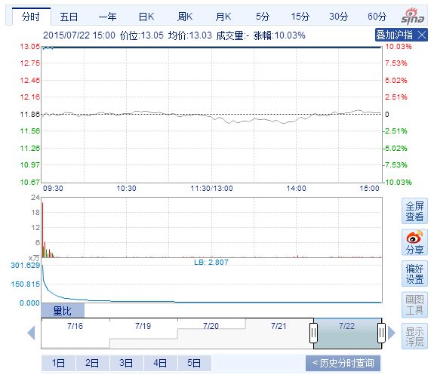

Stock info:

name: ????

code: sh600300

main inflow:2006.68

main outflow:856.17

retail inflow:264.86

retail outflow:200.56

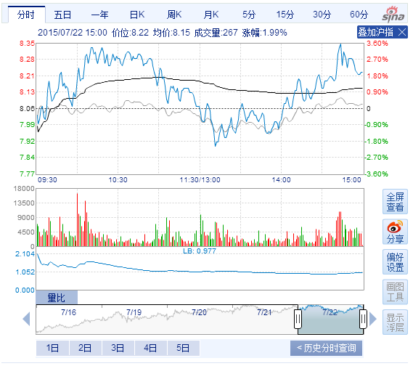

Stock info:

name: ????

code: sh600337

main inflow:223.9

main outflow:62.26

retail inflow:251.54

retail outflow:102.21

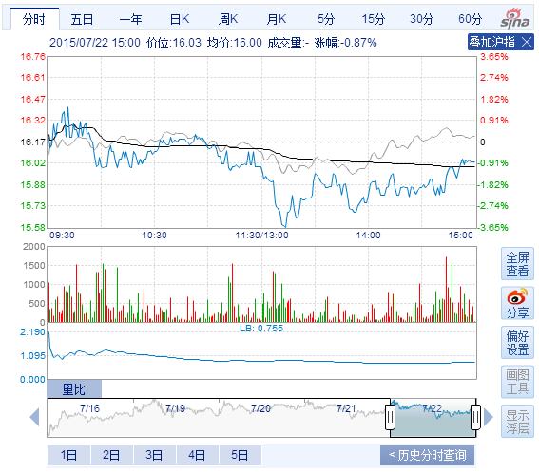

Stock info:

name: ????

code: sh600392

main inflow:4899.56

main outflow:0.0

retail inflow:311.23

retail outflow:0.0

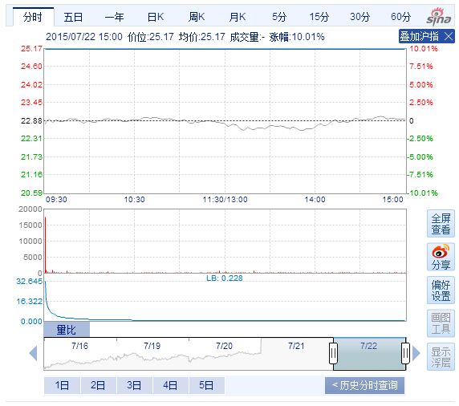

Stock info:

name: ????

code: sh600403

main inflow:93.16

main outflow:38.54

retail inflow:128.01

retail outflow:147.6

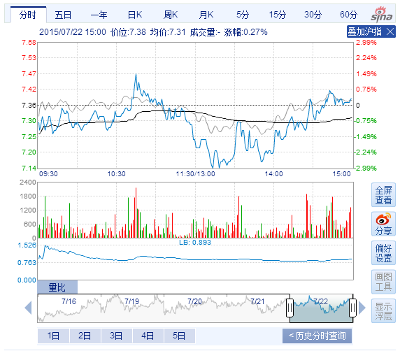

Stock info:

name: ????

code: sh600418

main inflow:122.42

main outflow:0.0

retail inflow:93.71

retail outflow:0.0

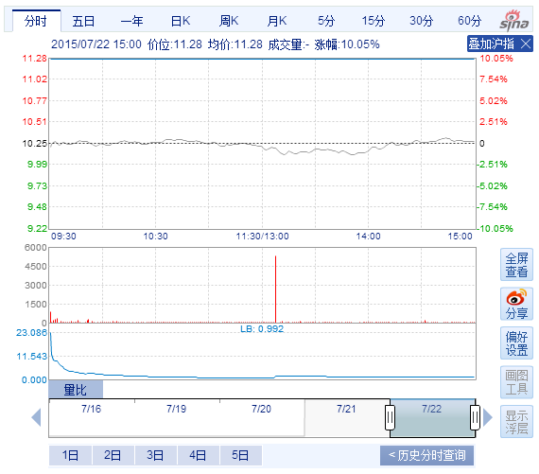

Stock info:

name: ????

code: sh600421

main inflow:250.46

main outflow:57.21

retail inflow:173.47

retail outflow:125.53

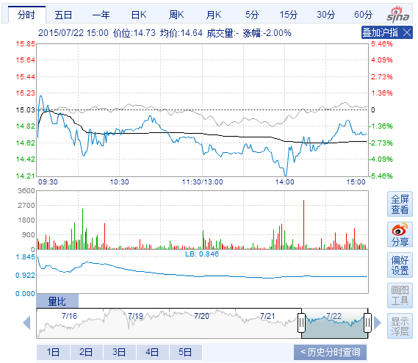

Stock info:

name: ????

code: sh600423

main inflow:1828.39

main outflow:731.55

retail inflow:228.81

retail outflow:182.53

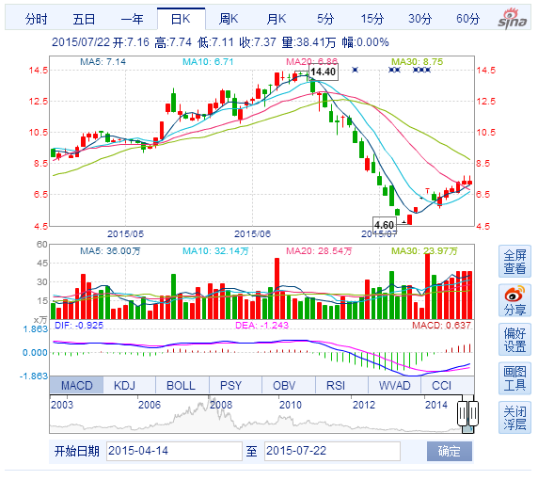

Stock info:

name: ????

code: sh600452

main inflow:246.64

main outflow:69.95

retail inflow:189.66

retail outflow:111.01

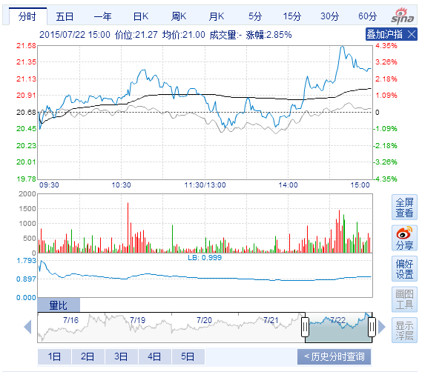

Stock info:

name: ????

code: sh600511

main inflow:1437.06

main outflow:685.22

retail inflow:231.03

retail outflow:164.74

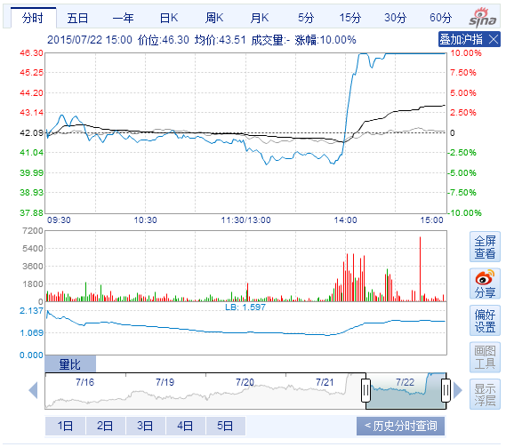

Stock info:

name: ????

code: sh600521

main inflow:2780.49

main outflow:899.27

retail inflow:178.16

retail outflow:102.9

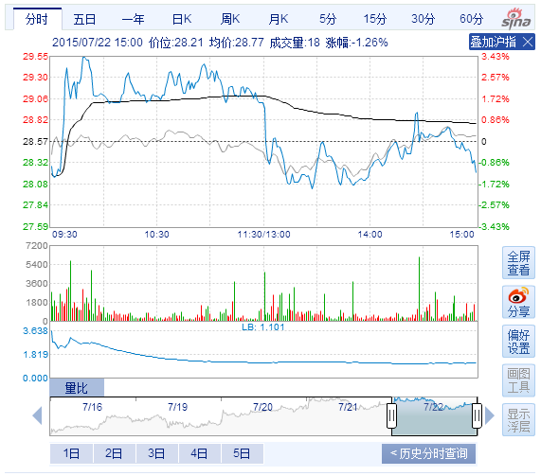

Stock info:

name: ????

code: sh600537

main inflow:1941.83

main outflow:946.94

retail inflow:301.67

retail outflow:153.17

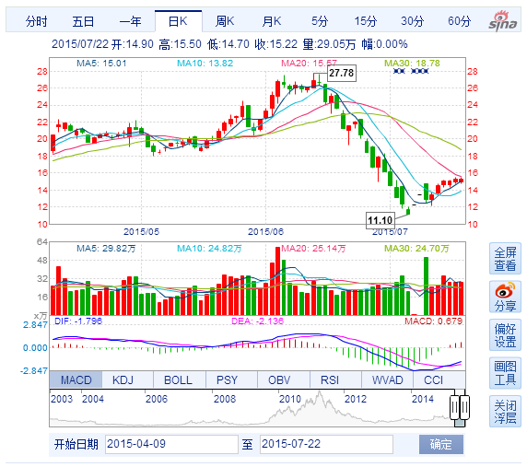

Stock info:

name: ????

code: sh600567

main inflow:190.55

main outflow:0.0

retail inflow:114.16

retail outflow:0.0

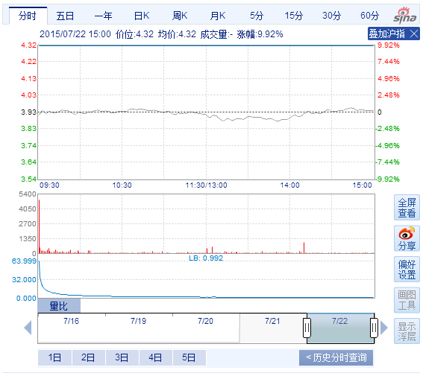

Stock info:

name: ????

code: sh600612

main inflow:34.31

main outflow:7.53

retail inflow:131.76

retail outflow:76.09

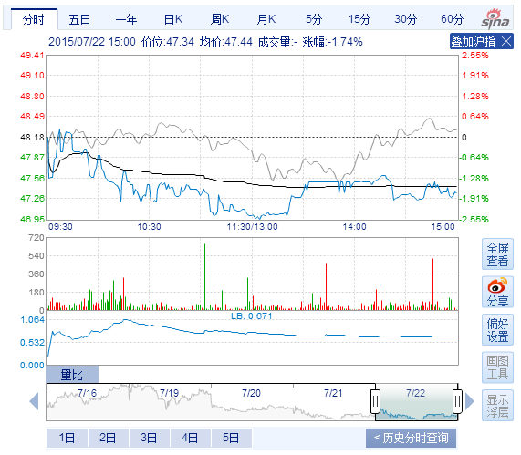

Stock info:

name: ????

code: sh600619

main inflow:302.44

main outflow:114.3

retail inflow:181.02

retail outflow:210.06

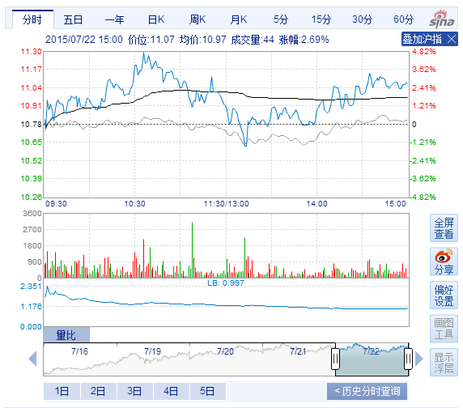

Stock info:

name: ????

code: sh600644

main inflow:121.24

main outflow:37.64

retail inflow:186.4

retail outflow:124.55

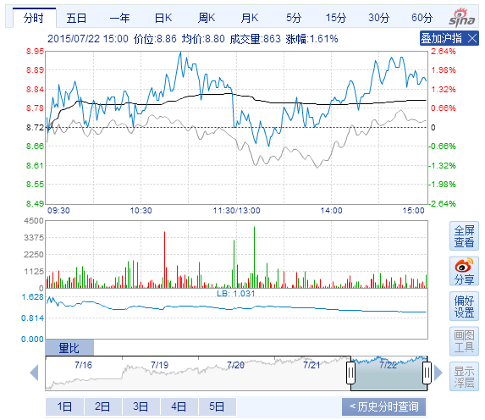

Stock info:

name: ????

code: sh600650

main inflow:1976.6

main outflow:986.31

retail inflow:253.64

retail outflow:91.58

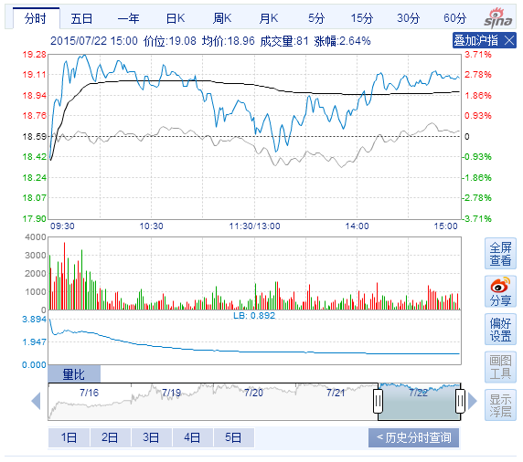

Stock info:

name: ????

code: sh600651

main inflow:14662.59

main outflow:6020.65

retail inflow:54.92

retail outflow:35.63

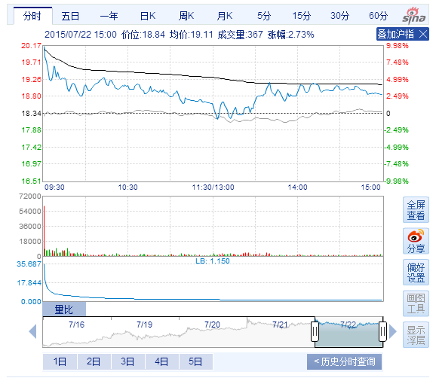

Stock info:

name: ???

code: sh600663

main inflow:2974.17

main outflow:1416.36

retail inflow:231.63

retail outflow:108.88

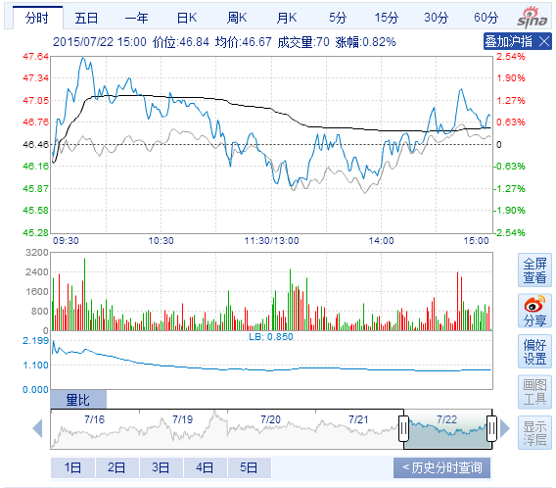

Stock info:

name: ????

code: sh600697

main inflow:241.04

main outflow:115.25

retail inflow:117.4

retail outflow:104.84

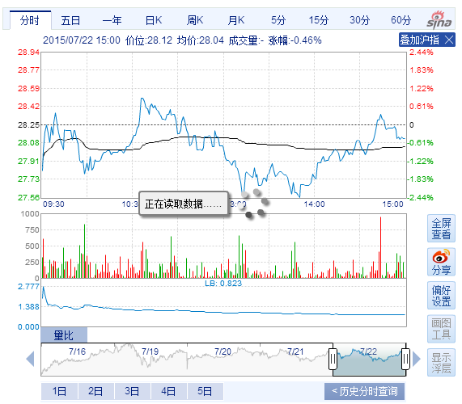

Stock info:

name: ????

code: sh600708

main inflow:1664.86

main outflow:654.34

retail inflow:283.93

retail outflow:212.98

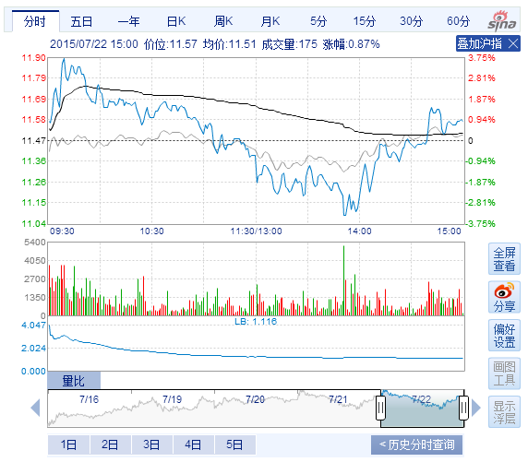

Stock info:

name: ST??

code: sh600714

main inflow:211.19

main outflow:91.67

retail inflow:226.18

retail outflow:138.77

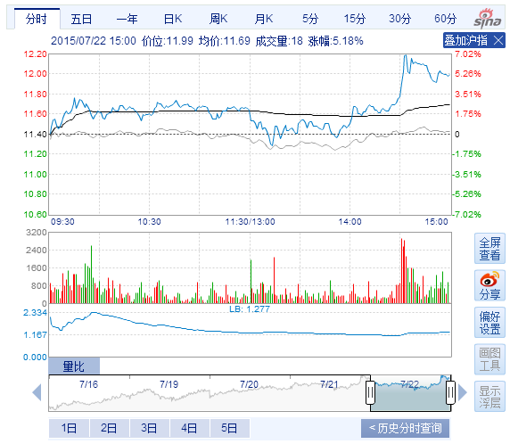

Stock info:

name: ST??

code: sh600715

main inflow:2016.22

main outflow:850.32

retail inflow:214.13

retail outflow:77.3

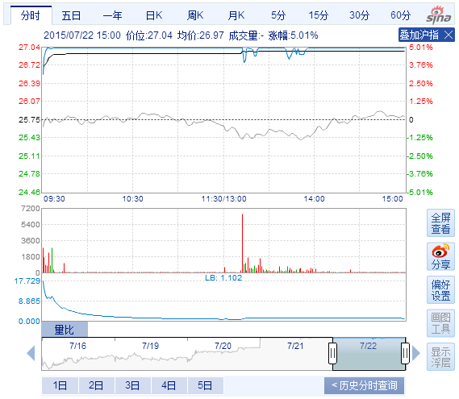

Stock info:

name: ????

code: sh600727

main inflow:415.51

main outflow:171.75

retail inflow:270.0

retail outflow:201.96

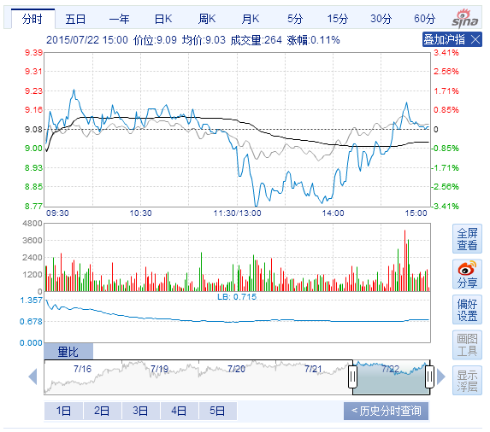

Stock info:

name: ????

code: sh600730

main inflow:12782.1

main outflow:5483.71

retail inflow:52.95

retail outflow:65.13

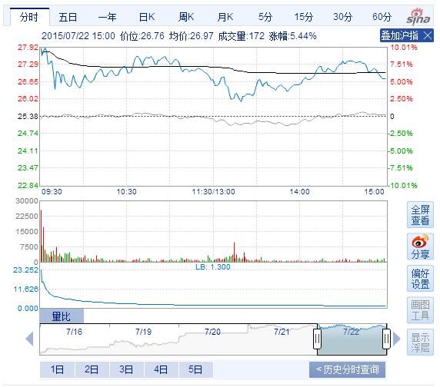

Stock info:

name: ????

code: sh600740

main inflow:527.37

main outflow:258.94

retail inflow:232.05

retail outflow:241.43

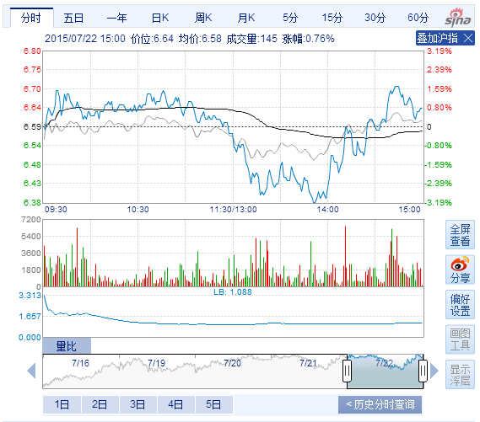

Stock info:

name: ????

code: sh600761

main inflow:220.89

main outflow:90.96

retail inflow:138.48

retail outflow:195.27

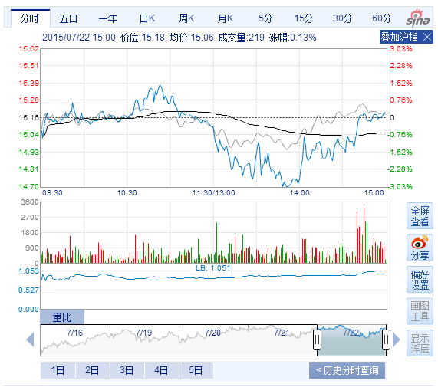

Stock info:

name: ????

code: sh600791

main inflow:360.42

main outflow:162.69

retail inflow:191.84

retail outflow:285.13

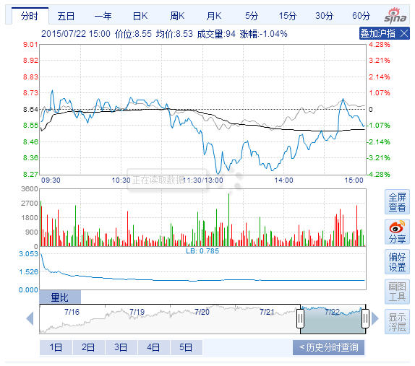

Stock info:

name: ????

code: sh600792

main inflow:316.37

main outflow:78.02

retail inflow:208.18

retail outflow:230.91

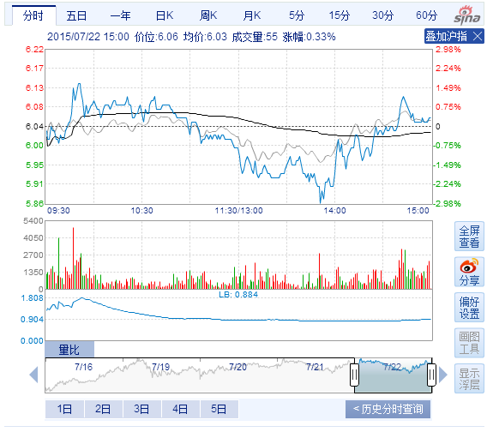

Stock info:

name: ????

code: sh600796

main inflow:910.23

main outflow:428.16

retail inflow:230.4

retail outflow:230.5

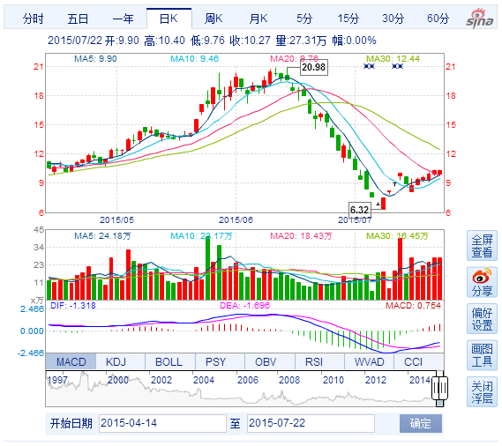

Stock info:

name: ???

code: sh600804

main inflow:1437.24

main outflow:0.0

retail inflow:118.26

retail outflow:0.0

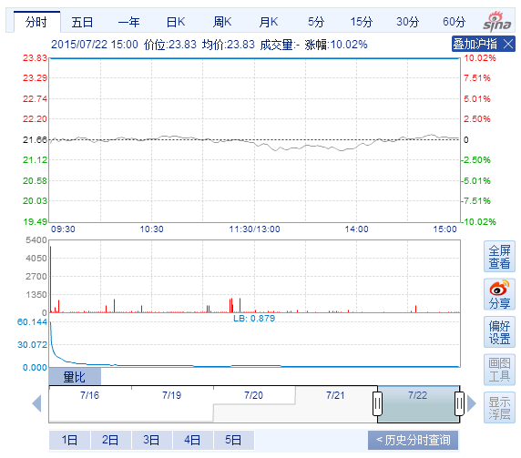

Stock info:

name: ???

code: sh600830

main inflow:1287.07

main outflow:614.19

retail inflow:205.42

retail outflow:157.18

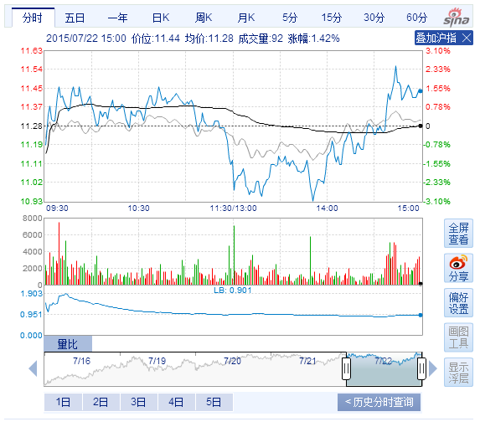

Stock info:

name: ????

code: sh600831

main inflow:1143.17

main outflow:471.79

retail inflow:237.14

retail outflow:180.49

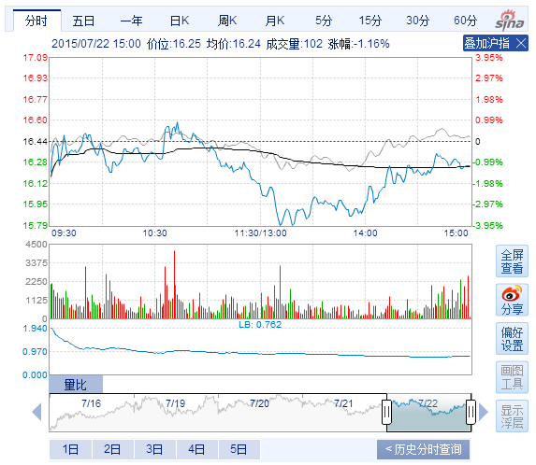

Stock info:

name: ST??

code: sh600844

main inflow:1118.85

main outflow:537.65

retail inflow:250.58

retail outflow:186.76

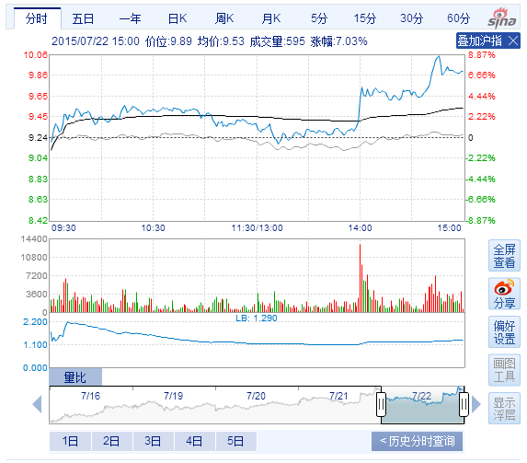

Stock info:

name: ST???

code: sh600847

main inflow:279.2

main outflow:108.48

retail inflow:163.01

retail outflow:178.38

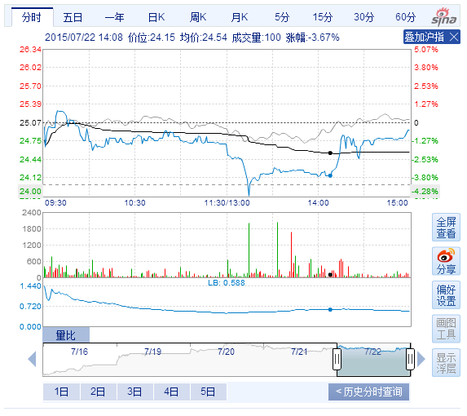

Stock info:

name: ????

code: sh600877

main inflow:1960.66

main outflow:909.93

retail inflow:282.93

retail outflow:181.93

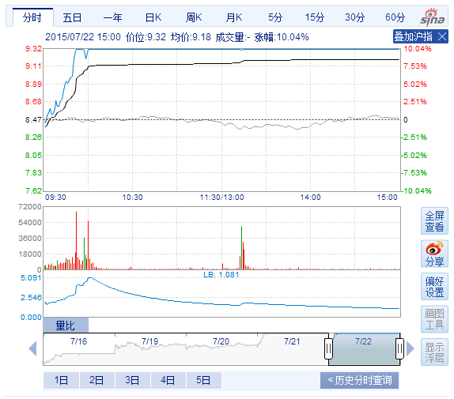

Stock info:

name: ????

code: sh600885

main inflow:78.22

main outflow:36.86

retail inflow:144.47

retail outflow:119.09

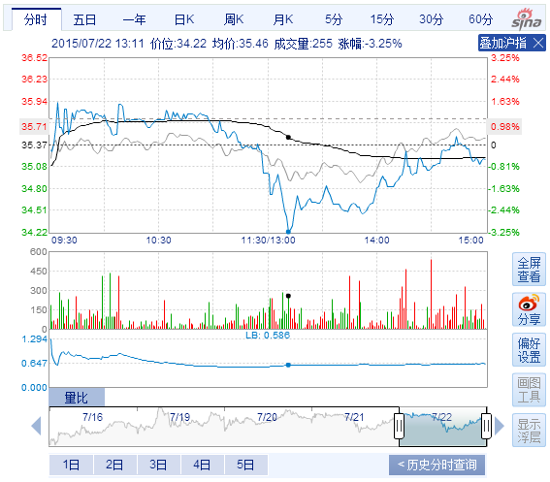

Stock info:

name: ST??

code: sh600890

main inflow:60.85

main outflow:0.0

retail inflow:22.58

retail outflow:0.0

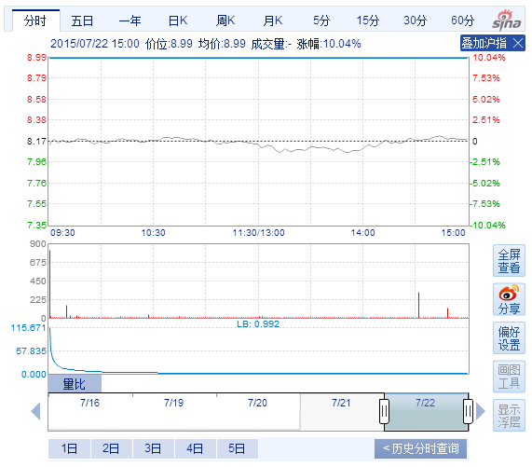

Stock info:

name: ????

code: sh600962

main inflow:2045.83

main outflow:0.0

retail inflow:173.1

retail outflow:0.0

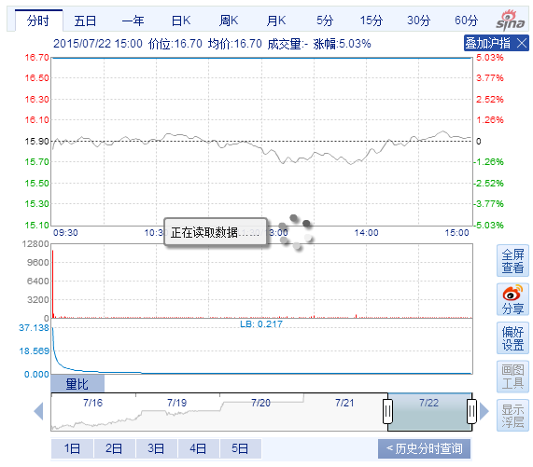

Stock info:

name: ????

code: sh600971

main inflow:209.08

main outflow:99.28

retail inflow:199.81

retail outflow:125.81

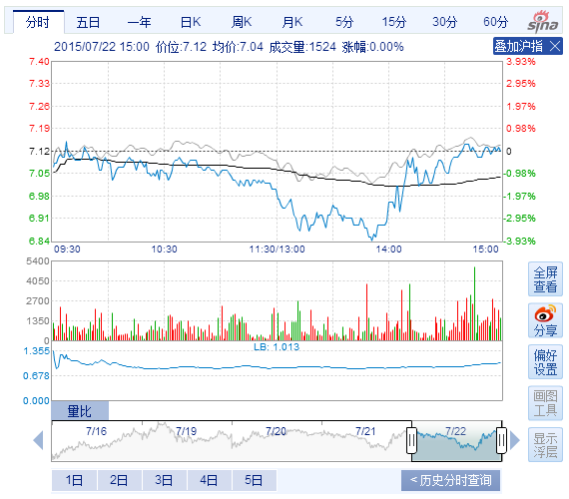

Stock info:

name: ????

code: sh600979

main inflow:956.07

main outflow:367.2

retail inflow:317.75

retail outflow:192.79

