SCARE CORE
Immersive Scream Park
Comprehensive Business Plan
Cowsland Farm, South Leverton, Retford DN22 0BY
301 acres | £30m investment | Target opening October 2028

Prepared by: Finley Murray
Founder & Artistic Director
February 2026
CONFIDENTIAL

Contents
Contents 2
1. Executive Summary 4
2. Vision & Mission 4
Vision 4
Mission 4
Core Values 5
3. The Concept 6
The Six Worlds 6
The Yard 6
Theatre Barn 7
HQ & Operations 7
4. Site & Location 9
Cowsland Farm, South Leverton 9
Why Cowsland Farm 9
5. Access & Transport 10
Road Network 10
Car Park 10
Road Crossing Solution 10
Transport Assessment 10
6. Capital Investment 12
Scare Core Ltd — £15M Breakdown 12
Immersive Core Ltd — £15M Breakdown 13
7. Revenue Model 14
Peak Season (October–December) 14
Ancillary Revenue 14
Theatre & Events (January–September) 14
5-Year Revenue Summary 14
8. Infrastructure 15
9. Governance & Leadership 16
Structure 16
Founder Transition 16
Financial Controls 16
10. Team & Recruitment 17
Permanent Staff (Year-Round) 17
Managing Director 17
Seasonal Team (October–December) 17
11. Marketing Strategy 18
Channels 18
12. Operations & Health and Safety 19
Consent-First Framework 19
Health and Safety Compliance 19
13. Key Risks & Mitigation 20
14. Financial Summary 21
15. Project Timeline 22
16. Appendices 22

1. Executive Summary
Scare Core is a £30 million immersive scream park development on a 301-acre site at Cowsland Farm, South Leverton, Retford, Nottinghamshire. The project targets a phased opening in October 2028, combining cutting-edge immersive theatre, multi-sensory horror design, and world-class production values to create the UK’s most intense and respected scare attraction.
The venture is funded through private equity, with £30 million allocated across two entities: Immersive Core Ltd (£15m, infrastructure and site) and Scare Core Ltd (£15m, attraction build and creative). The project carries no external debt.
The attraction features six themed maze barns, a central courtyard (The Yard), a dedicated Theatre Barn for year-round immersive productions, and full operational infrastructure. Conservative projections assume 1,000 nightly capacity in Year 1, growing to 1,400 by Year 5, across 24–30 operating nights per season.
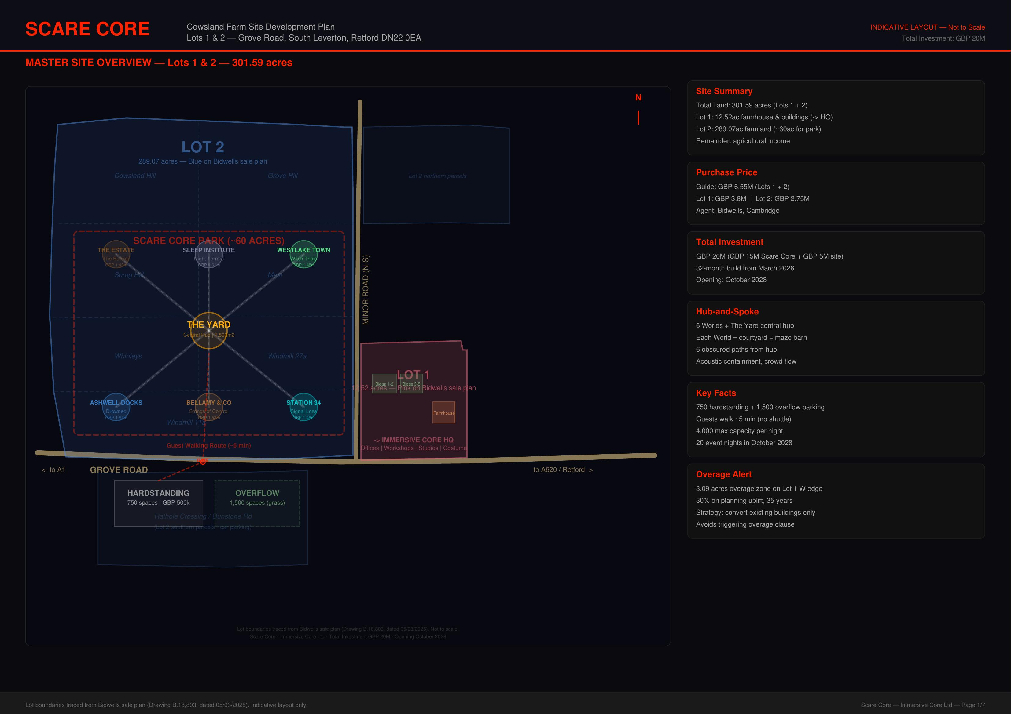
Figure 1: Cowsland Farm Master Site Overview

2. Vision & Mission

Vision
To create the UK’s most immersive and psychologically intense scare attraction, combining theatrical storytelling, cutting-edge technology, and environmental design to deliver transformative experiences that set a new industry standard.

Mission
To operate world-class immersive scare events and theatre productions that entertain, challenge, and inspire audiences while maintaining the highest standards of health, safety, consent, and pastoral care. This is not a theme park bolt-on. This is a standalone, purpose-built immersive horror venue with production values that rival West End theatre.

Core Values
- Artistic Excellence: Uncompromising creative vision and innovation
- Psychological Safety: Consent-first design; guests always in control
- Professionalism: Industry-leading H&S, training, and staff standards
- Community: Meaningful engagement with Bassetlaw and local economic benefit
- Sustainability: Year-round operations through diversified revenue streams

3. The Concept
Scare Core is not a traditional haunted house or theme park add-on. It is a highly themed, theatrical scare attraction featuring six distinct maze barns, each with its own narrative world, immersive environment, and cast of live performers.

The Six Worlds
Each maze barn occupies 8,000–12,000 sq ft and tells a self-contained horror narrative. Guests progress through themed environments with live actors, practical effects, projection mapping, spatial audio, and scent design. The six launch worlds are: The Facility, The Manor, The Carnival, The Descent, The Garden, and The Station.
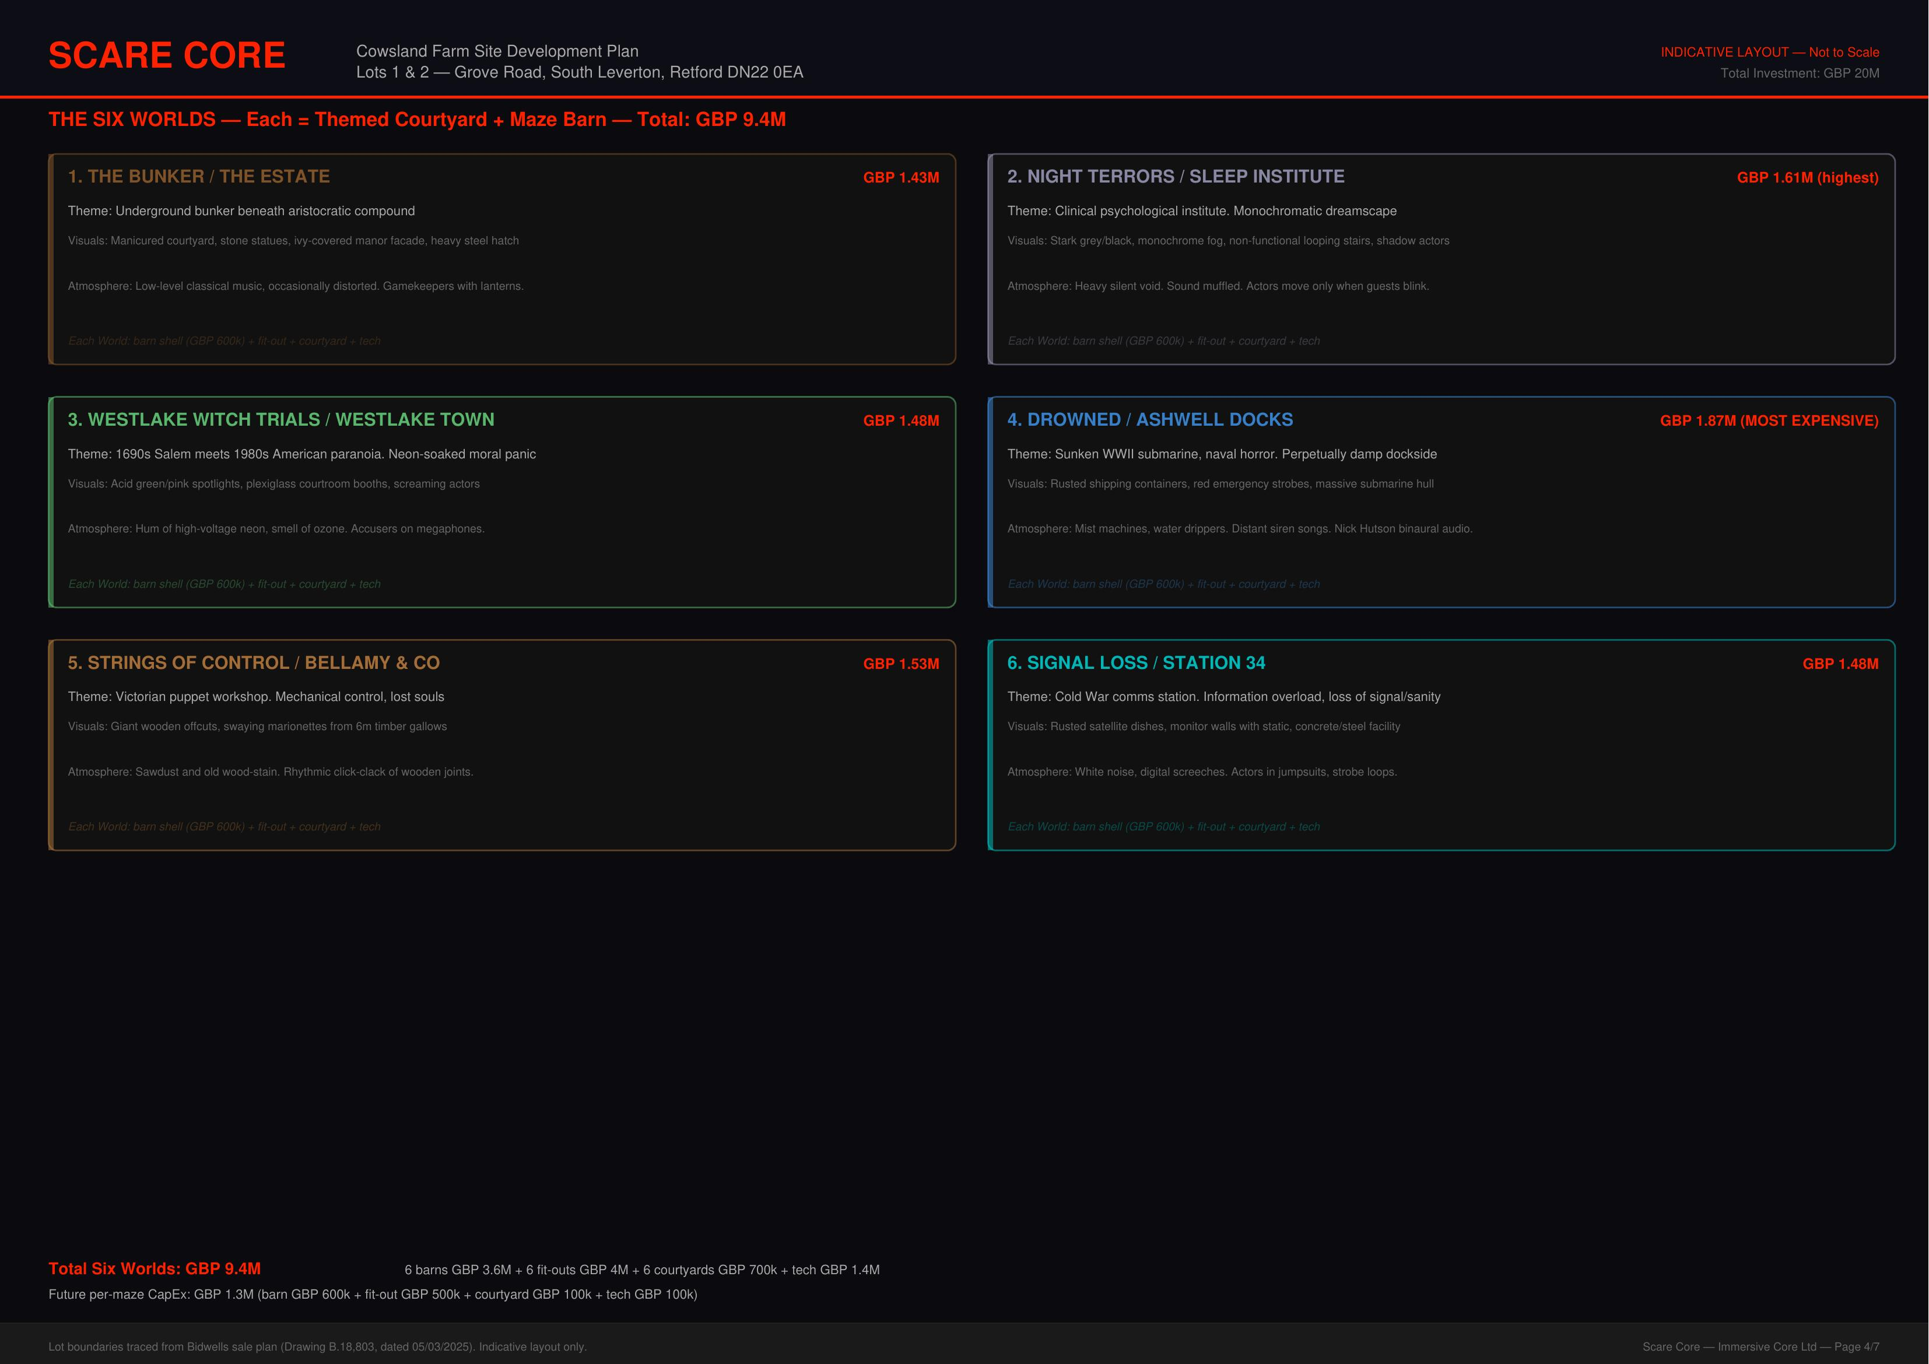
Figure 2: The Six Worlds — Maze Barn Layout

The Yard
The central courtyard serves as the heart of the guest experience. It’s where queuing becomes part of the show — roaming performers, street theatre, themed food and drink stalls, and atmospheric design create anticipation before guests enter any maze. The Yard also houses merchandise, guest services, and the main box office.
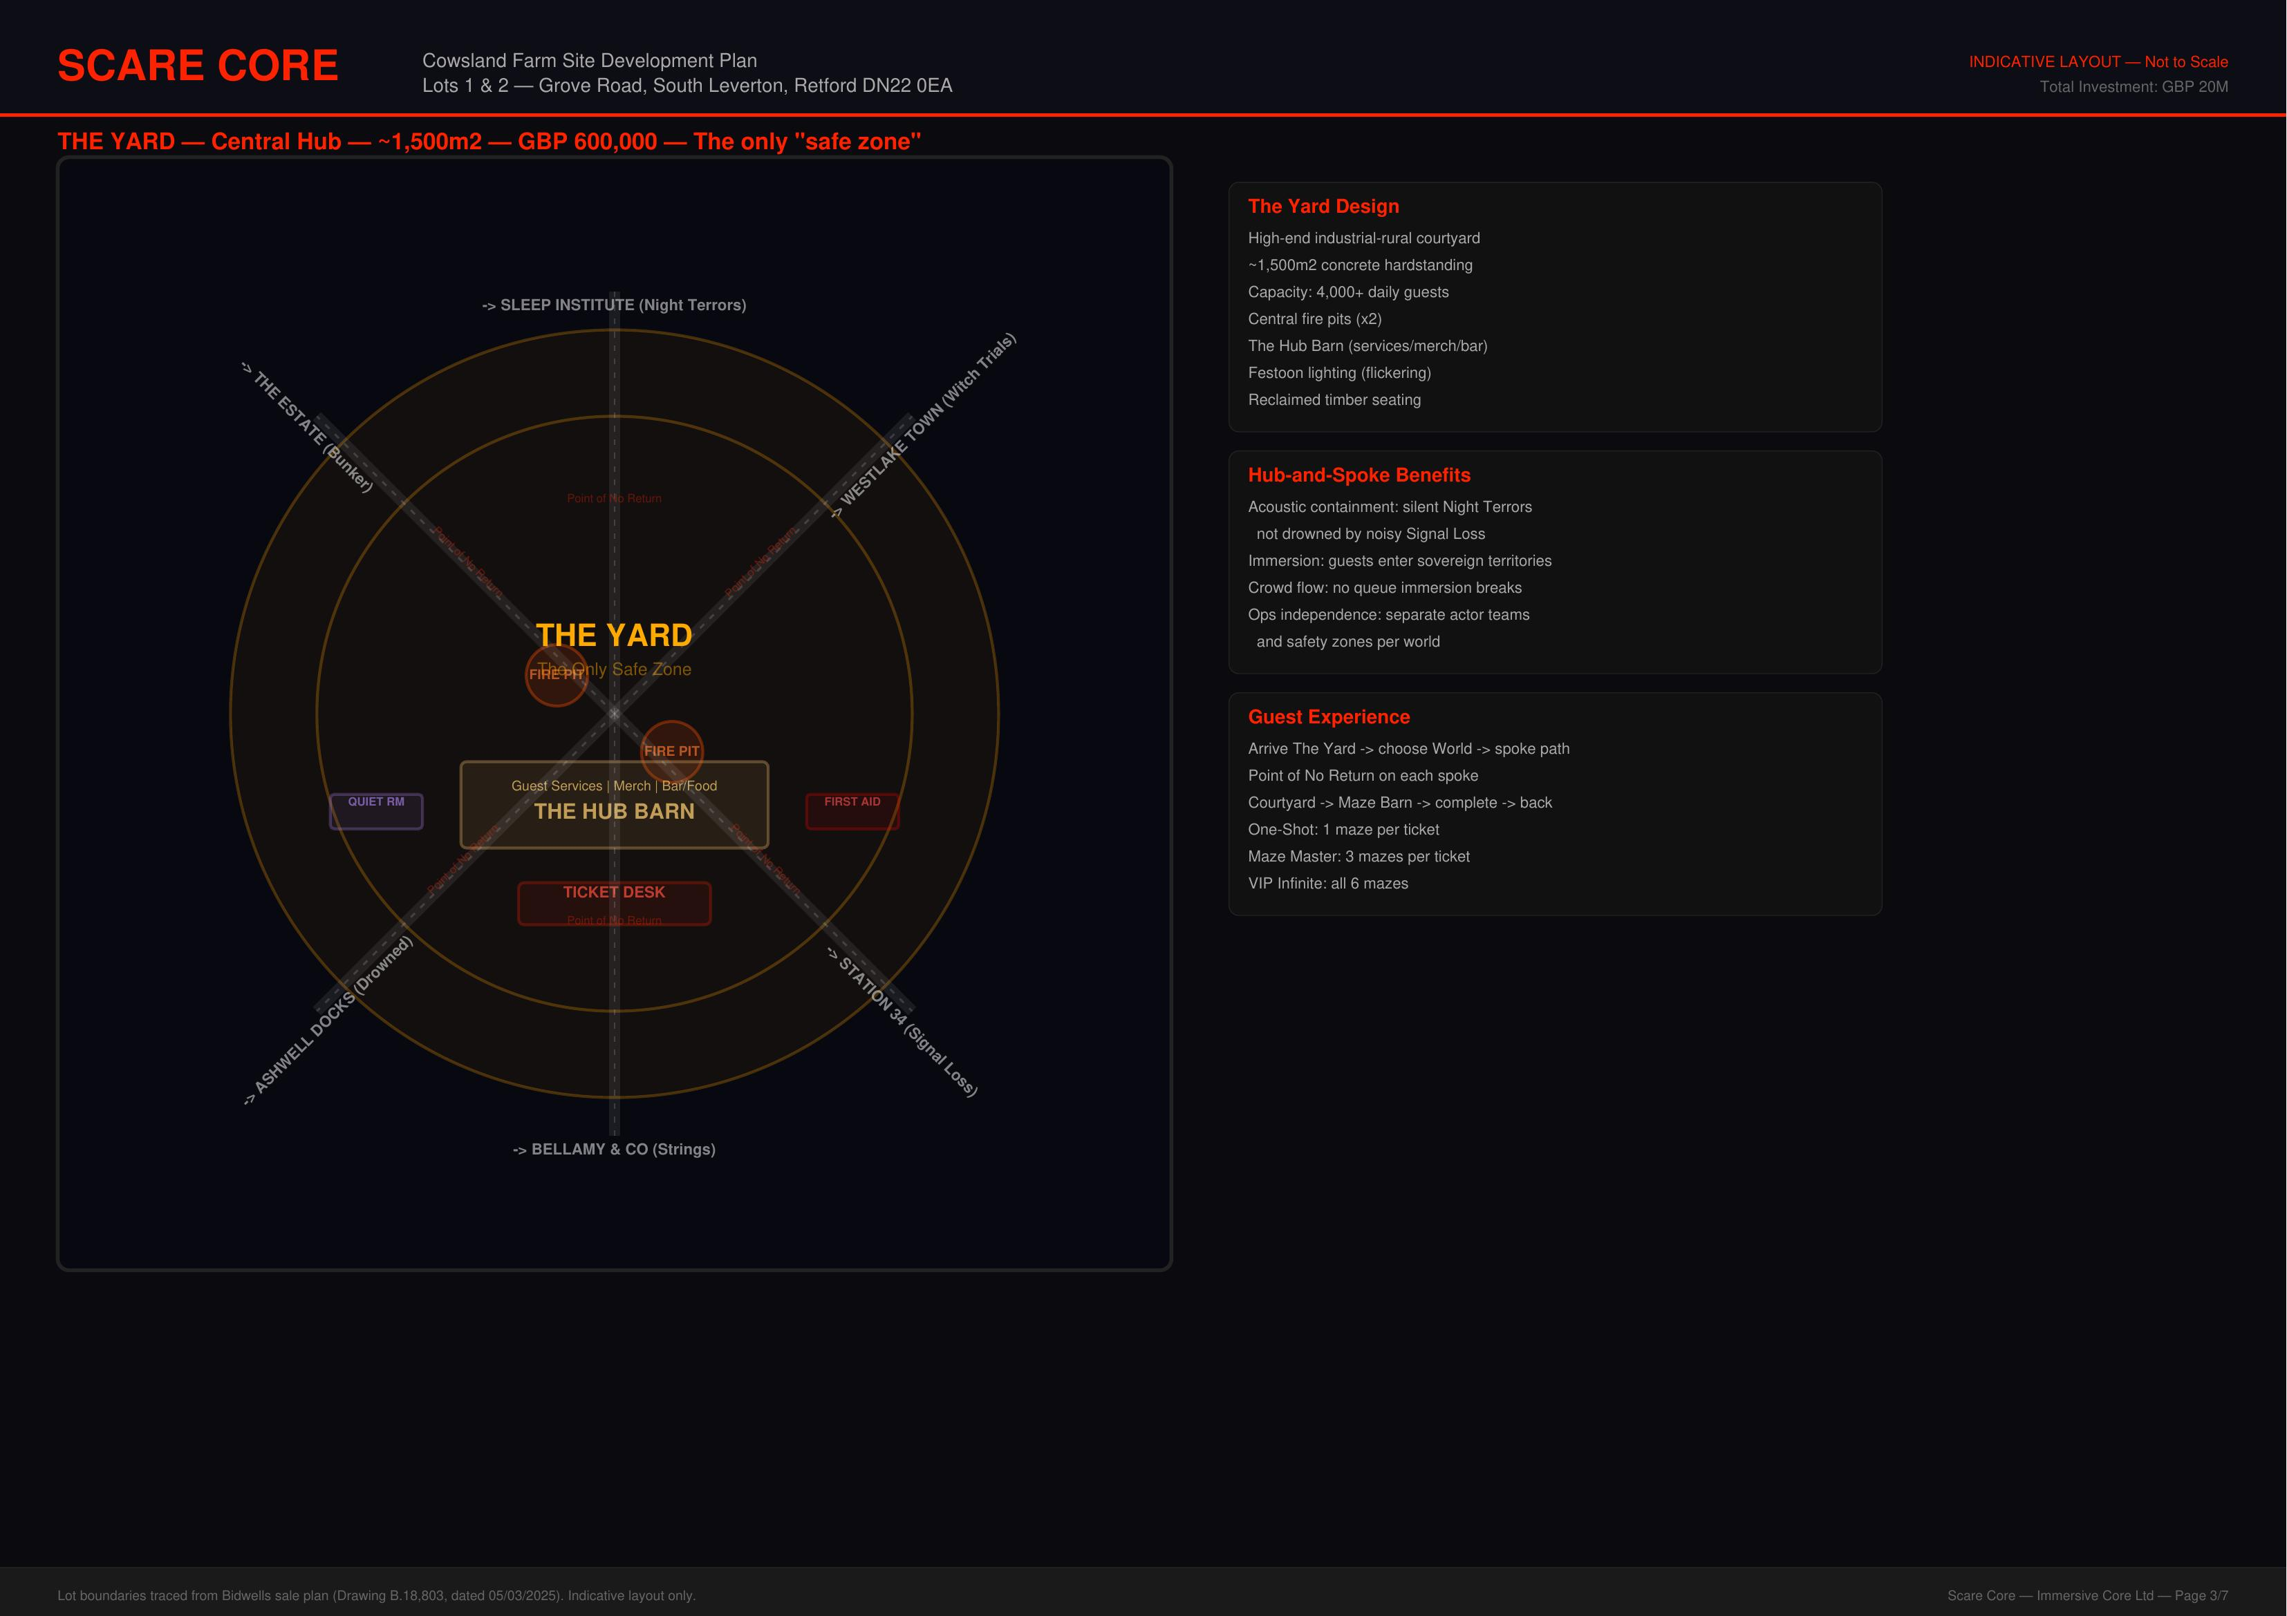
Figure 3: The Yard — Central Courtyard Design

Theatre Barn
A dedicated 3,000 sq ft performance space for year-round immersive theatre productions, running monthly residencies from January to September. This provides off-season revenue and builds the brand as a cultural venue, not just a seasonal scare attraction.

HQ & Operations
Lot 1 houses the operational headquarters: the Sector Hub (staff facilities, control room, costume and prop storage, first aid, production offices), the Farmhouse (GM/caretaker residence), and support buildings converted from existing agricultural structures.
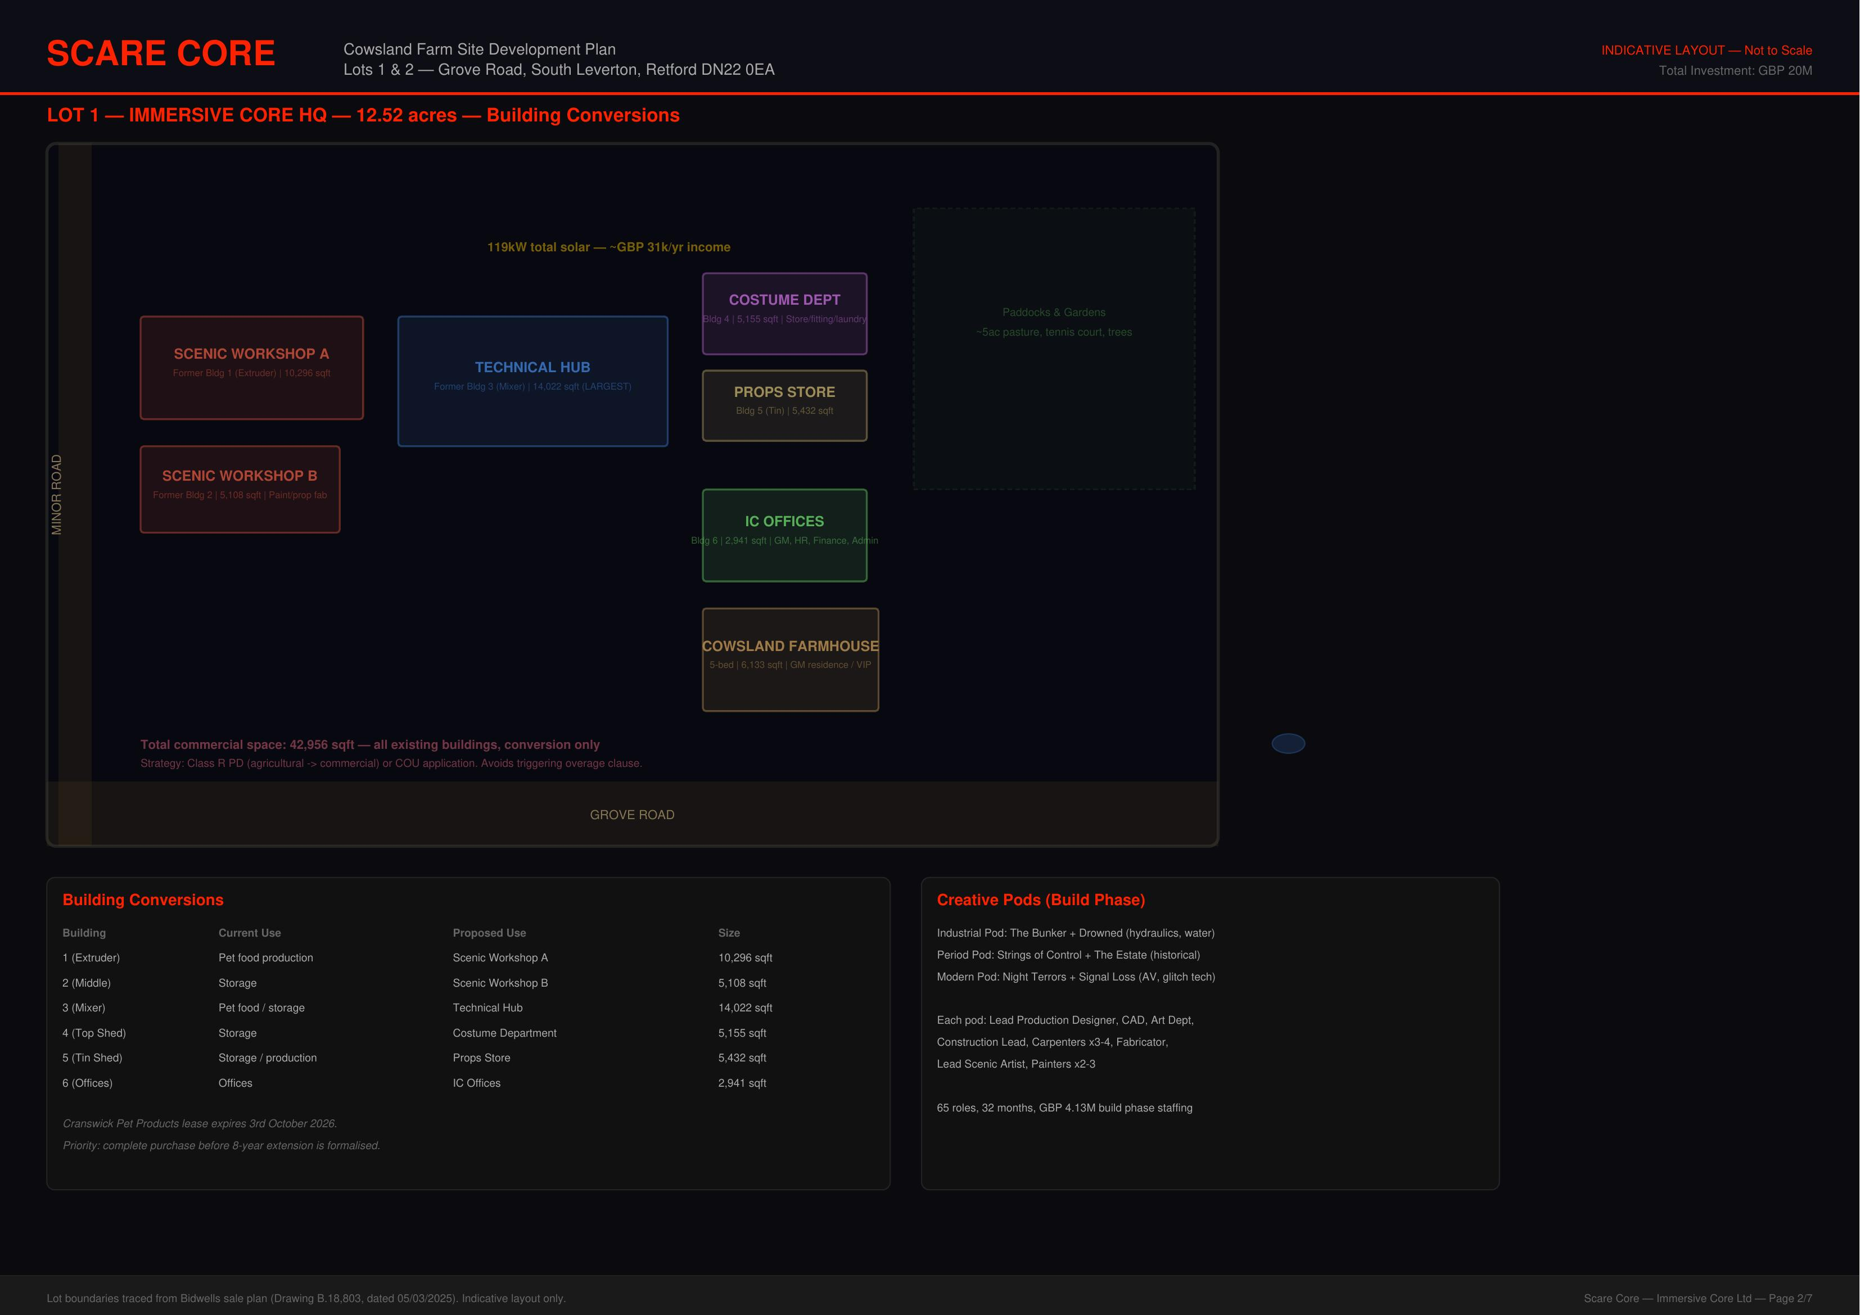
Figure 4: Lot 1 — HQ & Operations Zone

4. Site & Location

Cowsland Farm, South Leverton
The site is Cowsland Farm, a 301-acre mixed agricultural holding on the edge of South Leverton, approximately 5 miles east of Retford in North Nottinghamshire. The property is listed by Bidwells at a guide price of £6,550,000 and comprises arable land, pasture, woodland, farm buildings, and a farmhouse.
Site Detail | Specification
Address | Cowsland Farm, South Leverton, Retford DN22 0BY
Total area | 301 acres (121.8 hectares)
Guide price | £6,550,000
Land type | Arable, pasture, woodland
Existing buildings | Farmhouse, barns, grain stores, outbuildings
Road access | Grove Road (south), Retford Road (west)
Nearest A-road | A620 via Retford Road (2.5 miles)
Nearest town | Retford (5 miles)
Power infrastructure | Near former Cottam Power Station (grid connection)
Isolation | No residential neighbours within 500m of attraction zone

Why Cowsland Farm
The site was chosen for five reasons: total isolation (critical for immersive horror), existing farm buildings that reduce construction costs, a farmhouse for on-site management, 301 acres providing massive expansion potential, and proper two-lane road access via Grove Road and Retford Road to the A620.
The rural setting is the product, not a compromise. Guests arrive in darkness down unlit country roads, building anticipation from the moment they leave the A-road. This is impossible to replicate on an industrial estate or in a town centre.

5. Access & Transport
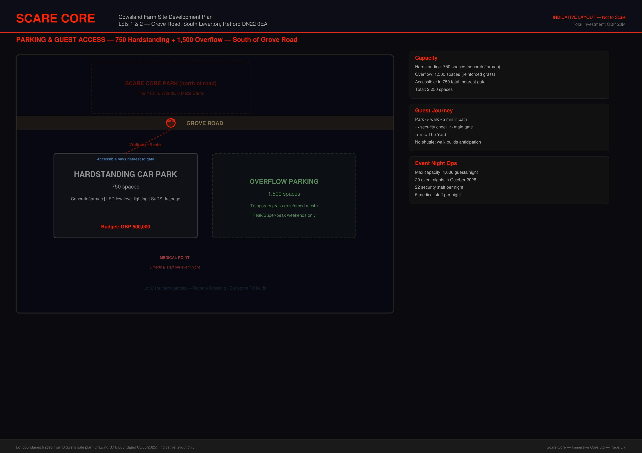
Figure 5: Parking & Access Plan

Road Network
Primary guest route: A620 → Retford Road → Grove Road → Cowsland Farm entrance. Both Grove Road and Retford Road are proper two-lane single carriageway roads with centre line markings, adequate for event traffic volumes. The road network historically served Cottam Power Station and its heavy vehicle traffic for decades.

Car Park
1,200-space compacted gravel car park with tarmac aisles, flood lighting, EV charging points, and dedicated coach parking for group bookings. Marshalled entry and exit with timed arrival slots to manage traffic flow.

Road Crossing Solution
Guests must cross Grove Road between the car park and the attraction site. The solution uses a temporary modular pedestrian bridge (hired seasonally from Beaver Bridge Hire) which becomes part of the immersive experience — an elevated crossing in darkness over the road below. A ground-level DDA-compliant crossing with temporary traffic signals provides accessible alternative access.

Transport Assessment
A full Transport Assessment will be commissioned as part of the planning application, including junction capacity modelling, traffic impact analysis, and recommended mitigation measures. Budget allows for junction improvements at the Grove Road / Retford Road junction if required.

6. Capital Investment
Total project budget: £30,000,000, funded entirely through private equity with no external debt.
Entity | Budget
Scare Core Ltd (attraction build, creative, fit-out) | £15,000,000
Immersive Core Ltd (site, infrastructure, buildings) | £15,000,000
TOTAL PROJECT INVESTMENT | £30,000,000
Source of funds | Private equity (founder-funded)
Total available capital | Confidential
Allocation to Scare Core | N/A
Debt position | Zero (fully equity-funded)

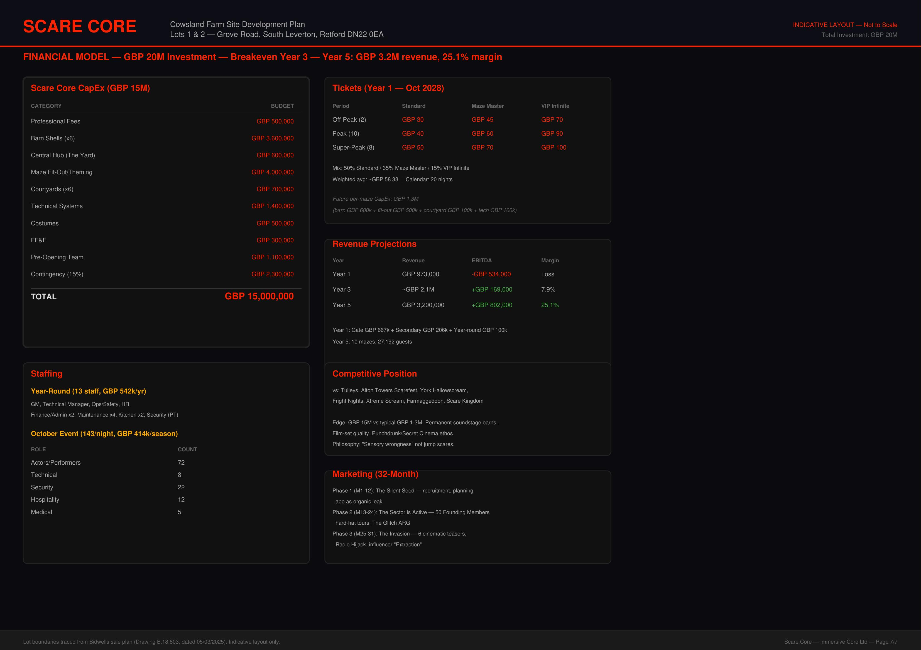
Figure 6: Costs & Revenue Overview

Scare Core Ltd — £15M Breakdown
Line Item | Budget
Professional fees (architects, QS, CDM, PM) | £500,000
Barn shells (6 maze barns + Theatre Barn) | £3,600,000
The Yard (central courtyard) | £600,000
Maze fit-out (sets, props, theming) | £4,000,000
Covered courtyards & walkways | £700,000
Tech & AV (sound, lighting, SFX, control) | £1,400,000
Costumes, props & consumables | £500,000
FF&E | £300,000
Pre-opening costs (staff, marketing, soft launch) | £1,100,000
Contingency (15%) | £2,300,000
TOTAL SC CapEx | £15,000,000

Immersive Core Ltd — £15M Breakdown
Line Item | Budget
Land purchase (Cowsland Farm, 301 acres) | £6,550,000
Legal, conveyancing & SDLT | £457,000
Planning, EIA & transport assessment | £700,000
Professional fees (PM, architect, QS, engineering, CDM) | £515,000
Earthworks & site preparation | £250,000
Drainage & flood management | £300,000
Access road upgrade | £200,000
Car park (1,200 spaces) | £1,500,000
Pedestrian bridge & DDA crossing (Year 1) | £50,000
HV power, water & sewerage | £500,000
Perimeter fencing, fire access, external lighting | £460,000
Sector Hub (operations centre) | £1,200,000
Farmhouse renovation (GM residence) | £150,000
Covered courtyard structures | £300,000
Technology & security (CCTV, IT, alarms) | £295,000
Landscaping & screening | £400,000
Contingency (10%) | £1,023,000
TOTAL IC CapEx | £14,850,000

Note: IC CapEx totals £14.85M against a £15M budget, providing £150,000 additional headroom.

7. Revenue Model

Peak Season (October–December)
Primary revenue is generated during the October–December scare season. Operating nights start at 24 in Year 1 (6 off-peak, 10 peak, 8 super-peak) and grow to 30 by Year 5 as demand builds. Maximum nightly capacity starts conservatively at 1,000 guests, rising to 1,400 by Year 5.
Ticket pricing uses a three-tier dynamic model: off-peak (weekday) at £18–25, peak (weekend/half-term) at £28–35, and super-peak (Halloween/Christmas) at £35–42. This generates a blended average of approximately £27 per ticket in Year 1.

Ancillary Revenue
Non-ticket revenue includes merchandise (£4/guest at 35% attach rate), on-site hospitality (£3/guest at 30% attach rate), and VIP/fast-track passes. Combined ancillary revenue is projected at £100–150k in Year 1, growing as brand awareness builds.

Theatre & Events (January–September)
The Theatre Barn provides year-round revenue through monthly immersive theatre residencies, corporate venue hire, and educational workshops. Off-season revenue is projected at £345k in Year 1, growing to £910k by Year 5 as the theatre programme matures and the venue gains cultural reputation.

5-Year Revenue Summary
Year | Projected Total Revenue
Year 1 (soft launch) | £645k (scare season only, no off-season Y1)
Year 2 | £1.19M
Year 3 | £1.93M
Year 4 | £2.27M
Year 5 | £2.90M

8. Infrastructure
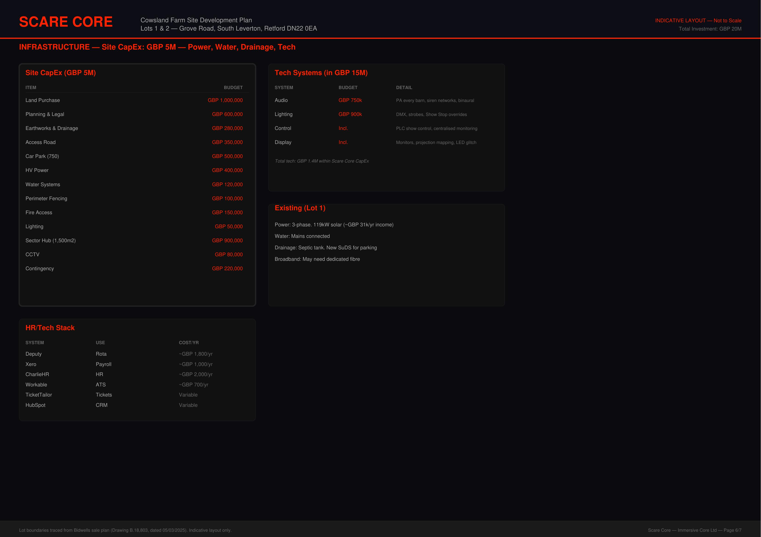
Figure 7: Infrastructure & Utilities Plan
The infrastructure plan leverages Cowsland Farm’s existing assets wherever possible. The site benefits from proximity to the former Cottam Power Station (visible from the site), which provides established grid connections that reduce HV power costs. Existing farm buildings are converted into the Sector Hub and support facilities, and the farmhouse is renovated as the GM’s residence — providing 24/7 on-site management at minimal additional cost.
Key infrastructure includes a 1,200-space car park, upgraded access from Grove Road, comprehensive drainage and flood management, perimeter security, fire access roads to all buildings, and full IT/telecoms connectivity including fibre broadband.

9. Governance & Leadership
Scare Core operates under a founder-led governance model that balances creative control with professional accountability.

Structure
- Finley Murray (Founder & Artistic Director): Creative authority and strategic vision. 100% shareholder.
- Managing Director: Day-to-day operations, P&L responsibility, team leadership. Reports to Founder.
- Finance Director: Independent financial oversight, reporting directly to Founder (not MD).
- Non-Executive Director: Independent board-level oversight and challenge.

Founder Transition
Years 1–2: 100% hands-on (creative direction, hiring, site leadership, on-site 5 days/week). Years 3–4: 60% involvement (artistic direction, key decisions, 2–3 days/week). Year 5+: 20% patron role (strategic advisor, monthly board meetings, builds external creative portfolio).

Financial Controls
Dual-approval spending: under £5k single signature (MD or FD), £5–25k dual signature, over £25k requires Founder approval. Monthly management accounts prepared by FD, reviewed by Founder and independent accountant. Annual external audit. Budget variance over 10% triggers immediate Founder notification.

10. Team & Recruitment

Permanent Staff (Year-Round)
Lean Year 1 team of 5 salaried staff plus the founder as CEO/Artistic Director. Key roles: Managing Director, Production Manager, Finance and Admin Manager, Marketing Manager, and Site Manager. Payroll processing outsourced to a bureau service. Year 1 is focused on completing the build and launching the first scare season. Theatre Programme Manager and FOH Coordinator join in Year 2 as off-season revenue streams come online. Team scales to 12 permanent staff by Year 5. Year 1 payroll: £276k (permanent staff) plus seasonal costs.

Managing Director
The MD is the most critical hire. Target profile: 10+ years in visitor attractions or live entertainment, proven CapEx build experience (£5M+), strong H&S credentials, and experience managing 100–500+ staff. Compensation package: £65–85k base salary, 20% performance bonus (EBITDA-linked), 2–5% equity/profit share, Cowsland Farmhouse accommodation (worth £15–20k/year), car allowance. Total package: £95–130k.
Recruitment channels: specialist leisure recruiters (PSD Group, Christie & Co), direct approach from Merlin Entertainments alumni, immersive theatre networks (Punchdrunk, Secret Cinema), and festival operations leaders.

Seasonal Team (October–December)
50–80 performers (actors, dancers, movement specialists) on 12-week seasonal contracts at £12–16/hour plus performance bonuses. Sourced via Stage Jobs Pro, drama schools, and social media. All undergo 2-week intensive bootcamp covering character work, movement, safety protocols, and consent training. 10–15 additional bar and hospitality staff for peak season.

11. Marketing Strategy
Target audience: experience-seeking adults aged 18–45 who value immersive entertainment and social sharing. The marketing strategy is digital-first, emphasising psychological intensity, production quality, and the consent-first safety framework.

Channels
- TikTok & Instagram: Behind-the-scenes content, performer training, guest reactions, atmospheric teasers
- YouTube: Long-form documentary content, barn walkthroughs, performer interviews
- Influencer partnerships: Micro-influencers (10–100k followers) in horror/theatre/experience niches
- Earned media: Regional press (BBC East Midlands), national entertainment and lifestyle media
- Strategic partnerships: Hotels, travel agencies, university student group rates
Marketing budget: £165k Year 1, reducing as organic brand awareness grows. Pre-opening PR campaign runs 6 months before launch with VIP preview events and press nights.

12. Operations & Health and Safety

Consent-First Framework
Every guest receives a pre-experience briefing covering intensity levels and opt-out options. A safe word protocol allows immediate exit from any experience without judgment. All performers are trained in emotional intelligence, recognising distress signals, and immediate response protocols. On-site first aid team and mental health pastoral staff are present on every operating night.

Health and Safety Compliance
Full HSE compliance with external consultant assessments and quarterly audits. Comprehensive insurance suite: public liability (£10M+), employers’ liability, property and contents, professional indemnity, and cyber/data protection cover. Site-wide risk assessments, COSHH compliance, documented emergency evacuation procedures, defibrillator, and pre-agreed police/ambulance access protocols.

13. Key Risks & Mitigation
Risk | Mitigation
Planning refusal | Pre-application consultation with Bassetlaw DC; EIA addresses environmental concerns; no residential neighbours within 500m; economic benefit case (jobs, tourism)
Cost overrun | 15% contingency on SC CapEx, 10% on IC CapEx; QS oversight; phased procurement; £150k IC headroom
Low attendance Year 1 | Conservative 65% utilisation assumption; aggressive digital marketing; VIP preview nights for influencers; timed entry slots prevent overcrowding
Road/access issues | Transport Assessment commissioned; junction improvements budgeted; timed arrival slots; pedestrian bridge for safe crossing; staggered exit management
Weather (outdoor elements) | Covered courtyards; all mazes are indoor barn structures; The Yard has covered areas; guests advised to dress for conditions
Key person risk (Founder) | Transition plan: MD handles operations from Year 3; creative documentation and process manuals; Show Captains trained to deliver rehearsals; succession planning
Seasonal revenue concentration | Theatre Barn provides Jan–Sep income; venue hire; corporate events; workshop programme diversifies revenue base
Competition | Unique positioning: no comparable scale UK scare attraction in the Midlands; production values exceed competitors; consent-first framework differentiates brand

14. Financial Summary
Full financial projections are provided in the accompanying Excel financial model (Scare_Core_Financial_Model.xlsx). Key figures:
Metric | Value
Total project investment | £30,000,000
Year 1 revenue (conservative) | £645k (scare season only, no off-season Y1)
Year 1 EBITDA | (£709k) operating loss
Breakeven | Year 4
Year 5 revenue | £2.90M
Year 5 EBITDA | £599k profit
Year 5 cumulative EBITDA | (£590k) cumulative loss, reducing year-on-year
Annual expansion CapEx (Y2+) | £1.3M (1 new maze/year)

Scenario Analysis
The financial model includes a full scenario analysis testing base, downside and upside cases across a 10-year horizon. In the downside scenario (20% lower utilisation, fewer operating nights, slower off-season ramp), the business still reaches EBITDA breakeven in Year 5 and cumulative positive in Year 8, with a 10-year cumulative EBITDA of £850k. In the upside scenario (higher pricing at £30 blended, 92% utilisation, faster theatre growth), breakeven arrives in Year 3 and 10-year cumulative EBITDA reaches £9.8M. Even the downside supports an enterprise value of £4.2M at 8x Year 10 EBITDA. A pricing sensitivity table demonstrates that a £3 increase in base ticket price pulls the cumulative positive point forward by a full year. The base case generates nearly £5M cumulative EBITDA over 10 years.

Cash Flow and Seasonal Funding
A quarterly cash flow statement is included in the financial model, breaking down 20 quarters across the five-year period. This reveals the seasonal funding pattern typical of October-focused attractions: scare revenue concentrates in Q4 while operating costs are spread year-round. The business maintains positive cash reserves through Year 2 (ending Q4Y2 at £448k), but enters a seasonal deficit in Q1 of Year 3 as accumulated operating losses outpace the working capital reserve. The maximum quarterly deficit is £728k in Q3 of Year 4, recovering to a positive £202k position by Q4 of Year 5. This seasonal gap will be managed through a revolving overdraft facility of approximately £750k, secured against the founder’s personal assets. Off-season revenue growth progressively reduces the seasonal deficit over time.

Strategic Intent
This is a long-term asset development backed by genuine commercial potential. The first four years represent a brand-building phase with operating losses funded by a £2M working capital reserve built into the £32M budget. The maximum cumulative EBITDA loss peaks at £1.39M in Year 3, within the £2M reserve, leaving £606k of headroom. Quarterly cash flow modelling identifies a seasonal funding gap of up to £728k in Q3 of Year 4, managed through a revolving overdraft facility secured against the founder’s personal assets. EBITDA turns positive in Year 4 at £206k, reaching £599k by Year 5 (20.6% margin). Cumulative EBITDA turns positive in Year 6 and reaches £4.99M by Year 10. Off-season revenue phases in from Year 2 and grows to £1.70M by Year 10, representing over 40% of total annual turnover.

10-Year Financial Outlook
The financial model extends to a full 10-year horizon. Revenue grows from £645k in Year 1 to £4.07M by Year 10, driven by scare season capacity growth (1,000 to 1,500 nightly), ticket price maturation (£27 to £42 blended average), and off-season revenue scaling to £1.70M. EBITDA margin improves from negative 110% in Year 1 to 33.4% by Year 10, reflecting operational leverage as fixed costs are spread across growing revenue. Year 10 EBITDA reaches £1.36M. Expansion CapEx slows from annual (Years 2 to 6) to biennial (Years 6 to 10), reducing capital intensity as the maze portfolio matures at 10 or more structures.

Asset Value and Balance Sheet
The financial model includes a full balance sheet tracking asset values across the 10-year period. The £32M investment creates a permanent asset base comprising 301 acres of freehold land (£6.55M, no depreciation), £7.2M of converted buildings depreciated over 25 years, £1.16M of infrastructure depreciated over 20 years, £4.35M of creative and technical assets depreciated over 7 years, £2.6M of IP and brand assets amortised over 10 years, and cumulative expansion CapEx depreciated over 10 years. Net asset value starts at £27.0M in Year 1 and stabilises at £23.0M by Year 10, reflecting depreciation offset by accumulated retained earnings and expansion investment. The land alone, at agricultural values of £11,000 per acre, is worth £3.3M. With leisure planning consent, that figure could reasonably exceed £7.5M. Even in a liquidation scenario, the floor value of land plus 50% of building and infrastructure cost is approximately £10.7M, representing a third of the total investment. This is not a vanity project that burns to zero. It is a real estate development with an operating business attached.

Enterprise Value and Return on Investment
At Year 10 EBITDA of £1.36M, applying sector-typical multiples of 6x to 12x yields an enterprise value range of £8.2M to £16.3M. At 8x, the enterprise value is £10.9M. Combined with the net asset value of £23M, the total value of the business at Year 10 comfortably exceeds the original investment. The 10-year cumulative EBITDA of £4.99M means the business generates meaningful cash returns on top of the asset base. Cumulative free cash flow (EBITDA less expansion CapEx) totals approximately £1.1M over the period. The return is not principally a cash-on-cash play. It is a value creation exercise: transforming agricultural land into a high-specification leisure asset with a growing income stream, proprietary IP, and significant expansion potential across the remaining 250 or more acres.

15. Project Timeline
Phase | Timeline
Land acquisition (Cowsland Farm) | Q2 2026
Planning application submission | Q3 2026
Planning determination | Q1 2027
Construction mobilisation | Q2 2027
Infrastructure build (roads, car park, utilities) | Q2–Q4 2027
Barn construction & Sector Hub | Q3 2027 – Q2 2028
Maze fit-out & theming | Q1–Q3 2028
Tech & AV installation | Q2–Q3 2028
Staff recruitment & training | Q1–Q3 2028
Soft launch / preview nights | September 2028
GRAND OPENING | October 2028

16. Appendices
A. Detailed Financial Model (Excel spreadsheet)
B. Cowsland Farm Site Plans (7-page A3 PDF)
C. Bidwells Estate Sale Brochure
D. Health and Safety Risk Assessment (to be commissioned)
E. Transport Assessment (to be commissioned)
F. Environmental Impact Assessment (to be commissioned)

