**CS3003001**

**Group 7 Team Member Names:**

Ashley Finn (finnac)

Jacob Costello (costeljt)

Triet Pham (phamt7)

*We couldn’t contact our 4th member until everything was finished so we decided to complete the project as a group of 3 and the 4th person will complete his own individual work.*

**ASSIGNMENT 6**

**Project Overview**

We decided to create the producer/consumer model for the PlayStation5 product. All producers will be providing products to a single warehouse and all consumers will be taking the products from that warehouse. There is no access restriction so everyone can access it anytime. The warehouse will be implemented as a stack data structure.

The code will be written in python.

**Project Responsibilities**

Ashley Finn: PM, Dev Ops, QA, Presentation. Organizing the video presentation, the word document deliverable, setting up the Github repository, doing QA work and communicating/organizing the dev work

Triet Pham: Dev. Created Producer, ItemQueue Classes and their implementations. Worked on Main to help create the thread environment.

Jacob Costello: Dev. Created PS5, Consumer Classes and their implementations. Worked on Main to help create the thread environment.

**Github Repository:** (will link at the very end, I think google doesn’t like github link??)

**Screen Snip:** An output example with 2 producers and 3 consumers:

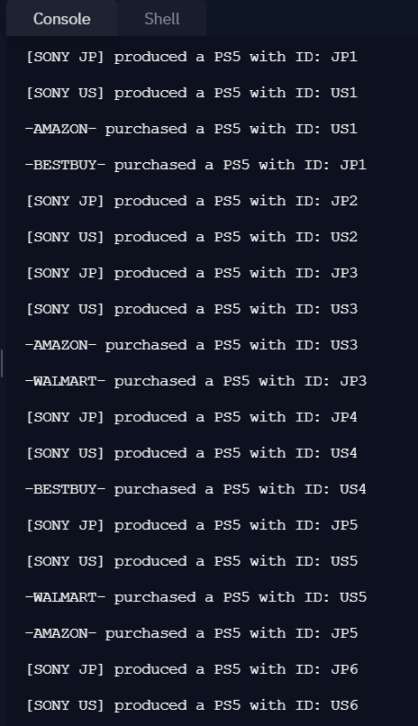

**Youtube Link:** <https://youtu.be/gdvhlN0BBWc>