Task2
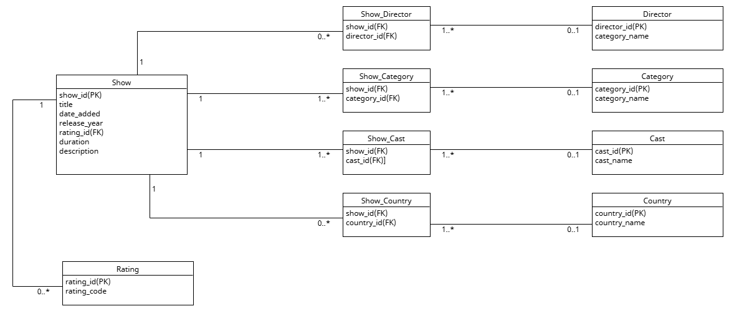

Rating
• rating_id VARCHAR(10) PRIMARY KEY
• rating_code VARCHAR(10) NOT NULL

Director
• director_id VARCHAR(10) PRIMARY KEY
• director_name VARCHAR(150) NOT NULL

Cast
• cast_id VARCHAR(10) PRIMARY KEY
• cast_name VARCHAR(150) NOT NULL

Country
• country_id VARCHAR(10) PRIMARY KEY
• country_name VARCHAR(100) NOT NULL

Category
• category_id VARCHAR(10) PRIMARY KEY
• category_name VARCHAR(100) NOT NULL

Show
• show_id VARCHAR(20) PRIMARY KEY
• type ENUM('Movie', 'TV Show') NOT NULL
• title VARCHAR(200) NOT NULL
• date_added DATE
• release_year INT
• rating_id VARCHAR(10)
• duration VARCHAR(50)
• description TEXT

Show_Director
• show_id VARCHAR(20)
• director_id VARCHAR(10)

Show_Cast
• show_id VARCHAR(20)
• cast_id VARCHAR(10)
• listed_order INT

Show_Country
• show_id VARCHAR(20)
• country_id VARCHAR(10)

Show_Category
• show_id VARCHAR(20)
• category_id VARCHAR(10)

Task3

CREATE TABLE Rating (
rating_id VARCHAR(10) PRIMARY KEY,
rating_code VARCHAR(10) NOT NULL,
description VARCHAR(200)
);

CREATE TABLE Director (
director_id VARCHAR(10) PRIMARY KEY,
director_name VARCHAR(150) NOT NULL
);

CREATE TABLE Cast (
cast_id VARCHAR(10) PRIMARY KEY,
cast_name VARCHAR(150) NOT NULL
);

CREATE TABLE Country (
country_id VARCHAR(10) PRIMARY KEY,
country_name VARCHAR(100) NOT NULL
);

CREATE TABLE Category (
category_id VARCHAR(10) PRIMARY KEY,
category_name VARCHAR(100) NOT NULL
);

CREATE TABLE Show (
show_id VARCHAR(20) PRIMARY KEY,
type ENUM('Movie', 'TV Show') NOT NULL,
title VARCHAR(200) NOT NULL,
date_added DATE,
release_year INT,
rating_id VARCHAR(10),
duration VARCHAR(50),
description TEXT,
CONSTRAINT fk_show_rating
FOREIGN KEY (rating_id) REFERENCES Rating(rating_id)
);

CREATE TABLE Show_Director (
show_id VARCHAR(20) NOT NULL,
director_id VARCHAR(10) NOT NULL,
PRIMARY KEY (show_id, director_id),
CONSTRAINT fk_sd_show FOREIGN KEY (show_id) REFERENCES Show(show_id),
CONSTRAINT fk_sd_director FOREIGN KEY (director_id) REFERENCES Director(director_id)
);

CREATE TABLE Show_Cast (
show_id VARCHAR(20) NOT NULL,
cast_id VARCHAR(10) NOT NULL,
listed_order INT,
PRIMARY KEY (show_id, cast_id),
CONSTRAINT fk_sc_show FOREIGN KEY (show_id) REFERENCES Show(show_id),
CONSTRAINT fk_sc_cast FOREIGN KEY (cast_id) REFERENCES Cast(cast_id)
);

CREATE TABLE Show_Country (
show_id VARCHAR(20) NOT NULL,
country_id VARCHAR(10) NOT NULL,
PRIMARY KEY (show_id, country_id),
CONSTRAINT fk_sco_show FOREIGN KEY (show_id) REFERENCES Show(show_id),
CONSTRAINT fk_sco_country FOREIGN KEY (country_id) REFERENCES Country(country_id)
);

CREATE TABLE Show_Category (
show_id VARCHAR(20) NOT NULL,
category_id VARCHAR(10) NOT NULL,
PRIMARY KEY (show_id, category_id),
CONSTRAINT fk_scat_show FOREIGN KEY (show_id) REFERENCES Show(show_id),
CONSTRAINT fk_scat_category FOREIGN KEY (category_id) REFERENCES Category(category_id)
);

Task4
INSERT INTO Rating VALUES
('R1', 'Mature Audience'),
('R2', 'Parents Strongly Cautioned'),
('R3', 'Parents Strongly Cautioned'),
('R4', 'Older Children'),
('R5', 'All Ages');

INSERT INTO Director VALUES
('D1', 'Kirsten Johnson'),
('D2', 'Julien Leclercq'),
('D3', 'Nosipho Dumisa'),
('D4', 'Theodore Melfi'),
('D5', Raghav Subbu');

INSERT INTO Cast VALUES
('C1', 'Ama Qamata'),
('C2', 'Khosi Ngema'),
('C3', 'Gail Mabalane'),
('C4', 'Melissa McCarthy'),
('C5', 'Mayur More');

INSERT INTO Country VALUES
('CT1', 'United States'),
('CT2', 'South Africa'),
('CT3', 'France'),
('CT4', 'India'),
('CT5', 'Canada');

INSERT INTO Category VALUES
('G1', 'Documentaries'),
('G2', 'International TV Shows'),
('G3', 'TV Dramas'),
('G4', 'Crime TV Shows'),
('G5', 'Comedies');

INSERT INTO Show VALUES
('s1', 'Movie', 'Dick Johnson Is Dead'),
('s2', 'TV Show', 'Blood & Water'),
('s3', 'TV Show', 'Ganglands'),
('s4', 'Movie', 'The Starling'),
('s5', 'TV Show', 'Kota Factory');

INSERT INTO Show_Director VALUES
('s1', 'D1'),
('s2', 'D3'),
('s3', 'D2'),
('s4', 'D4'),
('s5', 'D5');

INSERT INTO Show_Cast VALUES
('s2', 'C1'),
('s2', 'C2'),
('s2', 'C3'),
('s4', 'C4'),
('s5', 'C5');

INSERT INTO Show_Country VALUES
('s1', 'CT1'),
('s2', 'CT2'),
('s3', 'CT3'),
('s4', 'CT1'),
('s5', 'CT4');

INSERT INTO Show_Category VALUES
('s1', 'G1'),
('s2', 'G2'),
('s3', 'G4'),
('s4', 'G5'),
('s5', 'G2');

INSERT INTO Show (show_id, type, title, date_added, release_year, rating_id, duration, description) VALUES
('s1', 'Movie', 'Dick Johnson Is Dead', '2021-09-25', 2020, 1, '90 min', 'As her father nears the end of his life, filmmaker Kirsten Johnson stages his death in inventive ways.'),
('s2', 'TV Show', 'Blood & Water', '2021-09-24', 2021, 2, '2 Seasons', 'After crossing paths at a party, a Cape Town teen sets out to prove whether a private-school student is her sister.'),
('s5', 'TV Show', 'Kota Factory,' '2021-09-24, 2021,'2Seasons",In a city of coaching centers known to train Indiaâ€™s finest collegiate minds, an earnest but unexceptional student and his friends navigate campus life.),
('s3', 'TV Show','Ganglands', '2021-09-21', 2021, ' 1 Season', 'To protect his family from a powerful drug lord, skilled thief Mehdi and his expert team of robbers are pulled into a violent and deadly turf war.),
('s10', Moive', 'The Starling','2021-09-24', '104 min', 'A woman adjusting to life after a loss contends with a feisty bird that's taken over her garden â€” and a husband who's struggling to find a way forward.)

