


Using Google Reviews to Identify Healthcare Access Barriers in Germany: Insights Relevant to Refugees and Migrants

Hausarbeit
zur Erlangung des akademischen Grades „Master of Science (M.Sc.)“ im Studiengang Wirtschaftsingenieur der Fakultät für Elektrotechnik und Informatik, Fakultät für Maschinenbau und der Wirtschaftswissenschaftlichen Fakultät der Leibniz Universität Hannover

vorgelegt von

Name: Borchers Vorname: Finn
Geb. am: 07.09.2000 in: Langenhagen

Matrikelnummer: 10035703 Fachsemester: 6

Adresse: Nikolaistraße 5, 30159 Hannover

Prüfer: Prof. Dr. Michael H. Breitner
Betreuerin: M.Sc. Fenja Schulte
Hannover, den 20.05.2026
Abstract
Existing healthcare data often fail to capture lived, publicly articulated, and experience-based barriers to care. This paper examines whether Google Reviews of hospitals can serve as a complementary digital data source for identifying access, communication, and service-related barriers in the German healthcare system, with particular relevance for migrant-sensitive healthcare. ….

Keywords: …

Table of Contents
List of Figures i
List of Tables i
List of Abbreviations i
List of Appendixes ii
Research Summary iii
1. Introduction 1
1.1 Motivation 1
1.2 Research Gap 2
1.3 Research Need 4
1.4 Research Question 6
1.5 Aim and Structure of this Thesis 6
2. Theoretical Background 9
2.1 Technical Background 9
2.1.1 Foundations of Artificial Intelligence 9
2.1.2 Machine Learning Paradigms 10
2.1.3 Machine Learning Algorithms 11
2.1.4 Deep Learning and Neural Architectures 12
2.1.5 Generative AI and Large Language Models 13
2.1.6 Prompt Engineering and Structured Output 13
2.1.7 Speech Technologies in AI 14
2.2 Medical Background 16
3. Research Design 22
3.1 Design Science Research (DSR) 22
3.2 Step-by-Step Application of the DSR Framework 23
3.3 Literature Review Strategy 27
3.4 Modular Artifact Development 31
3.5 Ethical Considerations 33
3.6 Evaluation Strategy 35
4. Results and Findings 37
4.1 Literature Results 37
4.2 Ethical Considerations 52
4.3 LeA-AI App: Development Process and Technical Evolution 53
4.3.1 Platform Refactoring: Using a Cloud-Native Framework 54
4.3.2 Real-Time Speech-to-Speech Interface 55
4.3.3 Behavior Experiments and Homework Planning 55
4.3.4 Therapeutic Dialogue Management 55
4.4 The Final LeA-AI Artefact 57
5. Discussion and Implications 68
6. Limitations and Further Research 77
7. Conclusion 82
8. Acknowledgements 84
9. References 85
10. Appendix 96
11. Declaration of Honor 107

List of Figures

Figure 1: Overview of AI-supported Mental Health Apps in Psychocardiology 7
Figure 2: Application of DSR to the development of LeA-AI 24
Figure 3: Connected papers results graph for selecting Chiu (2024) 28
Figure 4: Chat interface of LeA-AI 57
Figure 5: Content/Modules interface of LeA-AI 58
Figure 6: Module Details page of LeA-AI 59
Figure 7: Video step page of LeA-AI 60
Figure 8: Homework page of LeA-AI 61
Figure 9: Homework Details page of LeA-AI 62
Figure 10: Settings page of LeA-AI 63
Figure 11: Dashboard of LeA-AI 64
Figure 12: Dashboard showing module structure of LeA-AI 65
Figure 13: Dashboard showing module details of LeA-AI 66

List of Tables

Table 1: Overview of Literature 30
Table 2: "Overview of Chatbots, Applications, and Wearables", based on Pavlopoulos et al. (2024) 49

List of Abbreviations

“AI”: Artificial Intelligence
“ML”: Machine Learning
…

List of Appendixes

Appendix 1: Chat-Viewmodel in the Dart Programming Language 105
Appendix 2: LeA-AI Prompt 106

Research Summary

The increasing global …

The central question is as follows:

“What barriers to healthcare access for refugees and migrants in Germany are identified in the literature, and how can these barriers be structured into a coherent framework?“

The overarching aim of this thesis is to examine how …

This study adopts a Design Science Research (DSR) approach, e…

Theoretical Background
Artificial Intelligence …

Research Design
To address the c…

Literature Review
The current state of r…

Discussion & Implications
The integration o…

Limitations & Further Research
Despite ….

Conclusion
AI has …

1. Introduction

1.1 Motivation
Deutschland als relevanter Kontext von Migration und Flucht (100 Mio. Menschen auf der Flucht weltweit, DE unter den Top 5 Zufluchtsländern, …)

psychische Belastung und Zugangsprobleme (Höhe Prävalenz von Depressionen, PTBS, Anxiety), Es gibt beim Einreisen Tests für Infektiöse Krankheiten, aber nicht pdsychische krankheiten…

Stigmatisierung, Unwissen bzgl. Versorgungslage (wo bekomme ich hilfe, wie, was kostet das?) sprachliche hürden, wenig deutsch kenntnisse

Online informationen, social media als informationsquelle -> potentiell interessant für das identifizieren von versorgunslücken, hürden, problemen, herausforderungen

- Social media und daten alsa grundlage für das bessere verständnis bzgl. gesundheitsversorgung

1.2 Research Gap
Was ist die lücke? Es gibt paper bzgl. … social meedia nutzung, auswertung von reddit, X, andere platformen, google reviews in den usa

Datenlücken in deutschland sind groß in bezug auf migration im speziellen

Wenig erforscht: Spezielle forschung um eine vulnerable gruppe: Migranten in deutschland, mithilfe von internetdaten, die öffentlich zugänglich sind (Google reviews)

Migrationsbezogene daten häufig nicht systematisch erfasst

1.3 Research Need
Probleme werden nicht aufgezeigt, nicht systematisch genug, und deswegen….

Daten sammeln, systematisch, auswerten, …

Versorgungslücken in der gesundheitsversorgung in DE besser verstehen

1.4 Research Question
Building on the urgent public health need and the technological potential outlined above, this thesis seeks to investigate how structured data analysis of Google reviews… can serve this need… .
Given the high prevalence of … and mental health disorders, and the current lack of targeted, scalable solutions for this complex … group, the central research aim is to explore the ….

To structure this investigation, the following guiding research question is proposed:

Primary Research Question (RQ1):
“How can Google Reviews of hospitals be used as a complementary data source to identify healthcare access barriers in Germany, particularly barriers relevant to migrant-sensitive care?”

Secondary Research Question (RQ2):
“How can AI be leveraged to gain deeper, more detailed insights in barriers across the health care system in Germany?”

This question aims to bridge the interdisciplinary gap between … By doing so, this thesis will contribute to a deeper understanding of how intelligent technologies can be purposefully designed and responsibly integrated to address one of the most pressing and under-served challenges in contemporary healthcare.

1.5 Aim and Structure of this Thesis
This thesis investigates how …

Erst Hintergrund erläutern, mit Problemen, Lücke, research question, literatur ergebnisse, dann unsere daten sammlung, aufbereitung, nutzuung verchiedenerr methoden (LLMs, topic modelling, DL,) , Sterne bewertungen, Taxonomy (Schema mit dem man anzahl an likes/sternebewertung einfließen lässt, identifikation von kernherausforderungen/barrieren, ….

Diskussion auswertun
Limitationen (kleiner datensatz, könnte, müsste größer, weiter detailliertter, größere stichprobe, nur niedersachsen, nur DE, Bias, automatische Google Übersetzung und Lokalisierung der Bewertungen, Bias des LLM,), die Autoren (also wir) haben nicht alle relevanten paper gefunden, hätten noch mehr suchen können, andere keywords für andere suchergebnisse…..

further research… mehr daten, größer, weiter, besser, andere social media quellen, andere reviews, cross verglerich, anderer methoden,

Kurzer Überblick zur systematik hinter unserer auswertung
Figure 1: Overview of systematic data collection, preparation, analysis for healthcare system challanges
Given the overview of this topic, the structure of this thesis reflects this interdisciplinary and practice-oriented approach (Figure 1). Following the introduction, the theoretical background chapter lays the foundation by covering both the technical aspects of AI, including

2. Theoretical Background

2.1 Migration and Healthcare Access in Germany

Seit 2015 erhöhte flüchtlingsbewegung, so viele flüchtlinge weltweit wie nie zuvor, DE unter den top ländfern, dier flüchtliinge aufnehmen,….

- Keine direkte wiederholung der dinge aus der introduction

Social media/Internet nutzung von flüchtlingen, probleme von flüchtlingen
Internet als informationsquelle für flüchtlinge

- Was kommt in die Haupt-Literatursuche rein? Also Kapitel 4??
- Google Reviews als Datenquelle um health care barriers besser zu verstehen

(Brenner & Lok, 2022)

2.2 Technical Background
Advances in AI, LLMs, what is AI, why AI can help with better, deeper understanding and analysis of data,

AI in general

Machine Learning (ML)
Deep Learning (DL)

Large Language Models (LLM)

3. Research Design

3.1 Data …
Scraping, wie funktioniert unser script…

Datensammlung (CDT, chrome dev tools…), urls beziehen über places API,….
… Likes, Sterne, Text an sich, …

Aufbereitung (fehler bei url fetching,… falscher place zur suchanffrage)
Methoden (topic clustering, llms)
Analyse (grafische auswertung, statistische auswertung, x-squared test, statistische signifikanz)

Figure 2: data pipeline…

3.2 Literature Review Strategy
The objective of this literature review is to develop a comprehensive understanding of how AI is currently applied in digital mental health applications, particularly those addressing depression, with the goal of identifying technologies and strategies that can be adapted to the context of psychocardiology. Given the limited number of existing applications or studies specifically focusing on psychocardiology, the search strategy is deliberately broad and centers on AI use in depression management more generally. This allows the identification of therapeutic approaches, interaction models, and system architectures that can inform the design and refinement of the LeA-AI artifact.

This literature review adopts a structured and transparent methodology to ensure methodological rigor, traceability, and relevance (Vom Brocke et al., 2020). Recognizing the iterative and exploratory nature of literature searches in complex, multidisciplinary domains such as AI in digital mental health, the review process is designed to align with what is described as an iterative review approach. This includes multiple cycles of searching, reading, refining search terms, and reapplying filters, a process particularly suited to fast-evolving fields like digital health. The review strategy also follows guidance on defining a clear search scope, using multiple complementary databases, and applying consistent inclusion and exclusion criteria to ensure quality and topical alignment (Vom Brocke et al., 2020).

To gather relevant literature, a structured and iterative search process is conducted using four academic tools: Consensus.app, Connected Papers, Google Scholar, and German National Library of Science and Technology (German: “Technische Informationsbibliothek”) (TIB). Each platform plays a distinct role in the review. Consensus.app is used as a deep semantic search tool, leveraging AI to retrieve highly relevant literature based on conceptual matching. It is especially helpful for identifying focused, peer-reviewed studies on specific AI use cases. Google Scholar provides a broader coverage of academic literature and helps discover alternative perspectives and recent publications that may not appear in domain-specific databases. Connected Papers is employed to visualize citation networks and explore related works in AI-supported mental health interventions (Figure 3).

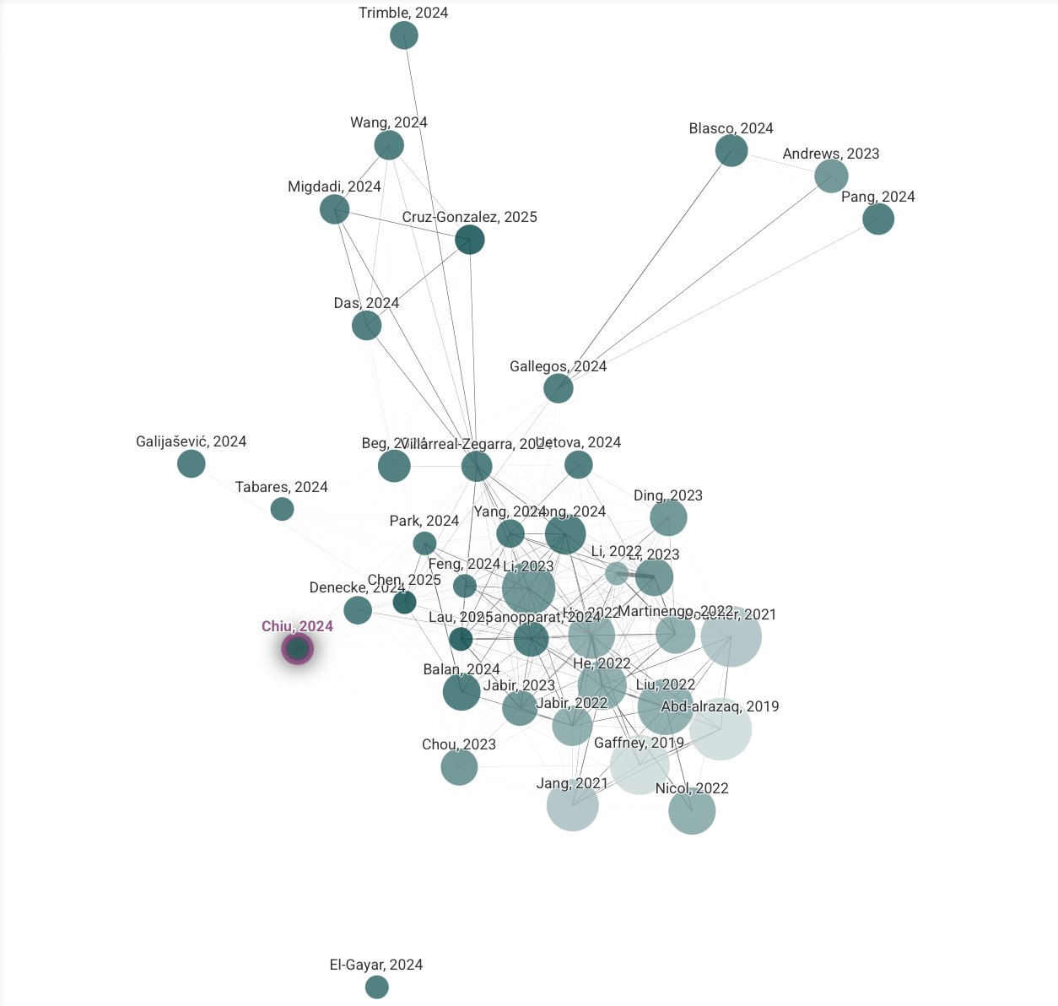
Figure 3: Connected papers results graph for selecting Chiu (2024)
Filters are applied across all platforms to ensure that only literature published within the past seven years is included, corresponding to the range of 2018 to 2025. This restriction is essential given the rapid evolution of AI technologies, particularly in health and human interaction contexts. The extended timeframe is deliberately chosen to capture the full arc of a transformative period in AI development. Beginning with the publication of “Attention Is All You Need” in 2017, which introduced the transformer architecture foundational to LLMs, and continuing through the years that saw their widespread application and societal impact (Vaswani et al., 2017). By 2020, the emergence of powerful LLMs like GPT-2 and GPT-3 significantly accelerated innovation in AI-supported communication, including applications in mental health. This timeframe also spans the COVID-19 pandemic, a period that not only heightened global awareness of mental health needs but also catalyzed the adoption of digital health technologies. Including both pre- and post-pandemic literature ensures that the review accounts for shifts in clinical practice, patient behavior, and the digital health ecosystem more broadly. Additional filters prioritize papers containing search terms within their title or abstract to ensure topical relevance.

Search strings are developed iteratively and include phrases such as
“Refugees Germany”

(“AI in depression apps”,
“Artificial Intelligence in Psychiatry” and
“Artificial Intelligence depression treatment”.)

Boolean operators and variations are applied to refine the results further, and in the case of Consensus.app, where each query returns only a limited number of articles, the process involves repeated searches to expand the pool of literature. This ensures that even indirectly related but valuable papers are not overlooked.

The initial search yields a total of n=120 records (41 from Connected papers, 64 from Consensus.app, 6 from Google Scholar, 9 TIB). A multi-stage screening process is then undertaken. First, 11 duplicate records are identified and removed. Among the remaining 109 papers, 13 are excluded due to inaccessibility caused by paywalls or unavailable files. From the 96 accessible records, 5 are removed after abstract screening for lacking relevance to either AI or mental health applications. One paper is excluded for being in Spanish, as only English-language publications are considered. A final content-level review leads to the exclusion of 27 more papers that either lack empirical data or do not offer substantial contributions to the research question. This results in 64 papers being retained for in-depth analysis.

To address limitations in automated database algorithms, a set of n=5 key publications is added manually to the final set. These include widely cited foundational works in AI research and more recent empirical studies, which help contextualize the current state of AI in digital mental health applications in psychocardiology (Larionov et al., 2023; Vaswani et al., 2017). This manual inclusion strategy follows the precedent set by researchers, who emphasize the necessity of supplementing search results to compensate for the known gaps in algorithmic filtering (Tornero-Costa et al., 2023).

The 69 selected papers are then reviewed and categorized based on their primary application of AI. The categorization follows a concept-centric approach which emphasizes organizing literature by key themes or concepts rather than by author or chronology. This method supports the synthesis of knowledge by uncovering patterns, gaps, and relationships between conceptual areas. Here, it enables a clear comparison of how AI is applied across diagnostic, therapeutic, and operational domains in mental health interventions. By clustering the literature in this way, the review not only provides an organized summary of the current research landscape but also helps highlight underexplored intersections, such as the application of AI in comorbid cardiac and mental health settings (Webster & Watson, 2002). While many studies focus on diagnostic use cases, others examine treatment delivery and broader clinical support systems. As a result, three main thematic areas emerge: AI for diagnosis (e.g., speech- or image-based depression detection), AI for treatment (e.g., chatbot-based therapy or automated CBT modules), and AI for other use cases (e.g., through documentation, predictive analytics, or workflow assistance) (Table 1). It becomes clear that the majority of existing research concentrates on CBT-based interventions or on diagnostic tools. Very few studies focus on voice-based AI interactions for therapeutic purposes, and none explore S2S communication or behavior planning within the framework of FACT.

Author | Year | Google Reviews | AI tools for analysis | Other data sources
Ali Husnain et al. | 2024 |  | x
Beg et al. | 2024 |  | x
Byeon et al. | 2023 | x
Chatterjee et al. | 2023 | x
Chen et al. | 2023 |  |  | x
Chiu et al. | 2024 |  | x
Choudhary et al. | 2024 |  |  | x
Dhaker et al. | 2023 |  |  | x
Eid et al. | 2023 | x
Elyoseph et al. | 2024 | x
Gamble et al. | 2020 |  |  | x
Jan et al. | 2018 | x
Larionov et al. | 2023 |  | x
Li et al. | 2023 |  | x
Mamidisetti and Reddy | 2023 | x
Matías-Cristóbal et al. | 2023 |  |  | x
Mehta et al. | 2021 |  | x
Nazir et al. | 2022 |  |  | x
Nelson et al. | 2025 |  | x
Nyabuto and Nambiro | 2024 | x
Pavlopoulos et al. | 2024 |  | x
S. et al. | 2023 |  |  | x
Sadeh-Sharvit et al. | 2023 | x
Schulte et al. | 2024 |  | x
Souza Filho et al. | 2021 | x
Su et al. | 2020 | x
Suman et al. | 2020 |  |  | x
Turchioe et al. | 2024 |  | x
Zaghloul et al. | 2024 |  |  | x
Table 1: Overview of Literature

The findings of the literature review directly inform the design decisions of the LeA-AI app. First, the strong emphasis in the literature on the challenges of user engagement and high dropout rates in digital mental health interventions supports the project’s move toward a speech-first interface. Voice interaction significantly reduces usage friction and provides a more natural and accessible alternative to text-based systems. Second, the lack of existing studies on behavior experiments or AI-driven behavioral activation underlines the novelty of the LeA-AI approach, which integrates real-time planning of behavior experiments tailored to cardiac patients with comorbid mental illness. While previous literature confirms the efficacy of CBT in both face-to-face and digital formats, there is currently little research applying FACT specifically within AI-supported environments. This underscores a significant theoretical and clinical gap that the LeA-AI artifact is uniquely positioned to address.
Overall, the literature review is conducted as a methodologically sound and iterative process, beginning with a broad search, followed by rigorous filtering, and finalized through thematic synthesis. From the initial 120 articles retrieved, 69 papers are ultimately included in the analysis. These provide a structured knowledge base that supports artifact development and highlights both well-established approaches and key areas where current research remains lacking. This foundation ensures that the design of the LeA-AI app is not only grounded in the most recent scientific understanding but also contributes to advancing the field through its focus on S2S interaction and behaviorally oriented therapy in psychocardiology.

3.3 Ethical Considerations
Given the sensitive google review data… namen, die haben wir ignoriert, personenbezogene daten wurden gefiltert…

4. Results and Findings

4.1 Literature Results
Was andere gemacht haben, Google reviews, in DE, in den USA, ….
Was haben die rausbekommen
Was sind die hauptbarrieren in DE?
Was findet man in google reviews, gibt es schon klinken analysen in der wissenschaftl. Literatur?

4.2 Data findings
Unsere Ergebnisse, Grafiken, Statistiken, …,

5. Discussion and Implications

The growing integration

Was heißt das den jetzt, stimmt das mit unseren findings überein? Was haben wir zu ergänzen mit uznserern daten?

Was ist bei uns komisch? Was ist gut, schlecht, präzise, aussagekräftig, oder nicht aussagekräftig

6. Limitations and Further Research

Nur Kleiner datensatz, brauchen mehr daten, mehr analysen

Der prompt des LLM könnte präziser sein

Die autoren könnten noch mehr lietaratur durchforsten

….

7. Conclusion

This thesis set

8. Acknowledgements

I am especially grateful to M.Sc. Fenja Schulte and Prof. Dr. Michael H. Breitner at Leibniz University Hannover, whose contributions and guidance have been essential. Their encouragement and the opportunity to contribute to the digital health initiatives at LUH have significantly enriched my academic journey.

Finally, I would like to thank all those who have supported me along the way, directly or indirectly, and have contributed to the successful completion of this thesis.

9. References

Brenner, S., & Lok, V. (2022). “We assist the health system doing the work that should be done by others” – a qualitative study on experiences of grassroots level organizations providing refugee health care during the 2015 migration event in Germany. BMC Health Services Research, 22(1), 309. https://doi.org/10.1186/s12913-022-07683-2
Larionov, K., Petrova, E., Demirbuga, N., Werth, O., Breitner, M. H., Gebhardt, P., Caldarone, F., Duncker, D., Westhoff-Bleck, M., Sensenhauser, A., Maxrath, N., Marschollek, M., Kahl, K. G., & Heitland, I. (2023). Improving mental well-being in psychocardiology—A feasibility trial for a non-blended web application as a brief metacognitive-based intervention in cardiovascular disease patients. Frontiers in Psychiatry, 14, 1138475. https://doi.org/10.3389/fpsyt.2023.1138475
Tornero-Costa, R., Martinez-Millana, A., Azzopardi-Muscat, N., Lazeri, L., Traver, V., & Novillo-Ortiz, D. (2023). Methodological and Quality Flaws in the Use of Artificial Intelligence in Mental Health Research: Systematic Review. JMIR Mental Health, 10. https://doi.org/10.2196/42045
Vaswani, A., Shazeer, N., Parmar, N., Uszkoreit, J., Jones, L., Gomez, A. N., Kaiser, Ł., & Polosukhin, I. (2017). Attention is All you Need. Advances in Neural Information Processing Systems, 30. https://proceedings.neurips.cc/paper/2017/hash/3f5ee243547dee91fbd053c1c4a845aa-Abstract.html
Vom Brocke, J., Hevner, A., & Maedche, A. (2020). Introduction to Design Science Research. In J. Vom Brocke, A. Hevner, & A. Maedche (Eds.), Design Science Research. Cases (pp. 1–13). Springer International Publishing. https://doi.org/10.1007/978-3-030-46781-4_1
Webster, J., & Watson, R. T. (2002). Analyzing the Past to Prepare for the Future: Writing a Literature Review. MIS Quarterly, 26(2), xiii–xxiii.

10. Appendix

11. Declaration of Honor
I hereby certify that I have written this thesis independently and have not used any sources or aids other than those indicated, that all passages in the thesis which have been taken verbatim or in spirit from other sources are marked as such, and that the thesis has not yet been submitted in the same or similar form to any examination authority.

Hanover, 20.06.2025
Place, date* Signature
*(date of submission)

Hiermit versichere ich, dass ich die vorliegende Arbeit selbstständig verfasst und keine anderen als die angegebenen Quellen und Hilfsmittel benutzt habe, dass alle Stellen der Arbeit, die wörtlich oder sinngemäß aus anderen Quellen übernommen wurden, als solche kenntlich gemacht sind und dass die Arbeit in gleicher oder ähnlicher Form noch keiner Prüfungsbehörde vorgelegt wurde.

Hannover, 20.06.2025
Ort, Datum* Unterschrift
*(Abgabedatum)

