Project 1:

Java 2D Graphics

Zachary Finnegan

CMSC 405

Computer Graphics

**Discussion**

Honestly, I didn’t have much of a test plan. You just press run and the program works and does the thing it’s supposed to do, or it doesn’t. There isn’t a way to select different functionality during runtime.

What I did do is take the templates provided and modified them to serve my needs. I am not sure how closely we could follow the template so if I adhered to closely please let me know and I will rewrite the program to be more original code.

I changed the graphics to be “ZACK!” instead of the “T’s.” I wanted to show that I could implement a variety of shapes. I made the 2D array’s bigger and added shadows to the letters by using the number 2 in the array to signify gray. The last thing I added was an underline using one of the API’s basic shapes and added a gradient color to it. I wanted to show my ability to use the API for 2D graphics as well.

I kept the animation code and the basic structure of the templates. I modified the view window and the number of frames. I added the transforms required by the project documentation and added a couple of other frames for fun.

The thing that perplexed me was why the default orientation of the objects was rotate counterclockwise by 90 degrees. My thought is that it has to do with the 2 for loops that read the 2D arrays. It must turn the rows into columns. I corrected this so that my graphic would look nice right off the bat by having the default rotation set to a clockwise rotation of 90 degrees.

**Frames**

Frame 0: Default

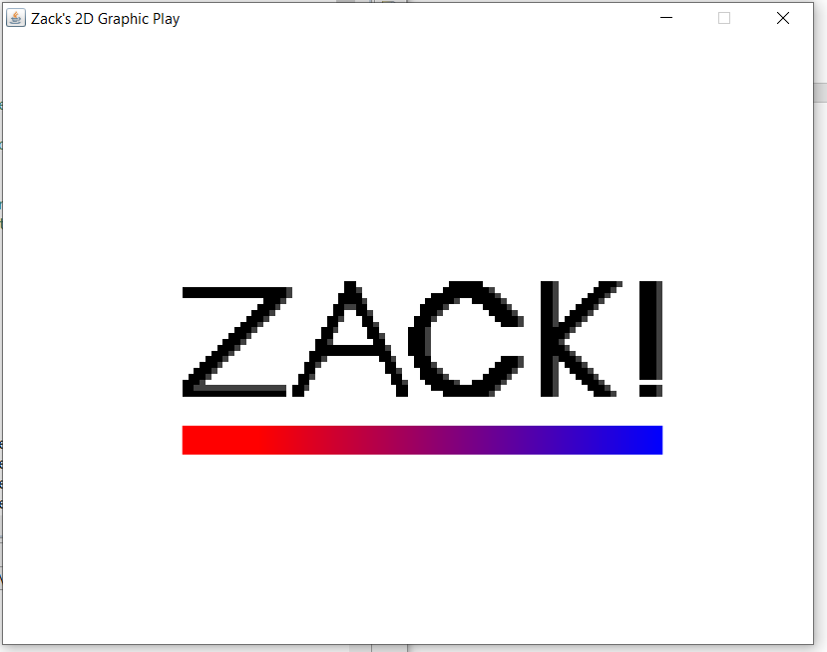

Frame 1: Translate (x = -5, y =7)

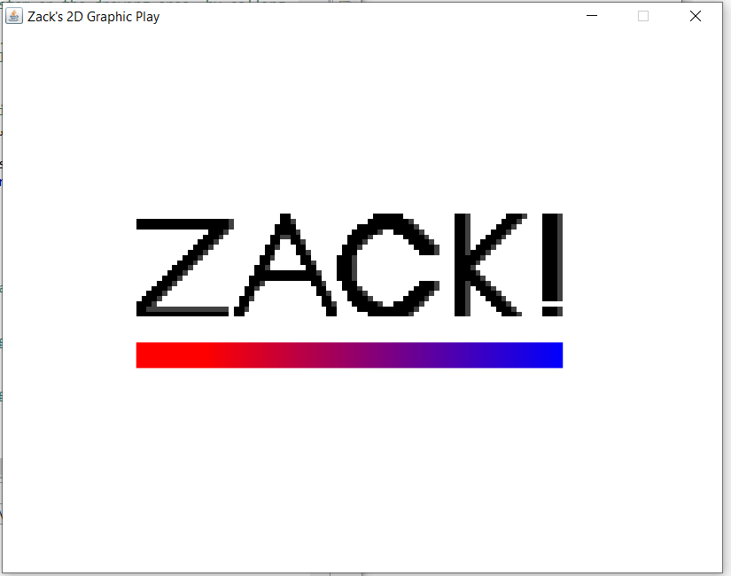

Frame 2: Rotate (45 degrees counterclockwise)

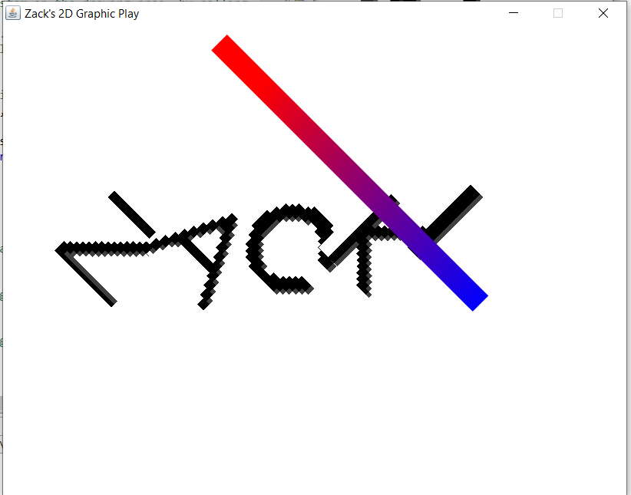

Frame 3: Rotate (90 degrees clockwise)

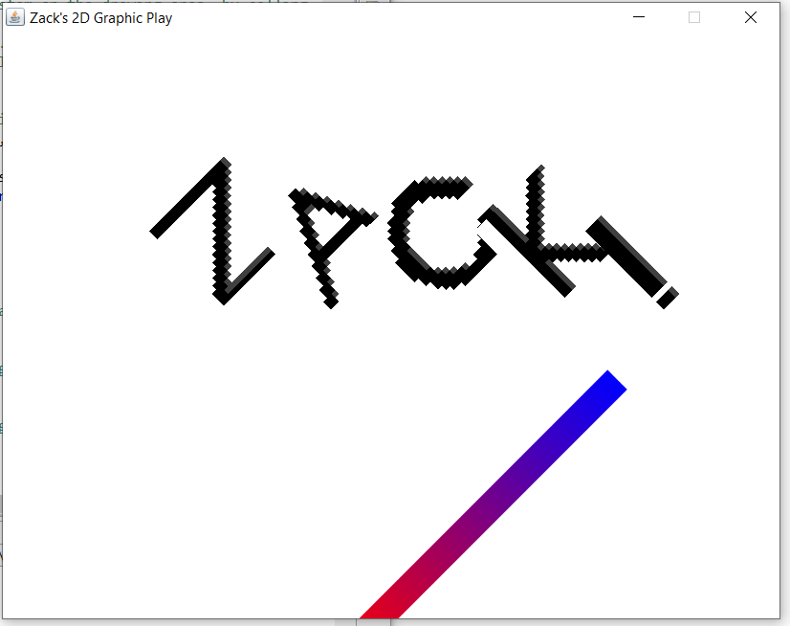

Frame 4: Scale (2x, 0.5y)

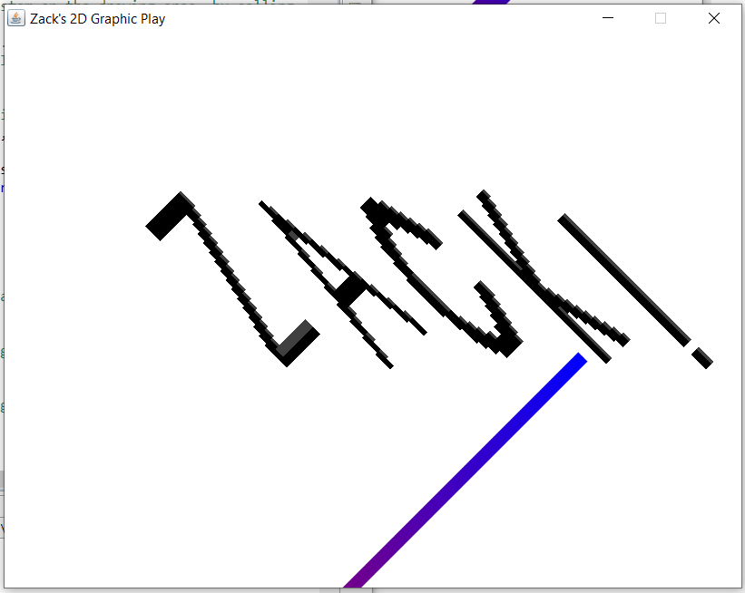

Frame 5: Return to Default

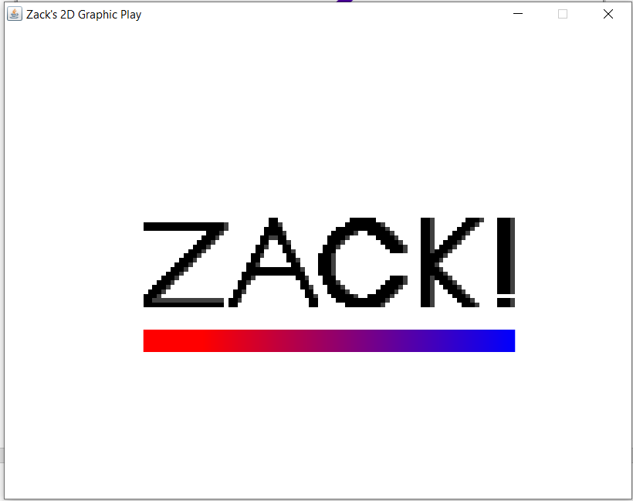

Frame 6: Translate (x=-5, y=-10), Rotate (60 degrees clockwise)

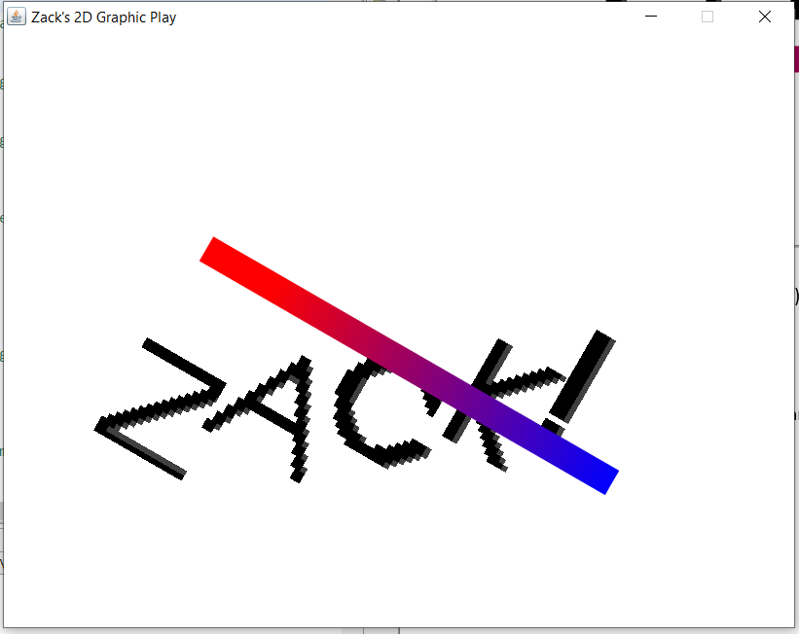

Frame 7: Translate (x=0, y=-5), Rotate (60 degrees clockwise)

