**Web Design Project**

[**S00233207@atu.ie**](mailto:S00233207@atu.ie)

**Student number: S00233207**

**Name: Finn Gallagher**

GitHub links - <https://github.com/finngall3/WebDesignProject>

<https://finngall3.github.io/WebDesignProject/>

Initial Proposal Sketch:

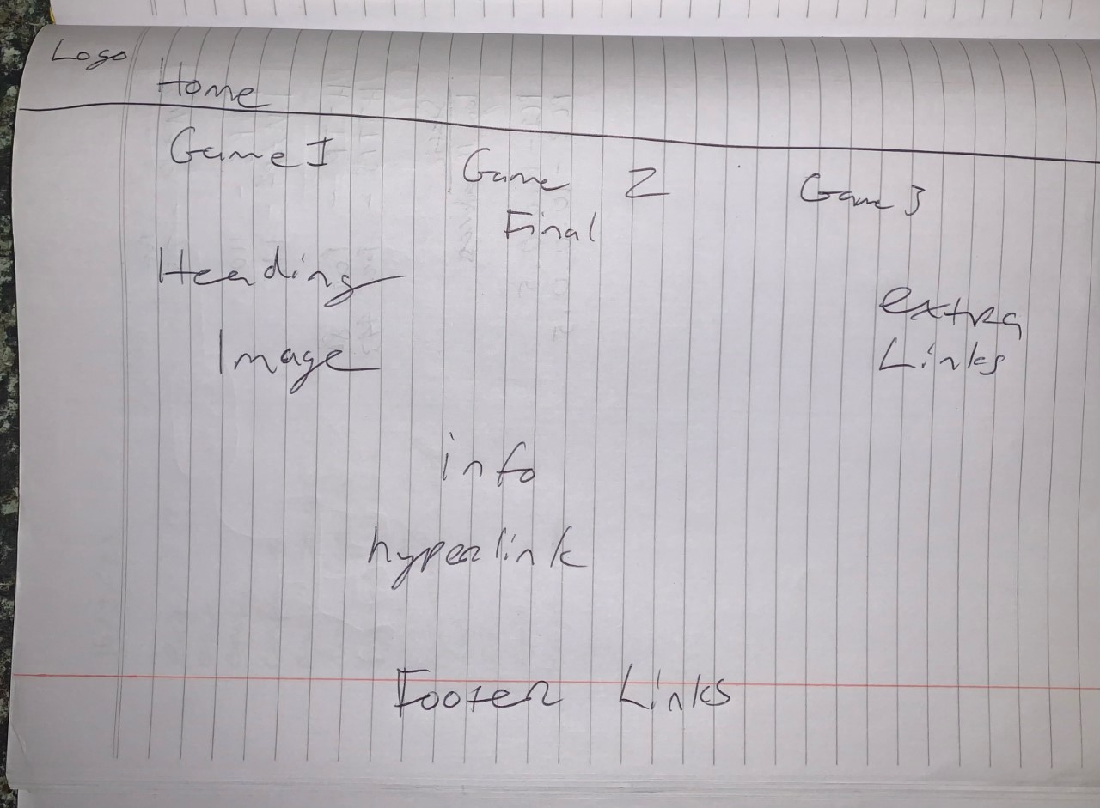

Checklist:

Index:

The index page acts as my home page where I introduce my chosen website topic (Man United in the Carabao Cup) and features links to all other pages on my website.

Each page after the index page breaks down and shows the result of each game as well as showing images of the players along with video highlights.



