**DREIDENTS DENTAL CARE ONLINE PATIENTS SCHEDULING WITH REMINDER SYSTEM**

**A Thesis Project**

**Presented To**

The College of Information Technology Education

University of Iloilo

PHINMA Education Network

# In Partial Fulfillment

**Of the Requirements for the Course**

IT 062 – System Analysis and Design

**By:**

Jan Russell Bautista

Ian Ray Meliton

Rundgie Fernandez

Kristoffer Ian Prado

Kenneth Robert Imalay

1. **Introduction:**

The aim of this project is to develop an online system that can handle and manage the scheduling, reminder and patient’s information system involved in “Dreident Dental Care” in an efficient and reliable way. After some questions with the owner itself, we were able to site that their clinic currently doesn’t have any online or computerized system. We proposed our system titled DDC-OPSRS (Dreident Dental Care Online Patients Scheduling with Reminder System) as it was a great opportunity to significantly help their clinic. Our system will replace Dreidents Dental Care’s current system where they only keep patient’s information on a piece of card which can easily be lost and it will take space over time. The system will instead store patient’s personal information online and can be easily be accessed by Front Desk or Admin for viewing, editing, or even printing. There will be no need for patients to go to the clinic itself or find a phone just to call the clinic if they don’t have one just to schedule an appointment as our system will enable them to do it online with just a few clicks. They will also get notification once their appointment has been successfully scheduled online via a pop-up on the website and also via text or email as a confirmation. One they have scheduled an appointment, they will get a reminder via text and email the day before their appointment so that they won’t forget. The system will get the information needed to send the patients a reminder for their appointment from the email or phone number they enter when they created their online profile. Patients will also be able to view and edit they existing profile if there is some need for changes. The clinic’s front desk or admin will also have an interface to easily track upcoming scheduled appointments of patients. They will also be able to view, edit, remove or even print patient’s information. They can also print weekly, monthly or yearly reports for tracking and storing purposes.

* 1. **Background of the Study**
     1. **Company Background**

The Dreidents Dental Care was established last May 29, 2017. The name of the clinic was derived from the German word, “Drei” which means “three” as there were 3 dentists that founded the clinic. The clinic is located at #23 Huervana St. Brgy, Railway, Lapaz Iloilo City and their clinic hours is from Monday to Saturday 9:00am-12:00noon and 1:00pm-5:00pm and Sunday by appointment. Dreidents Dental Care is owned by the Cavan Family which are dentist by profession together with their close friends. Currently, there are two dentists that regularly on duty and one dentist is on call with a secretary/receptionist. At the moment the three dentist has no specialization. The services they offer for the meantime are all for dental purposes.

* + 1. **Statement of the Problem**

Dreidents Dental Care currently doesn’t have any online or computerized system for their patient’s information and scheduling appointments. Whenever a patient wants to schedule an appointment, they have to call over the phone or go to the dental clinic itself just to have one scheduled. And patients are only told or reminded over the phone a day before when their next appointment will. Currently the information of the patients and are only written on a book and can be easily lost and takes space on their office.

* 1. **Statement of Objectives**
     1. **General Objectives:**

The general objective of the DDC-OPSRS (Dreident Dental Care Online Patients Scheduling with Reminder System) is to lessen the time it takes for pet owners to schedule an appointment for their pets. CSAH-OPSRS also gives a reminder every time an owners pet has a monthly or annual vaccination for their pets. CSAH-OPSRS is generally to remind, monitor, and store information of clients/pet owners in a reliable way possible.

* + 1. **Specific Objective:**

The specific objectives of the DDC-OPSRS (Dreident Dental Care Online Patients Scheduling with Reminder System) is to reduce the time to schedule an appointment for patients as they can do it online with our system without the need to go to the dental clinic itself. Patients will be able to create and edit information on their online profile they created. The system will also remind patients for their upcoming scheduled appointments through email and SMS from the information they provided on their online profile. Front Desk and Admins will be able track the schedules and the reminders on specific admin created interface. They can also add, edit, remove and also print patient’s online profile information or print monthly reports.

* 1. **Significance of the Study**

The DDC-OPSRS (Dreident Dental Care Online Patients Scheduling with Reminder System) is made for the convenience of the management of Dreident Dental Care and its patients. In addition, this project is to develop the system of the Dreident Dental Care to produce a unique quality of perfection to fulfill the customer’s satisfaction.

* 1. **Scope and Limitation of the Study**

**Scope:**

System will be able to record Patient’s information using a form. Patients and Admin can also add, edit or remove information. It will show a list all scheduled appointments made on the system based on the date at the Admin’s interface. The system will have a reminder system that will send Patients with notifications regarding their scheduled appointment via SMS and email

**Limitations:**

The system will not be able to work offline on both Patient and Admin if either has no internet connection. Patients won’t be able to receive any notification if they don’t have either email or phone. They won’t able to access the admin system as the Admin has a different login credentials. The system will be limited with either Patient’s or Dentist’s schedule availability and also with their computer literacy.

**Scheduled Feasibility Gantt Chart**

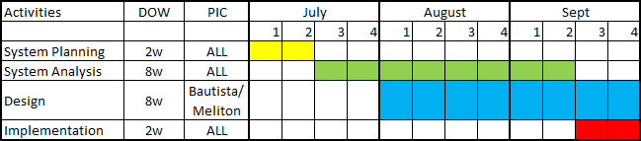

Data Flow Diagram (Existing System)

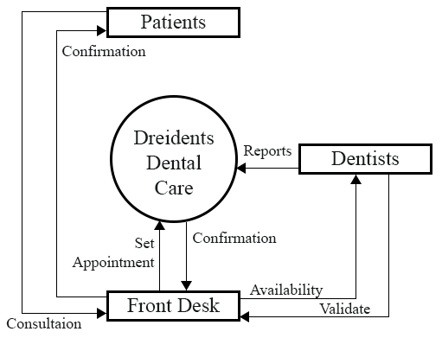

Data Flow Diagram (Proposed System)

**Dentists**

**Patients**

**Front Desk**

Login

Confirmation/via SMS Reports

Availability

Set Appointment

Validate