


ICTICT449 Use version control systems in development environments

ICTPRG437 Build a user interface

ICTPRG440 Apply introductory programming skills in different languages

ICTPRG302 Apply introductory programming techniques

Learner version

JavaScript Assessment 2

JavaScript Portfolio

Disclaimer: This resource was developed by Holmesglen Institute of TAFE in 2024 for the State of Victoria (Department of Education and Training) for educational purposes, is © State of Victoria (Department of Education and Training) and is available under a Creative Commons Attribution Non-commercial 4.0 International (CC BY-NC 4.0) license.
The license does not apply to: Trademarks or branding, including the Victorian Government logo and any unattributed content supplied by third parties

Learner version

JavaScript Assessment 2

Task title (Portfolio)

Section A – Program/course details
Qualification code: ICT40120 | Qualification title: Certificate IV in Information Technology (Programming)
Unit code:  CPRO1 – JavaScript  ICTICT449  ICTPRG437  ICTPRG440  ICTPRG302 | Unit title:  JavaScript  Use versions control systems in development environments  Build a user interface  Apply introductory programming skills in different languages  Apply introductory programming techniques
Pre/co-requisites: N/A

Section B – Assessment task details
Assessment number: 2 of 2 | Semester/year: 2/2026 |  | Due date: 20/11/2026
Duration of assessment: 8 weeks |  | Assessment task results: This assessment task will be marked as:  ☒ Ungraded result: satisfactory or not yet satisfactory

Section C – Instructions to learners

Assessment task description:
This assessment has two parts:
- Part A – Knowledge questions
- Part B – Portfolio section
For Part A, you are required to answer all questions in the boxes below each question. You should be writing at least 1 paragraph for your answers, unless the question specifies otherwise. Some questions have tables to fill out.
Part B is broken up into 6 different parts.
- Part B1: Data structures and algorithms – simple data types.
- Part B2: Using basic data structures – objects
- Part B3: String manipulation and files
- Part B4: Data structures and algorithms – complex data types
- Part B5: Build a graphical User Interface
- Part B6: Version control in a team environment

While doing each part the following requirements and guidelines must be followed:
Documentation Requirement
You are required to fully comment the codes, you must
- Comment all functions
- Comment all variables

Comply with Coding Guidelines
You must follow the coding guidelines below when developing the program (Refer to w3school JS style guide for detailed explanation for each of the following rules)
- Use camelCase for identifier names (variables and functions)
- All names start with a letter
- Always put spaces around operators (= + - * /), and after commas
- Always use 2 or 4 spaces for indentation of code blocks
- Statement rules
  - Always end a simple statement with a semicolon
  - Put the opening bracket at the end of the first line.
  - Use one space before the opening bracket.
  - Put the closing bracket on a new line, without leading spaces.
  - Do not end a complex statement with a semicolon.

Version Control
- You are required to create a repository to store your code.
- You are required to have at least 3 branches for your repository.
- Each question has an area for you to write in your branch name and commit number and date of the commit
- You need to have 3 merge requests as well for each repository.

Project setup
- You need to create a root folder called “JSAT2”
- Under this folder create the folders part1, part2, part3, part4, part4, part6.
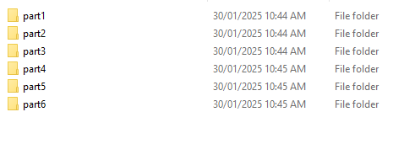
- All work for each part should be placed inside these folders
- You can create sub folders in each of these folders if you need to. I.e. one for wireframes for example.
- You are required to submit all your code zipped up to Brightspace

REFER TO THE SUPPORTING DOCUMENTATION FOR FUTHER ASSESSMENT DETAILS

Section D – Conditions for assessment

Unit application:
- This is an individual task.
- You must meet all criteria listed in the marking guide to be satisfactory in this task.
- You must submit all required working files, documentation, and any other assets that you feel may be required in a zipped file, including the completed and signed coversheet. The assessment must be completed and submitted electronically to Brightspace by the due date. If this is not possible, you must contact your assessor to gain written approval for an alternative arrangement for submitting the assessment.
- If not successful within the enrolment period as per Holmesglen assessment procedure, you will be requested to resubmit within 7 days of receiving feedback. You will have the opportunity to resubmit if any part of the assessment is deemed unsatisfactory (you are permitted TWO (2) resubmission per assessment task). Resubmissions must be submitted by the resubmission due date provided by your teacher.
- This task is open book. You may use the internet for research purposes only. All answers must be in your own words. Where a quote is used, you must cite the information source.
- If you feel you require special allowance or adjustment to this task, please discuss with your assessor within one week of commencing this assessment. Any change to assessment arrangements must be reviewed by the Education Manager and approved by the Head of Department.
- You can appeal an assessment decision according to the Holmesglen Assessment Complaints and Appeals Procedure.
- You are expected to dedicate time to develop this assessment task both in and out of the classroom.
- Leaner must contribute to and abide by organisational standards including intellectual property, privacy laws, and plagiarism and academic honesty. Further information is detailed at: https://holmesglen.edu.au/Students/Student-Resources/

- Use of Generative AI Tools in Assessments
You are permitted to use generative AI tools to support your research and development process for this assessment. This aligns with the broader educational focus on digital literacy and emerging technologies. However, your use of these tools must be transparent, responsible, and in accordance with academic integrity standards.

You must not use generative AI to:
  - Generate full-text responses for written assessment questions.
  - Write complete scripts or presentations without your own input.
  - Produce entire data sets, budgets, or analytical outputs without demonstrating your own understanding.

Your use of these tools should be to support your work, not to replace it. This includes tasks such as:
  - Brainstorming ideas.
  - Conducting preliminary research.
  - Structuring your presentation.
  - Editing and refining your written work.

- Academic Honesty and Plagiarism
Any use of AI tools must be clearly acknowledged. For example, you can include a note such as:
“Generative AI was used to assist with brainstorming and editing.”
Failure to follow these guidelines may be considered academic misconduct under Holmesglen’s policy.

Equipment/resources learners must supply: | Equipment/resources to be provided by the RTO:
Learners opting to BYOD laptop or intending to learn remotely will require access to:  - A MAC or PC/laptop with the following minimum specification:  - Quad Core CPU  - • CPU with minimum 4GHz processor or faster  - • RAM 16GB  - • 200GB of storage  - • Windows 10 OS, or virtual machine installed with Windows 10 OS (available free from https://developer.microsoft.com/en-us/windows/downloads/virtual-machines/ or https://www.microsoft.com/en-us/evalcenter/evaluate-windows-10-enterprise)  - • Monitor 24" (PC only, dual monitor optional but preferred)  - • Headset with microphone (webcam optional but preferred)  - • Access to reliable internet connection (ADSL or cable connection desirable)  - Applications are available through Holmesglen MyHorizon and some have free licences which can be downloaded via url below:  - • Brightspace (Learning Management System) access - https://holmesglen.brightspace.com/  - • MyHorizon - https://myHorizon.holmesglen.edu.au - free to download  - • 365 Microsoft office suite also can be downloaded via https://portal.office.com - free for all Holmesglen students  - • LinkedIn Learning - free access  - • WebEx - https://holmesglen.webex.com/ - free to download  - • Unity - https://unity.com/ - student license free to download  - • Maya - http://www.autodesk.com/education/free-software/maya - student license free to download  - • Substance Painter https://substance3d.adobe.com/education/ - student license free to download  - • Adobe Photoshop - https://www.adobe.com/au  - • ZBrush – https://pixologic.com/  - • GitHub desktop - https://desktop.github.com/ - free to download  - • 3D Coat - http:/3dcoat.com/download/  - • 7Zip or an equivalent compression utility - free to download  - • Google Chrome – recommended web browser  • OneDrive - https://www.microsoft.com/en-ww/microsoft-365/onedrive/online-cloud-storage - free to downloade | This is a blended learning course and as such a remote learner will access their own computer equipment as per the specification provided. The Institute will provide the following:  - Holmesglen CAIT computer classroom:  - data projector, whiteboard, computer with double screens, mobile Cisco Spark Board, Conference camera  - HP Z1 Entry Tower G5  - • Dual Displays 24” HP Monitor  - • CPU: Intel Core i7-9700K @ 4GHz  - • Motherboard: 8591  - • RAM 32GB  - • 1TB SSD  - • OS: Windows 10  - This will vary as CAIT upgrades computer rooms.  - • Internet connection  - Applications available at ZENworks and Holmesglen MyHorizon and free to download via url below:  - • Brightspace (Learning Management System) access - https://holmesglen.brightspace.com/  - • 365 Microsoft office suite also can be downloaded via https://portal.office.com - free to Holmesglen students  - • LinkedIn Learning - free access  - • WebEx - https://holmesglen.webex.com/ - free to download  - • Unity - https://unity.com/ - student license free to donwload  - • Maya - http://www.autodesk.com/education/free-software/maya - student license free to download  - • Substance Painter https://substance3d.adobe.com/education/ - student license free to download  - • Adobe Photoshop - https://www.adobe.com/au  - • ZBrush – https://pixologic.com/  - • GitHub desktop - https://desktop.github.com/ - free to download  - • 3D Coat - http:/3dcoat.com/download/  - • 7Zip or an equivalent compression utility - free to download  - • Google Chrome – recommended web browser  • OneDrive - https://www.microsoft.com/en-ww/microsoft-365/onedrive/online-cloud-storage - free to download

Section E – Assessment questions/criteria
Assessment number: 2 |  | Assessment title: Portfolio
CPRO1 - JavaScript  Unit code:  ICTICT449  ICTPRG437  ICTPRG440  ICTPRG302 | JavaScript  Unit title:  Use version control systems in development environments  Build a user interface  Apply introductory programming skills in different languages  Apply introductory programming techniques

PART A - KNOWLEDGE QUESTIONS (Written Response)
Provide your responses in the boxes below each question.

Question | Satisfactory response
Compare GIT Hub and one other Version Control System. Look at the functionality of each system and how they work. Record your answer below.  Based on your research, which Version Control System would you pick and why? | Yes ☐ No ☐
Answer:  Github and Bitbucket are both version control systems that use git, used by developers to collaborate and iterate on codebases by storing projects in repositories. Both platforms allow developers to create branches, commit changes, merge changes and collaborate with other developers.  The process of using these systems is largely similar, with developers cloning a remote repository to their local machine, then (optionally) creating a branch and pushing and pulling to/from the remote as they work on development. Both systems support merging these branches through pull requests to contribute to the codebase.  Github provides Github Actions, while BitBucket provides BitBucket Pipelines – so both VCS provide functionality for CI/CD.  One difference between the two platforms is their integration with other development tools. GitHub has a large ecosystem of development tools, open-source projects and integrations. Conversely, Bitbucket is developed by Atlassian and integrates closely with other Atlassian products, such as Jira. This can be useful for organisations that already use Atlassian software, though plugins and extensions are often available for GitHub use too.  I personally would make use of Github before Bitbucket. This is for two reasons; firstly, I have extensive experience with Github, including making use of its organisational tools such as projects and issues. In this way, I can manage a team seamlessly just through the use of Github. Secondly, Github has far more open source and available integrations and is more popular among various developers, from individual hobbyists to large companies. Bitbucket on the other hand largely relies on its complimentary Atlassian management softwires for large-sale project management (Jira, Trello) and has overall less available peripheral features than Github. I and many of the other developers I have worked with have less experience with Bitbucket compared to Github, making Github my preferred choice for a VCS. | Comment:

Question | Satisfactory response
Define distributed and centralised version control systems and discuss the differences between the two types | Yes ☐ No ☐
Answer:  A Distributed Version Control System (such as git) stores a complete copy of the project's version history on each developer's computer. Developers can make changes, create commits and view the history of the project without needing to be consistently connected to a central server. Changes can then be shared with other developers by pushing and pulling work.  A Centralised Version Control System (such as subversion) stores the main version history in a central server or repository. Developers connect to this central repository to obtain the latest version of the project and to submit their changes. The central server is therefore an integral to the development process, and developers must be connected while making changes.  Thus, the main difference is where the version history is stored and how developers work on a project. In a centralised system, the main repository and its history are stored on a central server, whereas in a distributed system, each developer has their own cloned repository containing the project's history. Distributed systems can allow developers to continue working and committing changes while offline, while centralised systems generally require a connection to the central server for most activities. | Comment:

Question | Satisfactory response
Describe the following concepts related to Version Control System (VCS)  - repositories and working copies  - merging and merge tools  - working and indiscriminative commits  - resolving conflict and backout changes | Yes ☐ No ☐
Answer:  A) A repository is the location where a version control system stores a project's files and the history of changes made to those files. It allows developers to track different versions of a project, collaborate, and see who made changes and when. A working copy is the version of the project that a developer has on their local computer and is currently working on. Developers can modify files in their working copy and then commit their changes to the remote repository.  B) Merging is the process of combining changes from two different branches of a project. Developers commonly use branches to work on separate features or fixes without changing the main version of the project or interfering with others’ work. Once the work is complete, the changes can be merged into another branch for all to see.  A merge tool is software that helps developers compare different versions of files and resolve differences when branches are being merged. It can show the changes made to each version and allow the developer to decide which changes should be kept or discarded, which can be particularly helpful when resolving merge conflicts.  C) A working commit can be understood as a commit that records a specific set of completed changes to the repository.  An indiscriminate commit is a bad-practice commit where many unrelated changes are completed in a single commit. This can make targeting bugs or completed work difficult and slow down development.  D) A conflict occurs when two or more changes made to the same part of a file cannot automatically be combined by the version control system, as they conflict. This commonly happens when two developers modify the same lines of code in different branches. Resolving a conflict involves reviewing the conflicting changes through merge tools and deciding which changes should be kept, modified or combined. Resolving merge conflicts can be time consuming and tedious, and should be avoided.  Backing out changes means reversing or undoing a previous change when it is no longer required or - more likely - has caused a problem. Version control systems allow developers to restore files to an earlier state or create a new commit that reverses an unwanted change or merge conflict. | Comment:

Question | Satisfactory response
Describe principles and techniques of creating repositories and branch workflows. (Hint: Look at the workflow in Part 6, list the steps and describe why) | Yes ☐ No ☐
Answer:  A repository is used to store the files, source code and version history of a software project on a remote server. Using a branch with the following workflow allows developers to work on changes separately from the main version of the project and contribute in a collaborative and controlled way. This reduces the risk of unfinished or incorrect code being added directly to the main branch.  The workflow follows these steps:  - A repository is created or joined via the VCS. For example, in Github the owner of the repository can add a collaborator.  - Then, the repository is cloned to the local machine. This creates a local copy of the project that can be edited and tested before changes are uploaded to the remote.  - Good practice is to then create a separate branch before making changes. This is important because then, the main branch is protected from direct changes, meaning merge conflicts can be better handled and potential bugs can be caught before editing this main version; Each developer can work on their own branch without affecting the ‘approved version of the project.  - The developer can then work on the codebase on the new branch. Changes are “staged” in git before a commit is made, meaning recorded as being different on the local machine and await the developer’s approval before being available on remote.  - Once a relevant piece of work or task is completed, staged files that have changed are committed locally to the branch. A commit creates a record of the changes in a “chunk” and provides a point that can be reviewed or returned to later.  - The branch and its commits are pushed to the GitHub repository. This makes the work available to other members of the project and allows a pull request to be created.  - A pull request is then created to show the effects of merging the branch into the main branch. This allows another developer to review the code before it becomes part of the main project, and for merge conflicts to be identified.  - The code is reviewed and feedback is provided via comments and discussion. The developer can make additional changes to address any problems identified during the review by making new commits, without having to create a new PR.  - Once the code has been reviewed and approved, the branch can be merged into the main branch and the PR can be closed.  - After the merge, the website is checked again (by the developer or QA team) to confirm that the changes work as intended. | Comment:

Question | Satisfactory response
List 3 best practices that you should follow while using a version control system. Describe why each practice is useful to follow. | Yes ☐ No ☐
Answer:  Descriptive commit messages  Developers should always use descriptive commit messages, ideally following the standard Git format with prefixes such as “feat” or “fix”. This makes it easy for other developers and yourself in the future to determine what a commit changed and its purpose. It also makes it easier to locate where bugs may have been introduced.  Frequent commits  Frequent commits should be made that isolate individual changes. Avoid big commits that introduce various changes, particularly changes that have different goals. For example, committing changes that resolve a bug, introduce a new feature, and update documentation all at once with a vague messages like “updated code and fixed bug” is bad practice. This makes targeting potential bugs or identifying where a change occurred difficult. Frequent, small commits create an easier-to-navigate project, where individual changes are isolated and easy to identify.  Branching  A new branch should be created for new work. The main branch should not be worked on directly, especially in a collaborative work environment. This ensures changes are isolated from the stable version of the project and reduce the risk of introducing system-breaking changes or merge conflicts. | Comment:

Question | Satisfactory response
Discuss a range of strategies when developing a user interface with HTML and CSS. Finish the table below, use examples. | Yes ☐ No ☐
Answer: | Comment:
  Requirement | Strategies
  Introduce a 20 px gap between two vertically aligned element. | The CSS margin or gap property should be used. For example, “margin-bottom: 20px;” can create a 20 px space below an element. If the elements are inside a flex or grid container, “gap: 20px;” could also be used.
  Place an element in the centre of its container. | CSS Flexbox can achieve this; “display: flex; justify-content: center; align-items: center;” will centre an element both horizontally and vertically within its container.
  Apply certain colour to all text-based element in a container | Apply the “color” property to the container. This can be done in a few ways, either by applying it to all HTML “div”, “section” or other elements, or by targeting a specific id or class. For example, “div { color: blue; }” will change all text elements inside a div to be blue unless another colour is specifically assigned to them.
  Display information in a table manner | HTML table elements such as “<table>, <tr>, <th>” and “<td>” should be used. CSS can then be used to control the table's appearance, such as changing padding, borders or colours.
  Set colour using RGB values and HEX values | CSS supports different colour formats, so RGB can be used with “color: rgb(255, 0, 0);” to show red, or a HEX value can be used with “color: #FF0000;” to achieve the same red colour.

Question | Satisfactory response
HTML + CSS + JavaScript languages are used as a combination to program web-based user interface. Discuss the role / functions of each of the languages in building web-based UI. | Yes ☐ No ☐
Answer:  HTML  HTML is like the building blocks of websites. It provides the raw content such as text, titles, images, and sections. It has almost no styling options beyond basic formatting such as “<strong>” or “<em>”, and lacks programming functionality. HTML offers the content used in UI, but does not offer styling options.  CSS  CSS is used with HTML to style websites to make them appealing, readable, and responsive. CSS works by targeting different elements within a website’s HTML and applying style rules, giving HTML elements different colours and behaviours. CSS is not a programming language, but does offer some programming-style tools such as variables, and can alter the behaviour of webpages such as by targeting pseudo-classes. CSS helps to make UI readable and appealing through manipulation of HTML element’s appearances.  JavaScript  JavaScript is the programming language used alongside CSS and HTML to give websites behaviour through scripts. In this context, JavaScript is a client-side programming language that can alter content and appearance by using HTML elements and CSS styling to dynamically change content and appearance of webpages, based on conditions within a script. JavaScript can control how and when UI appears and behaves, and can dynamically update or change the UI and content displayed to the user. | Comment:

Question | Satisfactory response
Identify application development languages that can be used to build the following application. And briefly describe each of them. | Yes ☐ No ☐
Answer:  . | Comment:
  Application Type | Language | Description
  Desktop Window Application | C# | C# is a programming language commonly used to create Windows desktop applications. It can be used with frameworks such as .NET or Windows Forms to create applications with graphical user interface, or engines such as Unity create games and interactive software.
  Web Application | JavaScript (with HTML & CSS) | JavaScript is commonly used alongside HTML and CSS to create interactive web applications. It runs in web browsers to create the structure, appearance and behaviour of a website. It can also be used on the server side, such as with Node.js
  Mobile Application | Swift or Java | Java and Swift are commonly used for mobile development; Java is often used for Android development, and Swift is usually used for Apple's mobile devices.
  Smart TV Application | JavaScript | JavaScript can actually be used to develop applications for some smart TV platforms. It can create interactive interfaces and functionality, especially on smart TVs that support web-based application technologies.
  Smart Watch Application | Java, Swift | Similar to mobile applications, Java and Swift are popular choices. Java is often used in android models such as Samsung watches, while Swift is used for Apple’s iOS in the Apple Watch.

Question | Satisfactory response
Describe what is UI (User Interface) prototyping and identify at least two prototyping tools. | Yes ☐ No ☐
Answer:  What is UI (User Interface) Prototyping?  UI Prototyping involves making mock-ups of possible looks and aesthetics for a website’s UI using design tools rather than programming tools. It allows quick development and idea-exploration while seeking feedback from a client, without wasting resources on development | Comment:
  Tools Name | Website
  Adobe Illustrator | Here
  Figma | Here

Question | Satisfactory response
What is UI style guide, and what should a UI style guide contain (with 50+ words)? | Yes ☐ No ☐
Answer:  What is a UI style guide?  A UI style guide is a document that defines the visual aesthetic and rules for a user interface design. It helps make sure that different sections and components of an application have a consistent appearance and behaviour. This can make the application easier to use, understand, maintain, and develop - especially when multiple developers or designers are working on the same project.  What should a UI style guide contain?  A UI style guide should contain guidelines for colours, fonts, typography, spacing, buttons, forms, icons, images, navigation, layout and any other design elements that should be consistent across an application or website. It can also include examples of how UI components should be used and rules for different screen sizes and devices. The guide may describe accessibility requirements, such as appropriate colour contrast and readable text. | Comment:

Question | Satisfactory response
Use example to explain the following JavaScript syntaxes. | Yes ☐ No ☐
Answer: | Comment:
  Syntax | Example
  Define variable | let name = "Finn";  This defines a variable called name and gives it the value "Finn", which can be changed. JavaScript also supports const for values that should not be reassigned, e.g. const birthplace = “Australia”;.
  Condition structure | if (age >= 18) {  console.log("You’re old!");  } else {  console.log("You’re young!");  }  This checks a condition and runs different code depending on whether the condition is true or false, here, based on the variable “age”.
  Loop structure | for (let i = 0; i < 10; i++) {  console.log(i);  }  This for loop repeats the code while the condition i < 10 is true. Here, it will print the numbers 0 to 9 before the condition turns false and the program will move past the loop.
  Define a function | function greet(name) {  return "Hello " + name;  }  This defines a function called greet, which accepts “name” as a parameter and returns a greeting. By calling it via greet("Finn");, it will return “Hello Finn”
  Define a class | class Bike{  constructor(colour, model) {  this.colour = colour;  this. model = model;  }  }  This defines a Bike class with “colour” and “model” properties. The constructor is used to initialise the properties when a new Bike object is created – ie. "let bmx = new Bike("Red", “BMX”);

Question | Satisfactory response
Identify the official standards of the following languages | Yes ☐ No ☐
Answer: | Comment:
  Language Name | Standard name | Description | Official link
  JavaScript | ECMAScript (ECMA-262) | ECMAScript is the official standard that defines the JavaScript programming language.  It includes its syntax, data types, objects and other language features.  The standard is maintained by Ecma International through Technical Committee 39 (TC39), and the current standard is ECMAScript 2026, 17th edition. | https://262.ecma-international.org/
  HTML | HTML Living Standard | The HTML Living Standard defines how HTML documents should be structured and how web browsers should process HTML.  It is maintained by the Web Hypertext Application Technology Working Group (WHATWG). Unlike older HTML standards that had numbered versions, it is continuously updated as the web develops. | https://html.spec.whatwg.org/multipage/
  CSS | CSS Specifications / CSS Snapshot | CSS is standardised through a collection of specifications maintained by the World Wide Web Consortium (W3C).  CSS specifications define how styles such as colours, fonts, spacing, layouts and other visual properties should work in web browsers.  CSS is developed as separate modules rather than one single version of the language. | https://www.w3.org/Style/CSS/

Question | Satisfactory response
Describe code conventions that are used to comment JavaScript code. (Hint: look in part B for commenting) | Yes ☐ No ☐
Answer:  All functions and variables should be appropriately commented. JSDoc is a documentation system used to add structured comments to JavaScript code, which can also be used to generate external documentation for added usability. JSDoc comments normally begin with /** and end with */, and they can describe what a function, class, variable or other part of the code does. JSDoc uses tags beginning with @ to provide additional information, which is highlighted in different colours in an IDE for added clarity compared to regular commenting.  Common JSDoc conventions include:  - @param – describes a parameter that is passed to a function.  - @returns – describes the value returned by a function.  - @type – specifies the expected type of a variable or value.  - @class – identifies and describes a class.  - @author – identifies the author of the code.  - @example – provides an example of how the code can be used.  - @deprecated – indicates that a feature should no longer be used! | Comment:

Question | Satisfactory response
Describe the following methodologies when programming with HTML/JavaScript/CSS languages. | Yes ☐ No ☐
Answer: | Comment:
  Methodology | Description
  Development process | The development process involves planning the requirements, designing the user interface, writing HTML for the page structure, CSS for the styling and JavaScript for functionality. The developer then tests the application, fixes problems or bugs, and makes improvements before deploying the finished application. Using version control such as Git can also help track changes, avoid mistakes, and work collaboratively during development.
  Debugging process | Debugging is the process of finding and fixing errors in HTML, CSS and JavaScript. Developers can use browser developer tools to inspect HTML and CSS, or debug JavaScript by viewing console errors and output, setting breakpoints, and stepping through code. The developer identifies the cause of the problem, makes a change and tests the application again to confirm that the problem has been resolved.
  Testing techniques | Testing techniques refers to the ways developers can test their code to find bugs and flaws. Testing with approaches such as UI Testing, Functionality testing, and Accessibility testing help ensure a shipped product meets user’s expectations and functions without issue, as intended.  Functionality testing largely tests the logic of an application. Plugins and various tools as well as Node can be used with JavaScript to help test the flow of logic in a script and ensure functions.  UI Testing encompasses all CSS, HTML, and JavaScript, as it focuses on use cases and actual interaction with the UI. The HTML content must show as intended, with the CSS styling enhancing the user’s experience. JavaScript’s influence on the appearance and function of content should also be tested here. Validation tools can be used to help in this area.  Accessibility testing largely related to HTML and CSS aspects of an application, including colour choices in CSS and things such as appropriate alt-text and element hierarchy in HTML.
  Using data structures | Data structures are used to organise and store data so that it can be accessed and processed efficiently. JavaScript provides basic structures such as arrays and objects, along with dynamic data structures such as linked-lists and trees for more complex data sets and opetations.  HTML and CSS do not really have capability for data structures, though CSS does allow the use of variables.

Question | Satisfactory response
Give two examples of web-based DevOps lifecycle tools. Describe the tools and identify their official websites. | Yes ☐ No ☐
Answer: | Comment:
  Tool name | Description | URL
  GitLab | GitLab is a web-based DevOps platform that provides tools for managing the software development lifecycle. It includes source code management, project management, continuous integration and continuous delivery (CI/CD), security testing, and deployment tools. | https://about.gitlab.com/
  Azure DevOps | Similarly, Azure DevOps from Microsoft is a collection of development tools that supports the software development lifecycle. It provides features for planning projects, managing source code, building and testing software, and deploying applications. | https://azure.microsoft.com/en-au

Question | Satisfactory response
Give two examples of DevOps automation tools. Describe the tools and identify their official websites | Yes ☐ No ☐
Answer: | Comment:
  Tool name | Description | URL
  GitHub Actions | GitHub Actions is a CI/CD and automation tool that allows developers to automate software development workflows. It can automatically build, test and deploy software when events such as code changes or pull requests occur. | https://github.com/features/actions
  Jenkins | Jenkins is an open-source automation server used to automate tasks such as building, testing and deploying software. It can be used to create automated CI/CD pipelines and can integrate with many other development tools. | https://www.jenkins.io/

Question | Satisfactory response
List at explain the following concepts for JavaScript  - Datatypes – list and explain at least 3 different datatypes  - Operators – list and explain 3 different operators  - Expression – explain what an expression is. You may use an example  - Variables – list and explain two different ways to create variables | Yes ☐ No ☐
Answer:  Datatypes  JavaScript has several different data types, and three examples of primitive types are:  String – Used to store text. For example: let name = "Finn";  Number – Used to store numerical values, including whole numbers and decimal numbers. For example: let age = 20;  Boolean – Used to store binary true or false. For example: let isHuman = true;  JavaScript also has Objects, which is a non-primitive data type defined by the user.  Operators  Operators are symbols or keywords used to perform operations on values, and three examples are:  Arithmetic operator + – Used to add numbers. For example: let total = 5 + 3; makes total contain a value of 8.  Comparison operator === – Checks whether two values are equal in both value and type. For example: total === 8 produces true.  Assignment operator = – Assigns a value to a variable. For example: let age = 20;  Expression  An expression is a piece of JavaScript code that produces or evaluates to a value. Expressions can contain values, variables and operators. For example “let total = price + 10;” is an expression that evaluates a calculation and assigns the sum to a variable.  Variables  Variables are like named containers that are used to store data accessed and used by a program. Two common ways to create variables in modern JavaScript are:  let – Creates a variable whose value can be changed later. For example: let score = 10;. Later in the program, you could write let score = 20 without issue.  const – Creates a variable that cannot be reassigned after it has been created. For example: const score = 10;. Later in the program, you could not write let score = 20, as this variable cannot be changed.  var is an outdated keyword that was previously used when declaring variables but is not best practice in modern JavaScript. | Comment:

Question | Satisfactory response
Explain JavaScript debugging techniques. Using an example explain how you would find an error in your code by debugging. | Yes ☐ No ☐
Answer:  JavaScript debugging techniques include:  Using the browser console - The console.log() function can display the values of variables and messages in the browser's developer console. This can help identify where a problem is occurring. Or, if error messages are printing, they will be shown here, which can help identify the cause of an issue.  Using breakpoints - A breakpoint pauses the execution of JavaScript at a particular line, where you can then examine the values of variables and follow the program's execution step by step.  Inspecting variables - Developers can check whether variables contain the expected values while the program is running, particularly with the use of breakpoints.  Example  let price = 20;  let quantity = 3;  let total = price * quantitty;  console.log(total);  The program contains a spelling error because quantitty was used instead of quantity, so this code will produce an error.  I would run the program and check the browser's developer console to see the output. The console would show an error saying that quantitty is not defined. I would then look at the line identified by the error and compare the variable names used in the code, and find the spelling error. I would update the line to:  let total = price * quantity;  Before running the program again and checking the console and output. The result should now be 60, confirming that the error has been fixed! This is how the console can be used to help debug with JavaScript. | Comment:

Question | Satisfactory response
Explain how you would test a JavaScript application. List the steps you would follow.  Talk about what methods you would use to test your code. | Yes ☐ No ☐
Answer:  The three main methods for testing a Javascript application include focusing on Functionality Testing, Usability Testing, and UI Testing.  For functionality testing, a developer should check the function of the application across multiple different browser types for accessibility, and validate the CSS and HTML of the webpages. Node and other tools can be used with JavaScript to help test functionality, but the developer should aim to test edge cases and invalid input; creating a checklist here for all functions in-need of testing is a good approach. The application should then be testing against this checklist, seeing that each piece of functionality behaves as intended.  Accessibility testing means ensuring the application adheres to minimum requirements as per a chosen regulation – such as the WCAG. Different tools can be used to ensure accessibility, such as the Adobe Colour wheel for potential colour palette issues (contrast, colour-blindness, etc.).  For UI testing, case diagrams should be used and tested against for different use cases. Webpage content should again be validated. This testing focuses on the interactions between the UI and the user, ensuring the webpages can be engaged with as intended. | Comment:

Question | Satisfactory response
Describe how you would document your programming activities. List what documents are created and what their purpose is. (Hint: you may want to look at part 5) | Yes ☐ No ☐
Answer:  Main documents produced while programming include general documentation, and test documentation.  General documentation encompasses documents written that explain the purpose and use cases of the different functions within a program, as well as how different parts of a program interact. This documentation is produced to help make clear how a program operates and how its design achieves different goals. Good documentation makes working with someone else’s code intuitive compared to sifting through code in order to understand a program’s flow.  Test documentation outlines how a program should be, or has been tested. It describes what methods were used to establish a program’s suitability and successful execution. Test documentation is important as it demonstrates how a program successfully meets the requirements, or highlights areas for further development and bug fixes. | Comment:

PART B - PORTFOLIO TASK

Criteria for assessment | Satisfactory  Yes No |  | Comment
The following has been submitted for assessment:
Part B1
B1.1 Learner has listed repository details | ☐ | ☐
B1.2 Learner has built the array to specifications
B1.3 Learner has sorted the array | ☐ | ☐
B1.4 Learner has inserted the required numbers into the array and kept the array in ascending order | ☐ | ☐
B1.5 Learner has removed the required numbers from the array and kept the array in ascending order. | ☐ | ☐
B1.6 Learner has implemented sequential search algorithm | ☐ | ☐
B1.7 Learner has implemented binary search algorithm | ☐ | ☐
B1.8 Learner has developed a test plan for parts B1.6 and B1.7 | ☐ | ☐
B1.9 Learner has conducted and recorded the results of the tests created in B1.8 | ☐ | ☐
B1.10 Learner has documented the JavaScript code file as per requirements and organisational requirements | ☐ | ☐
B1.11 Learner has used debugging tools to set a break point, step through code and look at variable contents | ☐ | ☐
B1.12 Learner has followed all guidelines and organisational requirements. | ☐ | ☐
Part B2
B2.1 Learner has listed repository details | ☐ | ☐
B2.2 Learner has built the object to specifications | ☐ | ☐
B2.3 Learner has added the new properties to the object | ☐ | ☐
B2.4 Learner has modified the required properties on the object | ☐ | ☐
B2.5 Learn has removed the required property on the object | ☐ | ☐
Part B3
B3.1 Learner has listed repository details | ☐ | ☐
B3.2 Learner has created the required strings | ☐ | ☐
B3.3 Learner has used length and charAt to get the required information | ☐ | ☐
B3.4 Learner has used slice and substring | ☐ | ☐
B3.5 Learner has used toUpperCase and toLowerCase | ☐ | ☐
B3.6 Learner has used concat, trim, replace and split as required | ☐ | ☐
B3.7 Learner has created algorithms to save to a text file and read from a text file | ☐ | ☐
B3.8 Learner has written a string to a text file | ☐ | ☐
B3.9 Learner has read text from a text file | ☐ | ☐
Part B4
B4.1 Learner has listed repository details | ☐ | ☐
B4.2 Learner has implemented the Movie class | ☐ | ☐
B4.3 Learner has created an array of 10 movies, unordered | ☐ | ☐
B4.4 Learner has sorted the array by Movie ID | ☐ | ☐
B4.5 Learner has implement either sequential or binary search algorithm | ☐ | ☐
Part B5
B5.1 Learner has listed repository details and initial commit | ☐ | ☐
B5.2 Learner has gathered and understood the UI requirements and organisational guidelines. The learner has communicated with the client about the requirements, guidelines and got a sign off. | ☐ | ☐
B5.3 Learner has listed the HTML guidelines they are following and described them | ☐ | ☐
B5.4 Learner has identified the software applications to be used to create the wireframe and UI prototype | ☐ | ☐
B5.5 Learner has created the UI wireframe using the tools listed in B5.4 | ☐ | ☐
B5.6 Learner has met the client to get feedback on the wireframe, made changes due to feedback and gotten client sign off to the changes made. | ☐ | ☐
B5.7 Learner has created a theme for the UI | ☐ | ☐
B5.8 Learner created a UI prototype using the tools listed in B5.4. The learner enhanced the wireframe with the theme colours defined in B5.7 | ☐ | ☐
B5.9 Learner has gotten feedback and made changes to the prototype, then gotten the client sign off. | ☐ | ☐
B5.10 Learner has described the content flow, UI actions and UI events for the application | ☐ | ☐
B5.11 Learner has determined the languages to be used to build the UI. The learner has described the languages and their purpose in building the UI | ☐ | ☐
B5.12 The Learner has built the UI with the languages listed in B5.11 and to specifications. | ☐ | ☐
B5.13 The learner had developed a test plan to test the UI functionality | ☐ | ☐
B5.14 The learner has conducted the tests in the test plan, recorded the results and made changes where needed. | ☐ | ☐
B5.15 The learner has demonstrated the UI to the client and obtained the final sign off. | ☐ | ☐
Part B6
B6.1 Learner has created the GitHub account and communicated any difficulties or disruptions while completing this task | ☐ | ☐
B6.2 Learner has cloned the required repository, created their team directory and required files. The learner has recorded the merge request, branch name and commit number | ☐ | ☐
B6.3 The Learner has received and recorded feedback from the teacher about their page. | ☐ | ☐
B6.4 The Learner has actioned changes from feedback and recorded the merge request, branch name and commit number | ☐ | ☐
B6.5 The learner has updated the myscript.js file to add in their details. | ☐ | ☐
B6.6 The learner has obtained the final sign off. | ☐ | ☐

Learner Acknowledgement and Cover Sheet
Academic Declaration:
By submitting this assessment task and signing the below, I acknowledge and agree that:
- This completed assessment task is my own work.
- I understand the serious nature of plagiarism and I am aware of the penalties that exist for breaching this.
- I understand the allowed usage of generative AI tools in assessment tasks and will clearly acknowledge where/when those AI tools have been used.
- I have kept a copy of this assessment task.
- The assessor may provide a copy of this assessment task to another member of the Institute for validation and/or benchmarking purposes.
- For electronic submissions, by typing your name in the student signature field, you are accepting this declaration.
Learner name: Finnley Newnham | Learner ID: 100721115
Submission Date: 12/11/26 Insert date
Learner signature:

Section F – Feedback to Learner
Has the learner successfully completed this assessment task? Yes ☐ No ☐
Assessor feedback (as appropriate): Insert feedback
Resubmission allowed: Yes ☐ No ☐ Resubmission due date: Insert date
Assessor name: Insert name
Date: Insert date
Assessor signature:

Part B1: Data structure and algorithm – simple data types
Programming Requirement
In this part, you are required to design and implement a range of algorithms to operate an array with given input. The following operations need to be done using JavaScript programming language and the result need to be verified using browser.
- Build an array with the following numbers.
  - 11, 5, 8, 3, 25, 16, 31, 45, 14, 20
- Sort the array in ascending order (means to arrange them from smallest to largest)
- Insert three numbers 19, 23, 30 into the sorted array in step 2, and keep the new array sorted in ascending order. You could decide where to insert.
- Remove two numbers 8, 31 from the array generated in step 3, and keep the new array sorted in ascending order
- Create a JavaScript function called “sequentialSearch”
  - This function accepts two parameters: an array and a value
  - This function searches the input array for the input value using sequential search
  - You cannot use the JavaScript build-in “find” function. You must implement the algorithm with you own code.
  - This function returns the index of the target value if found and or -1 if not found
- Create a JavaScript function called “binarySearch”
  - This function accepts two parameters: an array and a value
  - This function searches the input array for the input value using binary search
  - You cannot use the JavaScript build-in “find” function. You must implement the algorithm with you own code.
  - This function returns the index of the target array element if found or returns a -1 if not found

Documentation Requirement
You are required to fully comment the codes, you must
- Comment all functions
- Comment all variables

Comply with Coding Guidelines
You must follow the coding guidelines below when developing the program (Refer to w3school JS style guide for detailed explanation for each of the following rules)
- Use camelCase for identifier names (variables and functions)
- All names start with a letter
- Always put spaces around operators (= + - * /), and after commas
- Always use 2 or 4 spaces for indentation of code blocks
- Statement rules
  - Always end a simple statement with a semicolon
  - Put the opening bracket at the end of the first line.
  - Use one space before the opening bracket.
  - Put the closing bracket on a new line, without leading spaces.
  - Do not end a complex statement with a semicolon.

Debugging
You are required to use the developer tool in modern web browser (e.g. google chrome) to debug the code. You are required to demonstrate the following skills
- Setup break point to pause the execution
- Use code step through functions to step-by-step trace the code execution
- Examine variable contents in runtime

Testing
- You are required to develop a test plan for this programming task, using required test plan template.
- The test case shall have a full coverage of function “sequentialSearch” and “binarySearch”
- You are required to test your code according to test plan and record the test result.
- If any of the test cases failed, you are required to debug the codes, fix the issue and test again, until all test cases pass.

Version Control
- You are required to create a repository to store your code.
- You are required to have at least 3 branches for this part.
- Each question has an allowance for you to write in your branch name and commit number.
- You need to have 3 merge requests as well.

Submit for review
You are required to submit the following for review
- This assessment document with all questions answered
- All source code files
- Test plan & test result
You are required to compress all files should in a zip file and submit the zip file for review.

B1.1 Record GitHub repository details for this part:
Record the GitHub repository name:
ICT40120

Record the GitHub repository URL:
ICT40120

Record the date the repository was used.
Created on 06/08/2026, used throughout the project.

3 Pull requests were made as per the assessment requirements, and all branches merged into main at the completion of this part, with the following commit numbers:
- 8983f7030b071d2aaf28dc289728896472b58228
- E18cf3328f96fbbb228ee4f96fc00778c69242a4
- Ea49f26c70b0e475b866f491df2362d487e9a414

B1.2 Build an array with the following numbers in JavaScript and print the array in the console: 11, 5, 8, 3, 25, 16, 31, 45, 14, 20
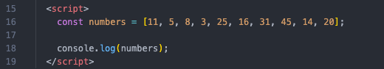
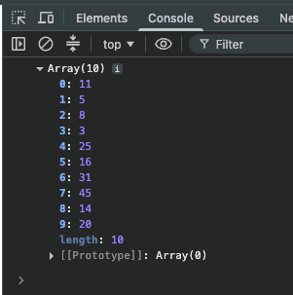

Is your result correct?
Yes / No.

Branch name | array-task | Commit Number: | 2436ce90336a3b935a348e72a3e1178a7ce11c36
B1.3 Sort the array created in Q1.1 above in “ascending” order (ascending is smallest to largest)

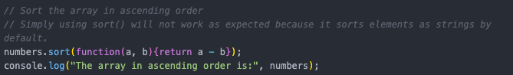
Is your result correct?
Yes / No.

Branch name | Array-task | Commit Number: | d2d40c0fc8ecfc12901989f139c0b00dbcd18a6b
B1.4 Insert three numbers 19, 23, 30 into the sorted array above, and keep the new array in ascending order

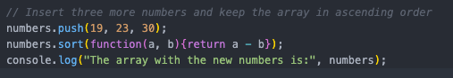

Is your result correct?
Yes / No.

Branch name | Array-task | Commit Number: | 37add032dc14b3626fa68b9ebff54cb79560d977
B1.5 Remove two numbers 8, 31 from the array generated in Q1.3, and keep the new array in ascending order.

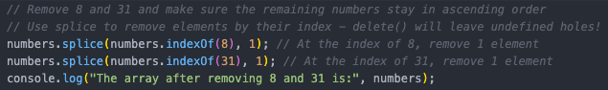

Is your result correct?
Yes / No.

Branch name | Array-task | Commit Number: | b6e38eb51c5248d28b730abb08e1a7f082a50ebd
B1.6 Implement the function “seqentialSearch” as per part 5 of the task description

Is your result correct?
Yes / No.

Branch name | Array-task | Commit Number: | 74669567412d18809efa9e139817c46a9f9de975  &  e29c578a2c9feb823cc303b749c2e921c898943c
B1.7 Implement the function “binarySearch” as per part 6 of the task description

Is your result correct?
Yes / No.

Branch name | Array-task | Commit Number: | C44d2ed7ad95965c05aa1d6b058eeb25549cf97c  &  e29c578a2c9feb823cc303b749c2e921c898943c
B1.8 You are required to develop a test plan that covers the functions “sequentialSearch” and “binarySearch” The test plan should be in the submission for review.
Your test plan will need to test the functionality of these two functions.
B1Test_Plan_and_Result_Template.slsx

Branch name | Array-task | Commit Number: | 6d6b44b958a753b0bf8f000b316c58ce67f2102a
B1.9 Conduct the tests in your test plan and record the results in your test plan file.

As tested in:
B1Test_Plan_and_Result_Template.slsx

Branch name | Array-task | Commit Number: | 6d6b44b958a753b0bf8f000b316c58ce67f2102a
B1.10 You are required to properly document your JavaScript code. The JavaScript code files must be submitted for review.

Record the name of the JavaScript code files for this part: script.js

Branch name | Array-task | Commit Number: | N/A
B1.11 While development of the functions in Q1.5 and Q1.6 use the debugging tools to show the following:

Breakpoint: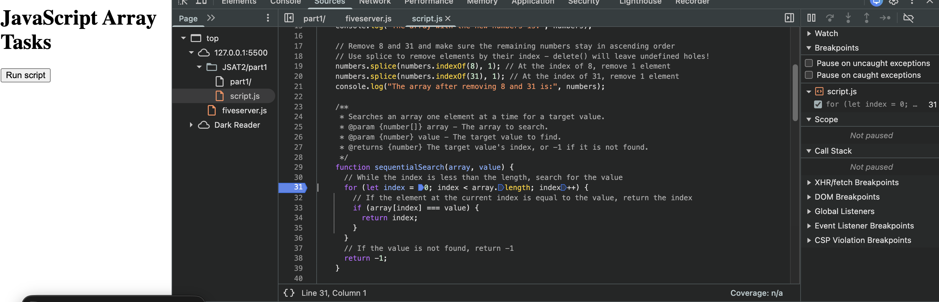

Step-through:

[function repeats this check until value is found or whole array is searched without a result – result found below]

A screenshot of variable contents (numbers array):
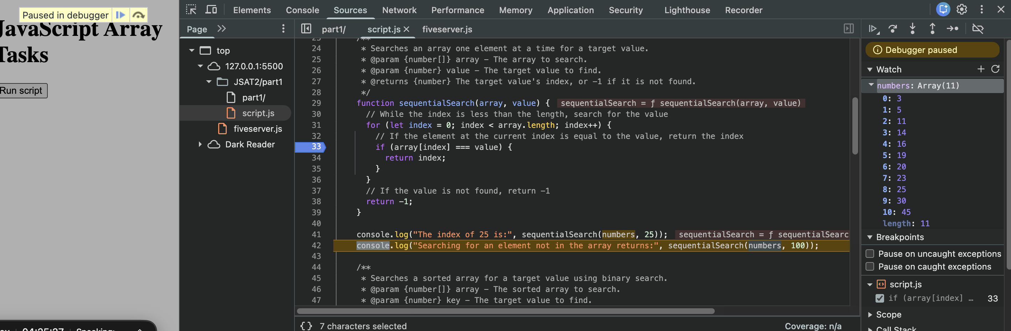

Branch name | Array-test | Commit Number: | 033f48372b53e87cb260187aa6e3bfa6b49dbe5b
B1.12 Confirm that all coding guidelines have been followed

Yes / No

Branch name | Array-test-coding-guidelines | Commit Number: | deb3250444fd883e73201934b7bab6cc74745562

Part B2 – Using basic data structures – Objects
Programming Requirement
In this part, you are required to design and implement a range of algorithms to operate an object with given input. The following operations need to be done using JavaScript programming language and the result need to be verified using browser.
- Build an object called “myMovie” with the following properties and data.
  - Title: The longest day
  - Year: 1964
- Add in the properties:
  - rating: 5
  - Summary: World War II movie about the Normandy landings
- Change the rating to 4 and change the year to 1962
- Remove the Summary property
As per the last part, each question will have a space for you to record a branch name and commit code.

B2.1 Record GitHub repository details for this part:
(Note: This repository can be the same as part1)
Record the GitHub repository name:
ICT40120

Record the GitHub repository URL:
ICT40120

Record the date the repository was used.
Created on 06/08/2026, used for this task on 27/08/2026.

B2.2 Build an object called “myMovie” with the following properties and data:
  - Title: The longest day
  - Year: 1964
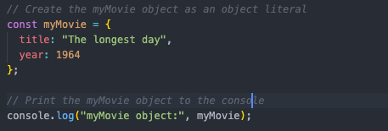

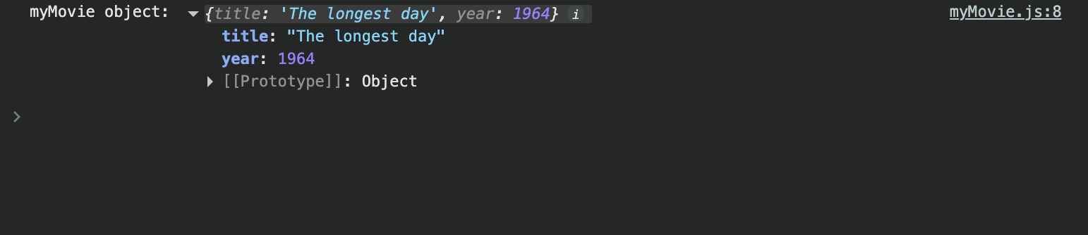

Is the result correct?
Yes / No

Branch name | Movie-task | Commit Number: | b937d992e7034a92825d82b550f4efd260c7b7b4
B2.3 Add the following properties and data to the “myMovie” object:
  - rating: 5
  - summary: World War II movie about the Normandy landings
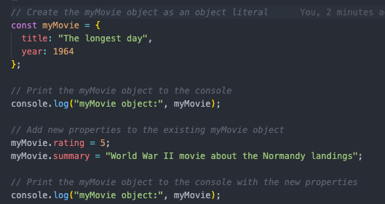

Is the result correct?
Yes / No

Branch name | Movie-task | Commit Number: | d199a02e46c28812d8375c7dc6964693520fbe35
B2.4 Change the data of the properties listed below:
  - Rating: 4
  - Year: 1962
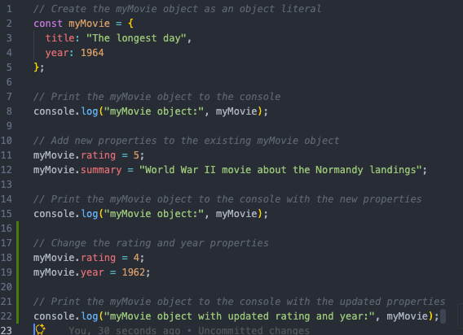

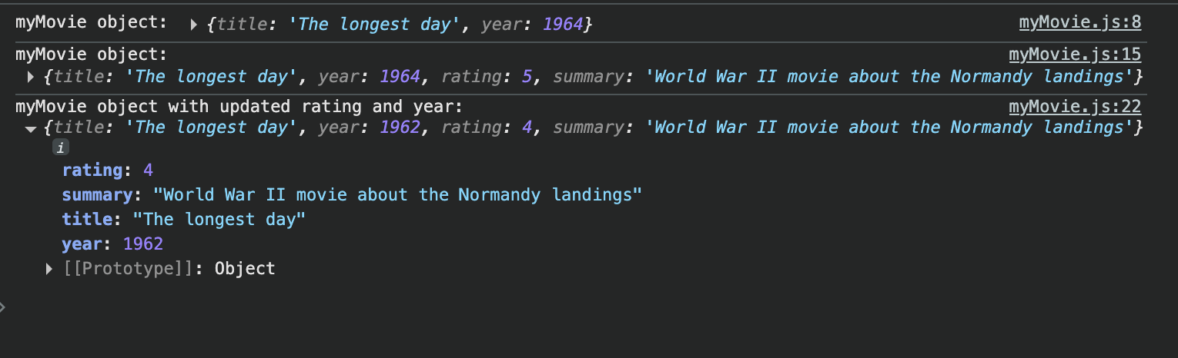
Is the result correct?
Yes / No

Branch name | Movie-task | Commit Number: | aed9a42b972d592a36d48d9c589b334a163374a6
B2.5 Remove the summary property from “myMovie”:
  - Title: The longest day
  - Year: 1964
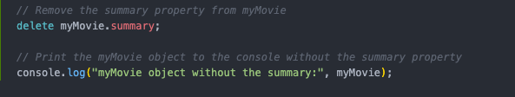
Is the result correct?
Yes / No

Branch name | Movie-task | Commit Number: | 5885db553d9d0260a7331c1e7e613fb8a587d536

Part B3 – String Manipulation and Files
Programming Requirement

In this part, you are required to design and implement a range of algorithms to manipulate strings. The following operations need to be done using JavaScript programming language and the result need to be verified using node.

You will then need to create an algorithm and implement this to write a string to a text file and read in a text file. Reading and writing to file can be done in either C# or JavaScript. If using JavaScript, you will need to verify the results using Node.js.

As per the pervious parts, there are spaces for you to record your version control. The repository, branch name and commit code.
You should start a new repository for this part.

- Define the following strings:
  - myString = “This is a string”
  - anotherString = “ Another string” (note there are 3 blank spaces at the beginning)
  - hello = “Hello there!
  - myName = your first name
- Use the utility functions length and chat to find out information
  - Find out the length of myString
  - Find out the first character of myString
  - Find out the 11th character of myString
- Use the slice and substring functions to create new strings.
  - Slice “is a” from myString
  - Use substring to get “the” from anotherString
- Change the case of the myName string
  - Print out the myName string in all upper case
  - Print out the myName string in all lower case

- Use concat, trim, replace and split to create new strings
  - Concat hello and myName together
  - Use the trim function to remove the spaces in anotherString
  - Use the replace function to change “is a” to an empty space in myString
  - Split myString on the spaces.
- Create algorithms
  - Create algorithm for saving string to a text file
  - Create algorithm for reading in the text file

- Write a text file
  - Name the text file output.txt
  - Create a string of data to save to a text file
  - Write the string to the text file
- Read text from a text file
  - Get the file name output.txt
  - Read in the text file
  - Prin the text that was read in, to the screen.
Submit for review
You are required to submit the following for review
- This assessment document with all questions answered
- All source code files
You are required to compress all files should in a zip file and submit the zip file for review.

B3.1 Record GitHub repository details for this part:
Record the GitHub repository name:
ICT40120

Record the GitHub repository URL:
ICT40120

Record the date the repository was used.
Created on 06/08/2026, used for this task on 20/08/2026.

B3.2 Define the following strings:
  - myString = “This is a string”
  - anotherString = “ Another string” (note there are 3 blank spaces at the beginning)
  - hello = “Hello there!
  - myName = your first name
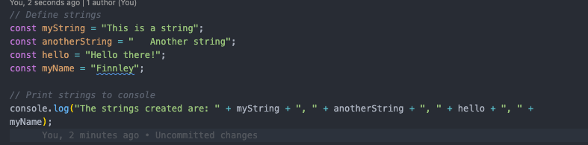

Is the result correct?
Yes / No

Branch name | String-task | Commit Number: | 34da5c3f9929112ef62bd9d35250e50afb5fbe7d
B3.3 Use the utility functions to find out the following information
  - Find out the length of myString
  - Find out the first character of myString
  - Find out the 11th character of myString
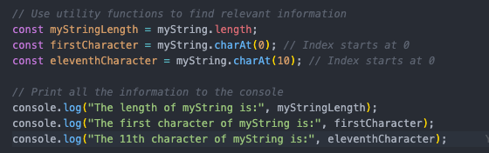
Is the result correct?
Yes / No

Branch name | String-task | Commit Number: | e84986f320e0bd06adde312c0b382aa56d7ee808
B3.4 Use the functions slice and substring to create new strings
  - Slice “is a” from myString
  - Use substring to get “the” from “anotherString”
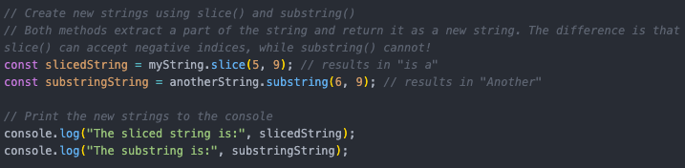

Is the result correct?
Yes / No

Branch name | String-task | Commit Number: | c0b34df960615cb83c5c4058b41040e5397dce41
B3.5 Change the case of the myName string
  - Change myName string to upper case
  - Change myName string to lower case
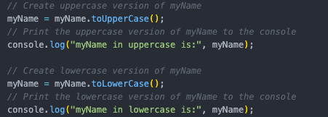

Also updated myName to no longer use const:

Is the result correct?
Yes / No

Branch name | String-task | Commit Number: | 9e9df9e4f5755d3c52bd847af0bd4282d25e79cc
B3.6 Use various utility methods to create new strings
  - Use the concat method to join the hello string and myName string
  - Use the trim method to remove the spaces in anotherString
  - Use the replace method to change “is a” to an empty space in myString
  - Use the split method on myString using the spaces to break the string
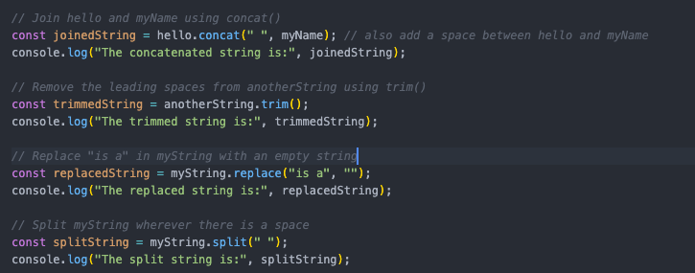
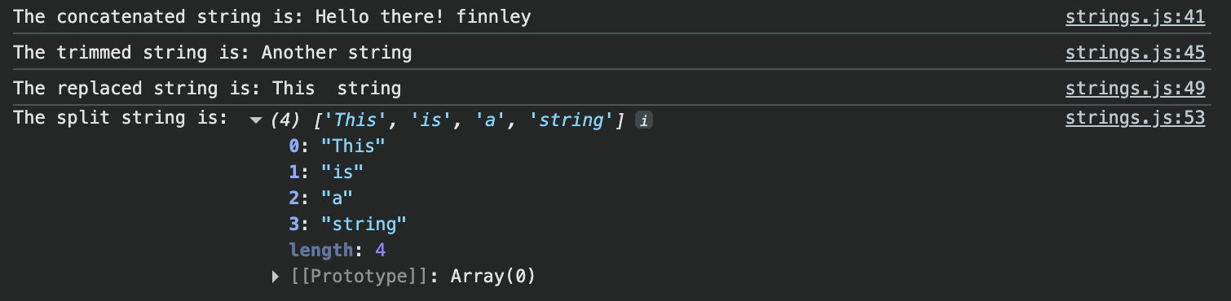
Is the result correct?
Yes / No

Branch name | String-task | Commit Number: | dbd8d4dfc845a277ea0372554e1b38959e97f559
B3.7 Create algorithms for file handling. You need to create 2 algorithms as listed below:
  - Create an algorithm for saving a string to a text file
  - Create an algorithm for reading in a text file
File writing:

1. Load the Node.js file-system tools.
2. Receive the name of the text file to read.
3. Open the specified file.
4. Read the file contents using UTF-8 text encoding.
5. Store the contents in a string variable.
6. Close the file.
7. Return the string containing the file contents.
8. Display the returned string on the screen.

END

File Reading:

1. Load the Node.js file-system tools.
2. Receive the name of the text file to read.
3. Open the specified file.
4. Read the file contents using UTF-8 text encoding.
5. Store the contents in a string variable.
6. Close the file.
7. Return the string containing the file contents.
8. Display the returned string on the screen.

END

Branch name | String-task | Commit Number: | 8d9713625cc86ffac51b85104ad678fc9b2c7fa7
B3.8 Write a text file
  - Name the text file output.txt
  - Create a string to save to the text file
  - Write the text file
Note: For this question you can use JavaScript or C#
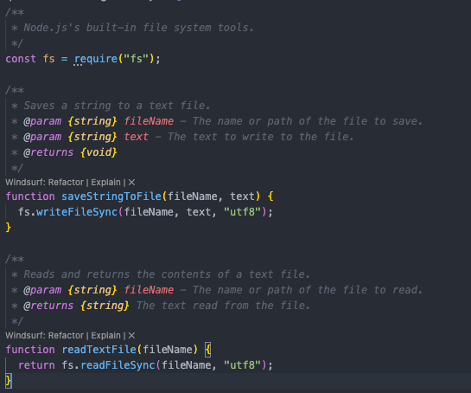
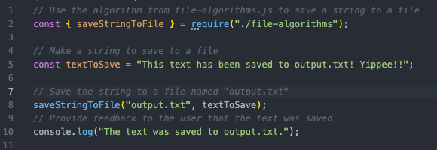

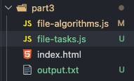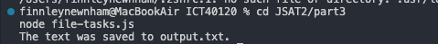
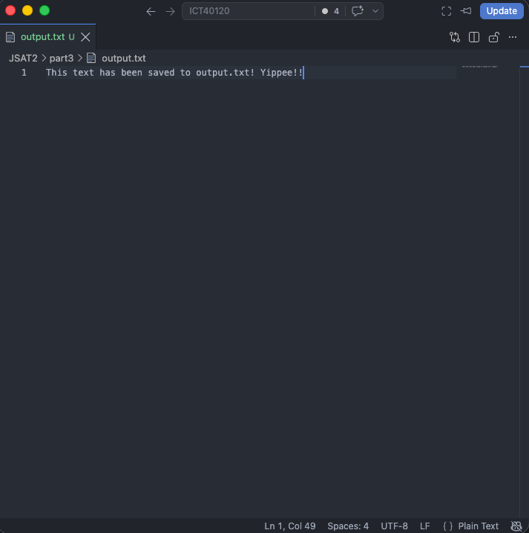

Is the result correct?
Yes / No

Branch name | String-task | Commit Number: | 9e990ee3eea46f635214d1b03b8129490e66583c
B3.9 Read the contents of a text file
  - Read in the text file output.txt from Q3.7
  - Read in the contents of the file
  - Display what was read in from the text file to the screen
Note: For this question you can use JavaScript or C#
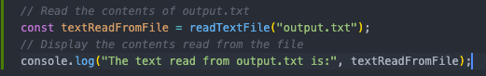

Is the result correct?
Yes / No

Branch name | String-task | Commit Number: | cbd582015f05312a1906599019d09b78470fe288

Part B4 – Data structures and algorithms – complex data types
Programming Requirement

In this part, you are required to design and implement a range of algorithms to operate an array of objects. The following operations need to be done using JavaScript programming language and the result need to be verified using browser.

You will be required to create a GitHub repository for this part. As per the previous parts, branch names an commit numbers can be recorded in each question below.

- Define a movie class with the following properties.
  - Movie ID
  - Title
  - Year
  - Rating
- Create an array of at least 10 movies with mock values
  - Movie ID must be unique for each movie.
  - Movie ID must not be sorted in the array
- Sort array by Movie ID in ascending order
- Implement at least one search algorithm (sequential search or binary search)
  - This function accepts two parameters: an array and a movie ID
  - This function searches the input array for the input movie ID using selected searching algorithm
  - You cannot use the JavaScript build-in “find” function. You must implement the algorithm with your own code.
  - This function returns the movie object found or return “null” if not found

Note: Students may use https://www.mockaroo.com/ to help generate mock data for array.

Submit for review
You are required to submit the following for review
- This assessment document with all questions answered
- All source code files
You are required to compress all files should in a zip file and submit the zip file for review.

B4.1 Record GitHub repository details for this part:
Record the GitHub repository name:
ICT40120

Record the GitHub repository URL:
ICT40120

Record the date the repository was used.
Created on 06/08/2026, used for this task on 08/10/2026.

B4.2 Define the movie class as required using JavaScript. Insert the screenshot of your code below
Movie.js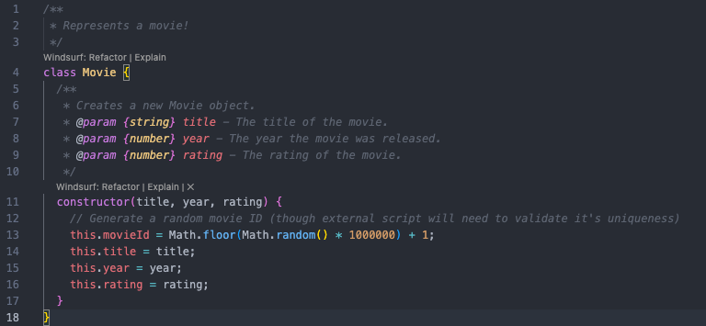
Index.html
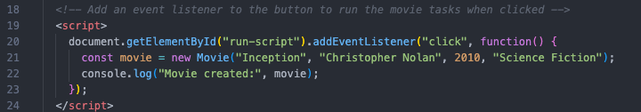
Console output on click:
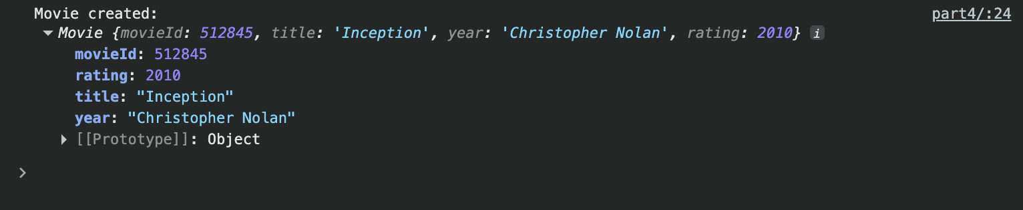

Branch name | movie-class-task | Commit Number: | e3bbd7bdc2564f91409e52ec562eddb460450273
B4.3 Create an array of at least 10 movies with mock values and print the array in console.
Remember: Movie ID must be unique for each movie and not sorted in the array.
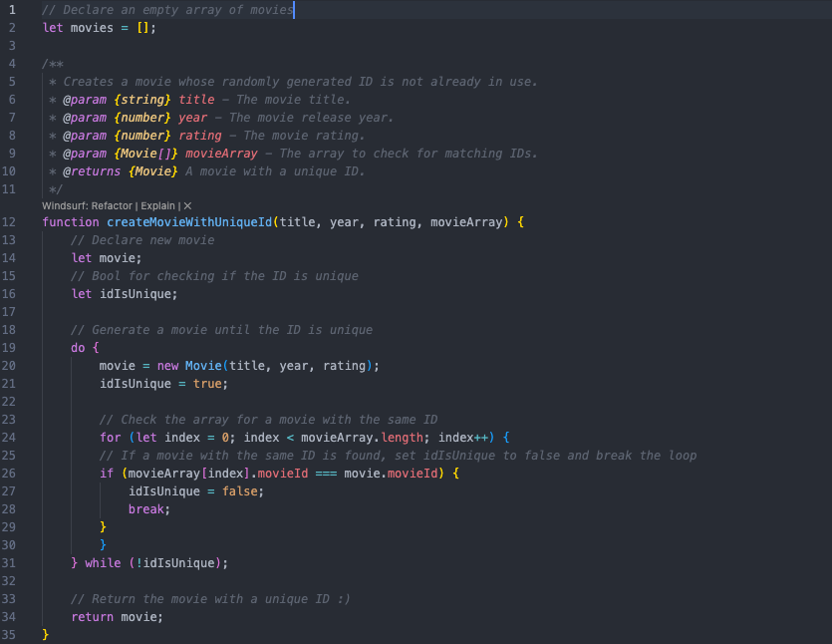
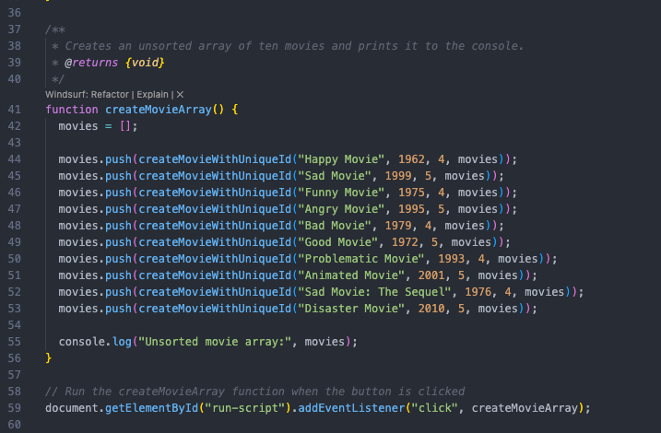
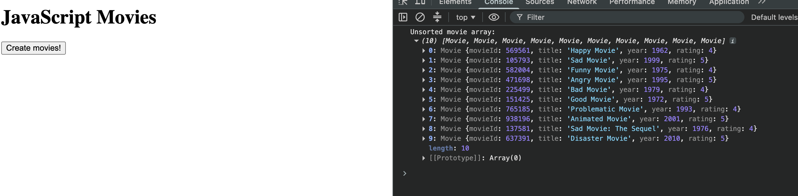

Is the result correct?
Yes / No

Branch name | Movie-class-task | Commit Number: | 1cbec3986b4893f617ff28676134710454ef45f3
B4.4 Sort the array in “ascending” order by Movie ID.
Remember: Movie ID must be unique for each movie and not sorted in the array.
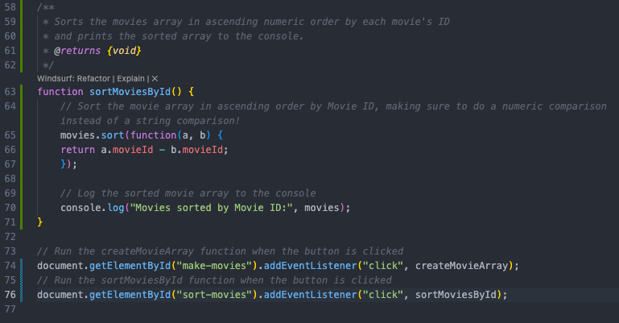

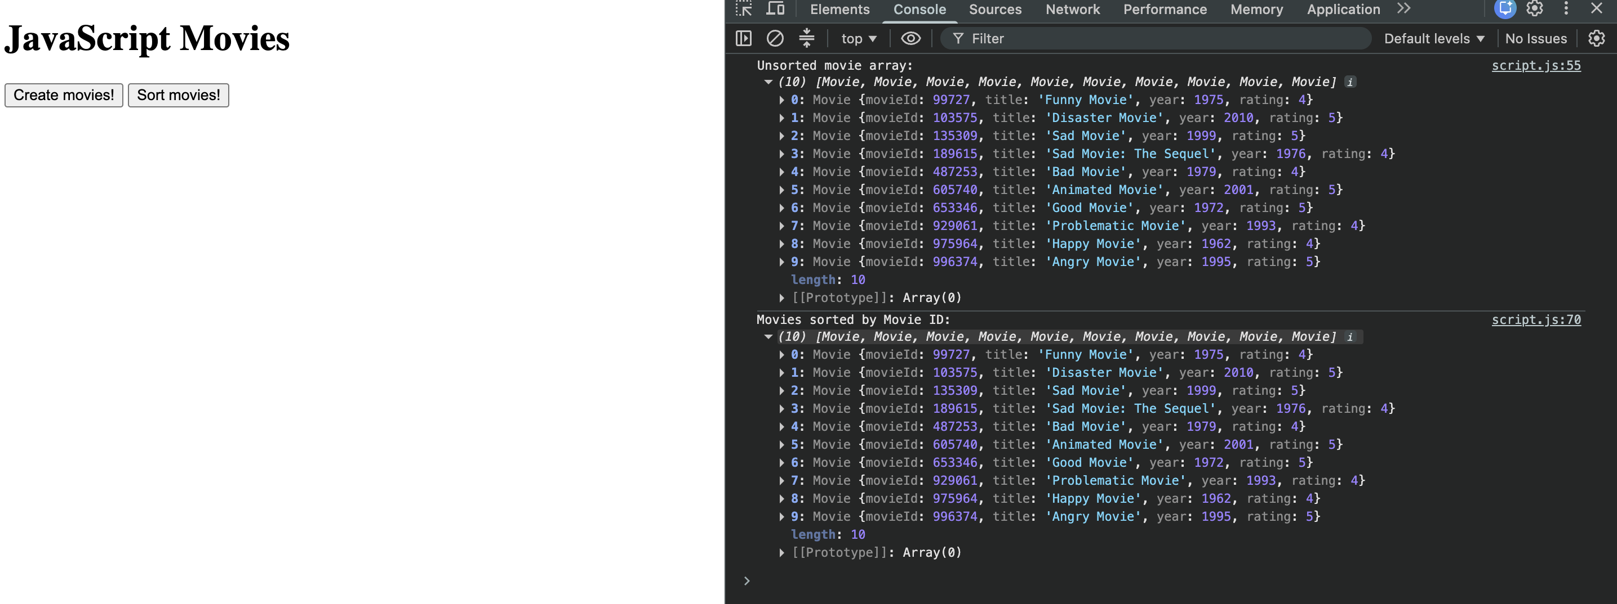

Is the result correct?
Yes / No

Branch name | Movie-class-task | Commit Number: | 1d51a7359cf586751ecf9aff04e34898c89d0ee8
B4.5 Implement at least one search algorithm (either sequential search or binary search) according to the requirements in the task description.
Which search algorithm was chosen:
Binary, based on part 1 with wrapper functions to demonstrate hard-coded values.

Search algorithm:

Wrapper functions:
Outputs:

Is the result correct?
Yes / No

Branch name | Movie-class-task | Commit Number: | Edab6ba3e9f82f7f95a8aa206b2c37af336a449a  &  72d3a28b122f6a6918497b8ff27a3205ce945d5b

Part B5 – Build a graphical user interface
UI Requirement
You are required to create a JavaScript array to maintain a list of the movie class defined in Part 4 and build a web-based UI to manage the movie list using HTML, CSS and JavaScript. This move list needs to be created as a class.

Also, you are required to create and maintain a repository for this project. You need to upload or push your changes after you complete each question. The repository name is completely up to you, but it must be public.

Remember to use branches and insert your commit numbers in each question

The web-based UI has four sections
- Movie maintenance section: this UI section allow user to insert, delete or modify one movie. In this UI, the following elements are required
  - A Movie ID input
  - A Title input
  - A Year input
  - A Rating input
  - A Submit button
  - The submit button will save a new movie, delete a movie or update a movie when the user clicks it.
  - These should change the movie list array.
  - The movie list should update after any of these actions are done.

- Display movie list: this UI section allow user to view the current movie list. In this UI, the following elements are required
  - A list view – this view is used to display information stored in the movie JavaScript array
  - A Refresh button – when user click on the Refresh button, all data in the list view will be refreshed with the current data stored in JavaScript

- Search movie: this UI section allow user to search movie information using movie ID, the following element are required
  - A movie ID input – user can input a movie ID for searching
  - A Search button – when user click on Search button, the program will search the movie list using the input ID and return result
  - A search result view – this view is used to display the search result. The movie details will be displayed if found or a “0 result” information will be displayed if not found.
  - Search by Title – when this is used search the movie list for something that contains the search string typed in. The list should update with all names shown in the list.

- Sort movie: this UI section allow user to sort the list in both a-z or z-a fashion and render to the screen,
  - Sort A-Z - This button should show the movie list sorted by Title A-Z and displayed to the screen
  - Sort Z-A – This button should show the movie list sorted by Title Z-A and displayed to the screen.
  - Best Movies - This button should show the movie list sorted by Rating Z – A and displayed to the screen.

Testing:
You are required to test both the UI and your JavaScript.
- You need test that your UI shows everything as expected and that it behaves as expected
- You also need to test that all your JavaScript functions work as expected.

For the UI defined above you need to style the layout with CSS for better user experience. Pick a theme (colours) to use and stick with it through the page(s).

Workflow
You are required to follow the workflow blow to finish the development.
- Establish UI requirement
- Build a prototype UI (wireframe and graphic design)
- Get feedback and make changes
- Design and implement the UI
- Get feedback and make changes
- Test the UI
- Fix any outstanding issues / bugs
- Documentation
- Obtain client sign-off

Coding guidelines
HTML & CSS - https://www.w3schools.com/html/html5_syntax.asp
JavaScript - https://www.w3schools.com/js/js_conventions.asp

Mock Data
Mockaroo: https://www.mockaroo.com/

Submit for review
You are required to submit the following for review
- This assessment document with all questions answered
- All source code files
- Wireframes in .png or .jpg format

B5.1 Record GitHub repository details for this part:
Record the GitHub repository name:
ICT40120

Record the GitHub repository URL:
ICT40120

The initial commit number:
d891bd9bebd280ae11b89e17a79ae7220daf1e11

Record the date the repository was used.
Created on 06/08/2026, used for this task on 15/11/2026.

B5.2 Gather the UI requirements and guidelines from the description above and communicate with the client. Confirm the requirements with your client and obtain client sign off.
List all requirements in the table below:
Requirement # | Requirement Details
1) Movie maintenance section | This section’s UI must contain:  - A Movie ID input  - A Title input  - A Year input  - A Rating input  - A Submit button  On clicking the submit button:  - Delete or update an existing movie, or save a new movie  - Update the movie list array with changes  - The movie list should update after any of these actions are done
2) Display movie list | This section’s UI must contain:  - A list view of the information stored in the movie JavaScript array  - A refresh button  On clicking the refresh button:  - All data in the list view will be refreshed with the current data stored in the JavaScript array
3) Search movie | This section’s UI must contain:  - A movie ID input where the user can input a movie ID for searching  - A Search button  - A search result view  - Search by Title option  On clicking the search button:  - The program will search the movie list using the input ID or title and return the result  - The search result view will update with the movie details displayed if found, or “0 result” information if not found.  - If using an ID to search for an existing movie, the single movie with a matching ID will be displayed  - If using title to search for existing movies, all movies with a title including the string provided will be shown
4) Sort Movie | This section’s UI must contain:  - Sort by title - A-Z option  - Sort by title - Z-A option  - “Best Movies” - sort by Rating option  On clicking the sort button:  - All movies in the JavaScript array should be sorted in the selected order and displayed to the screen
5) Testing requirements | Both the UI and JavaScript must be tested:  - Test that the UI shows everything as expected and that it behaves as expected  - Test that all JavaScript functions work as expected.
6) Style requirements | CSS must be used to enhance the user experience.  A consistent colour theme should be used.
Guideline # | Guideline Details
1 https://www.w3schools.com/html/html5_syntax.asp | These guidelines apply to the HTML & CSS portion of the webpage. They dictate how the content (HTML) should be structured and produced, along with how the styling language (CSS) should be used.
2 https://www.w3schools.com/js/js_conventions.asp | These guidelines relate to the scripting language the webpage will be using (Javascript). They establish conventions for code quality including syntax and naming, and help to ensure consistency.

Branch name | N/A |  |  | Commit Number: |  |  |  | N/A
Checklist and sign off
Skills to be observed during this task to the required standard.  Checklist (To be completed by the learner’s facilitator)  The following tasks are to be completed in relation to the brief for this project. Each of the skills must be observed on at least one occasion. |  |  |  |  |  | Date 1 |  |  |  | Date 2
 |  |  |  |  |  | 8/10/2026
 |  |  |  |  |  | Satisfactory |  |  |  | Satisfactory
 |  |  |  |  |  | Yes |  |  | No | Yes |  | No
Leaner has expressed UI requirements to the client |  |  |  |  |  | Yes
Learner has confirmed and understood the UI requirements |  |  |  |  |  | Yes
Learner has confirmed the task with the client |  |  |  |  |  | Yes
Learn has confirmed the specifications, standards and guidelines to be followed with the client. |  |  |  |  |  | Yes
Assessor Name |  | Amberle Seidl | Assessor Signature |  | Amberle Seidl |  | Date |  |  |  | 8/10/2026
B5.3 What are the HTML guideline documents that are to be followed? List the filename or URL of the guidelines. Describe the guidelines you are following (at least 1 paragraph)
URL: https://www.w3schools.com/html/html5_syntax.asp

The HTML guidelines I am following describe recommended syntax and formatting practices for writing HTML5 code. This includes the use of lowercase element and attribute names, using double quotation marks around attribute values, including the appropriate <!DOCTYPE html> declaration, and other such requirements. It dictates that all HTML elements must be properly structured and nested, and the guidelines also emphasise the importance of clear and consistent formatting to make HTML code easier to read and maintain.

Branch name | N/A |  |  | Commit Number: |  |  |  | N/A
B5.4 What are the software applications that are to be used to create the prototype UI (wireframe and prototype)
Possible tools:
Figma
Adobe Photoshop
Adobe Illustrator

What I am using:
Figma

Branch name | N/A |  |  | Commit Number: |  |  |  | N/A
B5.5 Build the wireframe of your UI using the tool you identified in question B5.4
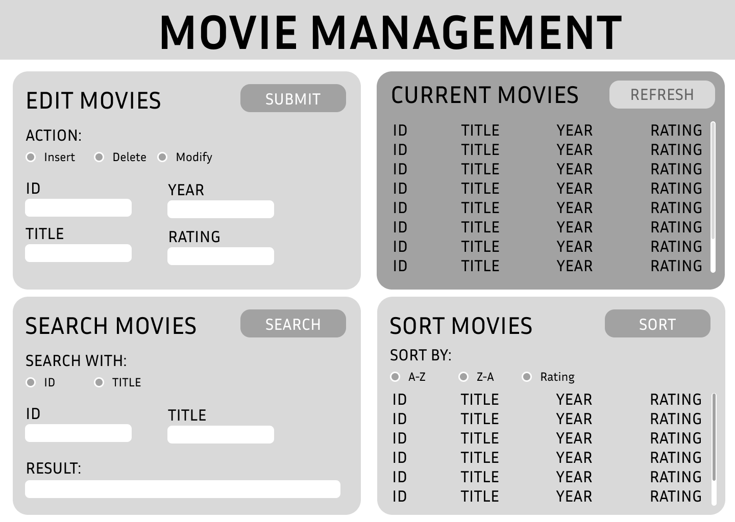

Branch name | N/A |  |  | Commit Number: |  |  |  | N/A
B5.6 Review the wireframe with the client and get feedback. Revise and update the wireframe from feedback given.
Feeback:
- Combine “Current Movies” and “Sort Movies” sections
- Have “Search Movies” result display in the above combined section
- Replace radio form elements with buttons
- Update “Edit Movies” section with more clear titles and keywords
- Ensure “Refresh” button in combined movie-list-display clears any search results

Updated Wireframe:
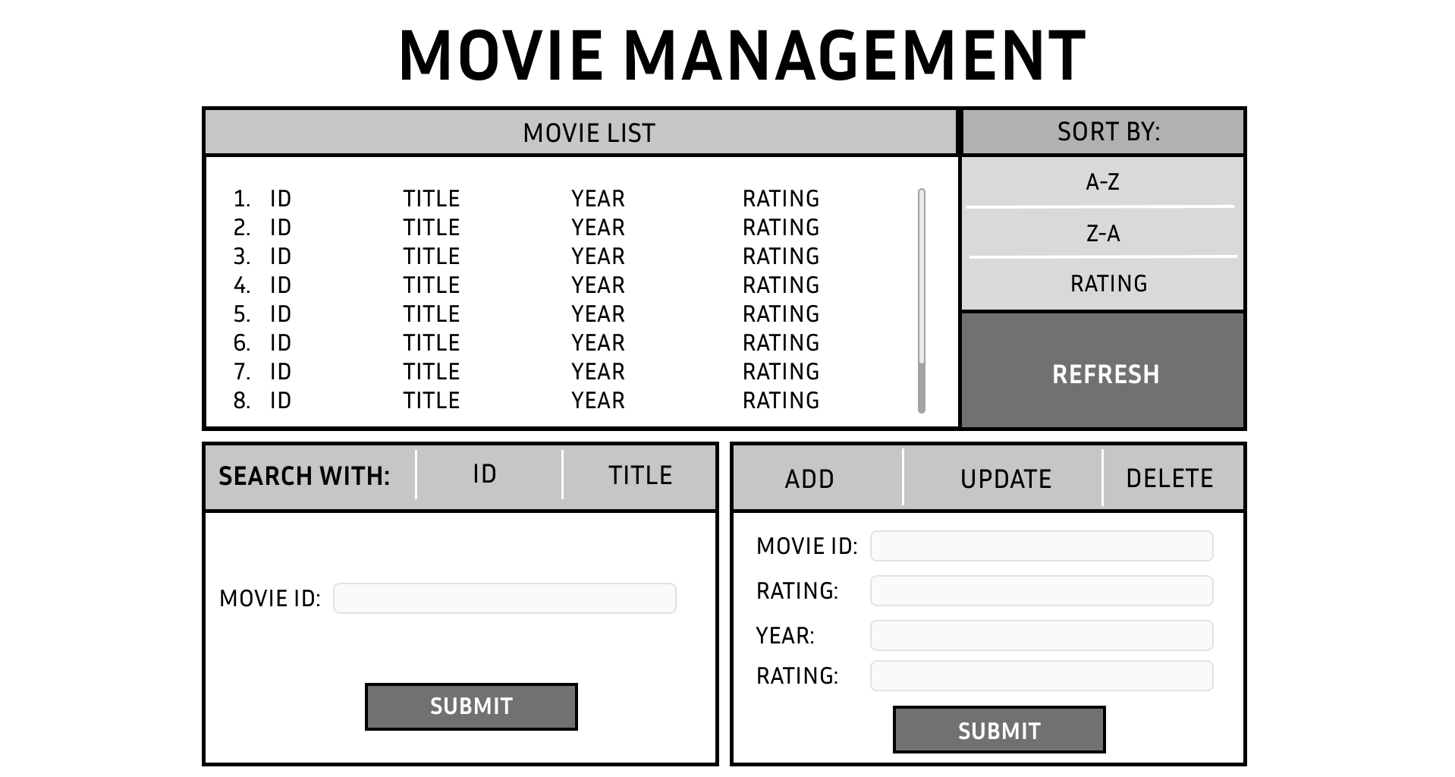

Branch name | N/A |  |  | Commit Number: |  |  |  | N/A
B5.7 Create the theme for your UI. Record the colours and font below
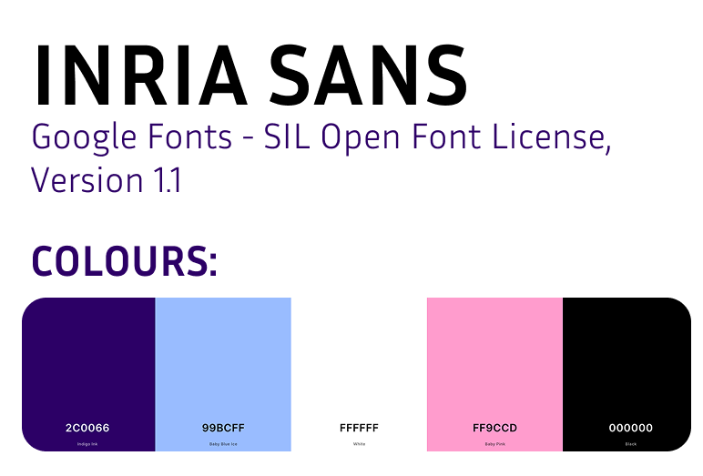
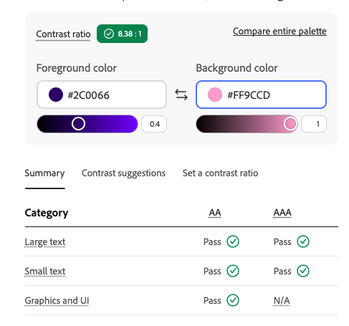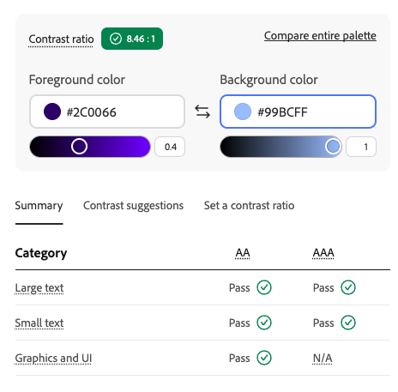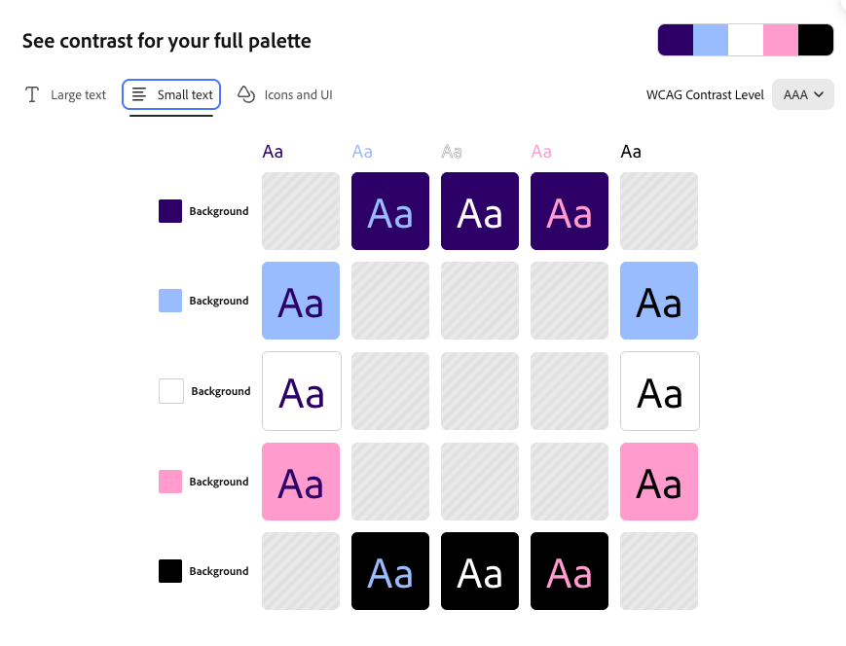

Branch name | N/A |  |  | Commit Number: |  |  |  | N/A
B5.8 Create prototype of the application using tools listed in B5.4. Enhance the wireframe with the theme colours.
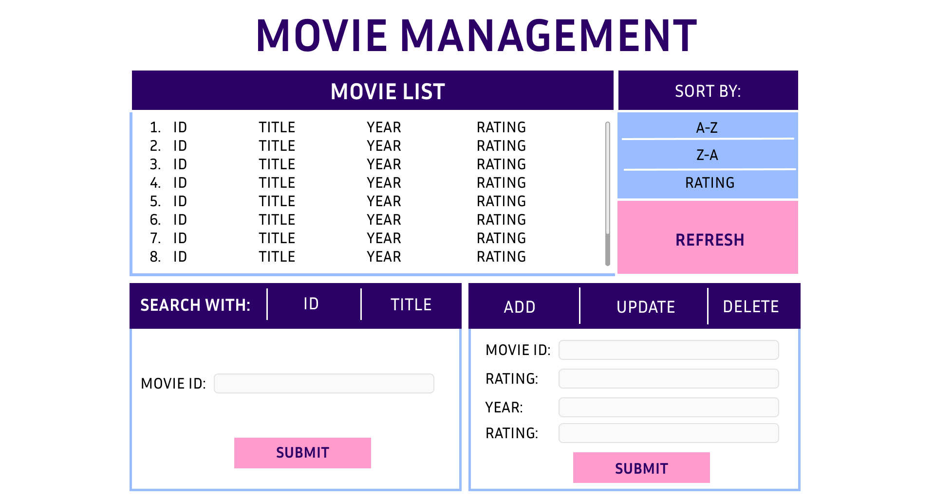
Branch name | N/A |  |  | Commit Number: |  |  |  | N/A
B5.9 Review the prototype with the client and get feedback. Revise and update the wireframe from feedback given. Obtain signoff
Feedback:
- Great layout
- Good colours

No further iterations were needed.

Branch name | N/A |  |  | Commit Number: |  |  |  | N/A
Client Name | Amberle Seidl | Client Signature | Amberle Seidl | Date | 8/10/2026
B5.10 Describe the content flow / UI Actions / UI Events of each of the UI sections required.
- Content flow: Describe the content flow from the user’s perspective
- UI Actions: describe the UI actions based on the UI design from the user’s perspective
- UI Events: describe the events triggered in HTML / JavaScript
UI Section | Content flow | UI Actions | UI Events
Movie maintenance  (add) | The user enters a new Movie ID, Title, Year and Rating, then submits the form. After submitting the form, the new movie is added to the movie list and the updated list is displayed. | User selects the “Insert” option from the buttons and enters the movie information into the form, then clicks the Submit button. | The click event on the Submit button triggers JavaScript to add the new movie to the movie array and refresh the movie list after checking that a movie with the same ID does not already exist.
Movie maintenance  (update) | The user enters the Movie ID of an existing movie along with the updated Title, Year and Rating. The program finds the movie with the matching ID, updates its information in the array, and refreshes the movie list. | User selected “Modify” from the buttons, enters the existing Movie ID and the updated movie information, then clicks the Submit button. | The click event on the Submit button triggers JavaScript to find the movie by ID, update its details in the array and refresh the movie list after validating the new details.
Movie maintenance  (delete) | The user inputs the ID of the movie they wish to remove. The program finds the movie with the matching Movie ID and removes it from the JavaScript movie array. The movie list is then updated so that the deleted movie is no longer displayed. | The user enters the Movie ID of the movie they want to delete and selects the “Delete” option from the buttons before pressing the “Submit” button. | The click event on the delete/Submit button triggers JavaScript to find and remove the movie from the array, then refresh the movie list.
Display all movies | The user sees the current movies stored in the JavaScript movie array under the "Current Movies” section. When the user refreshes the list, the latest data is displayed. | The user clicks the Refresh button. All movies are displayed. | The click event on the Refresh button triggers JavaScript to retrieve the current movie array and display all movies.
Search by ID | The user searches for a specific movie using its Movie ID. If a matching movie is found, its details are displayed. If no movie is found, the user sees "0 result" information. | The user selects “ID” from the radio buttons under “Search Movies”, enters an ID, and clicks the Search button. | The click event on the Search button triggers JavaScript to search the movie array for a movie with a matching ID and populates the list section with any movie found or a “0 result”.
Search by Title | The user searches for a specific movie using its title, or part of a title. If a matching movie is found, its details are displayed. If no movies are found, the user sees "0 result" information. | The user selects “Title” from the radio buttons under “Search Movies”, enters a title or part of a title, and clicks the Search button. | The click event on the Search button triggers JavaScript to search the movie array for movies with the provided string in their title, and populates the list section with any movies found or a “0 result”.
Sort Movie – Title A-Z | Under “Sort Movies”, the user chooses to view the movies alphabetically A-Z. The movie array is sorted from A to Z and the sorted list is displayed. | The user selects A-Z from the buttons and clicks the Sort button. | The click event on the Sort button triggers JavaScript to sort the movie array by title in A-Z order and updates the list view.
Sort Movie – Title Z-A | Under “Sort Movies”, the user chooses to view the movies alphabetically Z-A. The movie array is sorted from Z to A and the sorted list is displayed. | The user selects Z-A from the buttons and clicks the Sort button. | The click event on the Sort button triggers JavaScript to sort the movie array by title in Z-A order and updates the list view.
Sort Movie – Best Movies | Under “Sort Movies”, the user chooses to view the movies by rating. The movie array is sorted from highest rating to lowest, and the sorted list is displayed. | The user selects Rating from the buttons and clicks the Sort button. | The click event on the Sort button triggers JavaScript to sort the movie array by rating from highest to lowest, and updates the list view.

Branch name | N/A |  |  | Commit Number: |  |  |  | N/A
B5.11 Determine the languages used to build the UI. List all the languages used and describe what they are used for. (at least 1 paragraph for each description.)
Language Name | Description
HTML | HTML will be used to produce the content of the webpage. This includes things such as text, headings, buttons, etc. HTML is not a programming or styling language, and will just be used to implement the plain content and structure of the webpage. HTML is used across the web for this purpose.
CSS | CSS will be used to style the page. CSS is a styling language that changes the appearance and sometimes behaviour of HTML elements. CSS is also used across the web in this way. CSS helps to make webpages aesthetically pleasing and more readable and usable for users, as plain HTML is very unattractive and can be difficult to interact with without styling.
JavaScript | JavaScript will be used to manipulate the behaviour of the webpage and manage the data. JavaScript is a scripting language that can be used to control the content and presentation of a webpage by manipulating data and HTML elements, along with CSS styling. For example, JavaScript will be used here to store the Movie List data and perform operations and changes to this data, which will then be presented to the user in HTML elements, styled by CSS.

Branch name | N/A |  |  | Commit Number: |  |  |  | N/A
B5.12 Design and build the UI with the languages listed in B5.11
List all files and file paths for your UI:
part5/
├── index.html
├── Readme.md
├── B5Test_Plan_and_Result_Template.xlsx
├── css/
│ └── style.css
└── js/
├── movie.js
├── movie-list.js
└── app.js

Insert the screenshot of the UI as shown in a browser:

Feedback & Changes made throughout development:
- When hovering over a row in the list, the text would turn pink. This was not readable.
  - Updated to use the purple colour instead, compliant with accessibility standards.
- Users should not be able to input their own MovieID value.
  - A random ID is generated now and this input field under Add was removed.
- The traditional dialogue box asking for confirmation when deleting a movie was functional, but ugly.
  - A modal box was implemented to improve user experience.
- Error messages should be specific.
  - Specific error messages for each type of invalid/missing input were added to improve user interface

Branch name | Movie-application |  |  | Commit Numbers: |  |  |  | - 1aa67c9f11d4630040074da21b71539824ee9999  - C5101c8bf5dd4d2425348c73364d51af84e0cd5d  - F7b22fa45d6ce2f4ab7f1e428e25bc71d9ee43e3  - 4fa18b68f1a00f99798bd1a0897a9b8682ce98b0  - 18c7c2e51ca88e5d6a2d406339f857cf632e696c  - D677654402ed5f121482c7a85e14337d7a6f2982  - 5179d1cf8e4d6ae638dcc486d3602c242cc177a6  - E2c65a902e374ee504deb0a968bb1d553864e197  - E2c65a902e374ee504deb0a968bb1d553864e197  - 8600c235ea63f749d757641df1a93654b368da86  - A50967a5a3c5c9e18c6361a599a821bc7c90dbb4  - 3f50fa172cbd6d83688785ed87cbbca8ccbdb9dd  - 21f9e27754a23dbcbe1e40927c094db15cc46c8e  - A9a71f17f05c18e40f4002199a97dd1ff9e36eee  - 3c2101fddca7e546cdebf2827a5811b8765d7982
B5.13 Develop the test cases the verify the UI Functionality
B5Test_Plan_and_Result_Template.slsx

Branch name | Movie-application |  |  | Commit Number: |  |  |  | d677654402ed5f121482c7a85e14337d7a6f2982
B5.14 Test the UI according to the test cases created in B5.13. You must iterate your UI design and build, until the test results meet the requirements.
File name: B5Test_Plan_and_Result_Template.slsx

All tests were successful. Further iteration was not required.

Branch name | Movie-application |  |  | Commit Number: |  |  |  | N/A
B5.15 You are required to demonstrate your application to the client and obtain final sign-off
Branch name | N/A |  |  | Commit Number: |  |  |  | N/A
Checklist and sign off
Skills to be observed during this task to the required standard.  Checklist (To be completed by the learner’s facilitator)  The following tasks are to be completed in relation to the brief for this project. Each of the skills must be observed on at least one occasion. |  |  |  |  |  | Date 1 |  |  |  | Date 2
 |  |  |  |  |  | Satisfactory |  |  |  | Satisfactory
 |  |  |  |  |  | Yes |  |  | No | Yes |  | No
Leaner has used debugging techniques to detect and correct error
Learner has developed the application in accordance with client requirements and guidelines
Assessor Name |  | Amberle Seidl | Assessor Signature |  | Signature |  | Date

Part B6 – Version control in a team environment
Task Requirements

You are required to contribute to a project and work in a team collaboration environment using GitHub. The project is a website. And the URL of the website is https://github.com/Amberside/the-programming-team-202620

The home page of the website has been done. Your task is to create your own page on this website.

Each grid in the home page links to the page of a team member. The link has been defined in the home page (e.g., /team/amberle/index.html), but the member’s page has not been created yet. You need to join the team to get your page created, tested locally and then merge your changes to the project.
- Your teacher’s page (Amberle Seidl) has been created. Click on Amberle’s name to check the detail.
- Your page has not been created yet. Find and click on your name to check the detail, which is a 404 file does not exist error.

1. Requirement of your page
You shall create a sub-folder, the name of which is made of first name, under the “team” folder. In this folder, you shall create a file called “index.html”. Refer to Amberle’s page as an example.
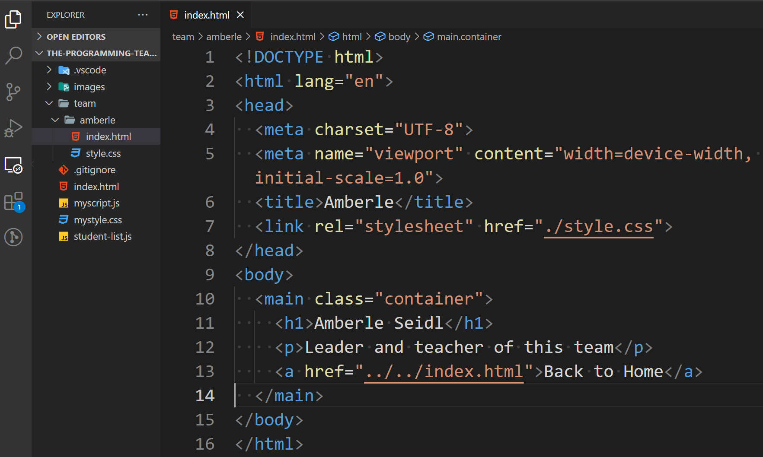
You must include your name.
You need to include some information about yourself.
You can think of this as a portfolio piece about yourself. Include things like experience and projects worked on.
2. VCS requirement
You must use GitHub as the VCS system for this task.

You shall provide your GitHub username to your teacher to add you a collaborator of the project, so that you could submit code.

You will also document the use of GitHub and the repositories here as well. Fill out the table provided. You must create at least 3 repositories while completing assessment task 2. These repositories must have at least 3 branches and be updated / merged 3 times.

You are not able to directly push updates to the “main” branch of the repository, instead, a new branch must be created for each push. And a pull request must be created for review. Your submitted code shall be reviewed and approved before merging to the main branch

3. Edit JavaScript & Feedback
You will need to update your name in the JavaScript array so that your page can be seen.
Lastly you will need to get feedback and make changes to your page.
4. Workflow & procedure
Step 1. Visit https://github.com/Amberside/the-programming-team-202620.git
Step 2. Click on Amberle’s name (the first grid) to view Amberle’s page (page can be viewed)
Step 3. Find your name, click on your name to check your page (page not found)
Step 4. Provide your GitHub username to your teacher to be added to the repository
Step 5. After your teacher invited you to the repository, accept the invitation in your email.
Step 6. Clone the repository to your local environment
Step 7. Create a new branch
Step 8. In folder “team”, create a sub-folder and name it using your first name
Step 9. In the sub-folder created above, create a file named “index.html”.
Step 10. Develop the content
Step 11. Test the result – Your page shall be displayed after clicking your name from the home page
Step 12. You may ask your teacher to confirm the test result before committing the codes
Step 13. Commit the codes
Step 14. Push/publish the commit to the server
Step 15. In GitHub website, create a pull request then notify your teacher to review the codes
Step 16 Respond to feedback.
Step 17. If your code is approved, your teacher will merge the code. Then you could view the website again to confirm the final result.
Step 18. Update the JavaScript file
Step 19. Obtain final sign-off from a supervisor

Upload your pages and this document to Brightpspace

B6.1 GitHub Details and config
finnleyjasper

No difficulties or disruptions.

B6.2 Create your team page
Clone https://github.com/Amberside/the-programming-team-202620.git

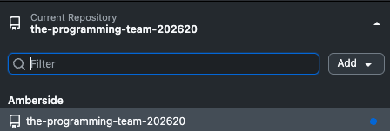

Merge request number: Added Finnley- #5

Branch name | Finnley-1 |  |  | Commit Numbers: |  |  | 22487118236e9ae0891419c1ea63e6b278689d1e  60d7c05031072b86b5be8bc14f0a19a5ddcfdc34  eb7c5623b36381553dfa59d03e5177249c0a607e  28b7353ab87fe1378d07e01c82dd0910356b71b1  Commit into main from PR: 12a14915a8b4cd664c697882f1126c0f48a1cbf4
B6.3 Get feedback from your teacher
Feedback:
- Make title font more readable
- Increase font size
- Add technical skills under skills list

B6.4 Make changes to your page based on the feedback.
Merge request number: feat: implement feedback - #10

Branch name | Finnley-1 |  |  | Commit Number: |  |  | 1af4f885927953869d0d4dc9f28bedb74098d028  3559e29514fe37f8631b5354984bec265ac27ec8
B6.5 Edit myscipt.js to add your details.
Accidently did this in my first pull request. This caused a merge conflict, which I fixed in the commit noted below.

Merge request number: Added Finnley- #5

Branch name | Finnley-1 |  |  | Commit Number: |  |  | 28b7353ab87fe1378d07e01c82dd0910356b71b1
B6.6 Obtain final sign off.
<Project has been signed off and approval given>
Yes / no
Assessor Name |  | Amberle Seidl | Assessor Signature |  | Amberle Seidl | Date |  | 8/10/2026

