Finn McSherry and Skylar Robinson
Professor Hasan
ME 4452
11/4/2026

Section 1: Project Motivation
We are pursuing this Sign Language Machine Vision Identification because of the need for sign language interpretation in the world. The average person cannot understand sign language, so everyday communication is very difficult for someone with hearing loss. Sign language interpreters are expensive and hard to come by, which creates the engineering need for a system that can recognize sign and translate them into text. This project could be used for everyday use: checking into a hotel, a routine traffic, stop, etc. It could also be applied to emergency situations to provide safety, such as the doctors in the emergency room need to know a patient's name or blood type, or during a 911 call. This will also reduce cost and make sign language interpretation more available.

Section 2: Project Background
Since originally writing this document, we have learned, practiced, and implemented neural networks. We have new insights, understandings, and ideas of how to code a neural network. For example, we now have a much better understanding of layers, nodes, weights, activation functions, and losses. Our first model we trained and tested is a baseline convolutional neural network (CNN).
Specifically, Convolutional Neural Networks are used for image processing. From lecture we learned that a CNN contains a convolutional layer which applies kernels to the input images to detect features such as edges and patterns. By applying these kernels, we create stacks of images that would then go through a ReLU activation, similar to a normal neural network. This ReLU activation introduces nonlinearity to the network. The next step in the process is pooling, where the information in the images is summarized and the feature map's spatial dimensions are reduced. The maps are then flattened into a 1-D vector before being fed through a traditional neural network. These layers use the extracted features to produce the final output of interest.

Real-time American Sign Language Recognition with Convolutional Neural Networks: describes a model uses to classify ASL finger spelling using a CNN and a pretrained architecture.
https://cs231n.stanford.edu/reports/2016/pdfs/214_Report.pdf

Deep Learning Technology to Recognize American Sign Language Alphabet has a great description of the why, what, who, and how for training a model based on ASL images. (https://www.mdpi.com/1424-8220/23/18/7970?utm_)

Static Alphabet American Sign Language Recognition using Convolutional Neural Networks gives a description of the CNN method that we will be using to identify the images and symbols in ASL. (https://ieeexplore.ieee.org/document/10009175?utm_)

Visual deep learning approaches for alphabetic sign language interpretation is similar to the sources above, but goes deeper on the theory of deep learning and how it works. (https://www.nature.com/articles/s41598-026-57945-w?utm_)

This PyTorch tutorial series walks through a complete image classification workflow, including tensors and modules, datasets and data loaders, image transforms, model building, autograd, optimization, and saving and loading a model. It provides a solid foundation for the core workflow in your lab.
PyTorch. “Learn the Basics.” PyTorch Tutorials, https://docs.pytorch.org/tutorials/beginner/basics/intro. Accessed 4 Nov. 2026.

This hands-on tutorial demonstrates image preprocessing, data augmentation, transfer learning, training and validation loops, accuracy measurement, and saving the best model. It uses ResNet rather than MobileNetV3, but the training workflow applies to image classifiers generally.
Chilamkurthy, Sasank. “Transfer Learning for Computer Vision Tutorial.” PyTorch Tutorials, https://docs.pytorch.org/tutorials/beginner/transfer_learning_tutorial. Accessed 4 Nov. 2026.

This research paper introduces MobileNetV3 and explains how its architecture was designed for efficient computer vision on mobile devices. It is the primary source for understanding the model’s design and tradeoffs.
Howard, Andrew, et al. “Searching for MobileNetV3.” Proceedings of the IEEE/CVF International Conference on Computer Vision, 2019, pp. 1314–1324. https://doi.org/10.1109/ICCV.2019.00140.

TorchVision’s documentation explains how to create MobileNetV3 models and use their pretrained weights. It is useful for checking the available model variants and the correct implementation details in PyTorch.
PyTorch. “MobileNet V3.” TorchVision, https://docs.pytorch.org/vision/stable/models/mobilenetv3.html. Accessed 4 Nov. 2026.

This tutorial explains how to save and load model weights and training checkpoints, including the model and optimizer state needed to resume training. It supports checkpointing and making consistent comparisons between saved models.
PyTorch. “Saving and Loading Models.” PyTorch Tutorials, https://docs.pytorch.org/tutorials/beginner/saving_loading_models. Accessed 4 Nov. 2026.

Section 3: Dataset Description
The dataset has 87000 total images, with 3000 images of each letter of the alphabet with 3 additional 3000-image folders for “Delete” and “Nothing” and “Space.” These images are .jpg files. The photos are all clear with different colored hands, flipped vertically and horizontally. Some of the photos are really dark, with some being extremely bright and well lit. Overall, there should be plenty of data to train a model. The source is “Akash Nagaraj,” a researcher with multiple datasets published on Kaggle. In addition, we have the ability to create more training/testing data using our own hands.
Further dataset exploration has been done since the previous update of this document. Dataset contains a total of 29 classes, which includes all 26 letters plus "delete", "nothing", and "space". The training data has been organized into separate subfolders: one for each class. The test data that was provided by Kaggle is housed in a separate folder to prevent data leakage and contains 29 images: one image per class.
We have also created a separate folder for a custom testing dataset using our own hands. Again, this folder is structured using 29 subfolders. We plan on creating at least five images per class, resulting in at least 145 images. These images will provide a secondary testing set, which will help us determine how well our model will be able to detect our own hands in real time. We will ensure that these pictures are not used in the initial model training.
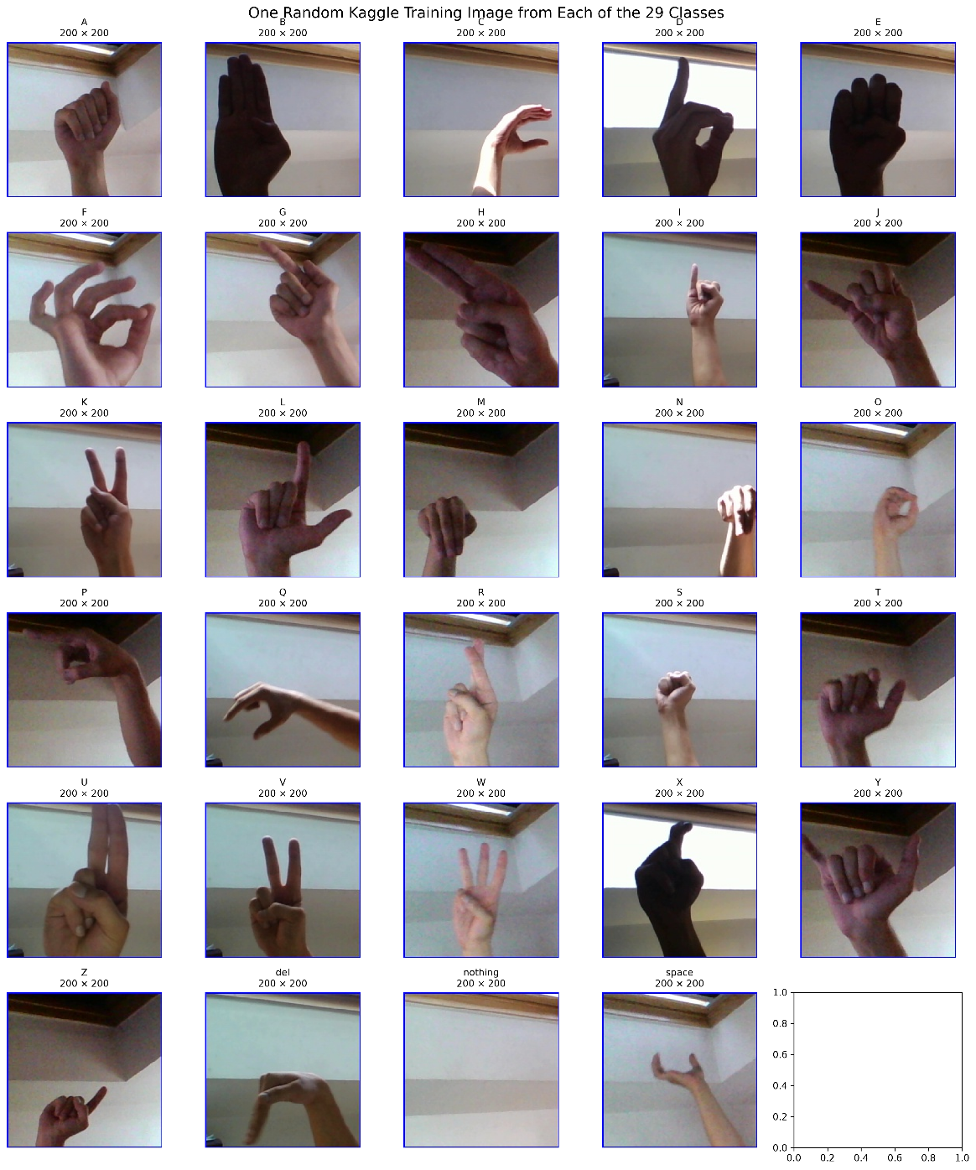
Figure 1. Random pictures from each of the 29 classes.

Table 1. The training and validation set breakdown.
Class name | training | validation | total
A | 2400 | 600 | 3000
B | 2400 | 600 | 3000
C | 2400 | 600 | 3000
D | 2400 | 600 | 3000
E | 2400 | 600 | 3000
F | 2400 | 600 | 3000
G | 2400 | 600 | 3000
H | 2400 | 600 | 3000
I | 2400 | 600 | 3000
J | 2400 | 600 | 3000
K | 2400 | 600 | 3000
L | 2400 | 600 | 3000
M | 2400 | 600 | 3000
N | 2400 | 600 | 3000
O | 2400 | 600 | 3000
P | 2400 | 600 | 3000
Q | 2400 | 600 | 3000
R | 2400 | 600 | 3000
S | 2400 | 600 | 3000
T | 2400 | 600 | 3000
U | 2400 | 600 | 3000
V | 2400 | 600 | 3000
W | 2400 | 600 | 3000
X | 2400 | 600 | 3000
Y | 2400 | 600 | 3000
Z | 2400 | 600 | 3000
del | 2400 | 600 | 3000
nothing | 2400 | 600 | 3000
space | 2400 | 600 | 3000

Section 4: Machine Learning Objective
The machine learning objective for this project is classification. We want to be able to hold up a sign in the ASL alphabet and have the computer classify it as the correct letter and print out the letter on the screen. Our primary goal for this project is to be able to recognize the entire ASL alphabet through image recognition. Our stretch goal is to be able to recognize a few key words using video recognition. We believe that we have the necessary tools due to the surplus of data available and the ease of creating testing data using our own hands. We will also explore the ability to do two-way communication with the person with hearing loss, where you could type a sentence and display an ASL animation of the translation.

Section 5: Model Plan
We would like to look into using a Convolutional Neural Network. This is an algorithm used to process and analyze visual data, such as images and videos. This gives us the ability to input both pictures and videos for training and testing, giving us more freedom in the scope of this project. In addition, there is documentation of convolutional neural networks being used for similar applications.
This project will use image classification to identify one of 29 classes in each webcam frame. We will train both a MobileNetV3-Small CNN as well as a custom CNN to compare performance. The performance will be evaluated using the validation set, the custom webcam set, as well as live use.
Both models receive RGB images resized to 160 x 160 pixels with normalization applied. A CNN applies kernels to detect image features. For the output $q = X *W$, the convolution for a single channel image can be represented as:
$$q_{ij} = \sum_{p=1}^{l}{\sum_{k = 1}^{l}{x_{i+p-1, j+k-1}W_{p,k}}}$$
Where:
i,j = the row and column of the output matrix
p,k = the row and column of the kernel
l = the kernel length

For colored images, the kernel dimension becomes (l x l x 3), which converts RGB images from (M x N x 3) to (M x N x d).
Following the convolution process, ReLU introduces nonlinearity and then max pooling reduces the dimensions. Max pooling takes a small kernel with a stride (s) greater than 1, and compacts the information. If the input has n pixels, the output after pooling with have $\frac{n}{s^{2}}$ pixels.
The custom CNN has three convolutional blocks with 32, 64, and 128 filters. Each block uses batch normalization, ReLU, and max pooling. Adaptive average pooling reduces the resulting features before a final layer produces 29 class scores.
MobileNetV3-Small uses a pretrained feature extractor, where its feature layers are frozen and we use transfer learning to adapt to ASL data.
For both models the output logits, z, will be converted to probabilities using softmax:
$$g\left(z_{m}\right)=\frac{e^{z_{m}}}{\sum_{m=1}^{M}{e^{z_{m}}}}$$

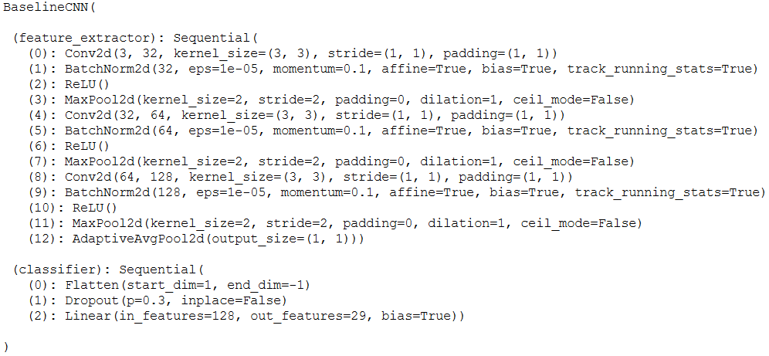
Figure 2. Baseline CNN steps.

The pseudocode for this model is as follows:
For each input image:
Resize image to 160 × 160 pixels
Convert image to a tensor and normalize its RGB values
If using the custom CNN:
For each of 3 convolutional blocks:
Apply convolution
Apply batch normalization
Apply ReLU activation
Apply max pooling
Apply adaptive average pooling
Flatten the features into a vector
Apply dropout
Produce 29 class scores (logits)
If using MobileNetV3-Small:
Pass image through pretrained feature layers
Pass extracted features through the 29-class classifier
Produce 29 class scores (logits)
Convert scores to probabilities with softmax
Predict the class with the highest probability
Training pseudocode
For each training batch:
Predict logits for the images
Calculate cross-entropy loss using the correct labels
Calculate gradients from the loss
Update trainable model parameters using AdamW
After each epoch:
Measure performance on the validation set
Save the model if validation accuracy improves

Section 6: Project Deliverables
We aim to deliver a model/program that can:
- Recognize someone’s hands in real-time on our laptops
- Print the sign language letters and words that they show
- Keep a history of the letters/words that they show
- Have an input box for non-deaf people to respond to the ASL user, allowing back-and-forth communication
- This model will be kept as simple/clean as possible, ensuring that it can identify the letters being signed without a lot of delay
- Accuracy statistics. We want to recognize 90+% of ASL letters in various backdrops, with varying speed, and using different hands
- We will have a final presentation and demonstration showing the model’s intended usage

Section 6: Model Description
In our project, we are using an 80%-20% split for training/testing data, as done in class. Our CNN has 3 blocks, having 32, 64, and 128 channels, respectively. Each block uses convolution, batch normalization, ReLU activation, and max pooling.
The next model we used was a MobileNetV3 transfer-learning model. This model has pretrained feature-extraction. Also, the 1000-class classifier is replaced with a 29-class classifier, with 1 class per letter and a class for delete, space, and nothing.
Both of these networks use cross-entropy loss, which is what we learned in class and the norm for many other neural networks. A difference between our code and what we’ve done in lab/class is the fact that we use AdamW, not Adam, optimization. Through our research, we found that AdamW optimization is optimal for most use cases due to the decoupling of gradient updates and weights. Aside from cross-entropy loss, we also report the validation set loss, the overall accuracy, the per-class accuracy, the recall, and the F1 score. We used a confusion matrix along with loss plots to help visualize the model’s accuracy and fit.

Section 7: Baseline Results

Our baseline results turned out to be very conclusive, showing that with each new epoch, the loss got lower and the accuracy got higher. Additionally, after the 15th epoch, the plots do not appear to be in steady state; they are still changing. With that said, more epochs could be helpful for making the loss and accuracy data even better. By the 15th epoch, the training loss was about 0.25, with an accuracy of about 95%. The validation set was even better, with loss and accuracy values of around 0.1 and 99%, respectively. This is very promising and shows that not only our code works, but that the model is not overfitting

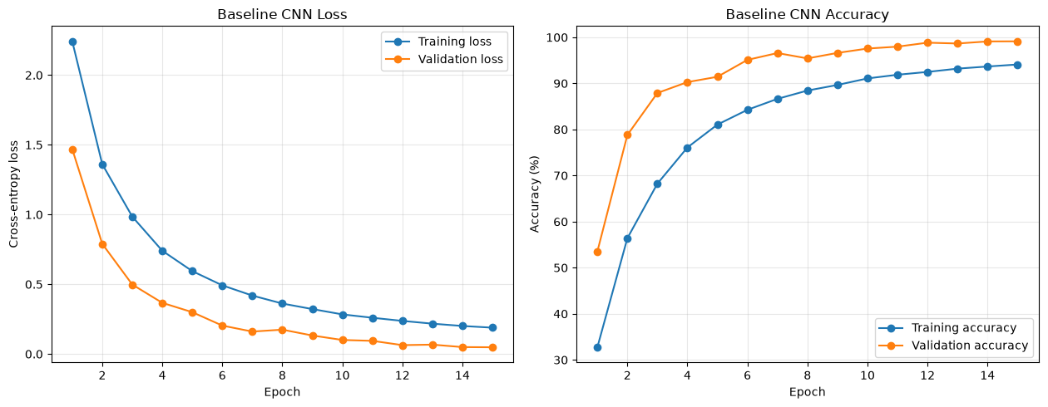
Figure 3. Baseline CNN loss and accuracy

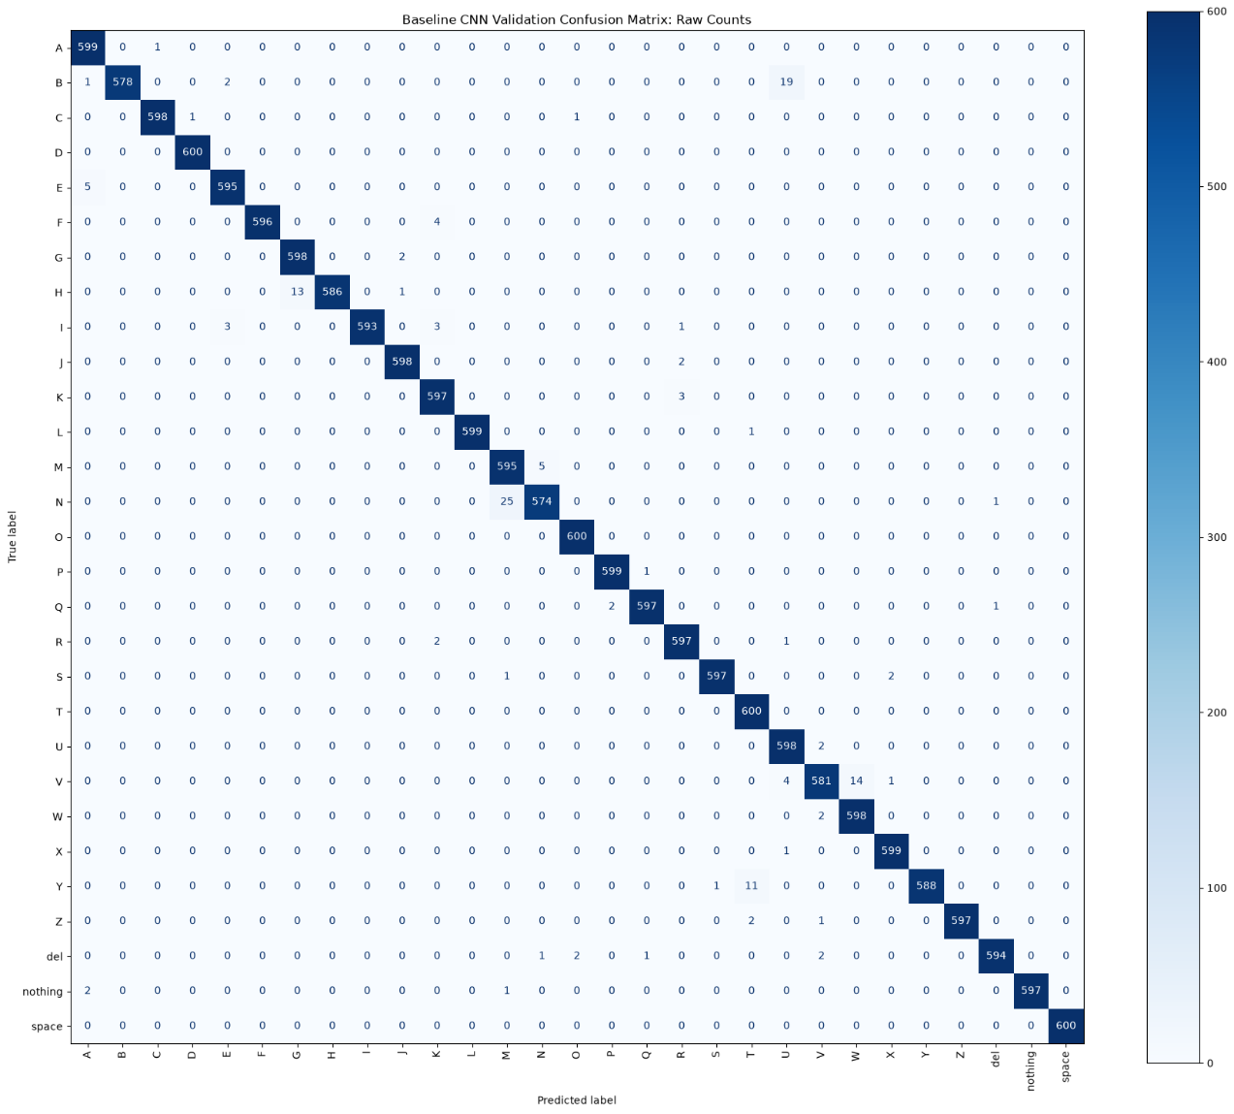
Figure 4. Baseline CNN confusion matrix
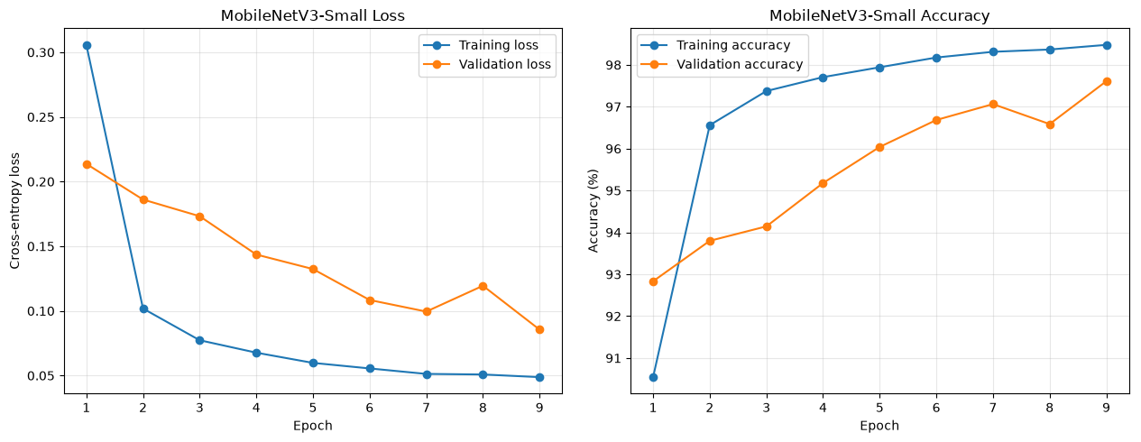
Figure 5. MobileNetv3 loss and accuracy
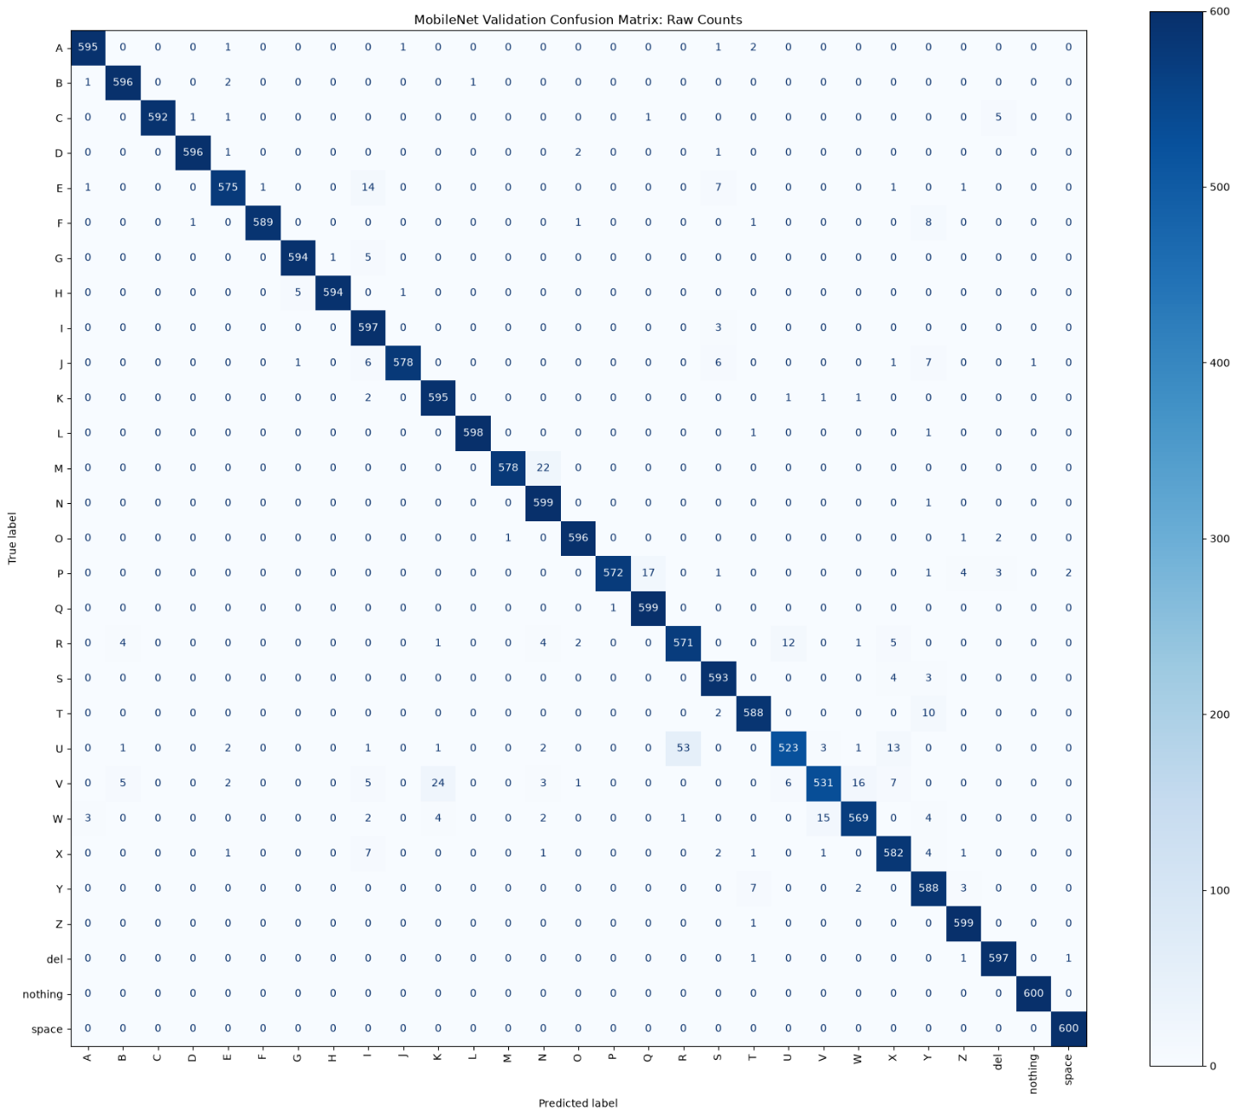
Figure 6. MobileNetV3 confusion matrix

References needed

