**Gel Electrophoresis Protocol**

1. Mix 1X TBE solution and agar gel in Erlenmeyer flask:  
   - 1% small gel: 50ml TBE and 0.5g agarose  
   - 2% small gel: 50ml TBE and 1.0g agarose  
   - 1% large gel: 200ml TBE and 2.0g agarose  
   - 2% large gel: 200ml TBE and 4.0g agarose
2. Microwave the solution and mix frequently by shaking the flask until solution is translucent. If the solution boils, shut down microwave few seconds and start over.
3. Leave the agarose solution cool for 2-5 minutes.
4. Tape the borders of the tray with 2 layers.
5. Add GelRed into agarose solution:  
   - 1.5 µl for small gel  
   - 6 µl for large gel
6. Poor the solution into the gel casting tray, add gel comes (given the number of sample to run + ladders), cover and let cool 20-40 minutes at room temperature depending on the size of the gel.

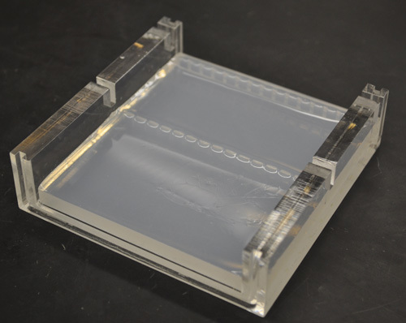

1. Prepare your samples and ladders: into new 8 tubes trips, mix 4 µl of 2X BlueJuice with 5 µl of DNA samples. Mix 4 µl of 2X BlueJuice with 1 µl of ladder (1 or 2 ladder depending on number of samples). Mix gently by pipetting 1-2 times. Add controls if necessary.
2. Remove the tape and comes from the gel then place the casting tray containing the gel into the gel box, fill the box with TBE (used TBE can be used).
3. Load 8 µl of DNA and BlueJuice in to the wells.
4. Close the gel box, make sure the red cable is connected to the electrode below the samples and is connected to (+). Run gel at 80-120 Volts for 30 minutes-2 hours.
5. Watch results on UV light. Place the Gel into the Bio-Rad imagery machine. Log into computer. Open Image analyzer software. Click on “New protocol”. Select “GelRed”. Click on “Position gel” and correct gel position. Clic on “Run protocol”. “Print”. Save as PDF and print with Mitsubishi printer (better to change the page setup to “no borders”). Discard gel, clean Bio-Rad machine. Log off.