**QUBIT Protocol**

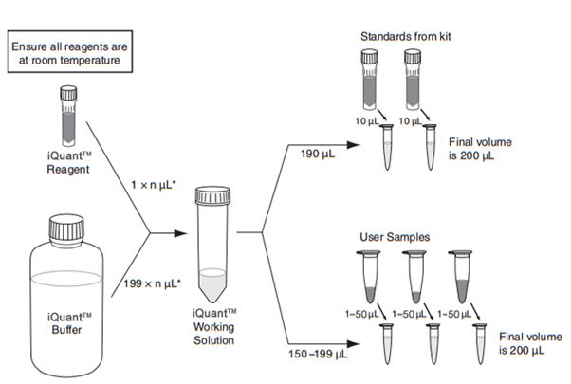

198

2

2

2

* Pick iQuant Reagent BR (Broad range). It is photo-sensitive and needs to be kept in the dark.
* Pick DNA standards from fridge and leave at room temperature.
* Pick iQuant Buffer BR (Broad range).
* DNA samples need to be unfrozen and reach room temperature (wait 5-10 minutes).
* Flick the DNA samples at the bottom of the tubes when unfrozen before DNA quantification to re-suspend the DNA.
* Qubit tubes: n samples + 2.

1. Prepare the iQuant Working solution in a tube protected from the light (with aluminum fold). For few sample DNA quantification we will prepare the solutions in 1.5 ml tubes).
2. Vortex the iQuant Working solution.
3. Distribute 190 µl of iQuant Working solution in 2 Qubit tubes and at 10 µl of standard DNA #1 (low DNA concentration) in one tube and 10 µl of standard DNA #2 (high DNA concentration).
4. Distribute 198 µl of iQuant Working solution in the reminding tubes and add 2 µl of DNA of each samples.
5. Close tubes, vortex each tubes during 2-3 seconds and leaves them at room temperature for 2 minutes.
6. Turn on the Qubit devise, select DNA, select Broad Range, select Read Standards, read standards #1 and #2, then read each samples.