**Evidence for Analysis and Design Unit.**

Finn Porter

E13

23 June 2017

**AD - 1 Use case Diagram**

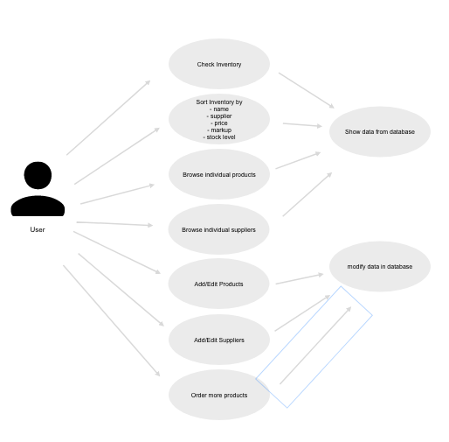

**AD - 2 Create a Class diagram using your Use case diagram.**

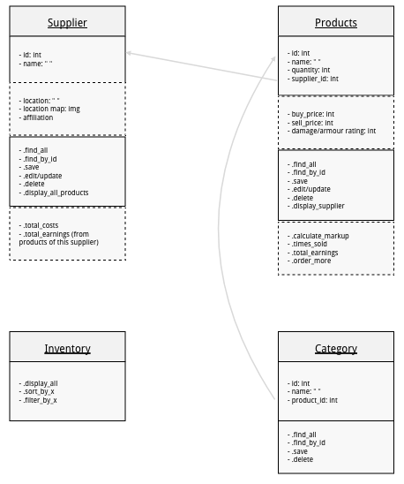

**AD - 3 Object diagram**

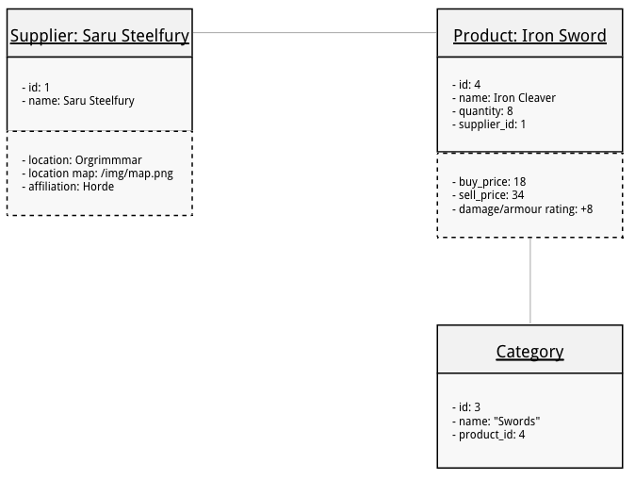

**AD - 4 Activity diagram**

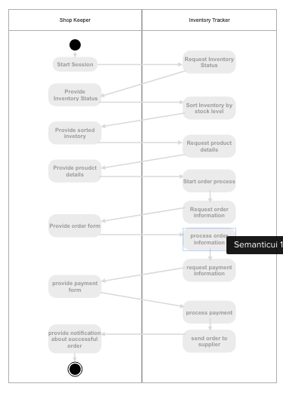

**AD - 5 Inheritance diagram**

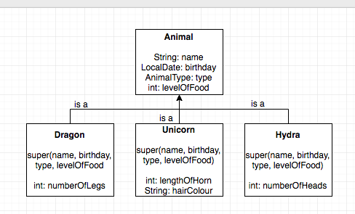

**AD - 6 Implementations Constraints**

