NASA TLX-Survey Tool Manual

1. Installation
An installation of the tool is not necessary. You can just start the .jar file. Make sure you have the Java Runtime Environment installed.

2. Usage

2.1 Main Menu
After the program is executed you will see the following screen:
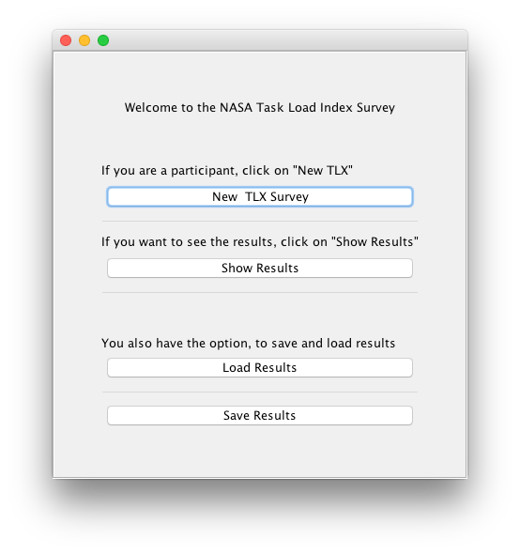
You have four different options to choose. If you click on the first button „New TLX Survey“ you can create a new survey. This option should be clicked of the participants of your study.
The second button „Show Results“ shows you all results, that were acumulated by your participants.
You can also load previous results or save new results.

2.2 Survey Input Screen
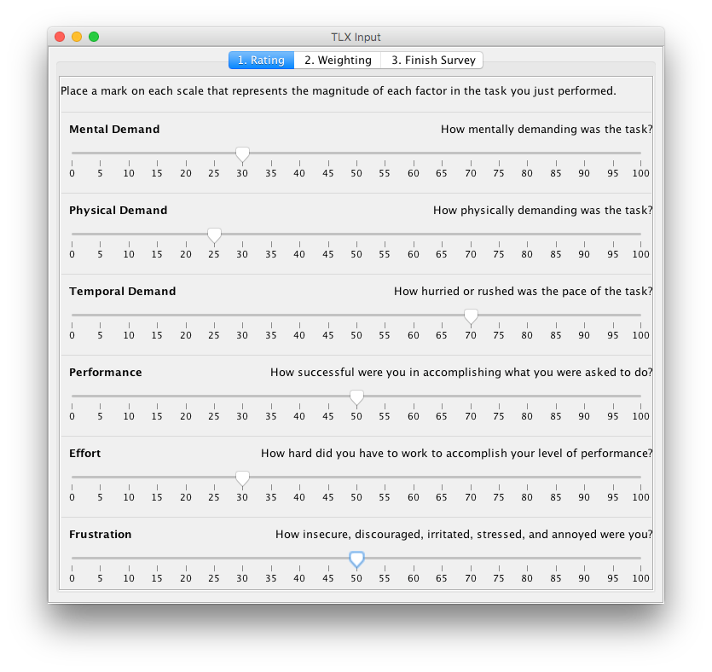
This is the survey input screen. There are three tabs and the participant has to fill out every input field. On the first tab are the different scores for the demands. After filling these out the user has to go on tab two.
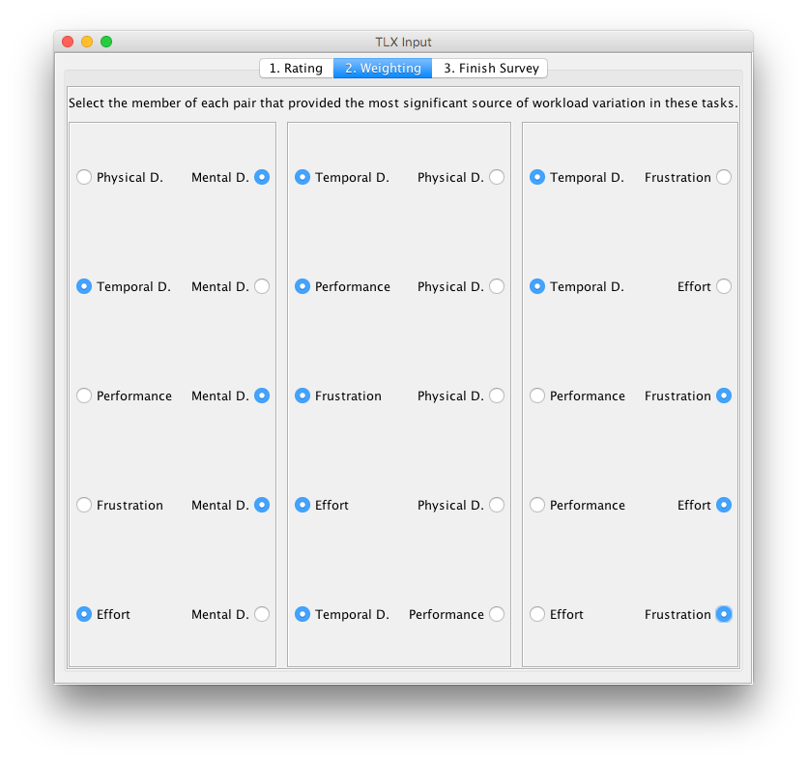
The different categories should now be weighted. Which item is more important should be declared.
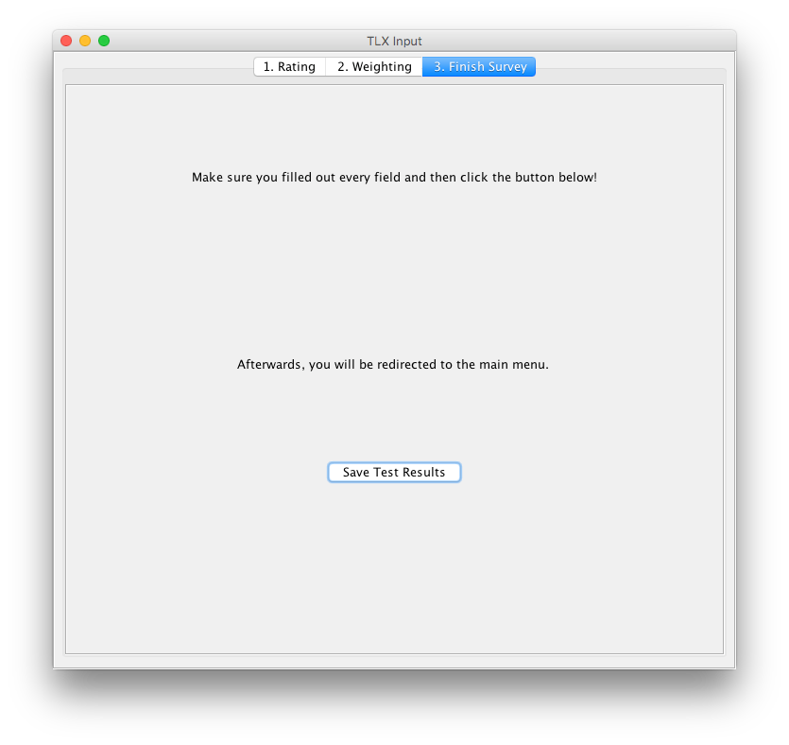
On the last tab, the user can save their result. It will be automatically added to the internal database.

2.3 Analysis Screen
If you click on the „Show Results“ button in the main menu, the user gets here. Here you can see all answers of the participants and the average score.
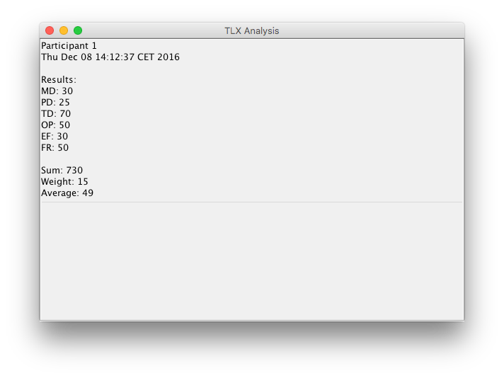

2.4 Loading and Saving
If there are results in the internal database you can save them to disk. They will automatically be written in a file called „results.tlx“. Make sure you save your results, before closing the program. This file will also be overwritten by later saves.

