Skew-T Diagram Simulation

Saturday 1-3-2025
Creating a simulation for a skew-t diagram means needing to use formulas, I do not have knowledge of these formulas.
This means much research has to ben done first.
TR79-006
Chapter 5: Determination of stability.
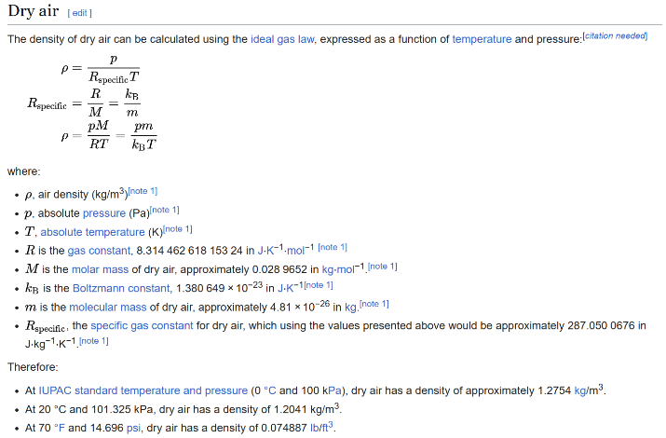
Laws of hydrostatics and thermodynamics.
https://en.wikipedia.org/wiki/Density
So, the first part is to create a parcel which rises up due to being lighter than its environment.
Density is defined by mass divided by volume. Because warm air is lighter (due to expansion of molecules jumping around) it has less density.
https://en.wikipedia.org/wiki/Density_of_air
Rspecific Is a constant in this formula: 287,05
Now it depends on absolute temperature and pressure on what the density is.

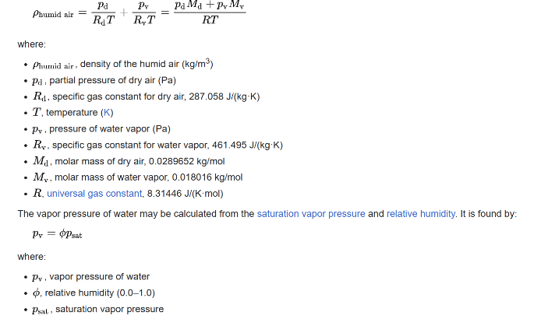
Humid air
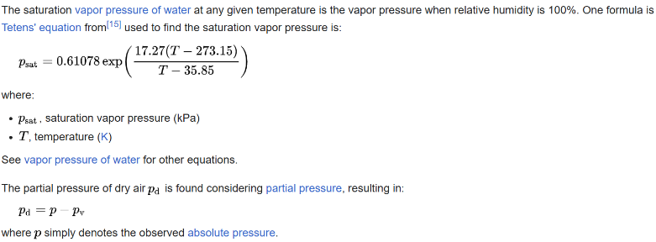
Density of humid air is a bit different. It uses the same formula as dry air but adds a alike-formula for humid air.

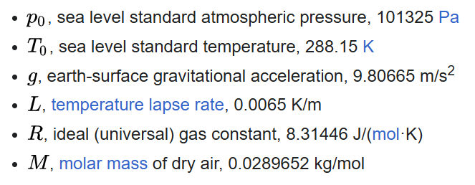
Here we have a nice list of constants.
Our given values are: height (m), pressure (hPa), temperature (C), wet bulb (C), Dew point (C), Humity (%), wind speed (km/h) and wind direction (degrees).

Our given values:
https://dataplatform.knmi.nl/dataset/access/radiosonde-debilt-daily-1
Okay alright, so I got the raw data, it appears that there is maybe a bit too much data in it…
10.000 rows of time, pressure, temp, humidity and ascentRate:
I first need to write a program which captures all this data nicely.

Sunday 2-3-2025
I finally got the project up and running, lots of implementing issues.
I just got the german raw radiosconde, and it does not look good, it is way different than the one of KNMI.
So, what is the plan?
The plan is to gather all the things I need. These are:
Height, pressure, dew point and temp.
I found out the KNMI offers a file called synchronizedSoundingData, this has the things I need.
Sounding-ID, Time since idk, exact date and time, pressure in hPa, temp, humid, windDir, windspeed, height, Lat- and Longitude, altitude. These are the main things I need.
The raw data of Germany consists of multiple days, meaning it has almost 100Million characters. I hope to find the data that is just for one day / one go.
In the german files, I can use the Metadaten_Sekunde_Aero_03015.txt to establish how many different sondes it consists of, then I can divide it with the total amount of characters and set the end of the file to that position, this should cut down the 300 million file to like 2 million which is good enough.
Alrighty, it is much faster than I thought and I got results:

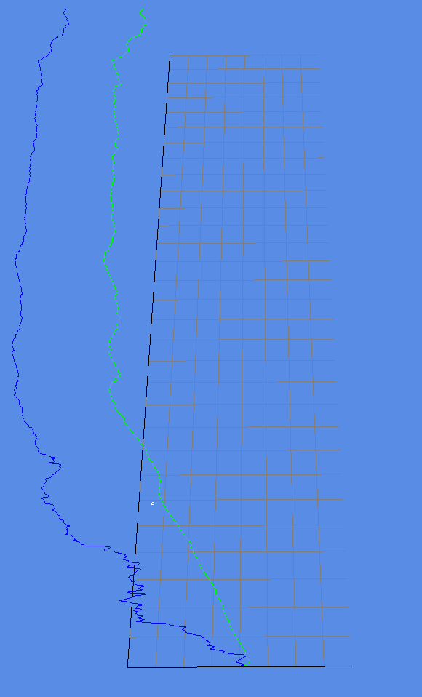
Altitude went way higher than I expected. I expected like 15K meters. But apparently the balloons go up to like 30K+ meters.
Oh no, the wind speed is not interpolated, this means that I have to take the position into account probably
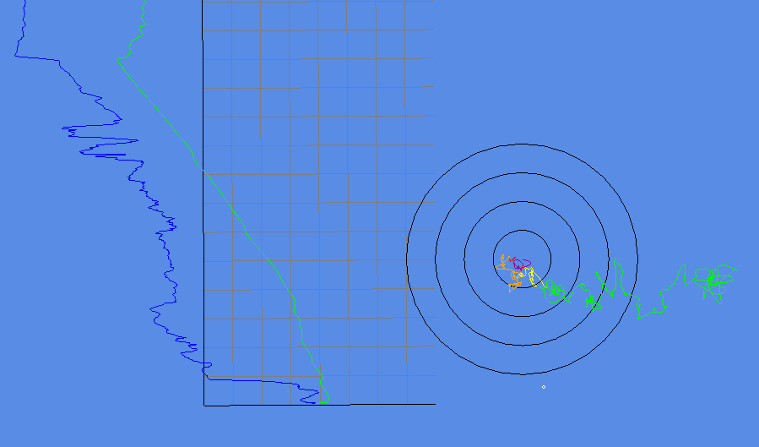
No wait, it is correct, this because the wind is calculate by the drift of the balloon. My hodograph is just flipped.
And instead of using windspeed + windDir I could use north and east, but I won’t.
Alrighty. KNMI done.
Lets make DWD work.
Alrighty, got it also working, it was way more complicated. Its is not that much slower luckily. But I do need a way to choose the date of these.
What is the next step?
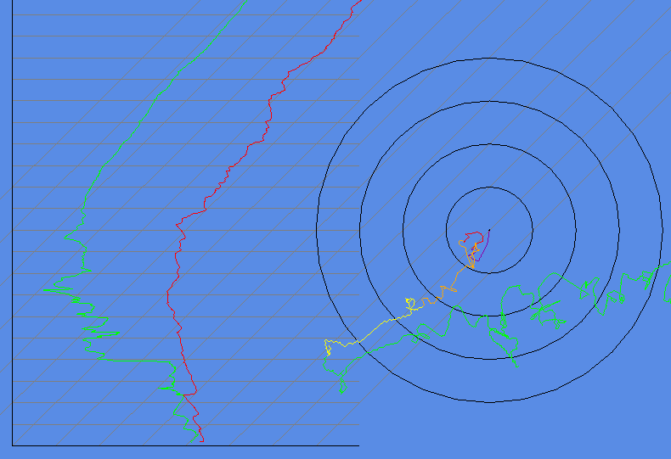
Lets make it actually skewed.
Much better.
Now I think we can work with our data.
What we want is a parcel rising up the skew-T.
I also need the dry and moist adiabatics.

Monday 3-3-2025
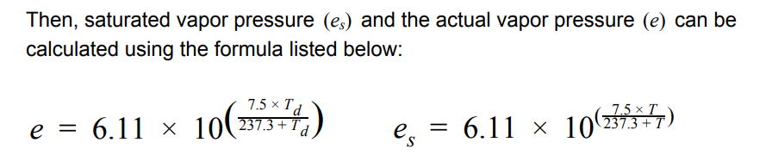
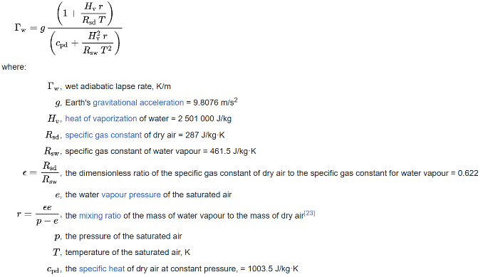
Moist adiabatic:
We need es

This becomes:
Tw = g * ((1 + (Hv * r) / (Rsd * T)) / (cpd + (Hv^2 * r) / Rsw * T^2))
Where r = (E * e) / (p - e)
Where e = 6.11 * 10^((7.5 * T) / (237.3 + T))
My e calculations are wrong I believe. I see it, I was doing division outside the pow.
Oh, my value turns out to be correct, but I just had to convert to km.
Alrighty, we got them working… but they are flipped?
I cant seem to get them right.
huh, how is there any problem, it should be all right.
Maybe my formula is wrong.
Oh wait, I may be plotting it wrong.
Also, why are the dry adiabatic lines on a skew-t curved?
This is so weird, there are none resources online asking about this subject. Like why???
Okay I have a theory/solution, what you see in the skew-T is not the dry adiabatic line, it is a parcel following it, meaning it will expand in upper air and do other stuff.
Wait I see something, I use a constant for gas constant, but it seems this changes with temp and pressure? https://en.wikipedia.org/wiki/Gas_constant Oh no, it still is the same it will always average out. Meaning the temp or volume will just change.
http://www.atmo.arizona.edu/students/courselinks/fall10/atmo551a/AdiabaticLapseRate.pdf good document.
I think that the problem is that everyone just assumes it is a constant, which it is not.
New formula just dropped:
dh = Cp * dT + a / ã * g * dz
ã = (a1 + a2) / 2
a = R * T / P
dh = 0
0 = Cp * dT + a/ã * g * dz
Cp * dT = -a/ã * g * dz
dT = -a/ã * g /Cp * dz
Good enough
Another https://commons.erau.edu/cgi/viewcontent.cgi?article=1374&context=ijaaa
And another one: https://commons.erau.edu/cgi/viewcontent.cgi?article=1053&context=ijaaa
Looks promising: https://essopenarchive.org/doi/full/10.22541/essoar.169111799.99044015
Maybe the dry adiabatic does not change with height, but then what do I see on skew-t’s?
That’s crazy, this last article believes the constant of dry adiabatic should be 13.58 C/km instead of 9.8C/km. That’s a big change
This article is from October 15, 2024, pretty new.
Okay also Cp – Cv = R;
In the document the author believes instead of using Cp, we should use Cv.
The author believes that we do not work in a constant pressure environment thus we use Cv, because our volume is constant. (I think)
So, for my program I should just use 9,8 (or the new 13.58), but my question still remains, why does the dry adiabatic look curved on the skew-t?
So, probably because of how the y-axis is made, like you see how higher, the bigger the gaps?
Yes, that’s why, but still, the dry adiabatic should be straight because the skew-t is following as height the km or feet. And because dry adiabatic follows that, it should also be straight, no?

Tuesday 4-3-2025
I grabbed my ruler and found at that the height values are not constant with height, it seems that the space in between grows, weird.
But on what is it then based? Also, should the skewed temperatures not also be curved?
I found out why. So, they are called also log-p diagrams, this means that the distance between 1000 and 500 hPa is the same as 500 and 250.
So, how will I do this?
I want to keep using the diagram based on height, because it makes more sense, but for user sake I also want to make it log-P.
How would I plot using log-P?
I think I sort of got it, but the last 300 meters seem to be too bendy.
Hmm, still seems wrong.
https://www.proquest.com/openview/7b745cf9a82b738e95f8b453c8df5dea/1?cbl=2026366&loginDisplay=true&pq-origsite=gscholar This is exactly what I want to do, but it is not open source unfortunately. Nvm, got it: file:///C:/Users/SKIKK/Downloads/TESE_RUI_PEDRO_DUARTE.pdf
We found the log formula!
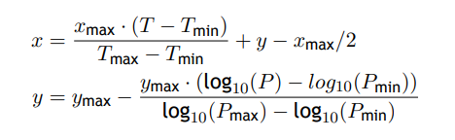
Seems to not fully work, I tried using it on a dry adiabatics, but they curved okay but bended to the right.
I am very confused on all the formulas
https://www.icams-portal.gov/resources/ofcm/fmh/FMH3/00-entire-FMH3.pdf
Okay, so I got the height I think working, so the pressure height now scales correctly, I wanted to use this with the dry adiabatic, yet it seems that the curvature is sooo small that I am still confused.
So, what do we do? In like 48 we did not move a centimeter.
I tried skewing, yet it still looks different on a real skew-t.
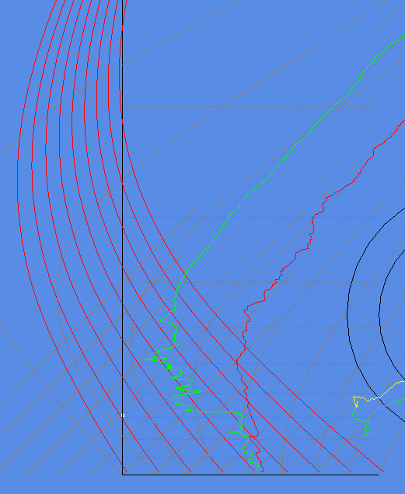
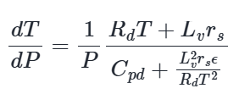
Found code: https://github.com/Unidata/MetPy/blob/main/src/metpy/calc/thermo.py#L459
These use the potential temperature to draw the dry adiabatic line.
Wait, it works?
I think this is exactly what a skew-T represent, but I tried this formula before without success. Seems I apparently did something wrong.
The moist adiabatics. I tried some formulas, but they did not work. So, I took a look at the one the other codebase uses:
And it integrates over this function.
Alright, it did not really work, I mean like… almost, but I think I will first try to understand this formula from the ground up.
Uhm, yeah, so I think I see nothing wrong, but so many ways to calculate rs. Jeez.
This one helps: https://www.inscc.utah.edu/~krueger/5300/lapse_rates.pdf
I am not getting the correct solution. Instead of 0.06 I am getting 0.0013.
Okay that was because I was using the wrong ws formula?
Still the plotting is not correct. They are bended way to much to the right.
For creating skew-T diagram https://badpets.net/Documents/Atmos_Thermodynamics.pdf
I feel like I am at the same problem at where I was with the dry adiabatics. Getting the correct change in temps but plotting it seems weird. I believe I have to reconstruct my function, but how.
Okay I implemented the code from that pdf, but its weird…
I need to research more into plotting wet adiabatic on skew-T

Wednesday 5-3-2025
https://www.tec-science.com/mechanics/gases-and-liquids/barometric-formula-for-an-adiabatic-atmosphere/ Good explanation of the formulas.
https://aerosol.ucsd.edu/sio217a-F13TermProjectPresentations/ROAST_project_SIO1.pdf New formula to try
Okay I feel like the formula I tried yesterday is much better. But the plotting seems weird.
I just don’t understand what I am doing wrong?
So, my values correspond to answers on for example: http://kishou.u-gakugei.ac.jp/tools/calc/gammaw.html
Yet, on the skew-T, it seems horribly wrong in comparison to others.
Also, people tell that the wet adiabatic should eventually line up with the dry, thus going to ~ -9.8Ckm, but mine goes to like 2 C/km as the calculator expects.
What about moist potential temperature. No that’s not it.
I think I need to give again a look at the py code.
Btw, good yt video: https://www.youtube.com/watch?v=ayqGKkl-3CU
I may see the problem, what I have been doing is checking temperature change between 1000 hPa and 600 hPa, but I should take small steps: 600 and 605 and 605 and 610 etc.
I feel like I am close.
https://unidata.github.io/MetPy/latest/api/generated/metpy.calc.moist_lapse.html
With this I can check my output.
The values seem to be just a little off.
Downloading boost takes a while.
No way, I almost got them.
It just has a very small offset.
Hmm idk if boost will help me.
Oh wait, the offset could be because of the different pressure height.
No, that makes it worse.
I think its good enough:
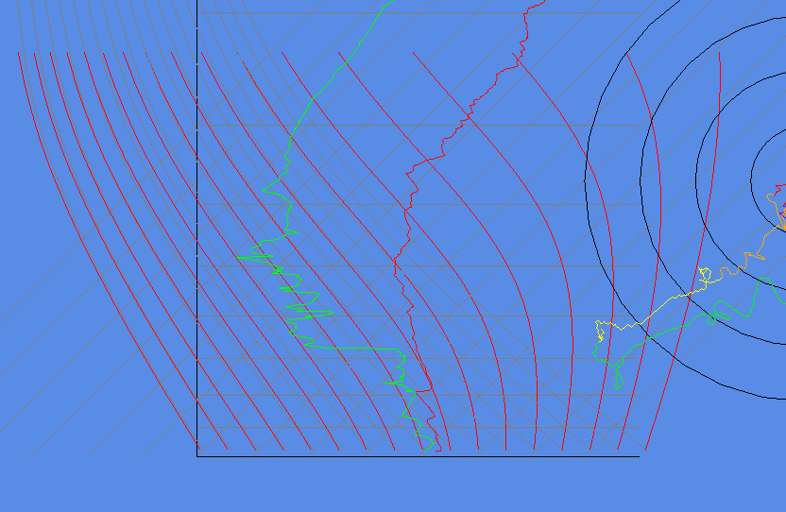
It is worse the higher/ to the right you go.
So the first few hPa is direct on point, but the higher the worse.
I am going to make this a github project since I see a future in this.

