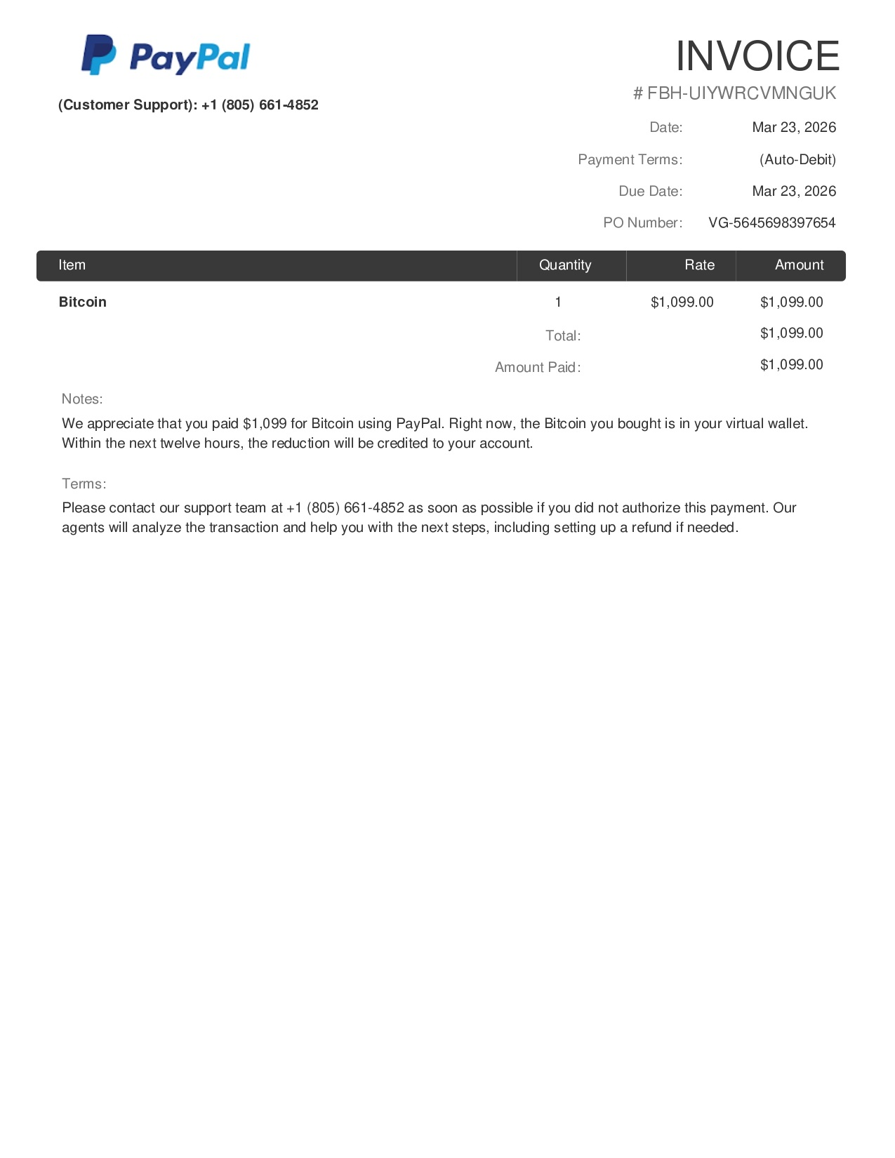

ook Your Exam Slot Right Now
Enroll for Free for Aakash Institute's Online Instant Admission Cum Scholarship Test.
This message was sent to prasharji406@gmail.com. If you don't want to receive these emails from Spotify in the future, you can edit your profile or unsubscribe.

