RESUME [ CV COPY ]

VIKRAM SAKET

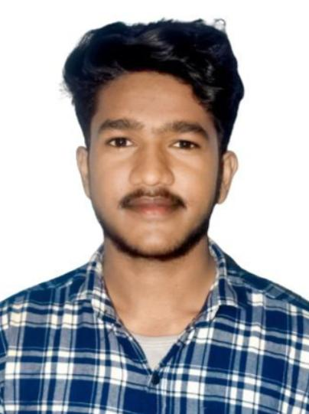[1]MOBAIL 6268384796.

EMAIL ✉️ [vikramsaket718@gmail.com](mailto:vikramsaket718@gmail.com)

Address:- Gram Khutha Post Baheliya Bhat Word No. 07 Diss. Satna ( m.p ) 485115

OBJECTIVE:-

To work in a healthy, innovative and challenging environment extracting the best out of me, which is conducive to learn and grow at professional as well as personal level thereby directing my future endeavors as an asset to the organization.

EDUCATIONAL QUALIFICATION :-

|  |  |  |  |
| --- | --- | --- | --- |
| Course / Degree | School / University | Grade / Score | Year |
| Intermediate | Higher secondary school bela | 1st | 2019 |
| Matriculation | Higher secondary school bela | 1st | 2021 |
| Graduation | Vindhya institute technology and science | 1st | 2021  Running |

# WORK EXPERIENCE :-

* Total Experience in Finance 11 Mouth / Banking Sector,
* Position :- ( FCO ) field credit officer

1 . Annapurna finance private Ltd.

• Customer Service Officer

. Data Operration / Teller Cashier /

# STRENGTHS AND QUALITIES :-

* Positive attitude , Business Development , Creative thinking .
* Effective Presentation , Financial services .
* Smart working , Banking Operations knowledge .
* Good motivation Skills & Good Communication Skills .
* Good Customer Management skill to solve repayment problem also .
* Self Dependability with ability to lead team of person .

# HOBBIES AND INTREST :-

* Reading , Meditation
* Learning

# PERSONAL INFORMATION :-

Name :- Vikram Saket

Father Name :- Mr. Shobhnath Saket

Mother Name :- Mrs. Savitri saket

Date of Birth :- 10-07-2003

Marital Status :- Un- Married

Sex :- Male

Category :- SC

Nationality :- Indian

Language :- Hindi , English

# DECLARATION :-

I here by declare that the above written information is true to the best my knowledge and belief .

Best Regard

Place :- SATNA VIKRAM SAKET

1.