QUANT VECTOR
A Python–MySQL Quantitative Financial Analysis, Statistical Fingerprinting and Historical Pattern Detection System

PROJECT SYNOPSIS
Class XII Computer Science
Academic Session 2026–27

Prepared By:
Name: Pragyan Dev
Class: XIIB
School: Vivekanad Public School

TABLE OF CONTENTS
TABLE OF CONTENTS 2
1. Executive Summary 4
2. Aim of the Project 4
3. Problem Statement 4
4. Why This Problem Is Worth Solving 5
5. Proposed Solution 5
6. Objectives 5
7. Technology Stack 6
8. Database Management System and Python–SQL Connectivity 6
8.1 Why MySQL 6
8.2 How Python Connects to MySQL 6
8.3 SQL Operations Demonstrated 7
8.4 Transaction Management 7
9. Database Design 8
10. Data Flow / System Workflow 9
11. System Architecture 9
12. Key Features of Quant Vector 10
12.1 Dataset Management 10
12.2 Market Data Ingestion 10
12.3 Statistical Fingerprinting 10
12.4 Historical Analogue Detection 11
12.5 Forward Outcome Analysis 11
12.6 Market Regime Discovery 11
12.7 Regime Transition Analysis 11
12.8 Market Intelligence Engine 11
12.9 Volatility, Momentum and Drawdown Analysis 11
12.10 Market Overview 11
12.11 AI Interpretation Layer 12
13. File Handling 12
14. Data Validation and Integrity 12
15. Sample User Workflow 12
16. Real-World Usefulness 13
17. Creativity and Innovation 13
18. Originality, Plagiarism and Copyright 13
19. Limitations 13
20. Future Scope 14
21. Expected Outcome 14
22. Project Development Timeline 14
23. Conclusion 14

1. Executive Summary
Quant Vector is a Python–MySQL application that converts large volumes of historical stock-market data into organised, queryable and analysable information. Historical prices are downloaded or imported from files, validated by Python, and stored in a relational MySQL database. From that stored history, Python computes a statistical fingerprint of market behaviour, searches the database for earlier periods that behaved similarly, clusters past markets into distinct regimes, and combines this evidence into a consolidated intelligence summary. 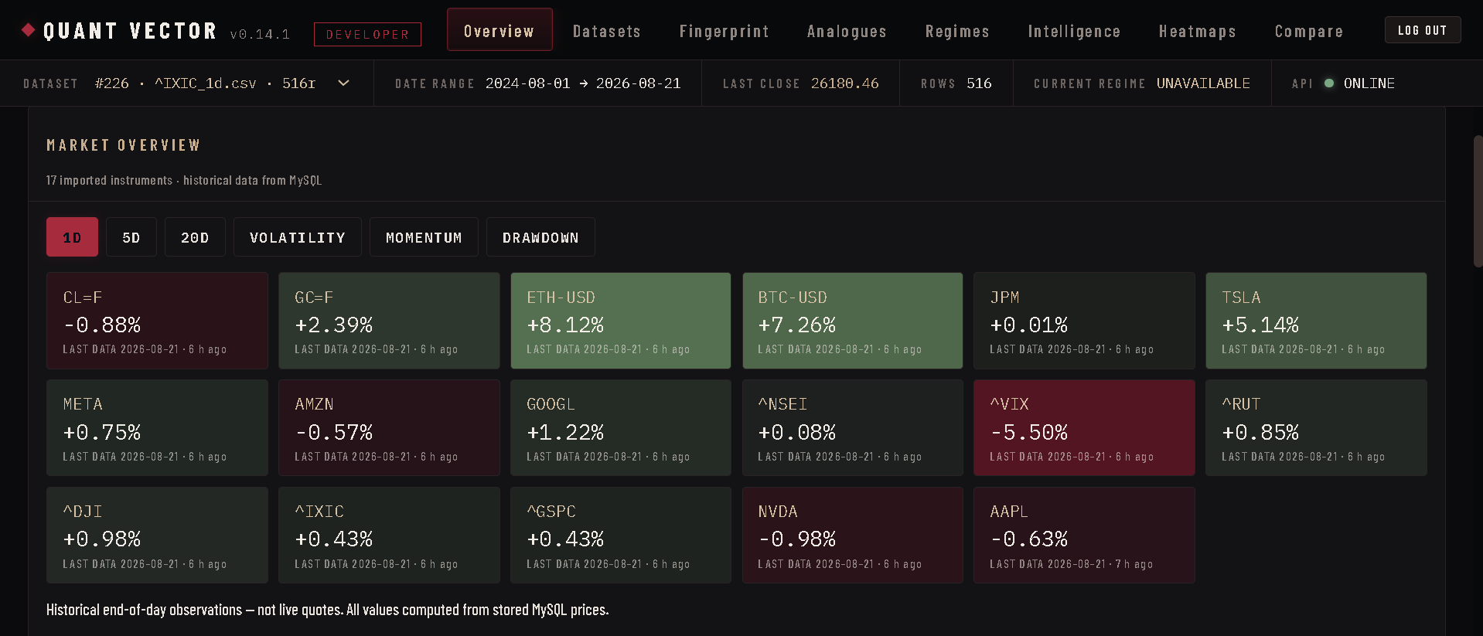
The project deliberately goes beyond a basic create-read-update-delete exercise. It applies the Class XII Computer Science syllabus Python programming, SQL, relational design and Python–SQL connectivity to a demanding real-world data domain, where correct storage and retrieval of tens of thousands of time-series records is what makes the analysis possible at all.
CORE ACADEMIC FOUNDATION
Python + mysql-connector-python + MySQL relational database

CORE DATA PIPELINE
Market Data → Python Validation → MySQL Storage → SQL Retrieval → Python Quantitative Engine → User Interface

2. Aim of the Project
The aim of this project is to create something tangible and useful using Python and Python–SQL connectivity: an application that stores real historical financial data in a MySQL database and automatically analyses it. Manual examination of thousands of OHLCV records (Open, High, Low, Close, Volume) spread across years is impractical; Quant Vector shows how a relational database plus Python computation can store, organise, retrieve and mathematically analyse such data reliably, while demonstrating connections, cursors, transactions, integrity constraints and database-backed caching throughout.

3. Problem Statement
Financial markets generate enormous numbers of records. Every trading day adds one OHLCV observation per instrument; years of history quickly grow into tens of thousands of rows per dataset. Raw records alone answer no questions. To be useful the data must be stored durably, organized relationally, queried selectively and compared systematically for example, “how did similar periods behave afterwards?” Answering such questions manually is slow, error-prone and effectively impossible at scale. There was therefore a need for a system that combines disciplined data storage with automated statistical comparison. Quant Vector addresses exactly this gap. The software describes historical behaviour statistically; it does not claim to predict or guarantee future market performance.

4. Why This Problem Is Worth Solving
- Volume: even a single instrument produces thousands of observations per decade far beyond spreadsheets or manual notes.
- Structure: meaningful questions require filtering by period, ordering by date and joining related tables, which is precisely what a relational DBMS provides.
- Comparison: detecting whether today resembles some earlier period requires scanning stored history systematically a database query problem as much as a statistical one.
- Educational value: the domain demonstrates indexing, constraints, transactions and caching working together under realistic data sizes.
- Research usefulness: students and researchers can explore how quantitative analysts think about historical evidence rather than intuition.

5. Proposed Solution
Quant Vector implements a complete pipeline in which every stage depends on Python–MySQL cooperation:
- The user imports a CSV file or fetches a listed instrument through the market-data provider layer.
- Python reads and normalises the raw records (dates parsed, numeric fields converted).
- Validation removes unparseable rows, invalid candles and duplicate dates.
- Clean records are inserted into MySQL inside committed transactions.
- SQL queries retrieve exactly the historical ranges needed for analysis.
- Python computes statistical characteristics over the retrieved frames.
- The engines identify historical analogues, market regimes and consolidated evidence.
- Derived results are written back into cache tables so repeated views are instant.
- A browser interface presents datasets, charts, tables and reports.

6. Objectives
- Demonstrate practical Python–MySQL connectivity using mysql-connector-python.
- Design a normalised relational schema with primary keys, foreign keys, unique constraints and indexes.
- Execute CREATE, INSERT, SELECT, UPDATE and DELETE operations from Python with parameterised queries.
- Manage transactions explicitly commit successful writes, roll back failures.
- Automate storage and updating of large time-series datasets.
- Compute statistical market characteristics (returns, volatility, drawdowns, percentiles).
- Identify historically similar periods and analyse their forward outcomes.
- Discover recurring market regimes through unsupervised clustering.
- Cache expensive analytical results in dedicated tables.
- Present results through a clear, usable interface.
- Preserve referential integrity and consistent state under all operations.

7. Technology Stack
Technology | Role in Project
Python 3 | Core language: connectivity, validation, all quantitative engines
FastAPI | Application/API layer exposing routes between interface and logic
MySQL 8 / InnoDB | Relational storage of datasets, prices and analytical caches
mysql-connector-python | Python–MySQL connectivity (connections, cursors, transactions)
pandas | Time-series frames used during validation and computation
NumPy | Numerical arrays and vectorised statistics
SciPy | Statistical computations (skewness, kurtosis, distributions)
statsmodels | Autocorrelation and statistical diagnostics
scikit-learn | K-Means clustering and PCA for regime discovery
yfinance | Market-data provider for historical OHLCV download
Recharts (React) | Presentation-layer charting only
React + Vite | Presentation layer: pages, dashboards, report view

The browser interface is only the presentation layer. The academic core of the project remains Python + MySQL: every number displayed in the UI was produced by Python reading from and writing to the relational database.
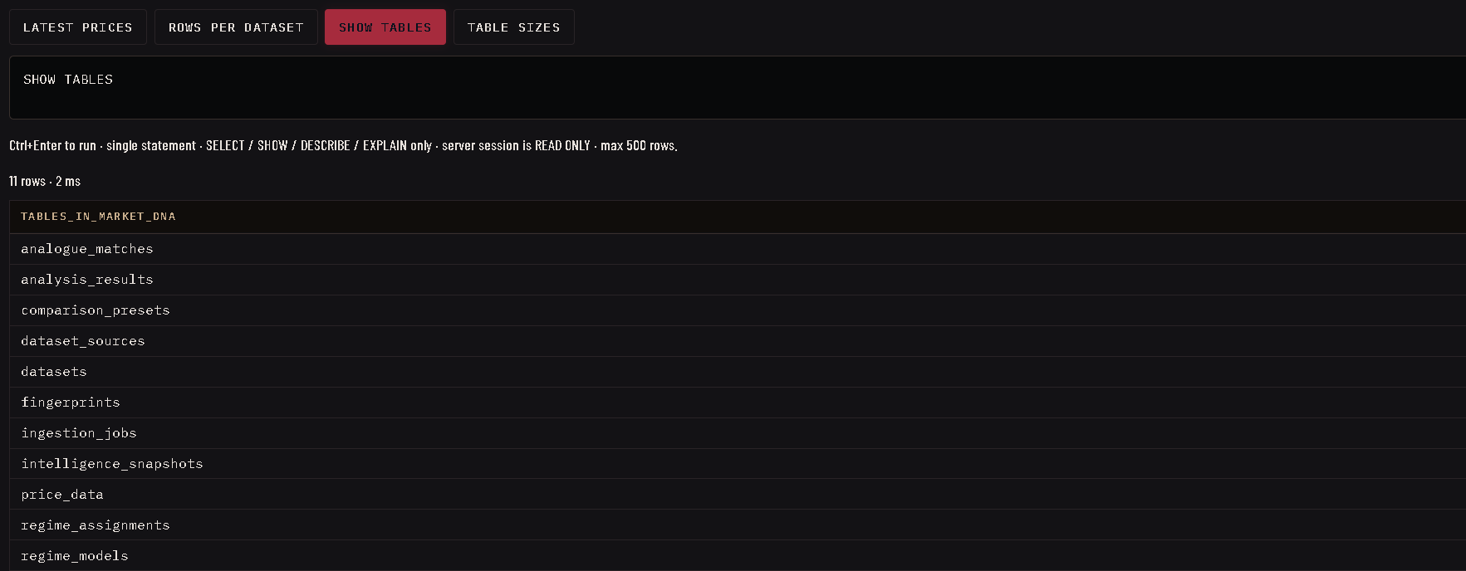

8. Database Management System and Python–SQL Connectivity

8.1 Why MySQL
MySQL provides durable structured storage, reliable indexed querying, declarative integrity constraints and ACID transactions. Historical prices must never be lost or duplicated, queries must slice years of data by date instantly, and related records must stay consistent when anything is removed requirements that map directly onto primary keys, foreign keys, unique indexes and transactions.

8.2 How Python Connects to MySQL
All connectivity flows through mysql-connector-python. The application opens a connection using configuration read from environment variables, obtains a cursor, executes parameterised SQL, commits or rolls back according to the outcome, and always closes the cursor and connection in finally blocks.
Python Application
↓
mysql-connector-python (connection → cursor → execute)
↓
MySQL Server (market_dna schema, InnoDB)
↓
Relational Tables ↔ Python analysis

A representative parameterised insert used when storing observations:
cursor.execute(
"INSERT INTO price_data (dataset_id, date, `open`, high, low, close, volume)",
"VALUES (%s, %s, %s, %s, %s, %s, %s)",
(dataset_id, day, open_, high, low, close, volume),
)

And a typical retrieval joining registry and cache tables:
SELECT s.id, s.generated_at, s.intelligence
FROM intelligence_snapshots AS s
JOIN datasets AS d ON d.id = s.dataset_id
WHERE s.dataset_id = %s AND s.param_hash = %s
AND s.latest_market_date = d.end_date

8.3 SQL Operations Demonstrated
- CREATE:schema objects are created idempotently with CREATE TABLE IF NOT EXISTS at startup.
- INSERT:bulk executemany inserts of price rows; INSERT IGNORE for duplicate-safe appends.
- SELECT:date-range slices, ordered histories, aggregate counts, MAX(date) lookups and JOINs between registry and cache tables.
- UPDATE:dataset rollups refreshed after incremental updates.
- DELETE:cache invalidation and cascade-driven removal of child rows.
- UPSERT:ON DUPLICATE KEY UPDATE keeps provenance rows current.

8.4 Transaction Management
Multi-statement writes are wrapped in explicit transactions. Storing a dataset inserts its registry row, all observations and its metric rows, then commits once any failure rolls back completely so partial datasets can never exist. Every helper closes cursors and connections in finally blocks, converts driver errors into a single application-level exception, and rolls back before propagating.

9. Database Design
The Quant Vector schema contains eleven database tables. All child tables reference datasets.id with ON DELETE CASCADE, so removing a dataset cleanly removes its observations, provenance and cached analyses in one statement while preserving referential integrity.
Table | Purpose | Key Relationship
datasets | Registry: filename, date range, row count, latest close | Primary entity; parent of all others
price_data | OHLCV time-series observations | FK dataset_id → datasets.id (CASCADE); UNIQUE (dataset_id, date)
dataset_sources | Import provenance: provider, symbol, interval | FK dataset_id → datasets.id (CASCADE)
analysis_results | Summary metrics per dataset | FK dataset_id → datasets.id (CASCADE)
fingerprints | Cached statistical fingerprints (name/value pairs) | FK dataset_id → datasets.id (CASCADE)
analogue_matches | Stored analogue windows with similarity and details | FK dataset_id → datasets.id (CASCADE)
regime_models | One persisted regime model per dataset | FK dataset_id → datasets.id (CASCADE)
regime_assignments | Per-window regime labels and confidences | FK model_id → regime_models.id
intelligence_snapshots | Parameter-keyed intelligence cache | FK dataset_id → datasets.id (CASCADE)
comparison_presets | Saved multi-dataset selections | Independent configuration table
ingestion_jobs | Import job status log for progress recovery | Job audit trail keyed by job_id

- Primary keys: AUTO_INCREMENT integer ids on every table.
- Unique constraint: uq_price_data_dataset_date guarantees one row per dataset per calendar day.
- Indexes: foreign-key columns and lookup keys are indexed for fast range scans.
- Engine: InnoDB everywhere, giving transactions and enforced foreign keys.

10. Data Flow / System Workflow
MARKET DATA
provider download or CSV file
▼
PYTHON INGESTION
fetch / read + normalise
▼
DATA VALIDATION
invalid candles, duplicates, minimum data
▼
MYSQL DATABASE
transactional inserts into relational tables
▼
SQL QUERY / RETRIEVAL
indexed range selects and joins
▼
PYTHON QUANT ENGINE
fingerprint · analogues · regimes · intelligence
▼
ANALYTICAL RESULTS
cached back into MySQL tables
▼
USER INTERFACE
charts, tables, printable report

11. System Architecture
USER INTERFACE
React + Vite presentation only
▼
FASTAPI APPLICATION LAYER
structured API routes and request validation
▼
ENGINES
Market Ingestion · Dataset Manager · Fingerprint · Analogue · Regime · Intelligence · AI Interpretation
▼
PYTHON–MYSQL CONNECTIVITY
mysql-connector-python connections, cursors, transactions
▼
MYSQL RELATIONAL DATABASE
market_dna schema · InnoDB · 11 tables

12. Key Features of Quant Vector

12.1 Dataset Management
Each import creates a registry row describing the dataset (filename, date span, row count, latest close), writes every validated observation to price_data and stores provenance in dataset_sources. Datasets can be listed, inspected, updated incrementally and deleted; deletion relies on cascading foreign keys rather than manual cleanup.
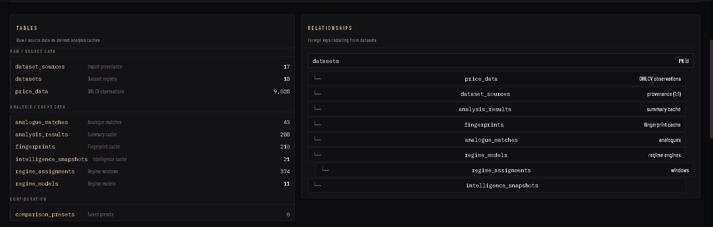

12.2 Market Data Ingestion
Imports run as staged jobs whose visible stages are FETCHING → VALIDATING → WRITING TO MYSQL → PREPARING DATASET → COMPLETE (or FAILED). Python fetches history through the provider layer (yfinance) or reads an uploaded CSV, normalises and validates it, then persists it transactionally. Each stage produces a receipt received, valid, rejected, inserted, replaced, unchanged so the user sees exactly what entered the database. Job states are also logged to an ingestion_jobs table so progress survives process restarts.
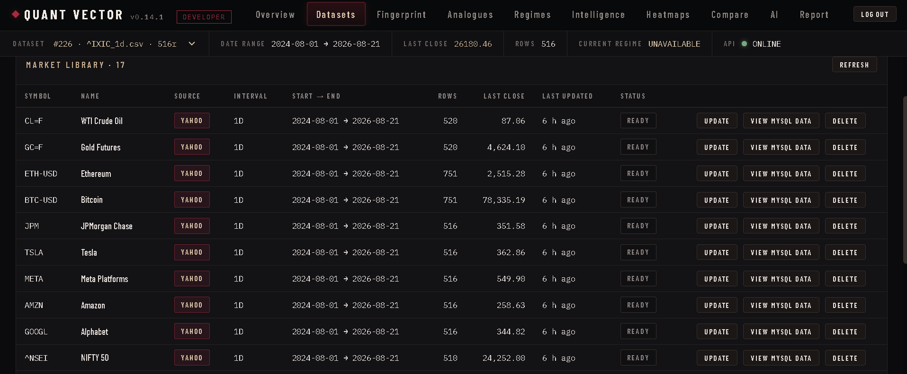

12.3 Statistical Fingerprinting
The fingerprint engine condenses a whole market period into a set of numerical characteristics computed by Python over data retrieved from MySQL: mean daily return, annualised volatility, skewness, kurtosis, maximum drawdown, 1-day VaR and CVaR at 95%, best and worst days, positive-day ratio, lag-1/lag-5 autocorrelation and relative volume. The result is a compact statistical identity of that period comparable across history cached in the fingerprints table.
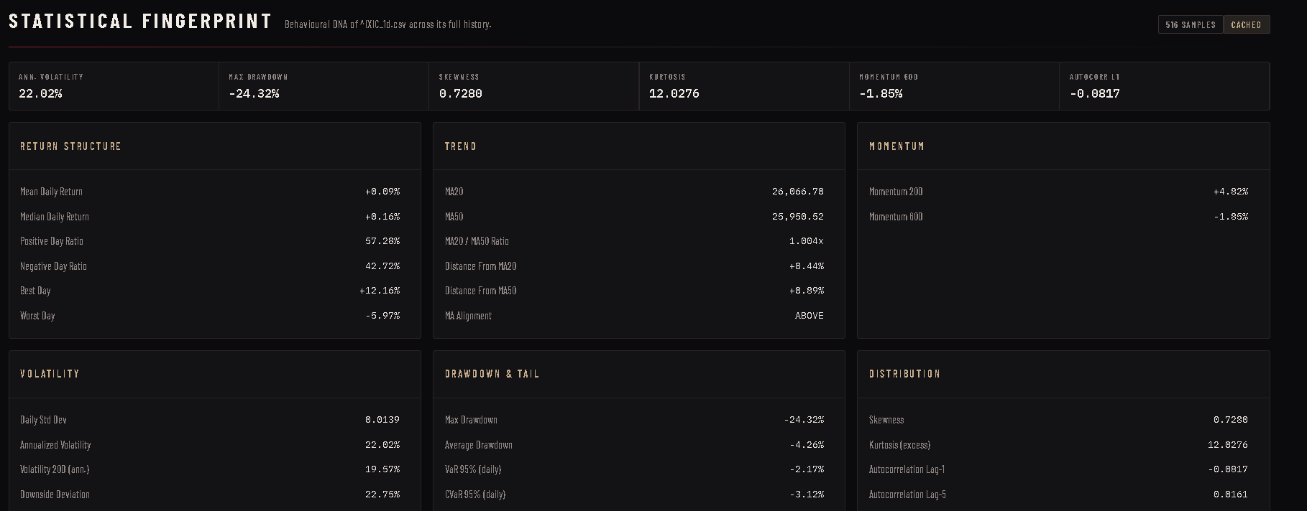

12.4 Historical Analogue Detection
Because years of observations live in one indexed table, Python can scan stored windows of recent history and compare each against every earlier window of the same length using a feature-vector distance. The closest matches the analogues are ranked by similarity and persisted with their details. Without centralised database storage this comparison would be impossible at scale.
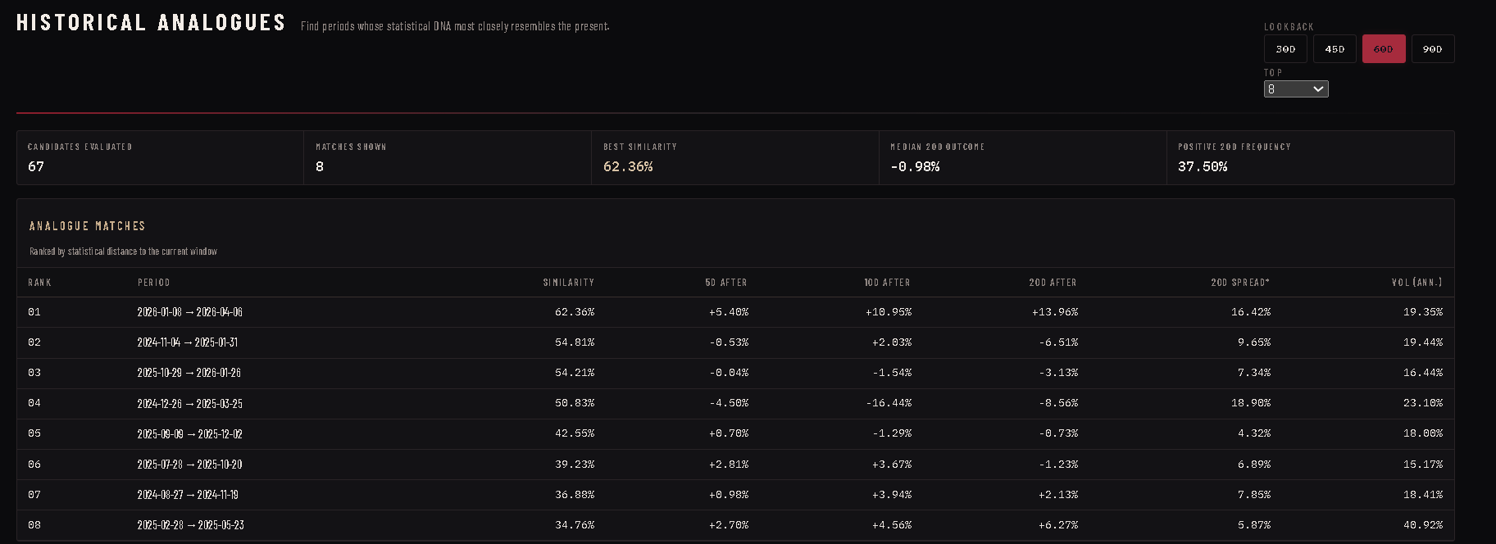

12.5 Forward Outcome Analysis
For every analogue period the system examines what actually happened next in the stored record: returns after 5, 10 and 20 trading days, plus the largest favourable and adverse moves within 20 days. Aggregated medians and frequencies across all analogues form an evidence-based historical context for the present.

12.6 Market Regime Discovery
Past market segments are grouped into distinct environments quiet, trending, volatile using K-Means clustering over window features, with principal component analysis reducing dimensions and silhouette scores guiding how many regimes fit the data. Persisted models include each window’s assignment, confidence and cluster distance.
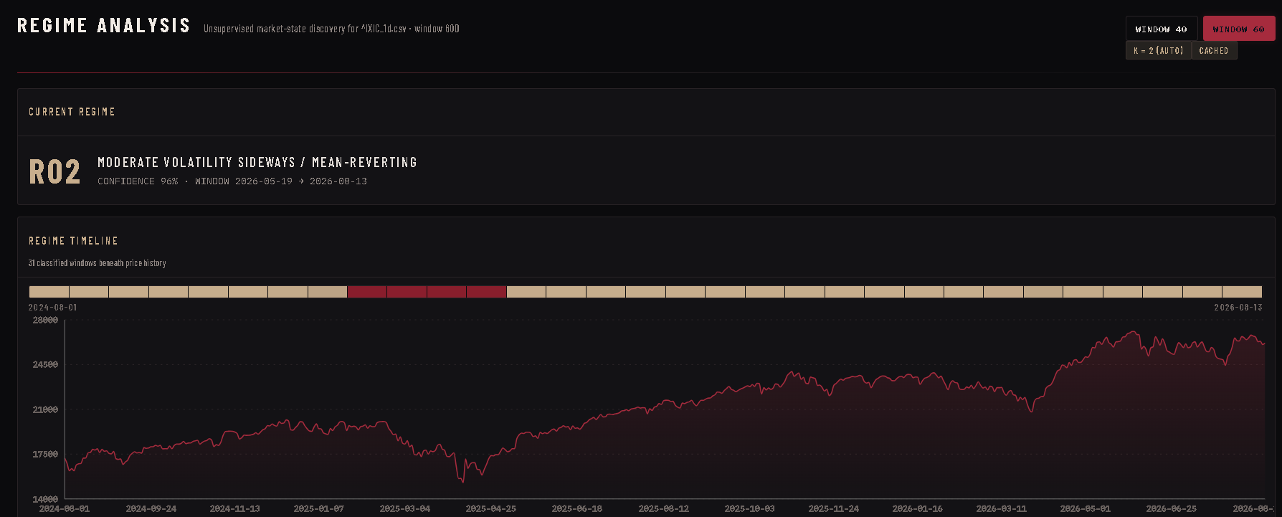

12.7 Regime Transition Analysis
Stored assignments allow the system to compute how often one regime followed another historically, producing a transition matrix with the most likely next states again derived purely from database-resident history.

12.8 Market Intelligence Engine
The intelligence engine fuses trend readings, analogue consensus, regime evidence and risk measures into a single weighted assessment with a directional bias, confidence level, agreement score and explicit contradiction reporting. Weights adapt to evidence quality, and the full snapshot is cached against its parameter hash so identical requests are served instantly.
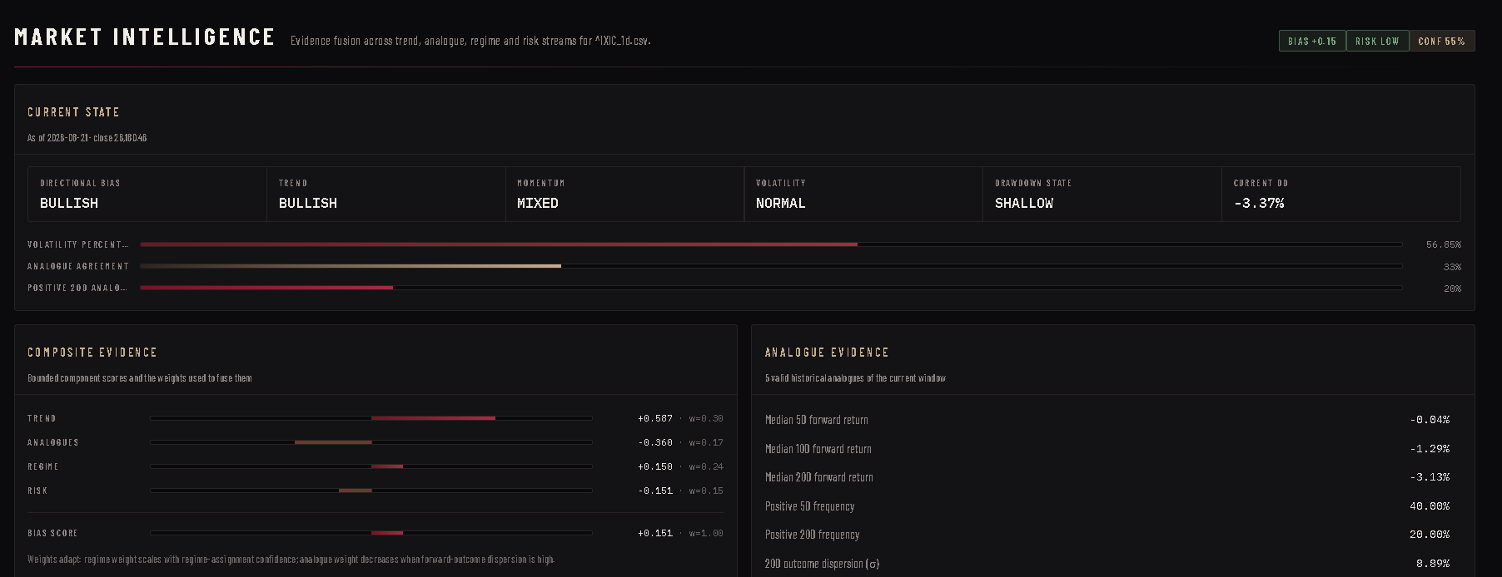

12.9 Volatility, Momentum and Drawdown Analysis
Throughout the application Python derives rolling 20-day momentum, annualised and percentile-ranked volatility, running-maximum drawdowns and moving-average relationships the vocabulary in which every engine expresses market state.

12.10 Market Overview
A dashboard summarises every stored instrument: latest close, 1/5/20-day returns, volatility, drawdown, 60-day momentum and current regime label computed from stored prices and rendered as an interactive heatmap.
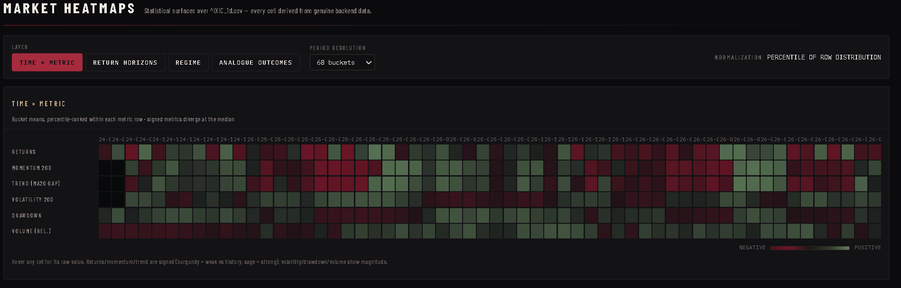

12.11 AI Interpretation Layer
An optional AI assistant, VECTOR, explains the quantitative output in plain language. It receives only structured JSON produced by the local engines and is instructed to use exclusively those numbers, cite their source tables, render charts and tables, and describe historical behaviour without advice. The AI never replaces the calculations it narrates results that Python and MySQL already produced.
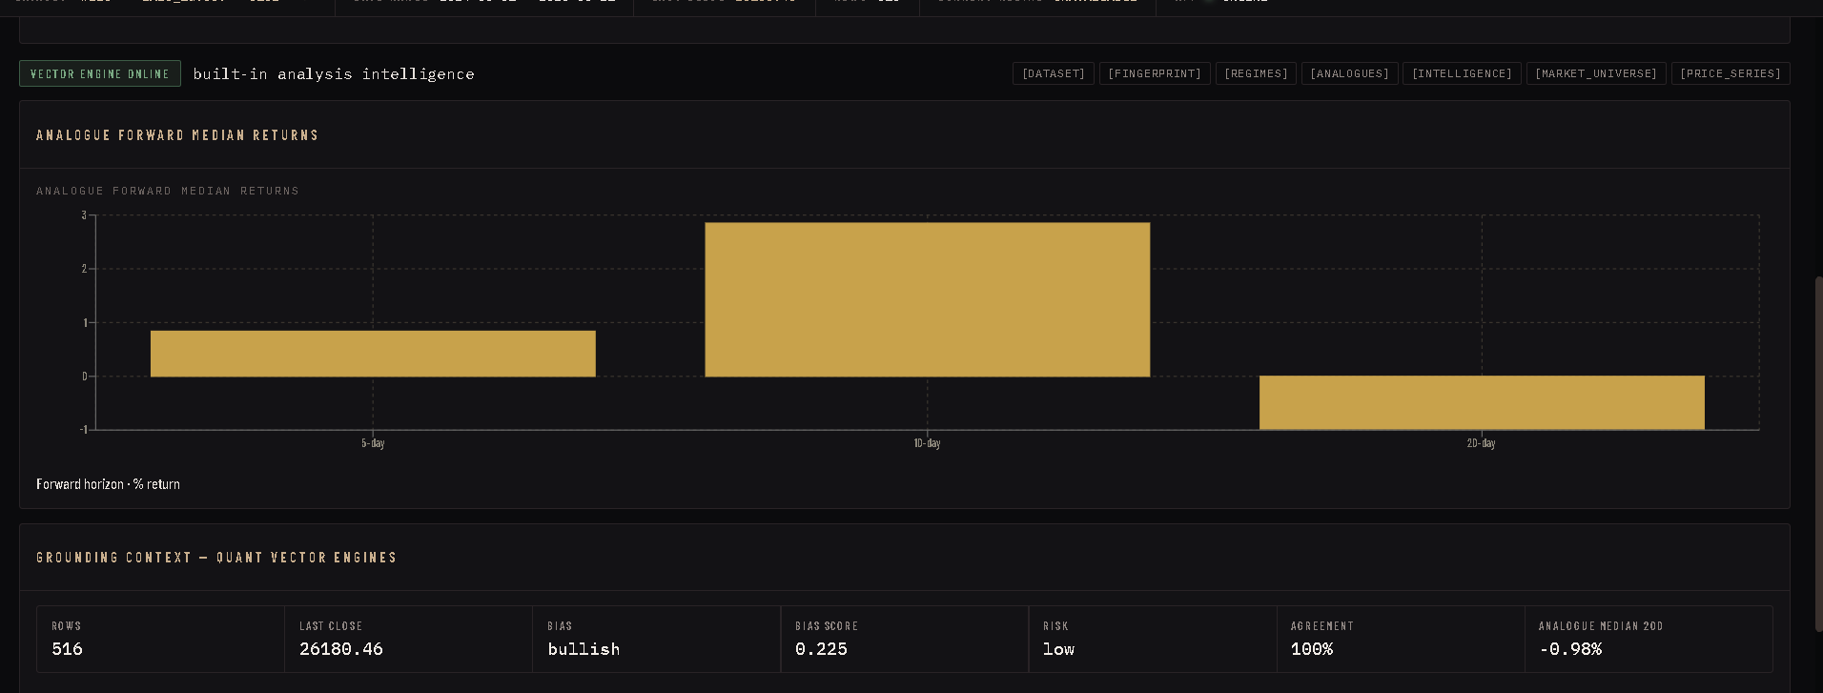

13. File Handling
Besides network downloads, Quant Vector accepts comma-separated-value files. Python reads the uploaded file, verifies required columns, parses dates, converts prices and volumes to numbers, rejects unparseable or internally inconsistent rows (high below low, negative volume), drops duplicate dates and enforces a minimum observation count before anything reaches MySQL. A bundled generator also produces sample CSV data for offline demonstration:
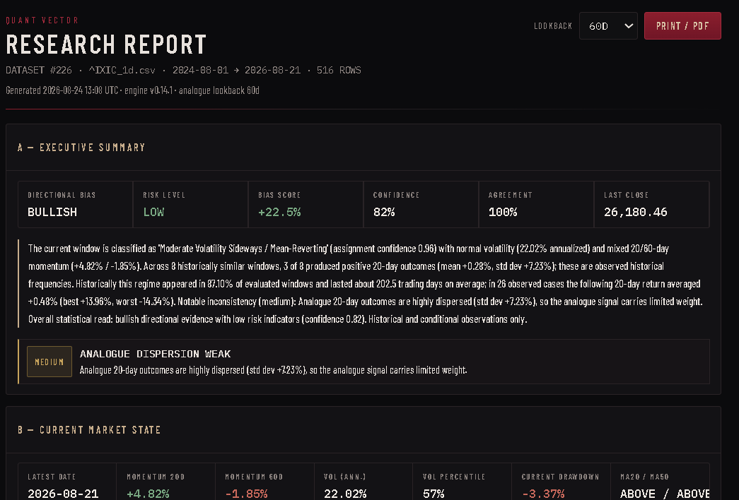
FILE → PYTHON → VALIDATION → MYSQL
csv file → pandas parse → column/type checks → candle sanity checks → duplicate removal → transactional bulk insert

14. Data Validation and Integrity
- Invalid candle detection: rows violating high ≥ max(open, close) and low ≤ min(open, close) are rejected.
- Duplicate-date prevention: enforced twice in Python during normalisation and in SQL by a unique index.
- Minimum-data requirements: analyses refuse datasets too short to be statistically meaningful.
- Missing-value handling: incomplete records are counted in the import receipt instead of silently stored.
- Referential integrity: foreign keys with ON DELETE CASCADE keep children consistent.
- Transactions: multi-table writes commit atomically or roll back entirely.
- Exception discipline: driver errors are converted to one application exception after rollback; connections always close.
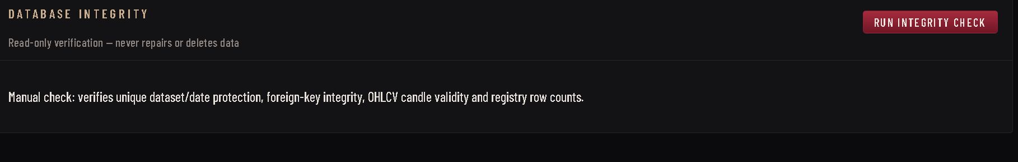

15. Sample User Workflow
- The user searches for an instrument, e.g. NIFTY 50.
- FETCH MARKET DATA starts a staged import job.
- Python retrieves historical OHLCV records from the provider.
- Records are validated and normalised.
- Valid rows are inserted into MySQL inside one committed transaction.
- The user opens the new dataset.
- Quant Vector retrieves the required history through indexed queries.
- A statistical fingerprint is calculated and cached.
- Similar historical periods are found and their later outcomes measured.
- Regime membership and the consolidated intelligence summary are generated.
- Results are presented as charts, tables and a printable research report.
All figures shown in this workflow come from stored history; the synopsis makes no claims about any particular instrument’s actual values.

16. Real-World Usefulness
- Financial education: demonstrates how analysts reason from historical evidence.
- Quantitative-finance study: a working miniature of professional research pipelines.
- Historical research: arbitrary periods can be compared systematically.
- Large time-series practice: realistic-scale data for learning DBMS design.
- Database learning: shows how caching tables make heavy analytics fast.

17. Creativity and Innovation
Conventional Class XII database projects library, hotel or inventory systems demonstrate the same syllabus concepts on modest, mostly static data. Quant Vector applies those identical concepts (tables, keys, constraints, connectivity, transactions) to a domain where the data is large, temporal and computationally demanding, and where the interesting work begins only after storage is done. The combination is unusual at this level:
DISCIPLINES COMBINED
Computer Science + DBMS + Statistics + Quantitative Finance

18. Originality, Plagiarism and Copyright
The application was independently designed and implemented for this project. Well-known open-source Python libraries (FastAPI, pandas, NumPy, SciPy, statsmodels, scikit-learn, mysql-connector-python, yfinance) are used as development dependencies under their respective licences, and publicly accessible market-data services may be consulted at runtime. All external libraries and data sources will be acknowledged in the final report; no copyrighted material is reproduced beyond what such licences and public interfaces permit.

19. Limitations
- Historical similarity does not guarantee similar future outcomes.
- Data quality depends on the external provider.
- Statistics summarise the past; they cannot foresee events.
- The application is educational and analytical not investment advice.

20. Future Scope
- Additional instruments, exchanges and higher-frequency intervals.
- Further data providers and automated scheduling of updates.
- Portfolio-level analytics across multiple stored datasets.
- Richer visualisations and comparative studies.
- Additional quantitative models alongside the existing engines.

21. Expected Outcome
The completed project demonstrates end-to-end command of the syllabus: Python opening and managing MySQL connections; SQL creating, inserting, selecting, updating and deleting relational data safely; file handling feeding validated records into the database; mathematical analysis executed over retrieved history; and a clean interface making all of it usable. It stands as evidence that Class XII-level Python and SQL can power a genuinely useful analytical system.

22. Project Development Timeline
Phase | Major Activity | Expected Output
1 | Problem identification and research | Requirement notes; study of market data formats
2 | Database design | Normalised schema.sql with keys, constraints, indexes
3 | Python–MySQL connectivity | Connection, cursor, transaction helper layer
4 | Market data ingestion | Provider fetch + CSV path with staged validation
5 | Quantitative engines | Fingerprint, analogue, regime and intelligence modules
6 | Interface development | Pages for datasets, analyses, overview, report
7 | Testing and validation | Automated backend suites and interface smoke tests
8 | Documentation and review | Report, acknowledgements and final synopsis

23. Conclusion
Quant Vector shows how the Python and SQL concepts of the Computer Science syllabus extend naturally into a substantial real-world application. Its value is created at the junction of the two: Python validates, computes and interprets; MySQL stores, protects and serves the history that makes interpretation possible.

IN ONE LINE
Python → MySQL → Quantitative Analysis → Useful Information

