India Foreign Reserves

Weekly Analysis

FintechPrepTeam

Drafted on - 14 December 22

## Description

The Reserve Bank of India (RBI) releases Weekly Foreign Exchange Reserves data. The reserves are split into 4 categories, each of which will be discussed in this report:  
1) Foreign Currency Assets (FCA)  
2) Gold  
3) Reserve Tranche Position (RTP)  
4) Special Drawing Rights (SDR)  
Each category is denominated in Rupees (INR) Crores and US Dollar (USD) millions.

## Summary

The RBI has released the Weekly Foreign Exchange Reserves data on 22 April 22. The latest position of the reserves is as follows:

| ReserveType | USDBillions |
| --- | --- |
| Total Reserves | 600.42 |
| FCA | 533.93 |
| Gold | 42.77 |
| RTP | 5.06 |
| SDRs | 18.66 |

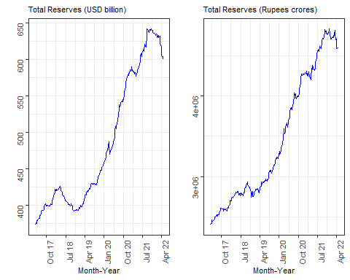

The total reserves changed by -0.13% in INR terms vs. -0.54% in USD terms. Previous week, the total reserves were USD 603.69 billion or INR 4,598,531 crores. The maximum total reserves held by RBI in USD is 642.45 billion or INR 4,835,997 crores.

## Market Update

The US Fed increased rates by 50bps this week. Due to the on-going war in Europe USD has been strengthening across major currencies. This re-valuation of the USD has impacted reserves in India.

## Foreign Currency Assets (FCA)

FCA includes a portfolio denominated in major currencies including US Dollar, Euro, Pound Sterling and Japanese Yen to name a few. The portfolio consists of securities (debt securities, derivative instruments), deposits at other central banks and BIS (Bank of International Settlements) and deposits with foreign commercial banks.

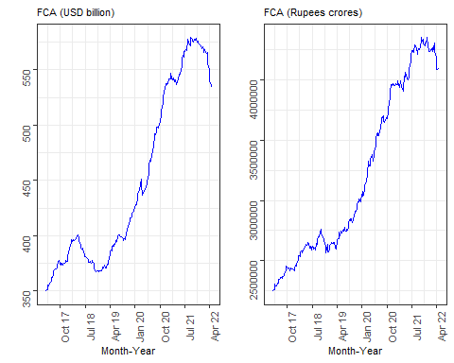

FCA changed by -0.12% in INR terms vs. -0.53% in USD terms. Previous week, the FCA was USD 536.77 billion or INR 4,088,715 crores. The maximum FCA held by RBI in USD is 579.81 billion or INR 4,353,228 crores.

## Gold

RBI holds physical gold domestically, at the Bank of England and at Bank of International Settlements (BIS)

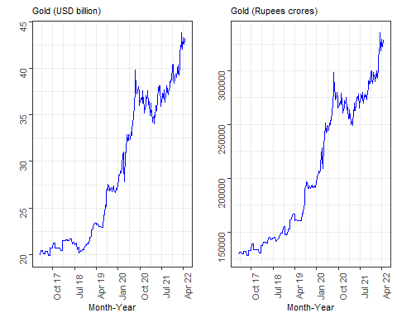

Gold reserves changed by -0.47% in INR terms vs. -0.87% in USD terms. Previous week, gold holdings was USD 43.15 billion or INR 328,649.2 crores. The maximum gold held by RBI in USD is 43.84 billion or INR 335,721.3 crores.

## Reserve Tranche Position (RTP)

Every member country contributes to the International Monetary Fund (IMF). The Reserve Tranche Position is that portion of contribution that the member country can access without paying any interest. This has been ~25% of the member country’s quota, but of course it can change.

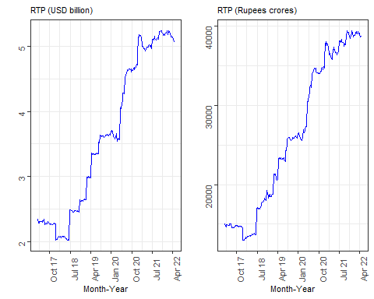

RTP changed by -0.37% in INR terms vs. -0.51% in USD terms. Previous week, RTP was USD 5.09 billion or INR 38,766.75 crores. The maximum RTP held by RBI in USD is 5.24 billion or INR 41,232.58 crores.

## Special Drawing Rights (SDR)

SDR is NOT a currency. Its is valued based on a basket of currencies – US Dollar, Euro, Chinese Renminbi, Japanese Yen, Pound Sterling.

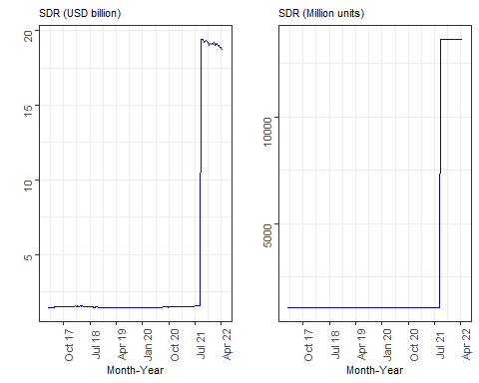

SDR changed by -0.18% compared to previous week. SDR holdings is currently USD 18.66 billion or 1.365677^{4} million units. The maximum SDR held by RBI in USD is 19.44 billion or 1.366171^{4} million units.