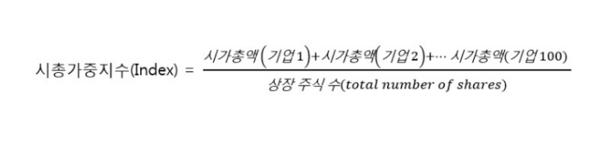

https://brunch.co.kr/@ahnhs910/12

https://securities.miraeasset.com/public/mw/blog/html/20210107095303.html?ver=20210112124142