CHAPTER – 4

PROJECT – 1

SCHOOL STUDENT MANAGEMENT SYSTEM

Objective
The objective of this project is to develop a simple School Student Management System using Object-Oriented Programming (OOP) concepts in Python. The project focuses on representing student information through classes, displaying student details, and updating student grades efficiently using class methods. It demonstrates the practical implementation of encapsulation, object creation, and method invocation in Python.

Technologies Used
- Python 3: Used as the programming language to implement the complete student management system.
- Object-Oriented Programming (OOP): Utilized to organize the program using classes, objects, constructors, and methods.
- Visual Studio Code: Used as the development environment for writing, executing, and debugging the Python program
- Python Terminal: Used to execute the program and display the output.

Workflow Explanation

- Create Student Class: Define a Student class with a constructor (__init__) to initialize student ID, name, age, and grade.
- Initialize Student Objects: Create student objects by passing the required information to the constructor.
- Display Student Information: Implement the display_details() method to print each student's ID, name, age, and grade in a structured format.
- Update Student Grade: Implement the update_grade() method to modify the student's grade and confirm the successful update.
- Display Updated Information: After updating the grade, display the student details again to verify that the changes have been applied successfully.

Program :

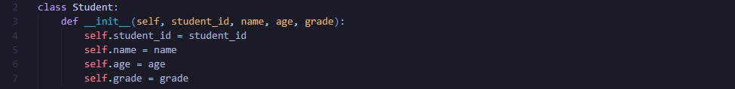
PART 1: Constructor Initialization
This part implements the __init__() constructor, which initializes the student object's attributes such as student ID, name, age, and grade whenever a new object is created.

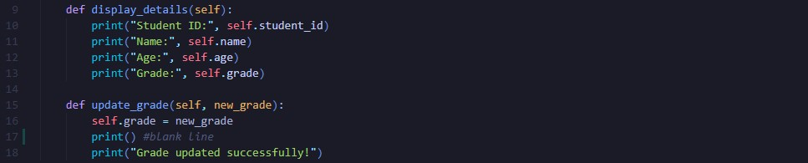
PART 2: Student Methods Definition
This part defines the member methods of the Student class. The display_details() method displays the student's information, while the update_grade() method updates the student's grade and confirms the successful modification.

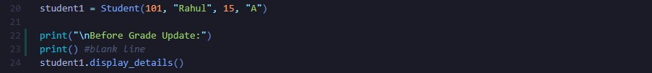
PART 3: Student Object Creation & Initial Display
This part creates a Student object by passing the required details to the constructor and displays the student's information before updating the grade. It demonstrates object creation and method invocation.

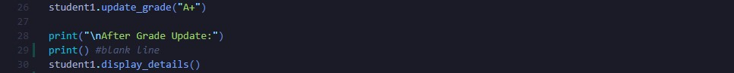
PART 4: Grade Update & Updated Display
This part updates the student's grade using the update_grade() method and displays the modified student information to verify that the grade has been successfully updated.

Conclusion

This project successfully demonstrates the implementation of Object-Oriented Programming principles using Python. By organizing student information within a class and performing operations through methods, the system provides a clean and modular approach to managing student records. It also improves code readability, maintainability, and reusability.

Key Takeaways

.
- Method Implementation: Understood how member functions perform operations such as displaying and updating object data.
- Encapsulation: Organized related data and functions inside a single class, improving code structure and maintainability.
- Code Reusability: Learned how objects created from the same class can manage multiple student records without duplicating code. Object-Oriented Design: Learned how to create classes and objects to represent real-world entities efficiently.
- Constructor Usage: Gained practical experience using constructors (__init__) to initialize object attributes automatically

