EQUITY & CREDIT RESEARCH | GROUP 43
Portfolio Credit Quality Review: 10-Year Strategic Analysis

Executive Summary
The Group 43 portfolio exhibits a profile of structural rigidity rather than just deterioration. While Investment Grade assets (AAA-BBB) maintain their dominant market share throughout the decade, the portfolio is burdened by a persistent, non-declining default layer. This static risk stratification signals a persistent inability to resolve distressed assets, resulting in a rigid capital structure where non-performing loans act as a continuous drag on portfolio health rather than being successfully worked out.
1. Initial Portfolio Structure (Year 1)
The portfolio inception data reveals a diversified credit strategy.
- Distribution: The initial mix was well-balanced, with no single rating category dominating the pool. Investment Grade assets (AAA to BBB) provided a strong initial baseline.
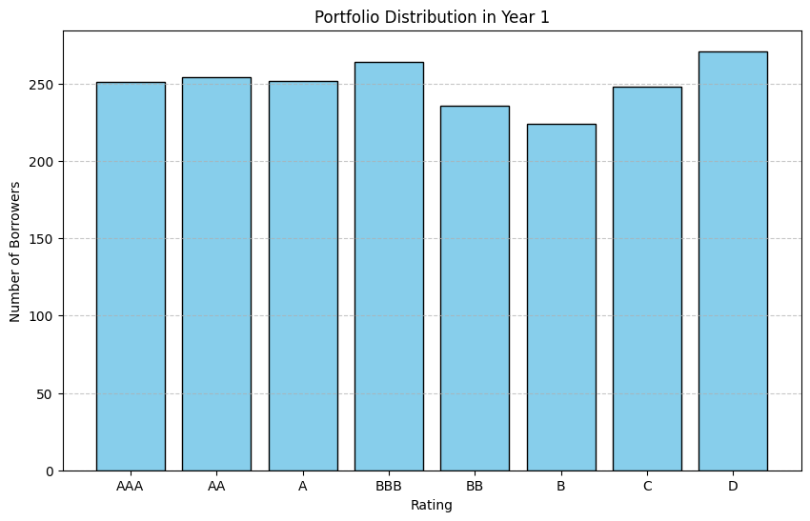
- Concentration Risk: Risk was evenly distributed, preventing immediate exposure to any single tier's volatility.

Figure 1: Initial distribution shows a balanced spread across rating categories, providing a stable starting baseline.

2. Migration Trends: Structural Stratification (Year 1 - Year 10)
The aggregated trend analysis (Figure 2) demonstrates a rigid credit hierarchy that persists throughout the observation period.
- Static Core: Contrary to typical degradation scenarios, Investment Grade assets consistently dominate the portfolio (>40% share) throughout the timeline. However, the parallel trajectory of the risk bands indicates a static credit profile, suggesting the bank is maintaining its quality mix but failing to generate any significant positive credit migration.
- The "Stubborn" Default Floor: A critical inefficiency is the persistence of the Default layer, which fluctuates between 10-15% without going down. This indicates a structural capital trap, where non-performing assets are "stuck" in the portfolio rather than being successfully removed/written off.
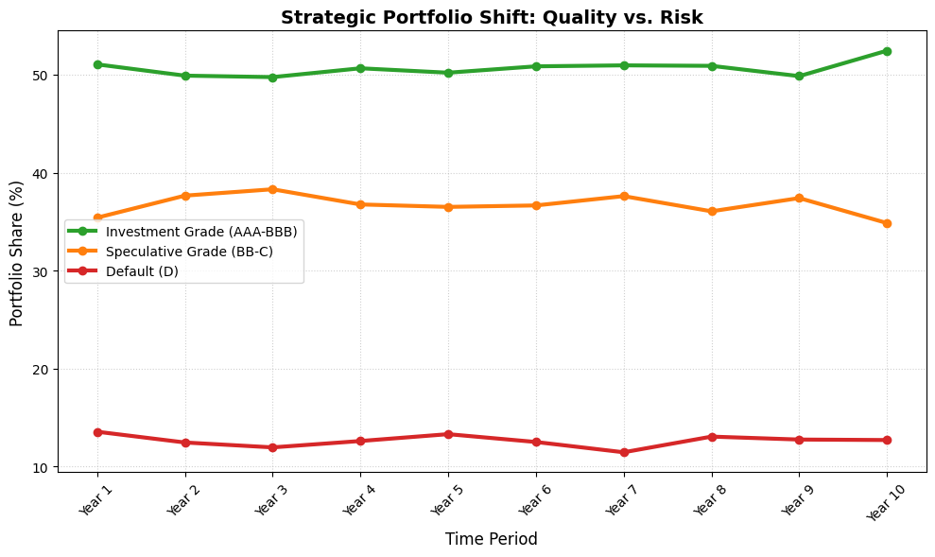

Figure 2: 10-Year Portfolio Risk Stratification. The parallel trend lines indicate a rigid credit hierarchy where high-quality assets fail to displace the persistent volume of defaults.
3. Key Risk Indicator: The Default Trajectory
The most critical risk identified in the portfolio is the trend of defaults.
- Inflection Point: The transition to default was not linear. As seen in Figure 3, the slope of the default curve steepens significantly after Year 5. This suggests that once borrowers remain in the portfolio for a medium term, their creditworthiness decays rapidly.
- Terminal State: By Year 10, the cumulative count of defaulted borrowers reached around 255. This "absorbing state" implies that recovery efforts for defaulted loans have been largely ineffective.
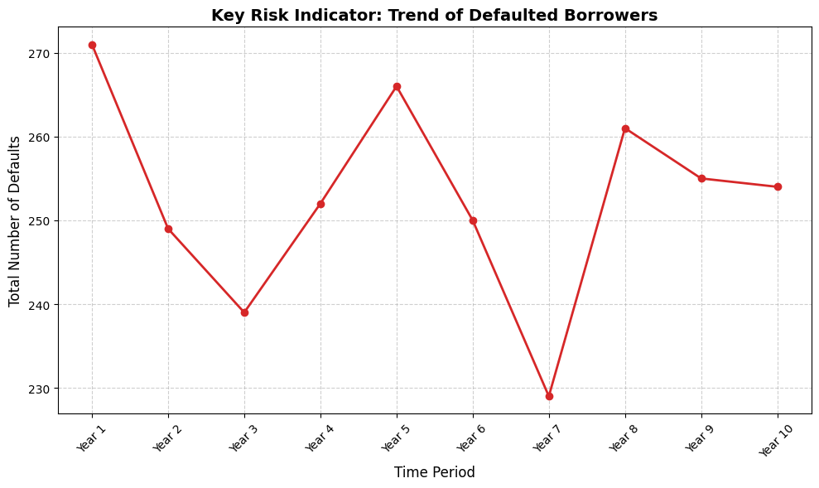
Figure 3: Cumulative defaults exhibit a zigzag increasing trend, acting as the primary driver for increased Expected Loss (EL).
4. Strategic Conclusion
The Group 43 portfolio exhibits structural stagnation, transforming from a diversified inception pool into a rigid asset mix burdened by persistent insolvency. The analysis confirms a static risk stratification, where the dominant Investment Grade share fails to erode the "stubborn" default layer, which acts as a continuous drag on profitability. With default volumes accelerating rather than resolving in the final years, the portfolio reflects a critical failure in remedial credit management, necessitating an immediate tightening of origination criteria to prevent further capital leakage into the 'loss' bucket.
Disclaimer: This report is for academic simulation purposes only. Calculations based on transition matrices derived from Group 43 dataset.
Code Link

