The Effect of Steeping Time on the Concentration of Polyphenols Within Green Tea

Owen Brooks

November 17, 2023

IB Chemistry HL

Purpose Question: To what extent does steeping time affect the concentration of poly phenols in green tea.

Independent Variable: Time steeped

Dependent Variable: Concentration of polyphenols

Background:

Tea, specifically green tea, is a passive interest of mine. After thousands of years human culture has become inseparable from the consumption of tea and the culture resolving around it (primarily in East Asia). Despite its significant role in daily human life for millennia, little is known about its incredibly complex chemical inner workings. For this reason, I started to read more of the existing research and knowledge of tea’s chemistry and began to design this experiment. Instead of attempting to experiment with incredibly diverse and complex inner mechanisms of tea (which is the forefront of most modern research on tea), I set to ask a much simpler, more practical question: to what extent does steeping time affect the concentration of polyphenols in green tea.

Green Tea is one of the many variants of tea hailing from the plant Camellia sinesis’ leaves. Variants of tea such as black, green, white, and oolong differ primarily in the extent to which they have been oxidized after harvesting; on a sliding scale of oxidation, green tea is not oxidized after harvest (maintaining its original color) while darker color teas have higher levels of oxidation (changing its once green color to a dark one, similar to other foods that are oxidized).[1] Oxidation level greatly affects the chemical composition of tea and by extension its taste and health benefits. Since this experiment tests green tea, it is of the utmost importance to understand the specific chemical composition of green tea.

Polyphenols are a primary component of tea, regardless of oxidation level; different levels of oxidized tea have different types of polyphenols and different concentrations. In green tea the major type of polyphenols are catechins, of which include catechin, epigallocatechin gallate, epigallocatechin, epicatechin gallate, gallocatechin, and epicatechin.[2] Of these, epigallocatechin gallate (EGCG) is the most predominant[3] within green tea and the subject of this experiment. Important to note all these types of catechins have very similar structures, meaning that this experiments assumption that all polyphenols within green tea are EGCG is not as far a stretch as it may seem.

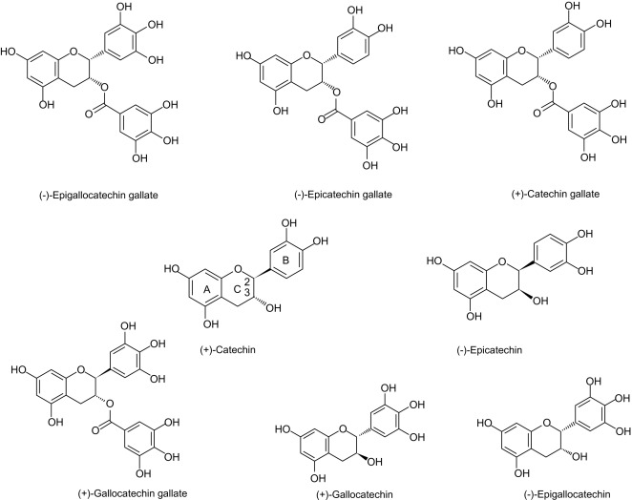

Chemical structures of catechins.[4]

This experiment of will be a measure of concentration of polyphenols (EGCG) in tea at different levels of steeping. Or in other words, the rate of dissolution: the rate a solute breaks down in the solute to form a solution. Green tea leaves are the solute; water, H2O, the solvent; tea, the solution. Fundamentally, the rate of dissolution of tea leaves in water is dependent upon the frequency of particles colliding. The kinetic energy of particles causes them to collide with each other. When a particle does not have sufficient kinetic energy, its collision will not be successful in breaking apart bonds. Additionally, when collision occurs at the wrong geometries, it will also not be successful. Anything that increases the frequency of the collisions between particles will also increase the rate of dissolution. The temperature of the water that the tea is placed in will increase the average kinetic energy of particles within the reaction and increase the rate at which dissolution occurs. For this reason, temperature of the tea is a crucial factor within the steeping of tea. The volume of the water also is significant factor within the steeping of tea since concentration of the reaction will increase the rate at which particles collide, being that space is more confined and all the particles are crammed together and forced to face each other. Both temperature and concentration are controlled within this experiment. However, the size of the particles and therefore their surface area are significant factors in rate of dissolution since more area to collide means more collisions. Surface area of tea leaves is the most important thing to take into consideration when testing the rate of dissolution (or steeping) of tea and the fact that tea leaves in tea bags are much more fine than leaves used in the more traditional way of making tea (literal leaves, not leaf dust) illustrates the relativity of tea steeping. This experiment tests tea inside tea bags that are mass manufactured and specifically this since the rate of dissolution of more traditional tea leaves is vastly different.

The tea will be titrated with KMnO4, or rather a standardized MnO4- rid of the impurities of KMnO4, which will oxidize all polyphenols (EGCG) as well as all other antioxidants within tea like vitamin C. The reaction is shown below.

Reduction Half Reaction:

MnO4- + 8H+ + 5e- → Mn2+ + 4H2O

Oxidation Half Reaction:

C22H18O11 → 22CO2 + 10H+ + 10e-

Full Reaction:

C22H18O11 + 28H+ + 28MnO4- → 22CO2 + 18H2O + 28Mn2+

Controlled Variables:

|  |  |  |
| --- | --- | --- |
| Controlled Variable | Importance | How the experiment deals with it |
| Temperature of water | The temperature of water will directly affect the rate of reaction and if temperature were to be not standardized the integrity of the experiment would collapse. | Measures the temperature of water right after being poured into the container with the tea. This way it is easily identifiable if there is any significant outlier in temperature. |
| Amount of tea (grams) | The amount of tea will determine how much substances are steeped into the water. Since this experiment measures steeping time as the independent variable, it must be standardized to have comparable measurement of concentration. | Establish the amount of tea within one of the stash tea bags and the weight of the bag itself then repeat to check for consistent amount of tea within stash tea bags by subtracting weight of bag from total weight of each tea bag. |
| The fineness of the tea leaves | The fineness of tea leaves dictates its surface area and consequentially the rate of reaction, or in this experiment, the rate at which it steeps. Tea leaves in tea bags is much more fine than traditional tea which for the most part leaves the tea leaves as is after processing. For this reason, the fineness of tea leaves is a defining characteristic as it directly affects how tea steeps, and therefore must be standardized. | Using same company and product of tea leaves ensures that the manufacturing process of the tea is consistent. By extension this, to a reasonable extent, standardizes the surface area of the tea leaves. |
| Volume of water (after boiling) | The volume of water must be measured after boiling since the boiling process will release water in the form of water vapor and skew the final volume. Additionally, the volume of water dictates the concentration of the solution and therefore must be standardized. | Measuring water after the boiling process and with the tea inside the container ensures that the volume of water when temperature is taken is accurate. |
| Color of solution of a finished titration | Discrepancies in the stopping point for titration will skew the measured MnO4- since subjective human perception of color will inevitably be mistaken. | Each titration is compared to the waste container in which all previously titrated samples were dumped, in a way, standardizing the target color. |

Materials:

* 50mL granulated cylinder
* Three 300mL identical container for steeping
* Kennel
* Twelve 60mL plastic cups for samples
* Thermomotor
* Three 50mL flasks for the titration of tea
* Titration set up: stand, latch, and burette
* Stash green tea (13 bags, 2.1g of tea leaves in each)
* 0.05M MnO4-
* 3M H2SO4
* 0.02M FeSO4 for clean up
* Two funnels
* Ceramic dish for tea disposal
* Water squirt-er
* Disposal container

Procedure:

1. Standardize MnO4- solution using iron ammonium sulfate: Add a drop of permanganate solution to 100mL of water to save as titration standard. Prepare a 10.00mL sample of Fe2+ standard solution with 10 drops of 3M H2SO4 in a 125mL flask. Titrate using the MnO4- in the burette until the permanganate matches your standard, and color is sustained for at least 10 seconds. Use the known molarity of Fe2+ solution, calculate the true molarity of the MnO4-.
2. Arrange the three 300ml containers side by side for simultaneous tea brewing and put a tea bag in each. Additionally prepare a time keeping device and thermometer and set organize/prepare the twelve 50ml plastic cups by steeping time and trial.
3. Bring at least 1 liter of water to a boil and measure 250mL (including tea bag) into first 300mL container then start the stopwatch, measure the temperature immediately then pour 250ml into the second, loop the stop watch, and take temperature of water. Repeat same process for the third.
4. When steeping is done for each respective 300 mL container, immediately remove the tea bag from the container to halt the steeping process.
5. For each 300ml container, pour at least 50ml of the steeped tea into one of the 60ml plastic cups.
6. Repeat this procedure of steeping tea until there have been three trials for steeping times of 1, 3, 5, 7 minutes respectively.
7. Titration process: put a plastic funnel into the top of the burette and with the water squirt-er run water through the burette into a disposal flask until all water is clear. Rinse the burette with the MnO4-. Now fill the burette with MnO4- and record the initial volume.
8. Using a granulated cylinder, measure out 40mL of the 60mL plastic cups for one of the steeping times, and put the measured 40mL within one of the three 50mL flasks. Repeat for the other two samples in the 60mL plastic cups that have the same steeping time as the first remaining two 50mL flasks not yet filled.
9. Using a tiny piper, put five drops 3M H2SO4 into each of the three 50mL flask.
10. Carefully titrate the MnO4- into the flask of tea until color of the tea has turned from a light yellow-gold color to a yellowish red and record endpoint of MnO4- within burette. Dispense of titrated tea into the a clean disposal container—this will be used as a titration reference for all following titrations.
11. Repeat this titrating process for the other two 50mL flasks containing tea of the same steep time, making sure to record the start and end point of the MnO4- within the burette.
12. Repeat this titration process for the other three steep times.
13. Once all samples have been titrated, dispose the MnO4- down the sink by either diluting it with water until its distinct pink-purple color is gone or neutralize the MnO4- with 0.02M FeSO4.

Diagram:

Safety:

Potassium Permanganate KmNO4 is powerful oxidizing agent that can react violently with easily oxidized substances and can also explode if heated in a closed container.[5] It can cause eye accidents and is a strong skin irritant, meaning it is important to use safety goggles and avoid contact with skin. It can be neutralized for proper disposal with a strong base like FeSO4 or diluted until neutralized.

Sulfuric Acid H2SO4 is a strong acid that can if in contact can cause irritation to skin, eye damage, and may be harmful if inhaled.[6] Wearing eye protection and gloves is important when handling, however this experiment only uses extremely small amounts of 3M H2SO4 and so a well ventilated area is not necessarily needed but would be for if using a higher quantity at this molarity or higher. Disposal will not be necessary since it is completely used up in the experiment.

Data Table:

Red=Outlier

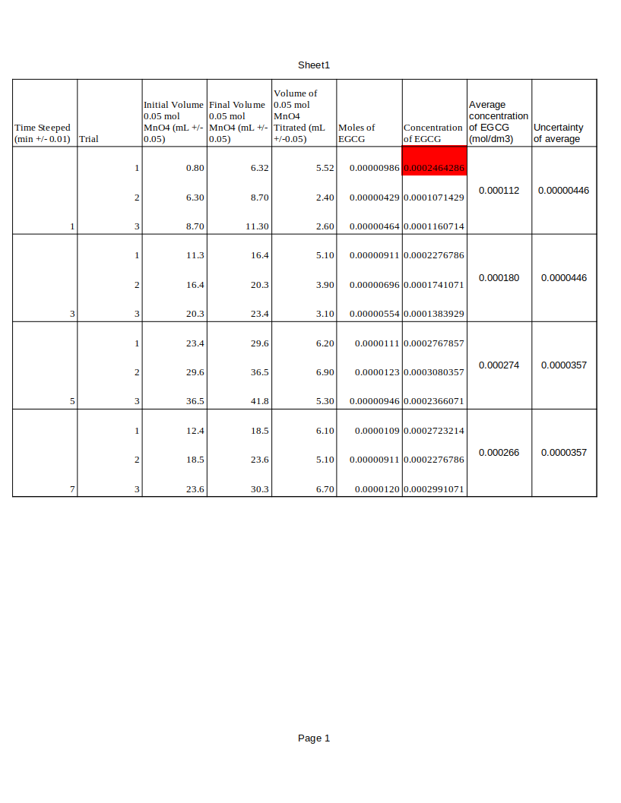

Calculations:

Volume of 0.05 mol MnO4- Titrated:

[final volume]-[initial volume]=[volume titrated mL]

ex.

8.7-6.3=2.4 mL

Moles of EGCG:

(([volume MnO4- titrated]/1000)*0.050)/28=[Moles of EGCG]

1000 = mL to L, 0.050 = molarity of MnO4-, 28 = mole conversion derived from chemical equation

ex.

((2.4/1000)*0.050)/28=0.00000429 mol

Concentration of EGCG:

[moles of EGCG]/([volume of solution]/1000)=[Concentration of EGCG mol/dm3]

1000 = mL to dm3

ex.

0.00000429/(40/1000)=0.000107 mol/dm3

Average Concentration of EGCG:

([trial 1 concentration]+[trial 2 concentration]+[trial 3 concentration])/3=[Average Concentration of EGCG]

ex.

(0.000248+0.000174+0.000138)/3=0.000180

Uncertainty on Average Concentration of EGCG:

([largest trial value]-[smallest trial value])/2=[Uncertainty on Average Concentration of EGCG]

(graphs)

ex.

(0.000228-0.000138)/2=0.0000446

Graphs:

Conclusion:

This experiment investigated the effects that steeping time has on the total polyphenol concentration in tea. The resulting data indicates that as steeping time increases, so to does the concentration of polyphenols within tea until it plateaus at around five minutes—something supported by both graphs. Additionally, steeping time and polyphenol concentration have a positive non-linear—R2 not applicable to non-linear relationship, but none the less can be reasonably said to indicate a moderate correlation and would be very valuable reference for any future retrials of the experiment. Notably at one minute, average concentration of EGCG is already at 0.000112 mol/dm3 (outlier excluded) suggesting that the first minute of steeping has a very fast rate of dissolution when compared to other minutes respectively. These results make sense since collision theory holds that rate of reaction is dependent upon temperature, concentration, and surface area of the reactants (tea and water), all of which are controlled, to an extent, within the experiment. Therefore, the rate of dissolution will be relatively consistent throughout trials since no external factor affecting rate of dissolution could be feasibly introduced. The only thing that can stop the rate of dissolution is for the limiting reactant (in this case tea leaves) to be completely eaten up—for each particle to collide with sufficient kinetic energy to be successful to the point no more collisions can happen. It is evident that, in this experiment, total dissolution of tea’s polyphenols occurs at around 5 minutes.

|  |  |  |
| --- | --- | --- |
| Sources of Error | How it can skew data | Suggested Improvements |
| MnO4- reacting to other components of the tea capable of being oxidized eg. Vitamin C | Will inevitably inflate amount of potassium permanganate needed to titrate and make it so that a 1:1 correlation between potassium permanganate and poly phenol content is impossible. | Using activated charcoal after steeping to rid of unwanted components within the solution |
| It is impossible for the eye to make a standardized assessment of when titration is complete—despite the experiments control for this. | Over titration or inconsistencies in when titration is deemed finished will result in inaccuracies within the data. | Studies have been done on the been done on best way to conduct this experiment—largely for commercial reason—and it has been found that using 1.10-phenanthroline-iron (II) indicator in a potassium permanganate oxidation titration would, at the endpoint, turn the color from a purplish red to colorless.[7] This would greatly improve the accuracy of this titration method. |
| Inconsistencies in size of the ground up tea within the tea bag cannot be reasonably controlled, despite controlling the brand and product. | Size of the grounded up tea will increase rate of reaction for the small tea particles, and decrease rate of reaction for the tea that has larger tea particles; being that the experiment is, in many way, a testing of rate of reaction, without consistent processing techniques by the tea manufacturers will make data obsolete for commercial tea brands. | Using a tea product that has a more clear understanding of the processing techniques—such as tea not in tea bags—will standardize the procedure and ensure validity of the data, since, of course, this experiment measures green tea—not a corporation’s manufacturing techniques. |
| The end point will never be the real equivalence point in the titration and thus give inaccurate representation of the moles of MnO4- used within the reaction. | Since the volume of MnO4- titrated into the tea solution will not be representative the the true volume needed to reach equilibrium in the reaction, the standardized end point created will be inaccurate and skew the experimental data from literature values and increase percent error. | Using the previously suggested indicator 1.10-phenanthroline-iron (II) indicator for the titration will ensure that the end point is as close to equivalence point within the reaction. That being said, this improvement can not with 100% certainty, even to the most masterful analytical chemist, ensure the end point is exactly the equivalence point. |
| Measuring the volume of water used for steeping is reliant on judgment and cannot be said to be reliable. | The volume of water used for steeping directly affects the concentration of the tea which is significant because exact measurements of this solution will be used for titration and so the moles of polyphenols will be reflective of an unreliable judgment of volume. | Accurately measuring the volume of water with a granulated cylinder with low uncertainty then heating up the water to 85oC will prevent water vapor from escaping and maintain a more accurate volume. |

1. “Tea Oxidation.” *ArtfulTea*, artfultea.com/blogs/tea-wisdom/tea-oxidation. Accessed 15 Nov. 2023.
2. “Flavonoids.” *Linus Pauling Institute*, 28 Apr. 2014, lpi.oregonstate.edu/mic/dietary-factors/phytochemicals/flavonoids.
3. Khan, Naghma, and Hasan Mukhtar. “Tea Polyphenols in Promotion of Human Health.” *PubMed Central (PMC)*, 25 Dec. 2018, www.ncbi.nlm.nih.gov/pmc/articles/PMC6356332.
4. “Catechin - an Overview | ScienceDirect Topics.” *Catechin - an Overview | ScienceDirect Topics*, www.sciencedirect.com/topics/biochemistry-genetics-and-molecular-biology/catechin. Accessed 15 Nov. 2023.
5. “Flinn Chemicals, Potassium Permanganate.” *Flinn Chemicals, Potassium Permanganate*, www.flinnsci.com/products/chemicals/potassium-permanganate. Accessed 15 Nov. 2023.
6. “Sulfuric Acid Solution 1 M - 6 M SDS (Safety Data Sheet) | Flinn Scientific.” *Sulfuric Acid Solution 1 M - 6 M SDS (Safety Data Sheet) | Flinn Scientific*, www.flinnsci.com/sds_801.02-sulfuric-acid-solution-1m---6-m/sds_801.02. Accessed 15 Nov. 2023.
7. Sun, Mu-Fang, et al. “Recent Advances in Analytical Methods for Determination of Polyphenols in Tea: A Comprehensive Review.” *PubMed Central (PMC)*, 13 May 2022, www.ncbi.nlm.nih.gov/pmc/articles/PMC9140883.