**OUTPUTS:**

**Booking Trade-1.**

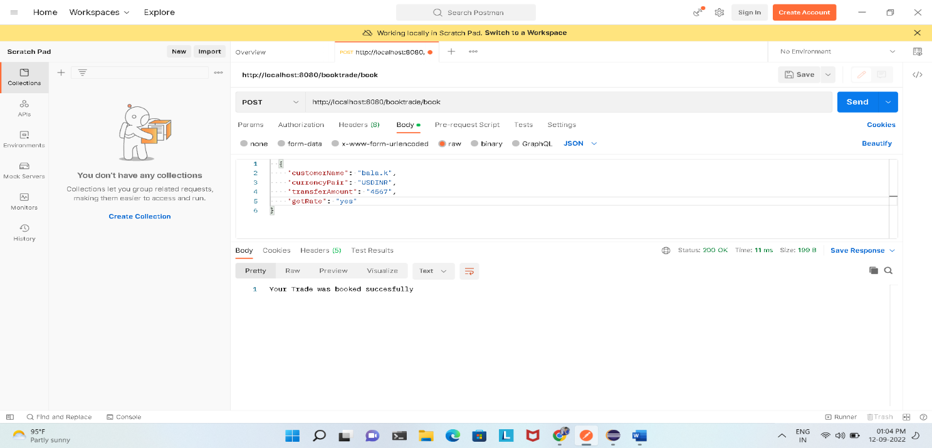

**Booking Trade-2.**

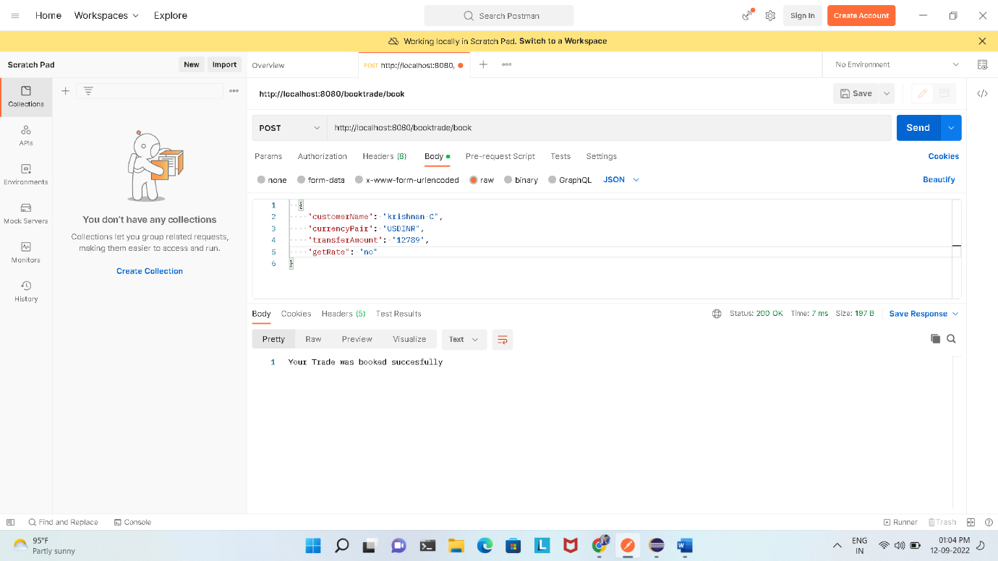

**Trading History:**

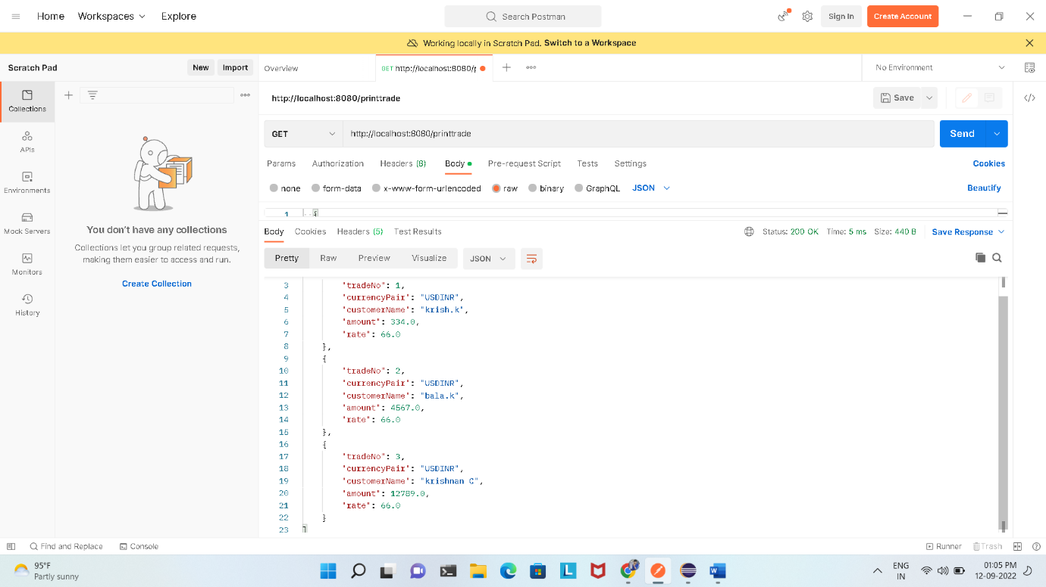

The above screenshot represents Printing the booked trades using the API.