Railsimulator

Faur Ioan-Aurel

Abstract

For the DCS (Distributed Control System ) there was an assignment at the end of the semester to build a railroad simulator. Starting with a map of the railway track and a table with all the available trains that could run on the given map, one should dynamically build the train time table. Of course this table is built by already knowing from where the train starts, where is the end of his route and all the station the vehicle visits. Alongside this data, minimum and maximum time that a train will spend to travel this locations will be specified. The system should provide a way to introduce delays on the railroad. If so, then the system should build a new time table, notify the monitor and simulate the new conditions.

In order to resolve this problem I proposed a distributed system that will meet the above requirements.

Introduction

The system I proposed is called Railsimulator (Fig 1.) and because of how the problem was tackled, the system is able to meet all the above requirements. Also it could be easly modified/ improved to do new things.
The method I proposed is to divide the system in a few small applications, each one with a well defined scope that will allow us to use a distributed architecture. Therefore, the system is built by one or more instances of a graphical user interface called monitors that simulate the railroad and notify the end user that a delay on the track appeared. The second part of the system is the actual simulator. His major job is to get the train time table from a third party called railway controller. After the time table is fetched, it connects to the first part of the system, the monitor, particularly one instance of the running monitors. When the connection is made the simulator starts sending command messages to the monitor to simulate the railroad. These commands depend on the time table.
Because two monitors can have more than one instance of a simulator connected to them, a problem occurs. All this simulator instances use the same time table, hence we need to find a way to synchronize the simulator. In order to resolve this, a fourth component called synchronization server is included. This server just sends a message to every simulator connected to him. The time between two messages is well defined and can be modified. Also we consider that the latencies on the network when the message is sent are very low. In reality this is not true, hence the use of more complex and more expensive methods for synchronization. One simple example would be GPS.

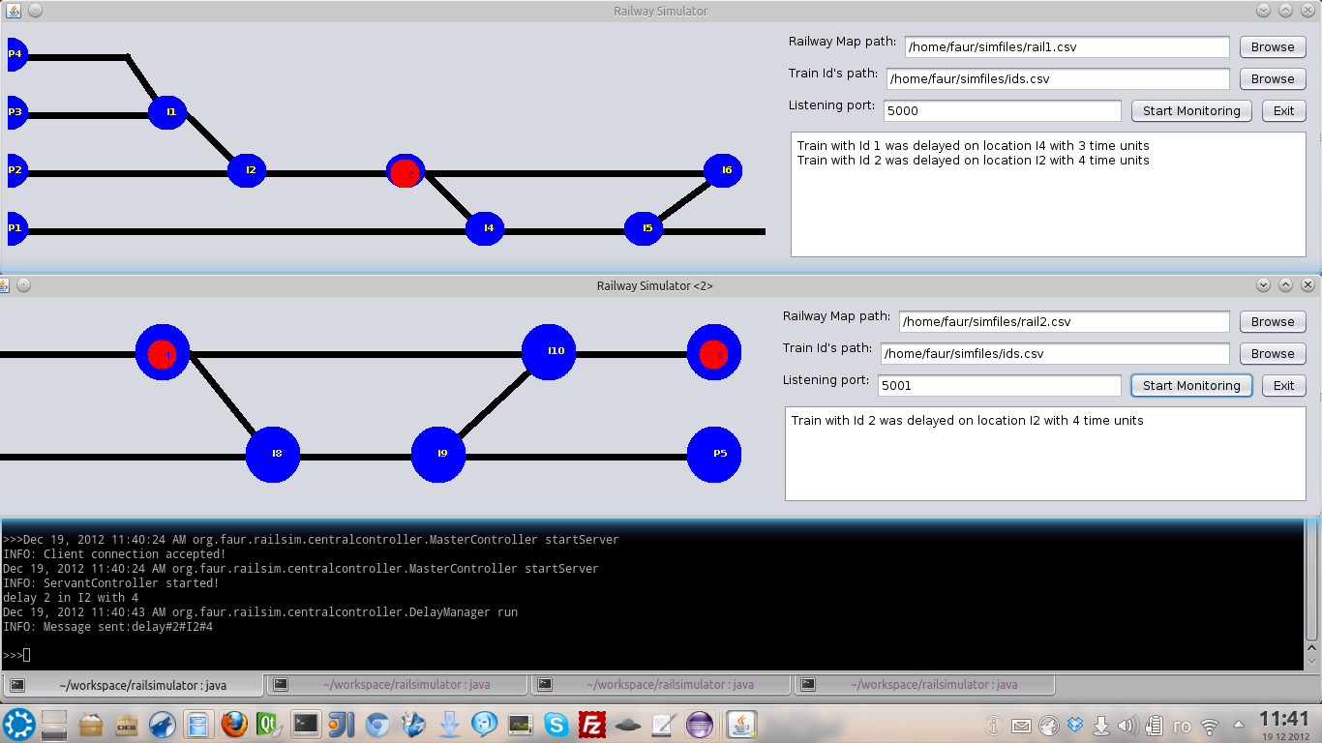
Fig. 1: Railsimulator
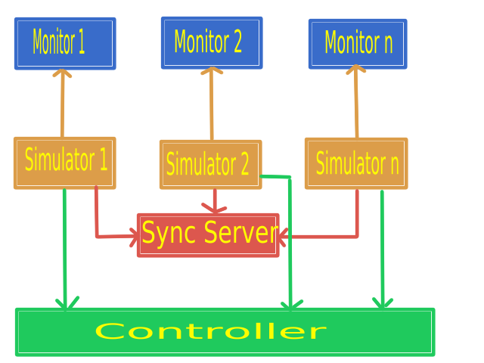
Fig. 2: Railsimulator architecture.

As we can see in the Fig 2. we can easily identify the monitors, the simulation engine alongside the synchronization server. And last the controller, a very important piece of the system that will provide the simulators with useful information like train time table, delays on the railroad. Also the controller will resolve any conflict on the time table if a train has been delayed by rescheduling all the trains. This is a very simple algorithm. More complex algorithms should reroute any delayed trains so that other vehicles should follow their normal path and time schedule.
Every piece of this system is a simple application that "speaks" to each other over the TCP/IP, a set of Internet protocols that make sure a message is delivered.
From Fig. 2, it can be easily deduced how the system works: a list of simulators connected to a list of monitors and synchronized by a synchronization server will parse a time table sent by the controller. When the table is received the simulator is going to interpret each line of the schedule. When the command is built, it is converted to a string and sent over TCP/IP to the monitor. From here on, things are very simple. After the command is parsed, the monitor will will render the animation corresponding with the command.

Architecture

Please check https://github.com/fioan89/railsimulator periodically for a more up to date Railsimulator.

The Monitor

RailwayMonitor which is the first layer of Railsimulator can be found on the org.faur.railsim.railmonitor package. As it was discussed early, this simple application can only receive commands from the simulator and render them on the user interface. More so, the application is able to notify the user about delayed train vehicles that appeared on the railway track.
The graphical user interface is very flexible. It allows the user to load a custom railroad, limit the number of trains or even specify which train vehicles are able to run on the specified track. This options are specified by two .csv files. For a simple example, please check /documentation/simfiles/route1.csv and /documentation/simfiles/ids.csv . The first file contains the railroad and the second files specifies the every train id that is able to run on a railroad.

!!! These files, use UTF-8 encoding and “ ” (space character) as column delimiter. Therefore, please setup your favorite editor accordingly.

The application can be run by executing this command:
java -cp .:./target/classes:./target/classes/commons-cli-1.2.jar org.faur.railsim.railsimulator.RailwayMonitor

Please note that RailwayMonitor should be started before the simulator.
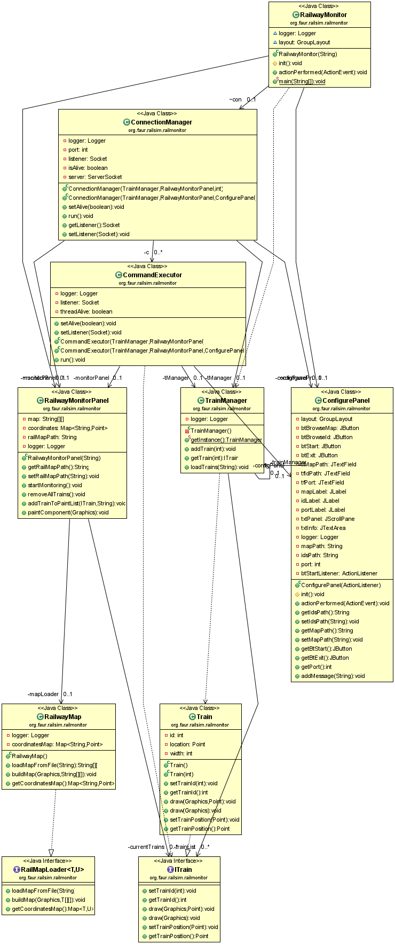
The Simulator

RailwaySimulator, the second layer of Railsimulator can be found on the org.faur.railsim.railsimulator package. This layer is responsible with three major things:
→ getting the time table from the controller.
→ interpreting the time table and sending the command to the monitor.
→ listening the controller for any train delays.
Since some major parts depends on the time table, is only natural to explain how this table looks and how the parsing works. So, here is how it looks:
P1 I4 I5 I6 I7 I8 I9 P5 P4 I1 I2 I3 P6 I1P3
1 # # # # # # # # # # # # # #
1 # # # # # # # 2 # # # # # #
1 # # # # # # # 2 # # # # # #
1 # # # # # # # 2 # # # # # #
1 # # # # # # # 2 # # # # # #
# 1 # # # # # # 2 # # # # # #

The first line contains a list of railroad locations. This is built by the controller from the tracks each train follows. The next lines represents train position in a single time unit. For example, the second line tell us that the train with the id 1 is at location P1 at time unit 1 (2 – 1 because the first line is occupied with locations). The last line tell us the train with id 1 is at location I4 and the train with id 2 is at location P4 at time unit 6 (7 – 1).
After the table is parsed and the simulator is connected to the RailwayMonitor and SynchronizationServer it will start sending commands to the monitor. These commands are taken from the time table and they instruct RailwayMonitor to draw a list of train id-s to a list of locations for one time unit. These commands are not built at random times. They are sent only when the simulator will receive a clock signal from SynchronizationServer. This signal is sent at a very well defined period which can be modified by the user when SynchronizationServer is started.

RailwaySimulator can be started by running this command:
java -cp .:./target/classes:./target/classes/commons-cli-1.2.jar org.faur.railsim.railsimulator.RailwaySimulator -controllerPort 16000 -controllerAddress localhost -syncServerPort 10000 -syncServerAddress localhost -monitorPort 5000 -monitorAddress localhost

For more details about the parameters for RailwaySimulator please check the source code documentation.

Please note that RailwaySimulator should be started only after the RailwayMonitor, SynchronizationServer and CentralController were started.

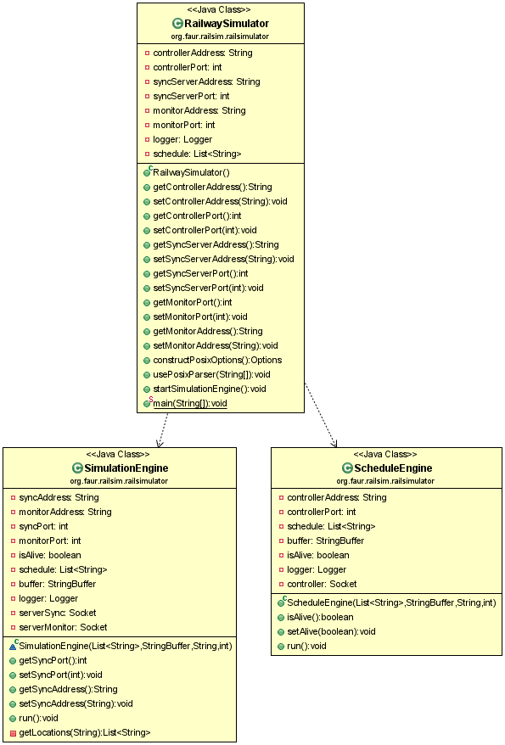

The Controller

CentralController can be found on the org.faur.railsim.centralcontroller package. It is the most complex from the entire Railsimulator system because of the algorithms that generates a time table just from a list of train routes. Also, this algorithms are responsible for regenerating the schedule when a train delay is read by the controller.
The first thing that the controller will do, is to read a list of train routes that are saved in a .csv file. The file looks like this:
trainId
P1 I4 I5 I6 I7 I8 I9 P5
[5,7] [3,5] [2,4] [1,4] [2,3] [1,4] [1,2] [4,5]
trainID
P4 I1 I2 I3 I6 I7 I8 I9 P5
[5,8] [3,5] [2,4] [2,3] [1,5] [1,4] [1,3] [3,4] [4,6]

Next, a scheduling algorithm will take each train id , the list of location that it will visit and the minimum and maximum time of visiting for each location and will build a time table that will be sent to a list of connected simulators.
Next, a user is able to introduce train delays on the controller. This train delays should come from a sensor that is placed on the railroad. This sensor will be implemented in a later version of Railsimulator. Until then, the delay is provided directly to the controller by readeing commands from the keyboard. These commands are valid if they have this form:delay <trainId> in <location> with <x time units>
For example: delay 2 in P4 with 6
CentralController can be run by executing this command:
java -cp .:./target/classes:./target/classes/commons-cli-1.2.jar org.faur.railsim.centralcontroller.MasterController -port 16000 -file /patjh/to/routes.csv

For more details about the parameters for CentralController please check the source code documentation.
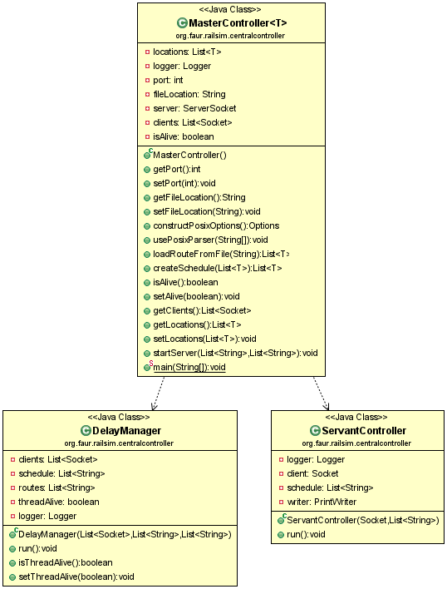

Sync Server

This small daemon can be found in org.faur.railsim.serversynchronizer . As the names suggests, this small server is used to synchronize a large amount of simulators, also called clients in the context of SynchronizationServer. Every operation that takes place on the client side is synchronized by the server so that the client can't do anything by himself until SynchronizationServer gives the “greenlight”.

There are six steps that a SynchronizationServer will follow in order to get a good client synchronization :
1. Start a counter with value 1. This will represent a time unit.
2. Send counter value to every connected client.
3. Stop the server execution a number of milliseconds. Usually this time is given by the user when a SynchronizationServer is started.
4. Increment the counter.
5. If the counter is above a threshold value (again, specified by a user ) the reset the value at 1.
6. Go back to step 2.

SynchronizationServer can be started with this command:
java -cp .:./target/classes:./target/classes/commons-cli-1.2.jar org.faur.railsim.serversynchronizer.SynchronizationServer -port 10000 -threshold 10000 -signaltime 1500

For more details about the parameters for SynchronizationServer please check the source code documentation.

Please note that SynchronizationServer should be started before the simulators!
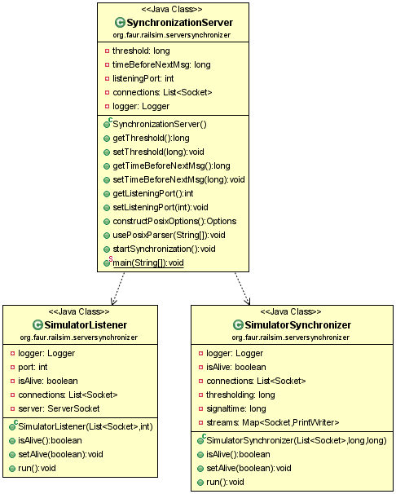

Conclusions

Because of the distributed and modular approach, Railsimulator is a reliable system that can easily meet every requirement specified in the Abstract section. Also, every module from Railsimulator can be easily replaced with more advanced and well designed modules, as long as the required protocol is used.

TO DO

- When the CentralController identifies a delay, a new table is generated and then it is sent to a list of simulators. After a simulator get's the new table, it immediately starts to execute the new schedule. This is considered as a bad behavior. The client should finish executing the old schedule and then start the new one.
- When a RailwayMonitor instance gets a notification which announce him that a train is delayed, the client logs the message. It will be nice to have some kind of animation that notifies the user (something like drawing that train with another color).
- CentralController should read the delays from a sensor. Right now this notification are sent by a user from keyboard.

