ELE432 WARM-UP HOMEWORK
SIMULATION RESULTS

Ömer Öztürk
2210357059

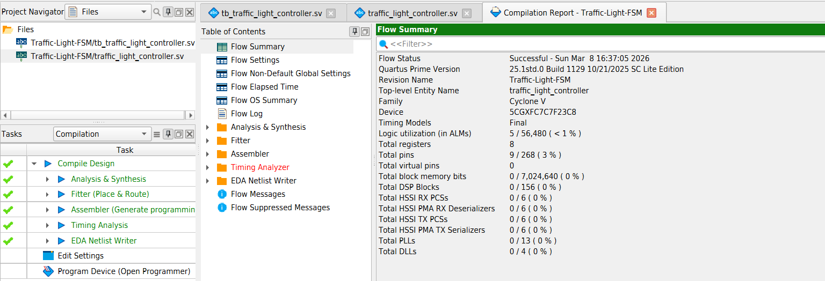
Compilation Report:
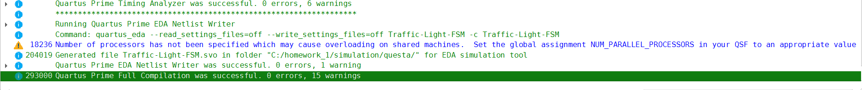
Info (293000): Quartus Prime Full Compilation was successful. 0 errors, 15 warnings

Waveform Analysis:
The following observations were made during the RTL simulation in Questa FSE:
Reset Verification: Upon asserting the reset signal, the FSM correctly initializes to S0.
Timed Transitions: When the transition to a yellow state occurs (S1 or S3), the internal TIMER increments from 0 to 4. The state transition to the next phase happens exactly when TIMER == 5.
Input Sensitivity: The FSM correctly monitors the TAORB input to determine when to leave the Green states.
