2018 Naha Workshop on Mathematical Analysis

Saturday, December 15, 2018, 10:00〜17:30
Okinawa Municipality Autonomy Hall, 4F, Meeting Room N0.6
http://rencho.me/tsubo/

Program
- 10:00-11:00 Takuya Watanabe (Ritsumeikan University)
Semiclassical distribution of resonances associated with an energy-level crossing

- 11:10-12:10 Tomoyuki Kakehi (University of Tsukuba)
Mean value operators on symmetric spaces

- 14:00-15:00 Hiroshi T. Ito (Ehime University)
On resonances of relativistic Hamiltonians

- 15:10-16:10 Wolfram Bauer (Leibniz University of Hanover)
On the complete integrability of the geodesic flow on pseudo-H type Lie groups

- 16:30-17:30 Kenro Furutani (Tokyo University of Science)
Riemannian submersion and Maslov quantization condition

Organizers
- Hiroyuki Chihara (University of the Ryukyus)
- Eiji Onodera (Kochi University)
- Koichi Kaizuka (Nippon Medical School)

Dinner: December 15, 18:30-, at Churasantei (Okinawan Restaurant)
Phone 098-861-0476, Address 5-15 Higashimachi, Naha, Okinawa 900-0034
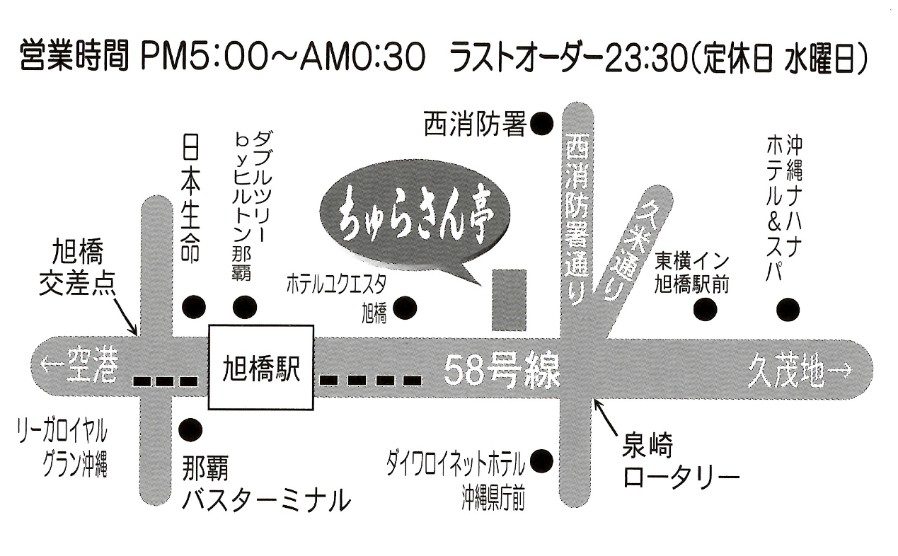

Inquiry: Hiroyuki Chihara (aji atmark rencho.me)

This workshop is supported by the following JSPS Grant-in-Aid for Scientific Research (KAKENHI).

- 16K05221 PI Hiroyuki Chihara (University of the Ryukyus)
- 16K05235 PI Eiji Onodera (Kochi University)
- 17K14208 PI Koichi Kaizuka (Nippon Medical School)

