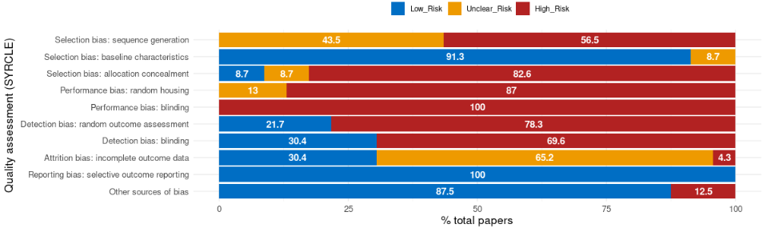
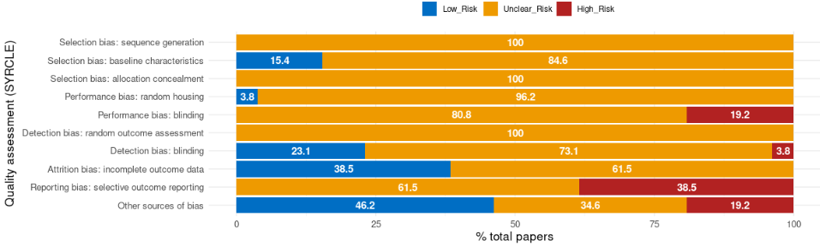
Figure 2. Risk of bias plots of AD animal studies evaluated using SYRCLE’s risk of bias tool. Plot created based on the original systematic review (top) and for our replication (bottom). Data are presented for the percentage of included studies assigned a low (blue), high (red) or unclear (orange) risk of bias for each of the 10 SYRCLE risk of bias domains and for our replication (bottom). Data are presented for the percentage of included studies assigned a low (blue), high (red) or unclear (orange) risk of bias for each of the 10 SYRCLE risk of bias domains.

Table 2. Quantitative comparison of summary meta-analysis with subgroup analysis between the original study and replication (4 different strategies) for the Morris Water Maze (MWM) escape latency outcome. Note: we multiplied the SMD and 95% CI values of the original review by –1 to account for direction of effect.
 | SMD | 95% CI | Subgroup Χ² | Subgroup P
Original review | 1.19 | [0.38; 1.99] | 0.93 | 0.63
(i) Last time point | 1.54 | [0.41; 2.68] | 12.39 | 0.002
(ii) Biggest difference | 1.54 | [0.80; 2.29] | 3.62 | 0.1637
(iii) AUC | 1.59 | [0.68; 2.51] | 0.68 | 0.7117
(iv) Results-aligned | 1.79 | [0.62; 2.95] | 2.26 | 0.3236

Table 3. Quantitative comparison of meta-analysis with subgroup analysis between the original and replication study for the Novel Object Recognition (NOR) outcome.
 | SMD | 95% CI | Subgroup Χ² | Subgroup P
Original review | 1.96 | [0.38; 3.54] | 27.48 | <0.00001
(i) Nested values  (for multiple outcomes) | 1.32 | [-0.15; 2.79] | 33.66 | <0.00001
(ii) Novel only  (for multiple outcomes) | 1.36 | [-0.07; 2.79] | 32.11 | <0.00001

