Predictive Modeling for Customer Churn
Fione Krasniqi

Intruduction
This project builds a machine-learning model to predict customer churn in the telecommunications industry. Customer churn refers to the situation where a customer cancels or stops using a company’s services. In telecom, churn directly impacts revenue, since acquiring new customers is significantly more expensive than retaining existing ones. By estimating the probability that a customer will churn, the company can take proactive actions such as offering discounts, improving service quality, or adjusting contract terms before the customer leaves. Predictive churn models help telecom companies balance two key objectives: maximizing customer retention while optimizing operational costs. If a model accurately identifies customers at high risk of churn, retention efforts can be targeted more effectively, rather than applied uniformly to all customers. This reduces revenue loss, improves customer satisfaction, and allows marketing and support resources to be used more efficiently. The model also supports data-driven decision-making by relying on measurable customer behaviour rather than intuition.

Understanding the dataset
The project uses a telecom customer dataset where each row represents a single customer and each column describes an aspect of that customer.
The dataset contains a large number of attributes; however, for churn prediction, the model focuses on a subset of key variables that capture customer demographics, service usage, contract structure, and financial behaviour. These columns provide the most meaningful signals for identifying customers at risk of churn.
Gender - customer’s gender.
Age - customer’s age in years.
Married - indicates whether the customer is married.
Number of Dependents - number of dependents financially supported by the customer.
Tenure in Months - number of months the customer has been with the company; a strong indicator of customer loyalty.
Internet Service - indicates whether the customer has an active internet subscription.
Internet Type - type of internet connection (e.g. cable, fiber), reflecting service quality and pricing differences.
Avg Monthly GB Download - average monthly data usage, capturing customer engagement with internet services.
Phone Service - indicates whether the customer subscribes to phone services.
Multiple Lines - indicates whether multiple phone lines are used under the same account.
Streaming TV / Streaming Movies / Streaming Music - indicate usage of streaming services, representing service bundling and customer engagement.
Contract - type of contract (month-to-month, one-year, or two-year); a key factor influencing churn flexibility.
Paperless Billing - indicates whether the customer uses paperless billing.
Payment Method - method used to pay bills (e.g. credit card, bank transfer).
Monthly Charge - current monthly cost of services.
Total Charges - total amount billed to the customer over their lifetime.
Total Revenue - total revenue generated from the customer.
Customer Status - original customer state from which the churn target variable is derived.
These variables collectively capture who the customer is, what services they use, how they pay, and how financially valuable they are, making them well-suited for predicting churn behaviour.

Data loading and preparation
The script begins by importing necessary Python libraries and reading the dataset from a CSV file:
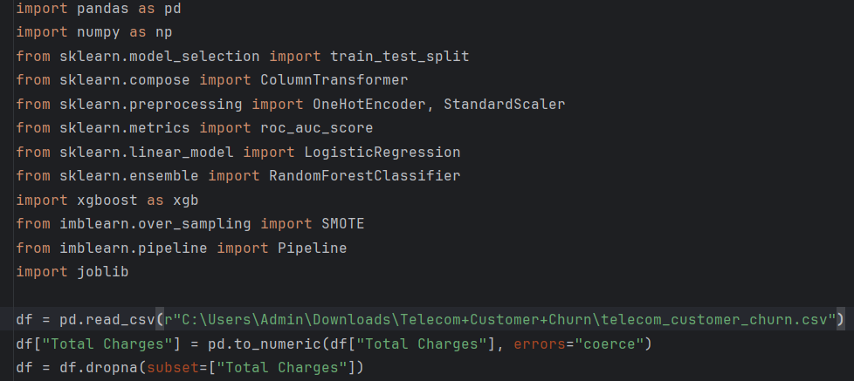
The Total Charges column may contain spaces or other non-numeric characters. Converting it with pd.to_numeric ensures it is numeric; invalid entries are set to NaN. Rows with missing Total Charges are then removed. This step eliminates data that cannot be interpreted as numbers.

Creating the target variable
The dataset includes a Customer Status column with categorical values like “Active”, “Churned”, and “Joined”. A new binary column churn is created: it equals 1 if the status is “Churned” and 0 otherwise. This will be the label the model predicts.

Dropping unnecessary columns
Personal identifiers (Customer ID) and descriptive columns (Customer Status, Churn Category, Churn Reason) are removed. Retaining them could lead to data leakage where the model uses information that would not be available at prediction time.

Handling missing values
The dataset may contain missing values in both numeric and categorical columns. These are handled separately:
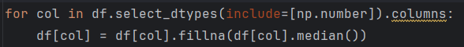
Numeric columns (identified via select_dtypes) are filled with their median values. Using the median instead of the mean is robust against outliers.
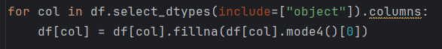
Categorical columns are filled with their most frequent value (mode). Filling missing categories with the mode preserves the distribution of values.

Feature and target separation
To prepare for model training, the feature matrix X and target vector y are defined:
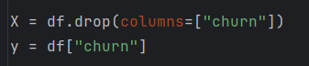
X includes all input variables, and y is the target variable we want the model to predict.

Identifying numeric and categorical features
Columns with data type object (typically strings) are stored as categorical_cols. Numeric columns are stored as numeric_cols. This distinction is used for specialized preprocessing.

Preprocessing with ColumnTransformer
A machine-learning model requires numerical input. The preprocessing step converts categorical variables into numerical form and scales numerical variables:
from sklearn.compose import ColumnTransformer
from sklearn.preprocessing import OneHotEncoder, StandardScaler
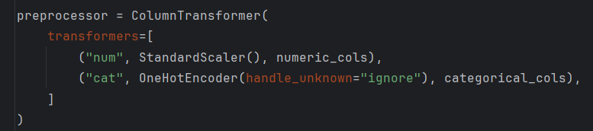
StandardScaler standardizes numeric features by centering them (zero mean) and scaling to unit variance. Scaling numeric data helps certain algorithms converge faster and perform better.
OneHotEncoder converts categorical variables into a set of binary columns one for each category so that there is no implied ordering.
ColumnTransformer applies these transformations to the appropriate columns and combines the results into a single feature matrix.

Splitting data into training and test sets
from sklearn.model_selection import train_test_split
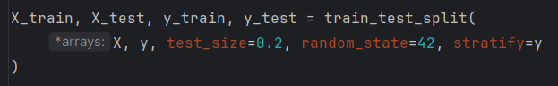
The data are split into 80% training and 20% testing.
stratify=y ensures that the proportion of churners and non-churners remains consistent across both sets. This is important when the classes are imbalanced.

Addressing class imbalance with SMOTE
Churn datasets often contain many more non-churning customers than churning customers. To avoid biasing the model toward the majority class, the script uses SMOTE (Synthetic Minority Over-Sampling Technique):
from imblearn.over_sampling import SMOTE
# The oversampling step is applied later in each pipeline
SMOTE generates synthetic examples of the minority class by interpolating between existing minority examples. This creates a balanced training set so that models learn to recognize patterns for both churners and non-churners.

Building machine-learning pipelines
Three models are trained and compared: logistic regression, random forest and XGBoost. Each model is packaged in a pipeline that performs preprocessing, oversampling and model fitting sequentially.
A pipeline ensures that the same preprocessing steps (scaling, encoding, SMOTE) are applied consistently during training and evaluation. This prevents data leakage and simplifies code maintenance.

Logistic Regression Pipeline
from sklearn.linear_model import LogisticRegression
from imblearn.pipeline import Pipeline
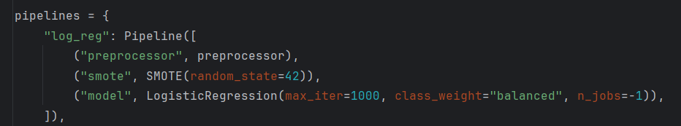
Logistic Regression is a linear classifier for binary outcomes. It uses the logistic (sigmoid) function to convert a linear combination of features into a probability between 0 and 1,
The class_weight='balanced' parameter tells the model to give more weight to the minority class, compensating for class imbalance.

Random Forest Pipeline
from sklearn.ensemble import RandomForestClassifier
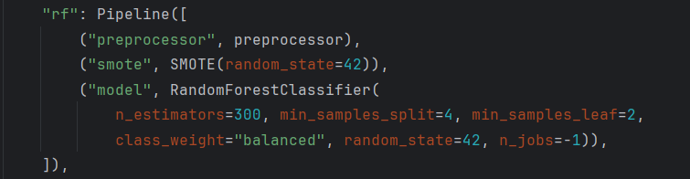
Random Forest is an ensemble method that builds many decision trees and averages their predictions. Each tree is trained on a different bootstrap sample of the data and uses random subsets of features at each split. This reduces overfitting and captures nonlinear relationships.
The hyperparameters (n_estimators, min_samples_split, min_samples_leaf) control the number of trees and the size of splits. class_weight="balanced" again addresses class imbalance.

XGBoost Pipeline
import xgboost as xgb
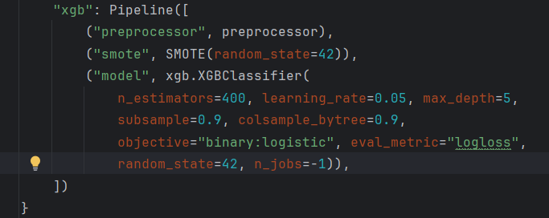
XGBClassifier is part of the XGBoost library (Extreme Gradient Boosting). It builds decision trees sequentially, with each new tree correcting the errors of the previous trees. XGBoost is known for high performance and includes regularization to prevent overfitting.
Key parameters:
learning_rate: controls how much each new tree contributes.
max_depth: limits tree complexity.
subsample and colsample_bytree: randomly sample rows and columns to introduce diversity and reduce overfitting.

Model training and evaluation
The script evaluates each pipeline using the Area Under the ROC Curve (AUC) metric. AUC measures how well a model ranks positive cases (churners) higher than negative cases. It is especially informative for imbalanced datasets.
from sklearn.metrics import roc_auc_score
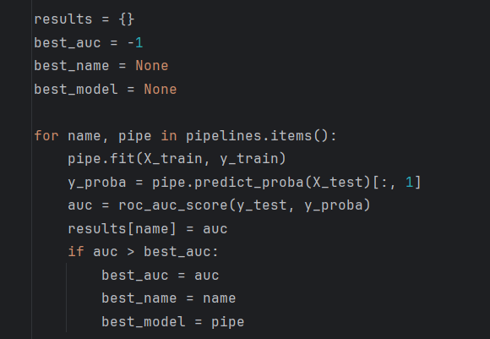
Each pipeline is fitted on the training data (fit(X_train, y_train)).
predict_proba generates the probability that each test sample is a churner. The second column ([:, 1]) corresponds to the churn class.
roc_auc_score computes the AUC by comparing predicted probabilities with the true labels.
The best model is selected based on the highest AUC score.
After training, the AUC for each model is printed, and the best model is identified.

Saving and using the best model
import joblib
joblib.dump(best_model, "best_churn_model.pkl")
The best performing pipeline is saved to disk using joblib.dump. This file can later be loaded to make predictions without retraining.
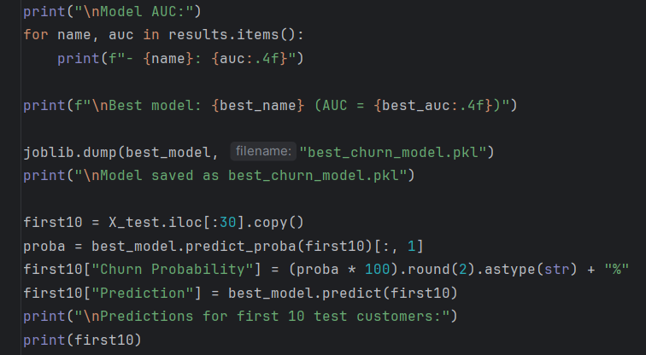
A subset of 30 customers from the test set is selected. The model predicts the probability of churn for each customer.
Probabilities are converted to percentages for readability (e.g., “35.74%”).
A binary Prediction column is added (0 = not predicted to churn; 1 = predicted to churn).
The resulting table is printed, showing the original features alongside the model’s predictions.

Model performance and results
Three classification models were trained and evaluated using ROC AUC, which measures how well the model distinguishes between churners and non-churners across all probability thresholds:
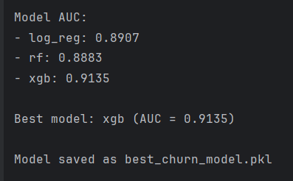
Among the evaluated models, XGBoost achieved the highest AUC, indicating the strongest ability to separate customers who are likely to churn from those who are not. This confirms that non-linear relationships and feature interactions play an important role in churn behaviour. As a result, XGBoost was selected as the final model and saved for further use.
The final model outputs a churn probability for each customer, representing the estimated likelihood that the customer will leave the company. To convert these probabilities into actionable predictions, a decision threshold of 50% (0.5) was applied:
Prediction = 1 (Churn) - churn probability ≥ 50%
Prediction = 0 (No Churn) - churn probability < 50%
This threshold provides a clear and intuitive interpretation: only customers with a high estimated likelihood of churn are flagged. The probability-based output also allows flexibility, as the threshold can be adjusted depending on business strategy for example, lowering it to capture more at-risk customers when retention is a priority.
