Fione Krasniqi

Predictive Modeling for Credit Risk

Introduction

This project builds a machine-learning model to predict the likelihood that a loan applicant will become seriously delinquent in the future. In banking, lenders face credit risk, the risk that a borrower will fail to repay their debt. A default occurs when a borrower does not make required loan payments, and high default rates can lead to substantial financial losses.
Predictive models help lenders balance two competing goals: offer credit to as many people as possible and keep defaults low. If a model accurately identifies risky applicants, lenders can offer more favourable terms to low-risk individuals while taking precautions with high-risk ones. This reduces the financial losses associated with default and allows lenders to operate more sustainably. The model also promotes fairer lending decisions by relying on quantifiable data rather than subjective judgments.

Understanding the dataset

The project uses the Give Me Some Credit dataset, which contains records for about 150 000 individuals. For each person, the dataset includes a target variable called SeriousDlqin2yrs, indicating whether the person experienced a 90-day delinquency (an account was 90 days or more past due) within the next two years. Only about 6.7 % of individuals in the dataset are defaulters, so the classes are highly imbalanced.
The dataset provides 10 explanatory variables that describe each applicant’s financial behaviour and personal characteristics. Key variables include:
- NumberOfTimes90DaysLate - how many times the person has been 90 days late on any payment (similar variables exist for 30-59 and 60-89 days).
- RevolvingUtilizationOfUnsecuredLines - ratio of credit card balances to available credit.
- DebtRatio - ratio of total monthly debt payments to monthly income.
- MonthlyIncome - the person’s monthly income in dollars.
- NumberOfOpenCreditLinesAndLoans - number of open credit cards and loans.
- NumberOfDependents - number of dependents.
- Age - age in years.
These features capture both behavioural information (e.g. prior late payments, credit utilisation, debt load) and personal information (e.g., age, income, family size). They are used to predict the likelihood of a future serious delinquency.
Because the dataset is imbalanced, the project pays special attention to class imbalance techniques so that the model doesn’t ignore the minority (default) class. The evaluation uses metrics like ROC AUC to gauge how well the model discriminates between defaulters and non-defaulters, which is especially important when the classes are uneven

Code explanation

The code uses pandas for data manipulation and scikit-learn to build models.

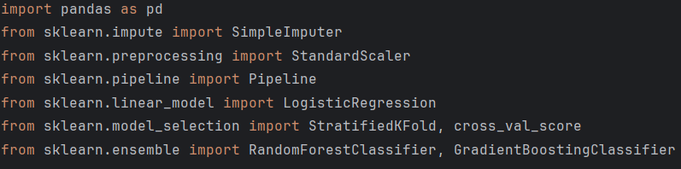
- pandas is used to load and manipulate tabular data.
- Imputation: Many real datasets have missing values. SimpleImputer fills missing values. Setting strategy='median' will replace missing numbers with the median of the column. Median imputation is suitable for numerical data and is less sensitive to extreme values.
- Standardization: Machine-learning algorithms such as logistic regression perform better when features are scaled. StandardScaler subtracts the mean and divides by the standard deviation for each feature, producing data with zero mean and unit variance.
- Pipeline: Pipeline lets you chain preprocessing steps with a model so that they are applied consistently during training and evaluation.
- Models: You import LogisticRegression, RandomForestClassifier and GradientBoostingClassifier.
  - Logistic Regression is a linear model for binary classification. It uses the sigmoid function to map a linear combination of inputs to a probability between 0 and 1. The sigmoid curve is monotonically increasing and bounded between 0 and 1, making it suitable for estimating default probabilities.
  - Random Forest is an ensemble model that builds many decision trees on random subsets of the data (bagging) and averages their predictions. It also selects random subsets of features at each split to reduce overfitting and improve performance.
  - Gradient Boosting builds trees sequentially, with each new tree trained to correct the errors of the previous ensemble by following the gradient of a loss function. A learning rate (shrinkage) controls how much each tree contributes; smaller rates reduce overfitting but require more trees.

Loading the dataset

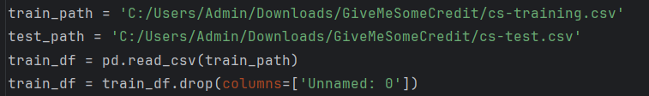

- You specify file paths for the training and test data.
- pd.read_csv loads the CSV file into a DataFrame.
- The dataset includes an unnamed index column which is removed with .drop(columns=['Unnamed: 0']).

Splitting features and target

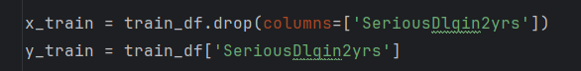

x_train holds the input features; y_train holds the binary target (1 for default, 0 for non-default).
Separating features and target is necessary for supervised learning.

Exploratory printing

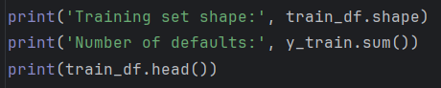

These print statements show the dimensions of the dataset, the number of positive cases (defaults), and the first few rows. It helps confirm that data is loaded correctly and reveals class imbalance (few defaults).

Preprocessing pipeline

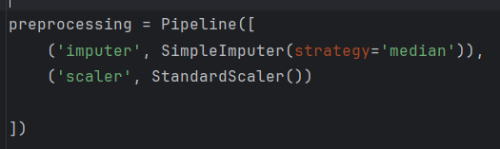

A Pipeline object is created with two steps:
  - SimpleImputer (strategy 'median') fills missing numeric values with the median.
  - StandardScaler standardizes features to zero mean and unit variance.
Chaining these steps ensures they are applied consistently in cross-validation and on new data.

Logistic Regression model

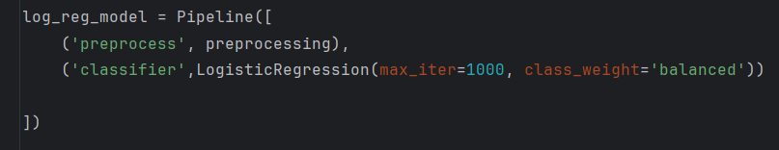

This pipeline first runs the preprocessing steps (imputation and scaling), then fits a logistic regression classifier.
- max_iter=1000 increases the number of iterations to ensure convergence.
- class_weight='balanced' addresses class imbalance. When classes are imbalanced, a model may predict the majority class always. Class weighting assigns higher weight to the minority class so the model pays more attention to these samples, reducing bias.

Cross-validation setup

- StratifiedKFold splits the dataset into n_splits folds while preserving the class distribution in each fold. This is important when the target classes are imbalanced.
- cross_val_score evaluates a model by cross-validation. It trains the model on each combination of folds and returns an array of scores.
- scoring='roc_auc' uses the Area Under the Receiver Operating Characteristic (ROC) Curve. ROC-AUC measures how well the model ranks positives higher than negatives over all possible classification thresholds; it is often used for imbalanced problems.
- The resulting auc_scores array contains AUC scores from each fold; the mean and standard deviation are printed to summarise performance.

Random Forest model

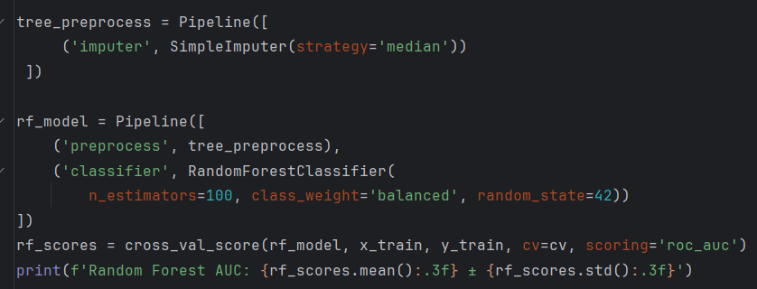

- Tree-based models like random forest don’t require feature scaling, so the pipeline includes only the imputer.
- RandomForestClassifier builds an ensemble of 100 decision trees (n_estimators=100) and averages their predictions.
- class_weight='balanced' again compensates for class imbalance.
- Cross-validation with roc_auc scoring evaluates the model across three folds.

Gradient Boosting model

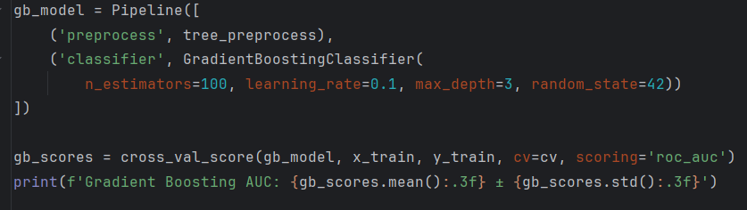
- GradientBoostingClassifier builds 100 shallow decision trees sequentially. Each tree is trained to correct the errors of the previous ensemble by following the gradient of the loss function (gradient descent).
- learning_rate=0.1 controls the shrinkage; smaller values reduce overfitting but require more trees.
- max_depth=3 limits tree depth, preventing overly complex trees.
- Cross-validation again computes AUC for each fold.

Selecting and training the final model

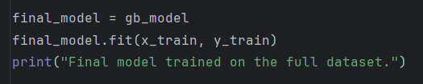

- The code chooses gradient boosting (gb_model) as the final model, likely because it performed best on the cross-validation metrics.
- fit trains the model on the entire training data (after cross-validation, we refit on all data so the model sees as many examples as possible).

Saving and loading the model

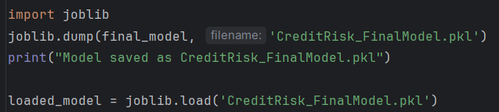

- joblib serializes (saves) Python objects. Saving the trained model to a .pkl file allows it to be reused without retraining.
- Loading the model shows how to restore it for future predictions.

Making predictions and creating a readable output

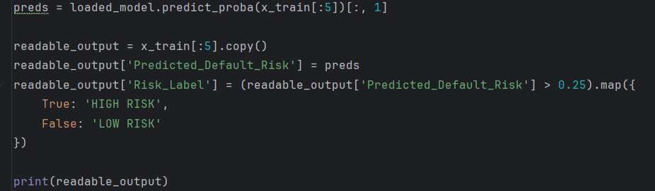

- predict_proba returns probabilities for both classes; [:, 1] extracts the probability of default (class 1).
- A copy of the first five rows of x_train is created, and a new column Predicted_Default_Risk is added.
- The code defines a threshold: if the predicted risk is greater than 0.25, the borrower is labelled “HIGH RISK”, otherwise “LOW RISK”. This threshold is arbitrary; in practice, you would tune it based on business objectives and the cost of false positives/negatives.
- Finally, the script prints the features for the first five people along with their predicted default risk and risk label.

Why this model is helpful

Accurately predicting who is likely to default helps lenders make better decisions:
- Reduce losses: By identifying high-risk applicants, lenders can adjust interest rates, request collateral or decline credit, reducing potential losses.
- Fairness: Class weighting and stratified cross-validation ensure the model pays attention to the minority (default) class and avoids bias. This aligns with fair lending practices.
- Transparency: Logistic regression provides interpretable coefficients; tree-based models can rank feature importance, giving insight into which factors most influence default risk.
- Scalability: Automated models can evaluate thousands of applicants quickly, improving efficiency and consistency.

Model performance and results

The final training dataset contains 150,000 observations with 11 features, each representing an individual borrower. Among them, 10,026 individuals experienced a serious delinquency, defined as being 90 days or more past due within the following two years. This confirms a strong class imbalance, with defaulters forming a relatively small portion of the population.

Three models were evaluated using ROC AUC, which measures how well a model separates defaulters from non-defaulters across all probability thresholds:
- Logistic Regression: AUC = 0.790 ± 0.001
- Random Forest: AUC = 0.834 ± 0.001
- Gradient Boosting: AUC = 0.864 ± 0.002
Gradient Boosting achieved the highest AUC, indicating superior ability to capture non-linear patterns and interactions between financial variables. It was therefore selected as the final model and retrained on the full dataset to maximise predictive performance.
Risk scoring and threshold selection
The final model outputs a predicted probability of default for each individual. To translate these probabilities into actionable decisions, a risk threshold of 0.25 was applied:

- HIGH RISK - predicted default probability greater than 25%
- LOW RISK - predicted default probability 25% or lower
This threshold was deliberately chosen to balance risk sensitivity and business practicality. Given the imbalanced nature of the dataset, using a standard 0.5 threshold would fail to identify many high-risk individuals. A lower threshold increases the model’s ability to flag potentially risky borrowers while still maintaining reasonable discrimination between classes.

