Predictive Modeling for Brain Tumor Classification
FIONE Krasniqi

Project context and motivation
This project builds a deep-learning model to classify brain MRI scans into different tumour categories. The model learns visual patterns directly from medical images and predicts the tumour type based on the scan. The primary goal is to support automated image analysis by providing fast and consistent classification of MRI data, which can assist clinicians during diagnosis and decision-making.
Manual interpretation of MRI scans is time-consuming and depends heavily on expert availability. A reliable image-based classification model can act as a decision-support tool by highlighting likely tumour types and reducing diagnostic workload. From a technical perspective, this project demonstrates how deep learning and transfer learning can be applied to medical imaging problems, where labelled data are limited and accuracy is critical.
The dataset consists entirely of brain MRI images, organised into folders based on tumour category. Each image represents a single MRI scan of a patient’s brain.
The data are structured into two main directories:
Training folder – contains labelled MRI images used to train and validate the model
Testing folder – contains labelled MRI images used only for final evaluation
Within each folder, images are stored in subdirectories named after the tumour classes. This directory structure allows the deep-learning framework to automatically assign labels to images based on their folder names.
All images are resized to a consistent resolution before being processed by the model. Pixel values are preprocessed to match the input requirements of the chosen neural network architecture.
The project uses transfer learning with a pre-trained EfficientNet model. Instead of training a convolutional neural network from scratch, the model reuses feature representations learned from large-scale image data and fine-tunes them for brain tumour classification. This approach improves performance, reduces training time, and lowers the risk of overfitting.
The model outputs a probability distribution across tumour classes, and predictions are evaluated using accuracy metrics, a confusion matrix, and class-level performance scores.

Importing libraries
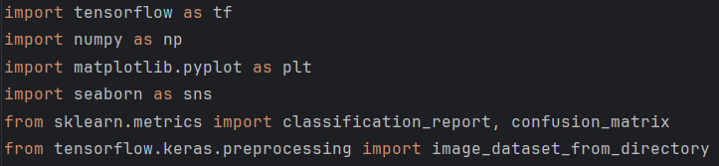
TensorFlow provides the deep-learning framework. Keras (bundled with TensorFlow) supplies high-level APIs for building and training models.
NumPy handles numerical operations and arrays.
Matplotlib and seaborn are used for plotting training curves and confusion matrices.
scikit-learn’s classification_report and confusion_matrix functions compute evaluation metrics.
image_dataset_from_directory loads images from a folder structure into a tf.data.Dataset with labels inferred from subdirectory names. If the directory contains separate folders per class (e.g., class_a/, class_b/), calling this function yields batches of images along with integer labels.

Setting constants and directories
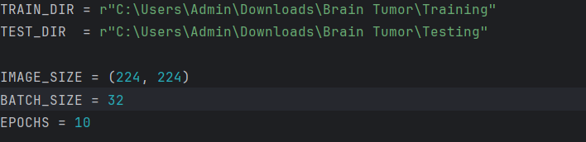
TRAIN_DIR and TEST_DIR point to folders containing training and testing images, organized by class.
IMAGE_SIZE defines how images are resized (224×224 pixels). EfficientNetB0 expects 224×224 RGB input.
BATCH_SIZE sets how many images are processed together in one forward/backward pass.
EPOCHS is the number of passes through the training data.

Loading and splitting the training data
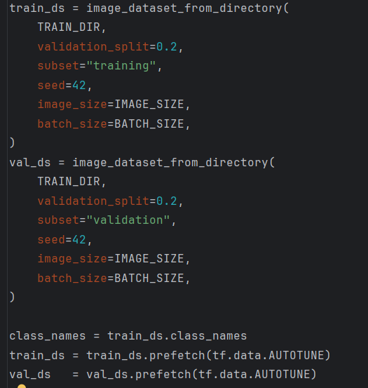
A 20% validation split is taken from the training directory. Using subset="training" and subset="validation" ensures disjoint training and validation sets.
seed=42 fixes the random shuffling for reproducibility.
image_size and batch_size control resizing and batching.
class_names = train_ds.class_names
class_names stores the list of tumour classes inferred from folder names.
train_ds = train_ds.prefetch(tf.data.AUTOTUNE)
val_ds = val_ds.prefetch(tf.data.AUTOTUNE)
Prefetching overlaps data preprocessing and model execution. Setting the buffer size to tf.data.AUTOTUNE lets TensorFlow tune how many batches to prefetch automatically.

Loading the test dataset
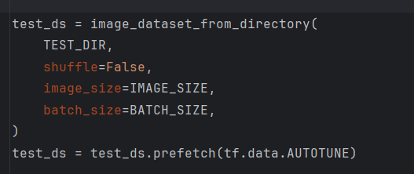
The testing data are loaded without a validation split. shuffle=False preserves the order for later display of predictions.
Prefetching is applied to overlap data loading with model inference.

Building the model with transfer learning
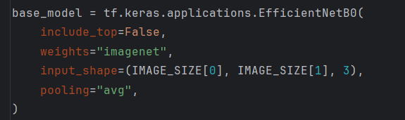
An EfficientNetB0 base model is loaded with ImageNet weights. include_top=False removes the original classification head so we can add our own.
EfficientNet uses a compound scaling method to balance depth, width and resolution, offering high accuracy with fewer parameters.
pooling="avg" applies global average pooling, producing a fixed-length vector from convolutional features.
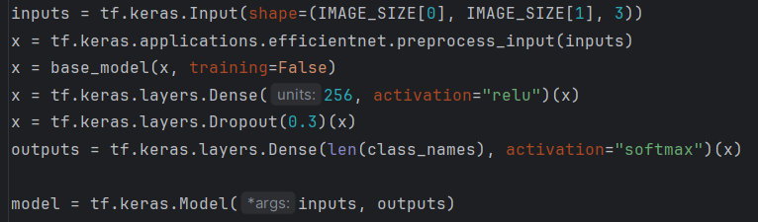
Preprocess input scales pixel values to match EfficientNet’s expectations (from [0,255] to a standardized range).
The EfficientNet base extracts high-level features.
A dense layer with 256 units and ReLU activation introduces learnable weights specific to the tumour dataset.
Dropout (rate 0.3) randomly deactivates 30% of neurons during training to reduce overfitting.
The final dense layer uses a softmax activation to output class probabilities for each tumour type.

Compiling the model
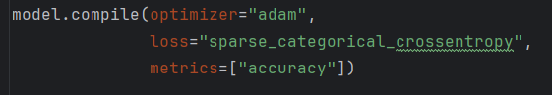
Adam is an adaptive optimizer that combines momentum and RMSprop to adjust learning rates for each parameter, accelerating convergence.
Sparse categorical cross-entropy is chosen because the target labels are integer indices rather than one-hot vectors. This loss computes the negative log-likelihood of the predicted probability assigned to the true class.
Accuracy is monitored as the primary metric.

Training and saving the model
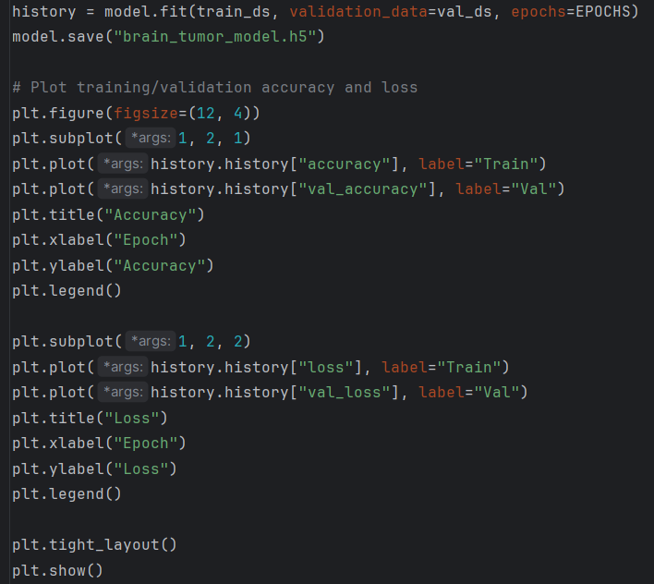
Two subplots display how accuracy and loss evolve across epochs for both training and validation sets. These plots help diagnose overfitting and convergence.

Generating evaluation metrics
Classification report prints precision, recall, F1-score and support for each class based on the true and predicted labels. Precision and recall derive from the confusion matrix: precision measures the fraction of predicted positives that are correct; recall measures the fraction of actual positives that are correctly identified.
The confusion matrix itself is also computed. It is a table showing true positives, false positives, true negatives and false negatives. A seaborn heatmap visualizes this matrix, helping identify which classes are often confused.

Visualizing predictions
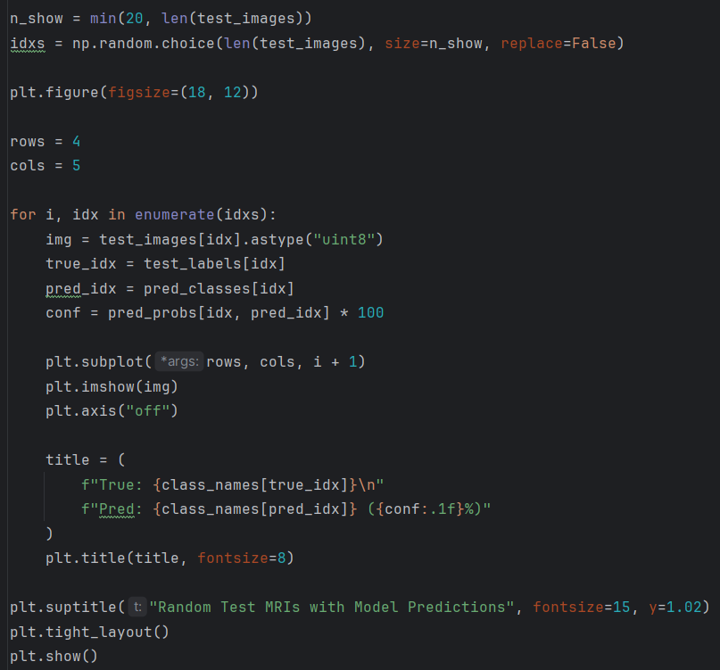
A random subset of test images is displayed with the true class label, the predicted class, and the model’s confidence (probability) in that prediction.
This qualitative assessment helps gauge whether the model’s mistakes are understandable (e.g., misclassifying similar tumour types).

Model performance and results
The trained model demonstrates strong classification performance on the unseen test dataset. Most predictions fall along the main diagonal of the confusion matrix, indicating that the model correctly classifies the majority of MRI scans across all tumour categories. This suggests that the model has learned meaningful visual patterns from the training data and generalises well to new images.

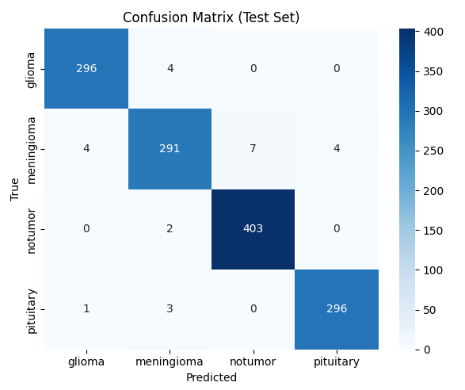

The confusion matrix summarizes how predicted classes compare to the true classes in the test set:
Glioma cases are classified with very high accuracy. Only a small number of glioma scans are misclassified as meningioma, and no confusion is observed with the other classes.
Meningioma shows slightly more misclassifications compared to other classes, primarily being confused with glioma and, to a lesser extent, pituitary tumours. This indicates some visual similarity between these tumour types.
No-tumor cases are classified almost perfectly, with only a negligible number of errors. This shows that the model is highly reliable at distinguishing healthy scans from tumour cases.
Pituitary tumours are also classified with high accuracy, with only minimal confusion with glioma and meningioma.
Overall, misclassifications are rare and mostly occur between tumour classes with similar visual characteristics, which is expected in medical imaging tasks.
The high concentration of correct predictions across all classes implies:
- High overall accuracy on the test set
- Balanced performance across classes, rather than the model favoring one category
- Strong precision and recall, especially for the no-tumor and glioma classes
This indicates that the model is not only accurate but also consistent across different tumour types.
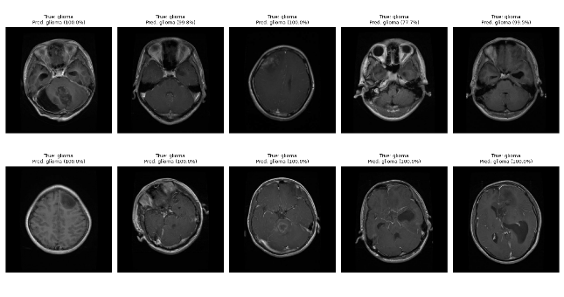
The displayed MRI samples from the test set further support the quantitative results. For each image, the predicted class matches the true class with high confidence probabilities, often close to or equal to 100%. This visual confirmation helps validate that the model’s decisions are aligned with recognizable anatomical patterns rather than random noise.

