Olist Marketplace Health: Delivery, Concentration, and Retention on a Verified Data Layer
Assessing whether a multi-table marketplace dataset can support operations, category, and customer decisions — and what a naive view would get wrong.
Ruijie Ma
Olist Brazilian E-Commerce Public Dataset (2016–2018)

Executive Summary
This report evaluates whether the Olist Brazilian marketplace dataset can support operations, category, and customer-experience decisions, and whether its headline numbers are trustworthy once the data is correctly cleaned and joined. The bottom line is that the data is decision-ready after three specific engineering fixes, and that it tells a clear, consistent story about where the business is strong and where it is exposed.
Three findings drive the recommendation. First, delivery time is the strongest structured signal most associated with low review scores: review score falls monotonically as delivery slows (Pearson r = −0.33), from 21 days on average for 1-star orders to 11 days for 5-star orders, and an independent AI reading of the review text agrees. Second, the business is highly concentrated: 18 of 74 product categories generate 80% of revenue and São Paulo alone accounts for 38% of it. Third, the marketplace is acquisition-driven — only 3.1% of customers ever place a second order — so retention is an opportunity, not a current strength.
The recommended next step is to publish the cleaned, order-grain revenue layer as the single source of truth for the dashboard and to prioritize delivery-time reduction as the highest-leverage satisfaction investment. Confidence is high: the order-value reconciliation is exact (r = 1.000 between order value and payments), every headline figure traces to a documented cleaning rule, and the AI labels are validated against an independent LLM (Claude) annotator (topic κ = 0.81, sentiment κ = 0.89). The main limitation is scope: this is a 2016–2018 Brazilian-marketplace snapshot with no cost data, so the report makes no profitability claims and does not generalize to other markets or to today.

Business Problem and Analytical Question
Olist operates a marketplace that connects small and mid-sized Brazilian sellers to large online storefronts. Leadership needs to know where to invest to protect revenue and customer satisfaction. The surface question is operational — “which numbers should we report, and what should we fix first?” The deeper problem is evidentiary: the data arrives as nine separate tables at different grains, and a naive join silently double-counts revenue. A decision built on the wrong number is worse than no decision.
This report therefore asks a paired question: (a) once the data is correctly cleaned and joined, what is associated with low review scores, where does revenue concentrate, and how well does the marketplace retain customers; and (b) which headline numbers change when the data is made decision-ready? This matters because the same dataset can support a defensible operations strategy or mislead it, depending entirely on whether the data-quality layer is built first.

Stakeholder and Decision Context
Stakeholder | Decision they need to make | What this report provides | Risk if unaddressed
Operations lead | Where to invest to lift satisfaction and repeat | Delivery-time vs review-score evidence; on-time rate | Churn and rating decay from slow delivery
Category management | Which categories to grow or monitor for concentration risk | Category revenue concentration (Pareto) | Over-reliance on a few categories
CX / Support lead | What customers actually complain about | Validated AI topic breakdown of negative reviews | Misallocated support effort
Data / BI lead | Whether the dashboard's numbers can be trusted | Data-quality layer + raw-vs-decision-ready reconciliation | Decisions on double-counted revenue

The Data/BI lead's need shapes the structure of this report: every downstream finding is only as trustworthy as the reconciliation that precedes it, so the data-quality layer comes before any business conclusion. The sharpest trade-off is between speed and correctness — the naive join is faster to write but inflates revenue and average order value, so the report treats the order-grain rebuild as non-negotiable.

Source and Data Inventory
This report uses real commercial data published by Olist (Brazil), anonymized, covering September 2016 through August 2018, distributed via Kaggle (olistbr/brazilian-ecommerce) under a CC BY-NC 4.0 license. The evidence base is nine relational tables. The strongest evidence comes from the orders, order-items, and reviews tables, because they are primary transactional records that reconcile against payments almost exactly. The most caveated sources are the free-text reviews (sparse — only 41% carry a written comment) and the geolocation table (heavily duplicated). As a result, the structured findings are treated as decision-ready, while the text and geo analyses are treated as directional and are validated before use.
Table | Grain | Rows | Role in the analysis
orders | one row per order | 99,441 | Spine: status, timestamps, delivery
order_items | one row per item | 112,650 | Product revenue + freight (fans out)
order_payments | one row per installment | 103,886 | Cash collected, installments (fans out)
order_reviews | one row per review | 99,224 | Review score + free text
products / translation | one row per product | 32,951 / 71 | Category (PT → EN)
customers | one row per order-customer | 99,441 | Identity: customer_unique_id
sellers / geolocation | seller / zip prefix | 3,095 / 1,000,163 | Seller state; lat-lng (deduped)

Data and Source-Quality Layer
The data-quality review indicates that the Olist dataset is decision-ready for revenue, delivery, concentration, and retention questions after three structural fixes, and partially usable (text analysis only on the commented subset) for voice-of-customer questions. The strongest elements are the transactional tables, which reconcile almost exactly; the main weaknesses are join grain, a duplicated geolocation table, and a per-order customer key. Each is handled below, with the wrong and right numbers shown so the impact is explicit.

The three engineering hazards
1. Join fan-out / double-counting. 9,803 orders contain more than one item (up to 21) and 2,961 contain more than one payment row (up to 29). A naive orders × items × payments join multiplies rows, so summed product revenue inflates to R$14.21M versus the correct R$13.59M (+5%), and summed cash inflates to R$20.31M versus R$16.01M (+27%). Treatment: aggregate items and payments to order grain before joining; report product revenue and cash separately. This is the project's signature reconciliation (Figure 7).
2. Geolocation duplication. The geolocation table holds 1,000,163 rows for only 19,015 zip prefixes (~53×). A geo join on the raw table would explode every downstream count. Treatment: deduplicate to one row per prefix (mean latitude/longitude, modal city/state) before any geo join; state-level analysis uses the customers table's state field directly.
3. Customer identity resolution. The 99,441 customer_id values collapse to 96,096 customer_unique_id values — Olist issues a new customer_id per order. Treatment: key all retention and RFM logic on customer_unique_id. The resulting 3.12% repeat rate is reported as a finding (an acquisition-driven marketplace), not a bug.

Other documented data-quality issues
Referential integrity is clean: every item, payment, and review links to a valid order (zero orphans). The remaining issues are bounded and documented in the QA tracker, and each is tied to the specific conclusion it can or cannot support:
- Reviews: 58,247 (59%) have no comment text; text analysis is scoped to the 40,977 that do, and missingness is flagged, never imputed.
- Orders: missing delivery dates (2,965 customer, 1,783 carrier, 160 approval) align with non-delivered statuses and are excluded from delivery metrics but kept for the status mix.
- Products: 610 lack a category; two categories are absent from the translation table (pc_gamer, portateis_cozinha_e_preparadores_de_alimentos) and are given manual English labels.
- Payments: 9 rows are ≤ 0 and 3 are typed not_defined; both are flagged and excluded from cash metrics. Orphans: 775 orders carry no item row (non-purchasable/canceled) and are excluded from revenue.
Conclusion boundary: the data supports revenue, delivery, concentration, and retention findings at high confidence. It does not support profitability claims (no cost data) and supports voice-of-customer findings only on the commented-review subset, treated as a validated sample.

KPI and Metric Dictionary
Metric | Definition / logic | Value | Why it matters
GMV | Sum of order_items.price (excludes freight) | R$13.59M | Gross demand scale
Net product revenue | GMV restricted to delivered orders | R$13.22M | Decision-ready revenue
Freight | Sum of order_items.freight_value | R$2.25M | Reported separately
AOV (net) | Net revenue ÷ delivered orders | R$137 | Basket economics
On-time rate | Share delivered ≤ estimated date | 92% | Delivery promise kept
Delivery days | delivered_customer − purchase | med 10.2, p90 23 | Satisfaction signal
Repeat rate | Share of customer_unique_id with >1 order | 3.12% | Retention vs acquisition
Review topic / sentiment | AI-classified from text, validated on a sample | 1,000 labeled | Voice of customer

The most important metric choice is GMV versus net product revenue. GMV (R$13.59M) measures gross demand, but the dashboard should publish net product revenue on delivered orders (R$13.22M) as the reportable figure, because revenue the customer never received is not revenue the business can count. Both are computed at order grain so neither inherits the fan-out double-count.

Methodology and Analytical Framework
The decision question is whether the numbers can be trusted and what they imply, so the method is a data-quality audit and reconciliation rather than a predictive model. The analysis proceeds in four steps. First, a Step-0 signal check profiles all nine tables and confirms the headline figures against expectation (order value vs payments r = 1.000; delivery vs score r = −0.33). Second, a reproducible Python pipeline rebuilds the data at the correct grain, deduplicates geolocation, resolves customer identity, and derives the analytical fields. Third, DuckDB SQL re-computes the same aggregates independently as a cross-check and emits Tableau-ready output tables. Fourth, a large language model classifies a validated sample of review text and the labels are triangulated against the structured delivery signal.
Key assumptions are stated rather than hidden: revenue is measured at order grain; “delivered” uses order_status; missing delivery dates are excluded from delivery metrics; RFM uses customer_unique_id; and AI labels are validated on a sample, not exhaustive. Every transformation lives in a re-runnable script (raw → cleaned → output), so the pipeline is reproducible and auditable. Tables in this report use 11-point font as a deliberate, uniform exception for fit; all body text is Times New Roman 12-point.

Findings
Finding 1. Late delivery is the strongest structured signal associated with low review scores. The evidence is a clean monotonic relationship: average delivery time rises from 10.7 days for 5-star orders to 21.3 days for 1-star orders, with an overall correlation of r = −0.33 across 95,830 reviewed deliveries. This matters because it identifies a controllable operational lever — speed — rather than an unfixable taste problem. For the operations lead, the implication is direct: delivery-time reduction is the highest-leverage satisfaction investment. Confidence is high (large n, consistent gradient); the relationship is a strong association, not proof of causation.
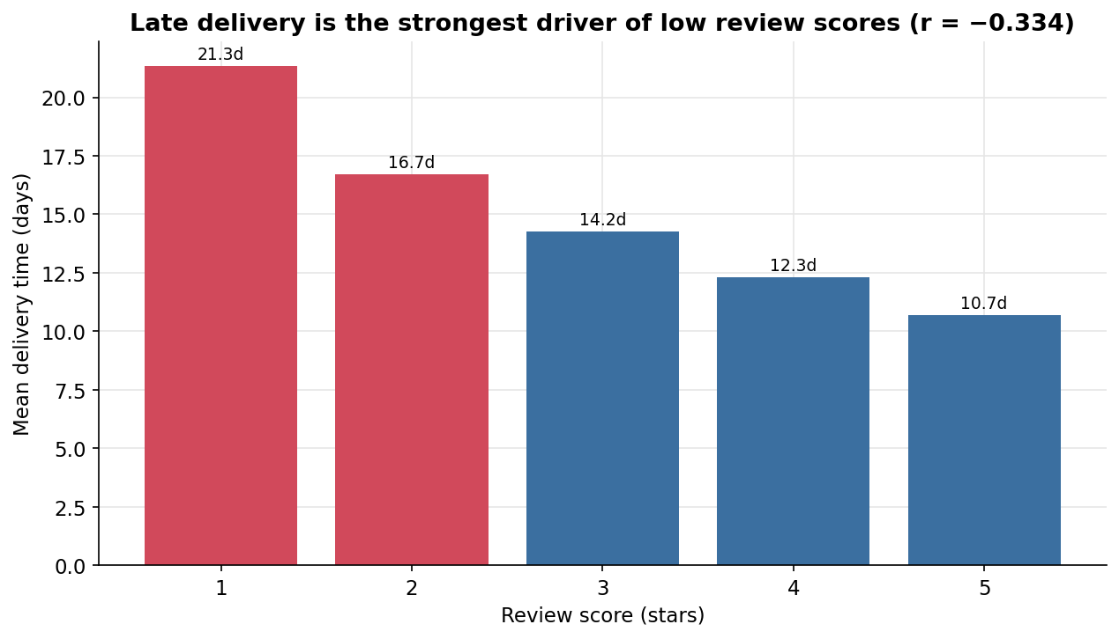
Figure 4. Late delivery is the strongest signal associated with low review scores.
Signal: Mean delivery time rises steadily as review score falls, from ~11 days at 5 stars to ~21 days at 1 star.
Analysis: The gradient is monotonic and the correlation (r = −0.33) holds across ~96k reviewed orders, so slow delivery is systematically associated with dissatisfaction rather than noise from a few late parcels.
So What: Treat delivery-time reduction as the primary satisfaction lever and track p90 delivery days as a dashboard KPI alongside the on-time rate.
Caveat: Correlation is not causation; review score also reflects product and expectation effects, so delivery is the strongest single signal, not the only factor.
The same pattern appears in the binary on-time flag: late orders carry far lower scores, which is why the 92% on-time rate, while healthy, still leaves a meaningful tail of dissatisfied customers.
Finding 2. Demand is seasonal and peaks every November. Monthly orders climb across the two-year window and spike to 7,451 placed orders in November 2017 (Black Friday), the single largest month. For planning, this means capacity, inventory, and carrier contracts should be sized to the Q4 peak, not the annual average. Confidence is high; the two partial edge months (2016-09 and 2018-09) are excluded from trend reading.
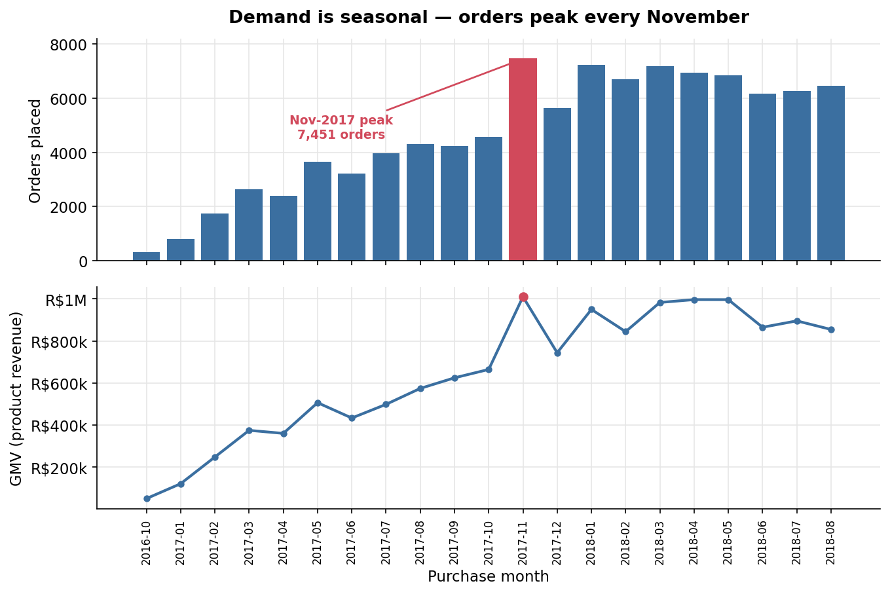
Figure 1. Demand is seasonal — orders peak every November.
Signal: Monthly orders and GMV trend upward over 2016–2018 and spike sharply in November 2017.
Analysis: The November peak reflects Black-Friday demand; because delivery time is closely associated with satisfaction, the highest-volume month is also the period of greatest delivery-SLA risk.
So What: Size fulfillment capacity and carrier SLAs to the November peak, and watch delivery days most closely in Q4 when the satisfaction risk is concentrated.
Caveat: The first and last months are partial and excluded; month-over-month growth also blends true growth with the platform's expanding seller base.
Seasonality and the delivery-satisfaction link compound: the busiest month is precisely when slow delivery would do the most reputational damage, making peak-season logistics planning a priority.
Finding 3. Revenue is highly concentrated in a few categories and in São Paulo. 18 of 74 categories produce 80% of revenue, led by health & beauty (9.3%) and watches & gifts (8.9%); geographically, São Paulo alone is 38% of revenue and the top three states are 63%. Concentration is efficient but it is also exposure: a shock to one category or region would move the whole business. This is developed in Module C. Confidence is high for the head of the distribution; thin long-tail categories are treated as directional.
Finding 4. The marketplace acquires far more than it retains, and the voice of the customer confirms the delivery story. Only 3.1% of customers place a second order, so 94% of revenue comes from one-time buyers. Separately, an AI classification of 1,000 reviews finds that negative reviews split between product-quality issues (52%) and delivery (38%) — and the orders behind delivery complaints took 26 days on average versus 13 across the sample, tying the text back to the structured r = −0.33 signal. For the CX lead, dissatisfaction is operational (product condition and delivery), not about price.
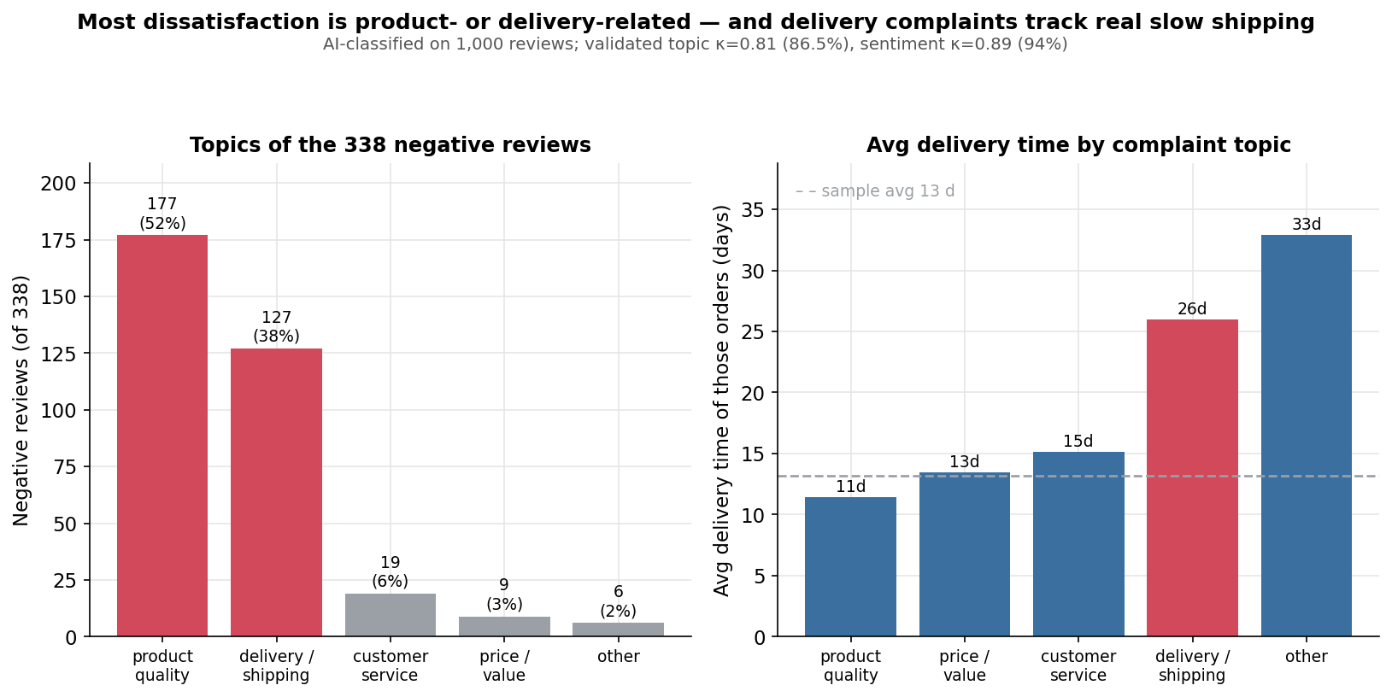
Figure 8. Most dissatisfaction is operational — and delivery complaints track genuinely slow shipping.
Signal: Among 338 negative reviews, product-quality and delivery dominate; delivery complaints correspond to orders that took 26 days versus a 13-day sample average.
Analysis: Because the AI sentiment labels (which never saw the star rating) line up with the stars (negative→1.8, neutral→3.9, positive→4.8) and delivery complaints map to genuinely slow orders, the text and the structured data corroborate each other.
So What: Point CX and quality-assurance effort at product condition (wrong/damaged/missing items) and delivery speed, not at price; use the validated topic mix to allocate support staffing.
Caveat: Labels are validated on a 1,000-review sample (topic κ = 0.81, sentiment κ = 0.89), not exhaustive; the product-vs-delivery boundary on missing/wrong-item orders is the main source of label disagreement.
This corrects the intuitive assumption that delivery dominates complaints: product condition is actually the larger bucket, but delivery complaints are the ones provably tied to slow shipping, so both deserve operational attention for different reasons.

Deep-Dive Module A: Data Quality and Reconciliation
Module A is included because the project is built on raw, multi-grain operational data, and the entire report depends on getting the revenue number right. The key risk is the join fan-out described in the data-quality layer. The reconciliation below shows exactly how the headline metrics change once items and payments are aggregated to order grain before joining.
Metric | Naive raw join | Decision-ready | Inflation
Product revenue | R$14.21M | R$13.59M | +4.5%
Cash collected | R$20.31M | R$16.01M | +26.9%
AOV (per order) | R$144 | R$138 | +5%

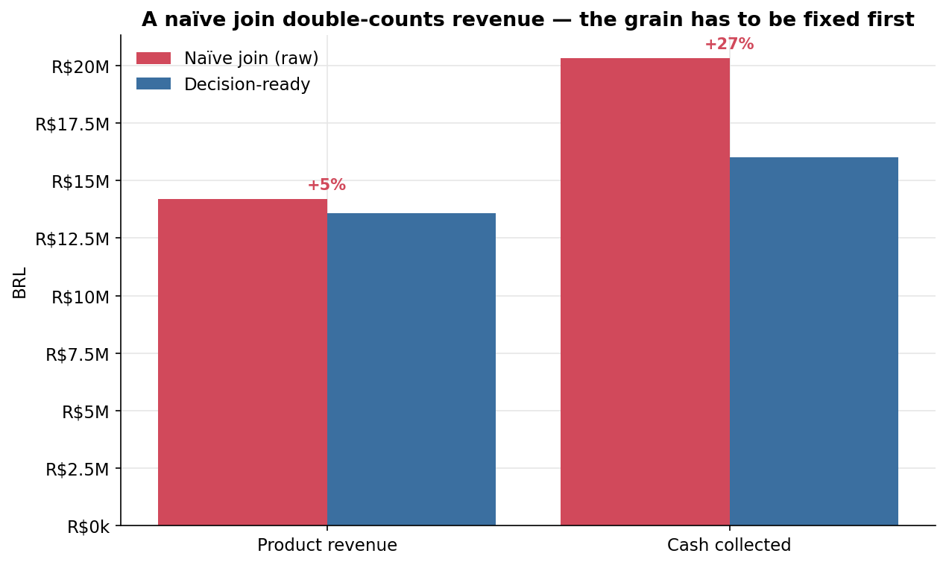
Figure 7. A naive join double-counts revenue — the grain has to be fixed first.
Signal: The raw orders × items × payments join reports R$14.21M of product revenue and R$20.31M of cash; the order-grain rebuild reports R$13.59M and R$16.01M.
Analysis: Product revenue inflates modestly (multi-payment orders repeat the price) but cash inflates by 27% (multi-item orders repeat each payment), so the error is largest exactly where finance would look — cash collected.
So What: Publish the order-grain layer as the dashboard's single source of truth; never sum price or payment_value over the raw multi-table join.
Caveat: The corrected figures still depend on the cleaning rules (delivered-only net revenue, excluded orphans); they are decision-ready, not absolute truth.
This reconciliation is the clearest demonstration of the report's thesis: the same dataset yields different headline numbers depending on whether the grain is fixed first, so the data-quality layer is a prerequisite for every downstream decision.

Deep-Dive Module C: Customer, Product, and Concentration
Module C is included because the dataset has rich product, geography, and customer-identity fields, and concentration is more decision-relevant than averages: it shows where the business is dependent. Three lenses follow — category, geography, and retention — plus the delivery-time distribution that underlies the satisfaction story.
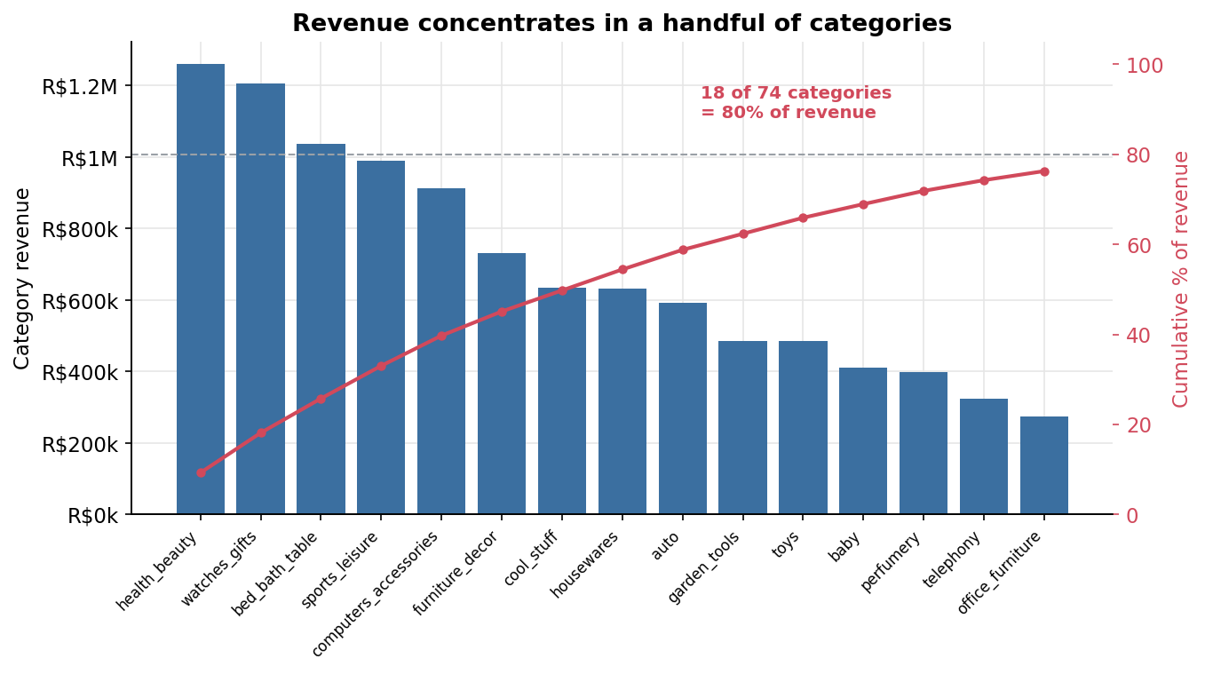
Figure 2. Revenue concentrates in a handful of categories.
Signal: Cumulative revenue reaches 80% by the 18th of 74 categories; health & beauty and watches & gifts alone are 18%.
Analysis: A short head of categories carries the marketplace, which is efficient for merchandising focus but concentrates exposure: a supply or demand shock in one category moves the whole P&L.
So What: Grow and protect the top categories deliberately, and monitor category concentration as a standing risk metric rather than assuming the long tail diversifies it.
Caveat: Category labels include an ‘unknown’ bucket for 610 unmapped products; the long tail is directional and should not be over-read at the individual-category level.
Concentration is the recurring shape of this marketplace — it appears again in geography and in the customer base — so the same risk-management logic applies across all three.
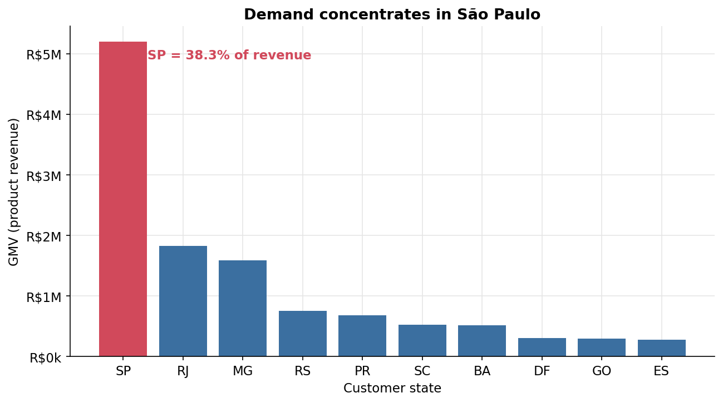
Figure 6. Demand concentrates in São Paulo.
Signal: São Paulo is 38% of revenue; the top three states (SP, RJ, MG) are 63%.
Analysis: Demand mirrors Brazil's economic geography, so logistics performance into and within the Southeast disproportionately determines national satisfaction.
So What: Optimize fulfillment and carrier SLAs for the Southeast first, where the revenue and the delivery-risk both concentrate; treat under-penetrated states as growth options, not current strengths.
Caveat: Geographic revenue uses the customer's state from the customers table; thin states carry small samples and unstable per-capita rates.
Because delivery time is closely associated with satisfaction and demand concentrates in the Southeast, regional logistics is where operational investment and revenue protection coincide.
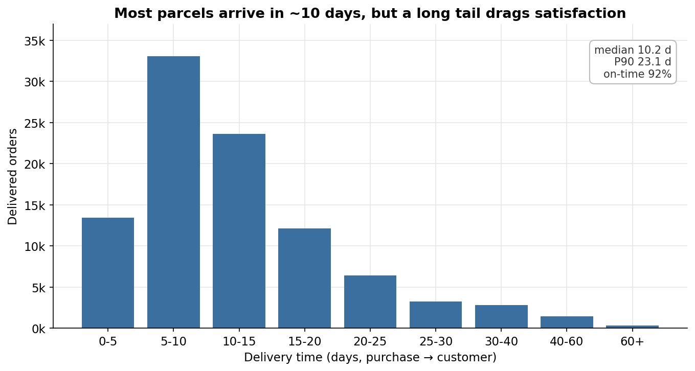
Figure 3. Most parcels arrive in ~10 days, but a long tail drags satisfaction.
Signal: Median delivery is 10 days and the on-time rate is 92%, but the p90 stretches to 23 days.
Analysis: Typical performance is good; the problem is variance — the slow tail is where 1- and 2-star reviews concentrate, so the average understates the satisfaction risk.
So What: Manage the tail, not the median: set alerts on p90 delivery days and on the orders that breach the estimated date, which is where ratings are lost.
Caveat: Delivery days are computable only for delivered orders with both timestamps; undelivered orders are excluded and reported separately in the status mix.
The distribution explains why a healthy headline on-time rate still coexists with a visible band of dissatisfied customers: a minority of very slow orders does outsized reputational damage.
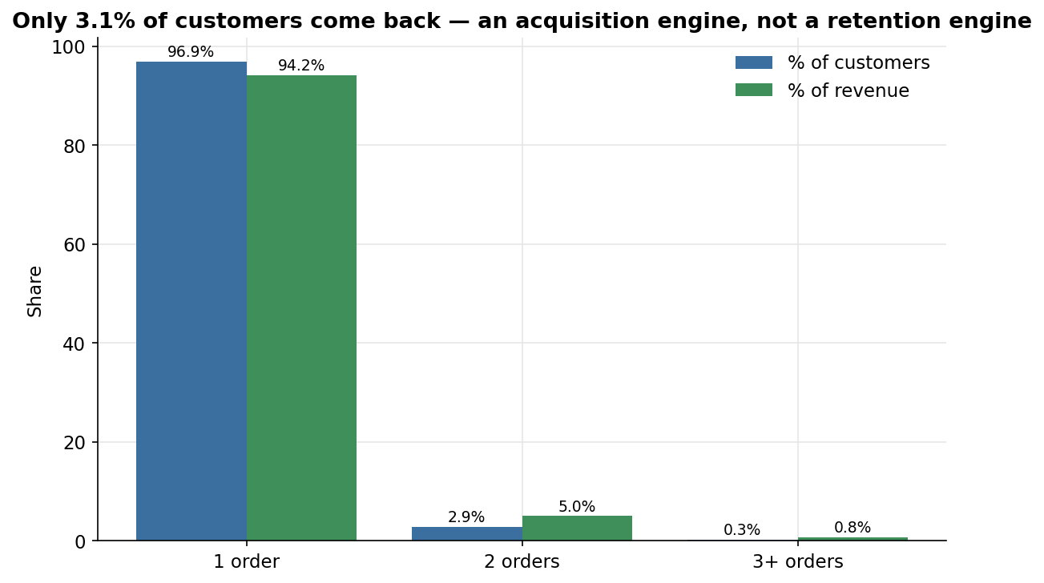
Figure 5. Only 3.1% of customers come back — an acquisition engine, not a retention engine.
Signal: 97% of customers order once and generate 94% of revenue; only 3.1% order again.
Analysis: Keyed correctly on customer_unique_id, the data shows the marketplace grows by acquiring new buyers rather than deepening existing relationships, which makes revenue sensitive to acquisition cost.
So What: Treat repeat rate as a strategic opportunity: even a small lift in second-order rate would meaningfully change unit economics, so test post-purchase retention against the delivery and product issues identified above.
Caveat: A 24-month window truncates the true lifetime of late-cohort customers, so the repeat rate is a lower bound; it is still strikingly low.
Retention and satisfaction connect directly: the delivery and product-condition problems associated with low scores are plausible suppressors of the second order, so fixing them is also a retention lever.

Deep-Dive Module B: KPI, BI, and Dashboard Readiness
Module B is included because the project's output is meant to feed a Tableau dashboard. The question is not which metrics exist but which the decision requires, and whether they are trustworthy enough to publish. The pipeline emits a set of decision-ready aggregate tables to data/output/ — monthly trend, category Pareto, delivery distribution, score-vs-delivery, RFM/repeat, revenue by state, the raw-vs-decision-ready reconciliation, and the validated AI topic breakdown — each at a single, documented grain so the dashboard inherits the corrected numbers rather than re-deriving them.
Dashboard readiness rests on three checks. First, are the metrics defined and reconciled? Yes: every KPI in the dictionary traces to a formula and a cleaning rule, and order value reconciles to payments at r = 1.000. Second, does the visual hierarchy match the decision flow? The intended top layer is the satisfaction-and-delivery status (review score, on-time rate, p90 days), the middle layer explains drivers (delivery distribution, category and state concentration), and the bottom layer provides drill-down (RFM segments, topic mix). Third, can a reader act without a separate explanation? Each output table carries an action-titled figure in this report, so the dashboard can reuse the same titles. The one metric to publish as the headline revenue figure is net product revenue on delivered orders (R$13.22M), not GMV or any raw-join total.

Risks, Limitations, and Counterarguments
Several limitations bound the conclusions. This is a 2016–2018 Brazilian-marketplace snapshot, so the findings should not be generalized to other markets or to the present. The data carries no cost information, so the report makes no profitability or margin claims. The delivery–satisfaction relationship is a strong association, not a proven cause, because review score also reflects product and expectation effects. Free-text coverage is sparse, so voice-of-customer findings rest on the 40,977-review commented subset and a validated 1,000-review sample rather than the full population. Geolocation was deduplicated by approximation.
A reasonable counterargument is that product quality, not delivery, is the real satisfaction problem, since product-quality complaints are the larger negative bucket (52% vs 38%). This view is partly valid and is why the recommendations address product condition as well. However, the stronger interpretation remains that delivery is the dominant structured signal: the star-rating gradient against delivery time is monotonic and population-wide, whereas product complaints, though numerous, do not show a comparable structured signal in this dataset. Both deserve action; delivery is the more measurable and controllable lever today.

Recommendations
Recommendation 1. Publish the order-grain layer as the dashboard's single source of truth. This addresses the fan-out double-count (Module A). The Data/BI lead should point Tableau at data/output/ and adopt net product revenue on delivered orders (R$13.22M) as the published revenue definition. The expected outcome is consistent, defensible reporting; the main trade-off is a one-time migration off any existing raw-join queries. Success is measured by every KPI tracing to a documented rule. If a future number cannot be reconciled to the order grain, pause and re-audit before publishing.
Recommendation 2. Make delivery-time reduction the primary satisfaction investment. This addresses Findings 1 and 4. The Operations lead should target the slow tail (p90 and estimated-date breaches), prioritizing the Southeast and the November peak where revenue and delivery-risk concentrate. The expected outcome is higher review scores and reduced churn; the dependency is carrier capacity and SLA terms. Success is measured by p90 delivery days and the on-time rate. If p90 does not improve after carrier changes, escalate to a regional fulfillment review.
Recommendation 3. Test retention against the product and delivery issues, and monitor concentration. This addresses Findings 3 and 4. With only 3.1% repeat, the Growth and CX leads should pilot a post-purchase retention motion for buyers in the top categories and states, and add category and geographic concentration to the standing risk dashboard. The expected outcome is a higher second-order rate and earlier warning of concentration shocks; the trade-off is marketing spend against uncertain lift. Success is measured by repeat rate and by the share of revenue outside the top category and state. If repeat rate does not move, treat the marketplace as acquisition-led and optimize acquisition cost instead.

Conclusion
This report shows that the Olist dataset can support real operations, category, and customer decisions — but only after a deliberate data-quality layer rebuilds it at the correct grain. The most important takeaway is not any single metric; it is that the headline numbers themselves depend on getting the join grain, the geolocation duplication, and the customer identity right first. Once they are, the story is consistent: delivery time is closely associated with satisfaction, revenue and demand concentrate in a few categories and in São Paulo, and the marketplace acquires far more than it retains. For decision-makers, the next step is to publish the corrected revenue layer and invest in delivery speed where the revenue and the risk coincide. More broadly, the case demonstrates that traceable data quality is not overhead — it is the precondition for any defensible recommendation.

References
Olist. (2018). Brazilian E-Commerce Public Dataset by Olist [Data set]. Kaggle. https://www.kaggle.com/olistbr/brazilian-ecommerce (CC BY-NC 4.0).
American Psychological Association. (2025). Student paper setup guide. APA Style.
Minto, B. (2009). The pyramid principle: Logic in writing and thinking. Pearson Education.
DuckDB Foundation. (2024). DuckDB: An in-process SQL OLAP database. https://duckdb.org

Appendix

A. Data-quality register (condensed)
ID | Area | Issue (real numbers) | Treatment
DQ-01 | Join grain | 9,803 multi-item; 2,961 multi-payment orders | Aggregate to order grain; show reconciliation
DQ-02 | Geolocation | 1,000,163 rows for 19,015 prefixes (~53×) | Dedupe to one row per prefix
DQ-03 | Identity | 99,441 customer_id → 96,096 unique | Key RFM/repeat on customer_unique_id
DQ-04 | Reviews | 58,247 (58.7%) lack comment text | Scope text analysis to 40,977; flag, don't impute
DQ-05 | Orders | Missing delivery dates (2,965/1,783/160) | Tie to non-delivered; exclude from delivery KPIs
DQ-06/07 | Products | 610 missing category; 2 untranslated | Map to EN; bucket nulls as unknown
DQ-08/09 | Payments / orphans | 9 value≤0; 3 not_defined; 775 no-item orders | Flag and exclude from cash/revenue
DQ-10 | AI derivation | LLM topic/sentiment labels | Validated: topic κ=0.81, sentiment κ=0.89

B. AI validation summary
Classifier: Claude (Opus) using a fixed rubric, reading review text only. Scope: a reproducible random sample of 1,000 of the 40,977 commented reviews. Validation: a second, independent LLM (Claude) annotator (blind to the bulk labels) re-labeled the 200-review gold set. Topic agreement = 86% (κ = 0.81); sentiment agreement = 94% (κ = 0.89); both correct = 82%. External check: text sentiment matches the star-derived sentiment on 83% of all 1,000, with mean stars of 1.8 (negative), 3.9 (neutral), and 4.8 (positive) — confirming the labels track a rating they never saw. Full detail: ai/validation_report.md.

C. Reproducibility
All artifacts regenerate from data/raw/ via the repository scripts: build_pipeline.py (raw → cleaned → output), analysis.ipynb (the eight figures), sql/ run through scripts/run_sql.py (DuckDB cross-checks), scripts/ai_sample.py and ai_validate.py (the AI layer), and this script (the report). The full data dictionary and QA tracker live in documentation/.

